

Department of Computer Science
at
The University of Vermont

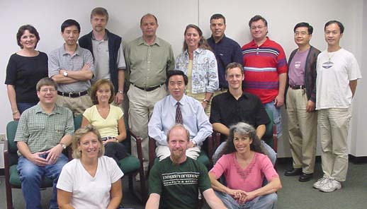

Faculty Profiles

Fall 2007

