FORGET ME NOT

System Design Specification

____________________________________________________________________________

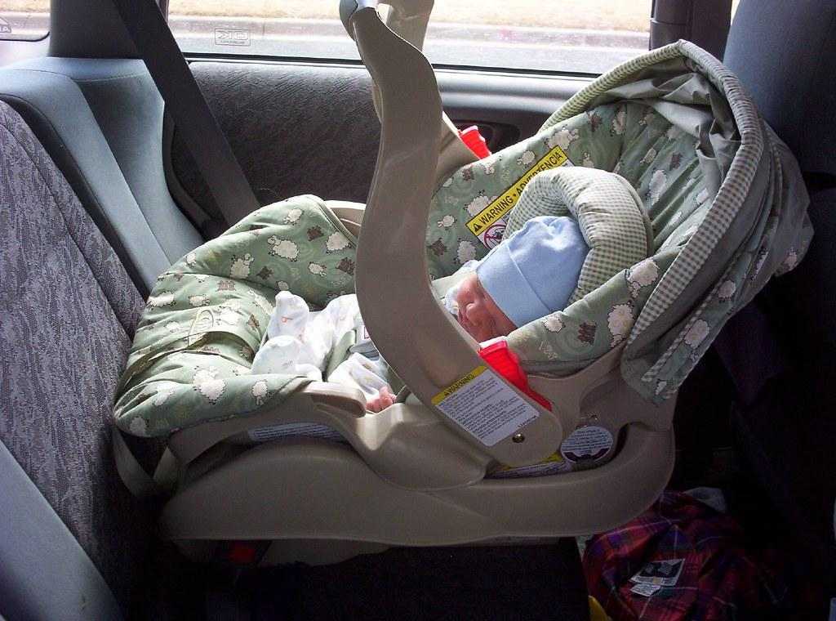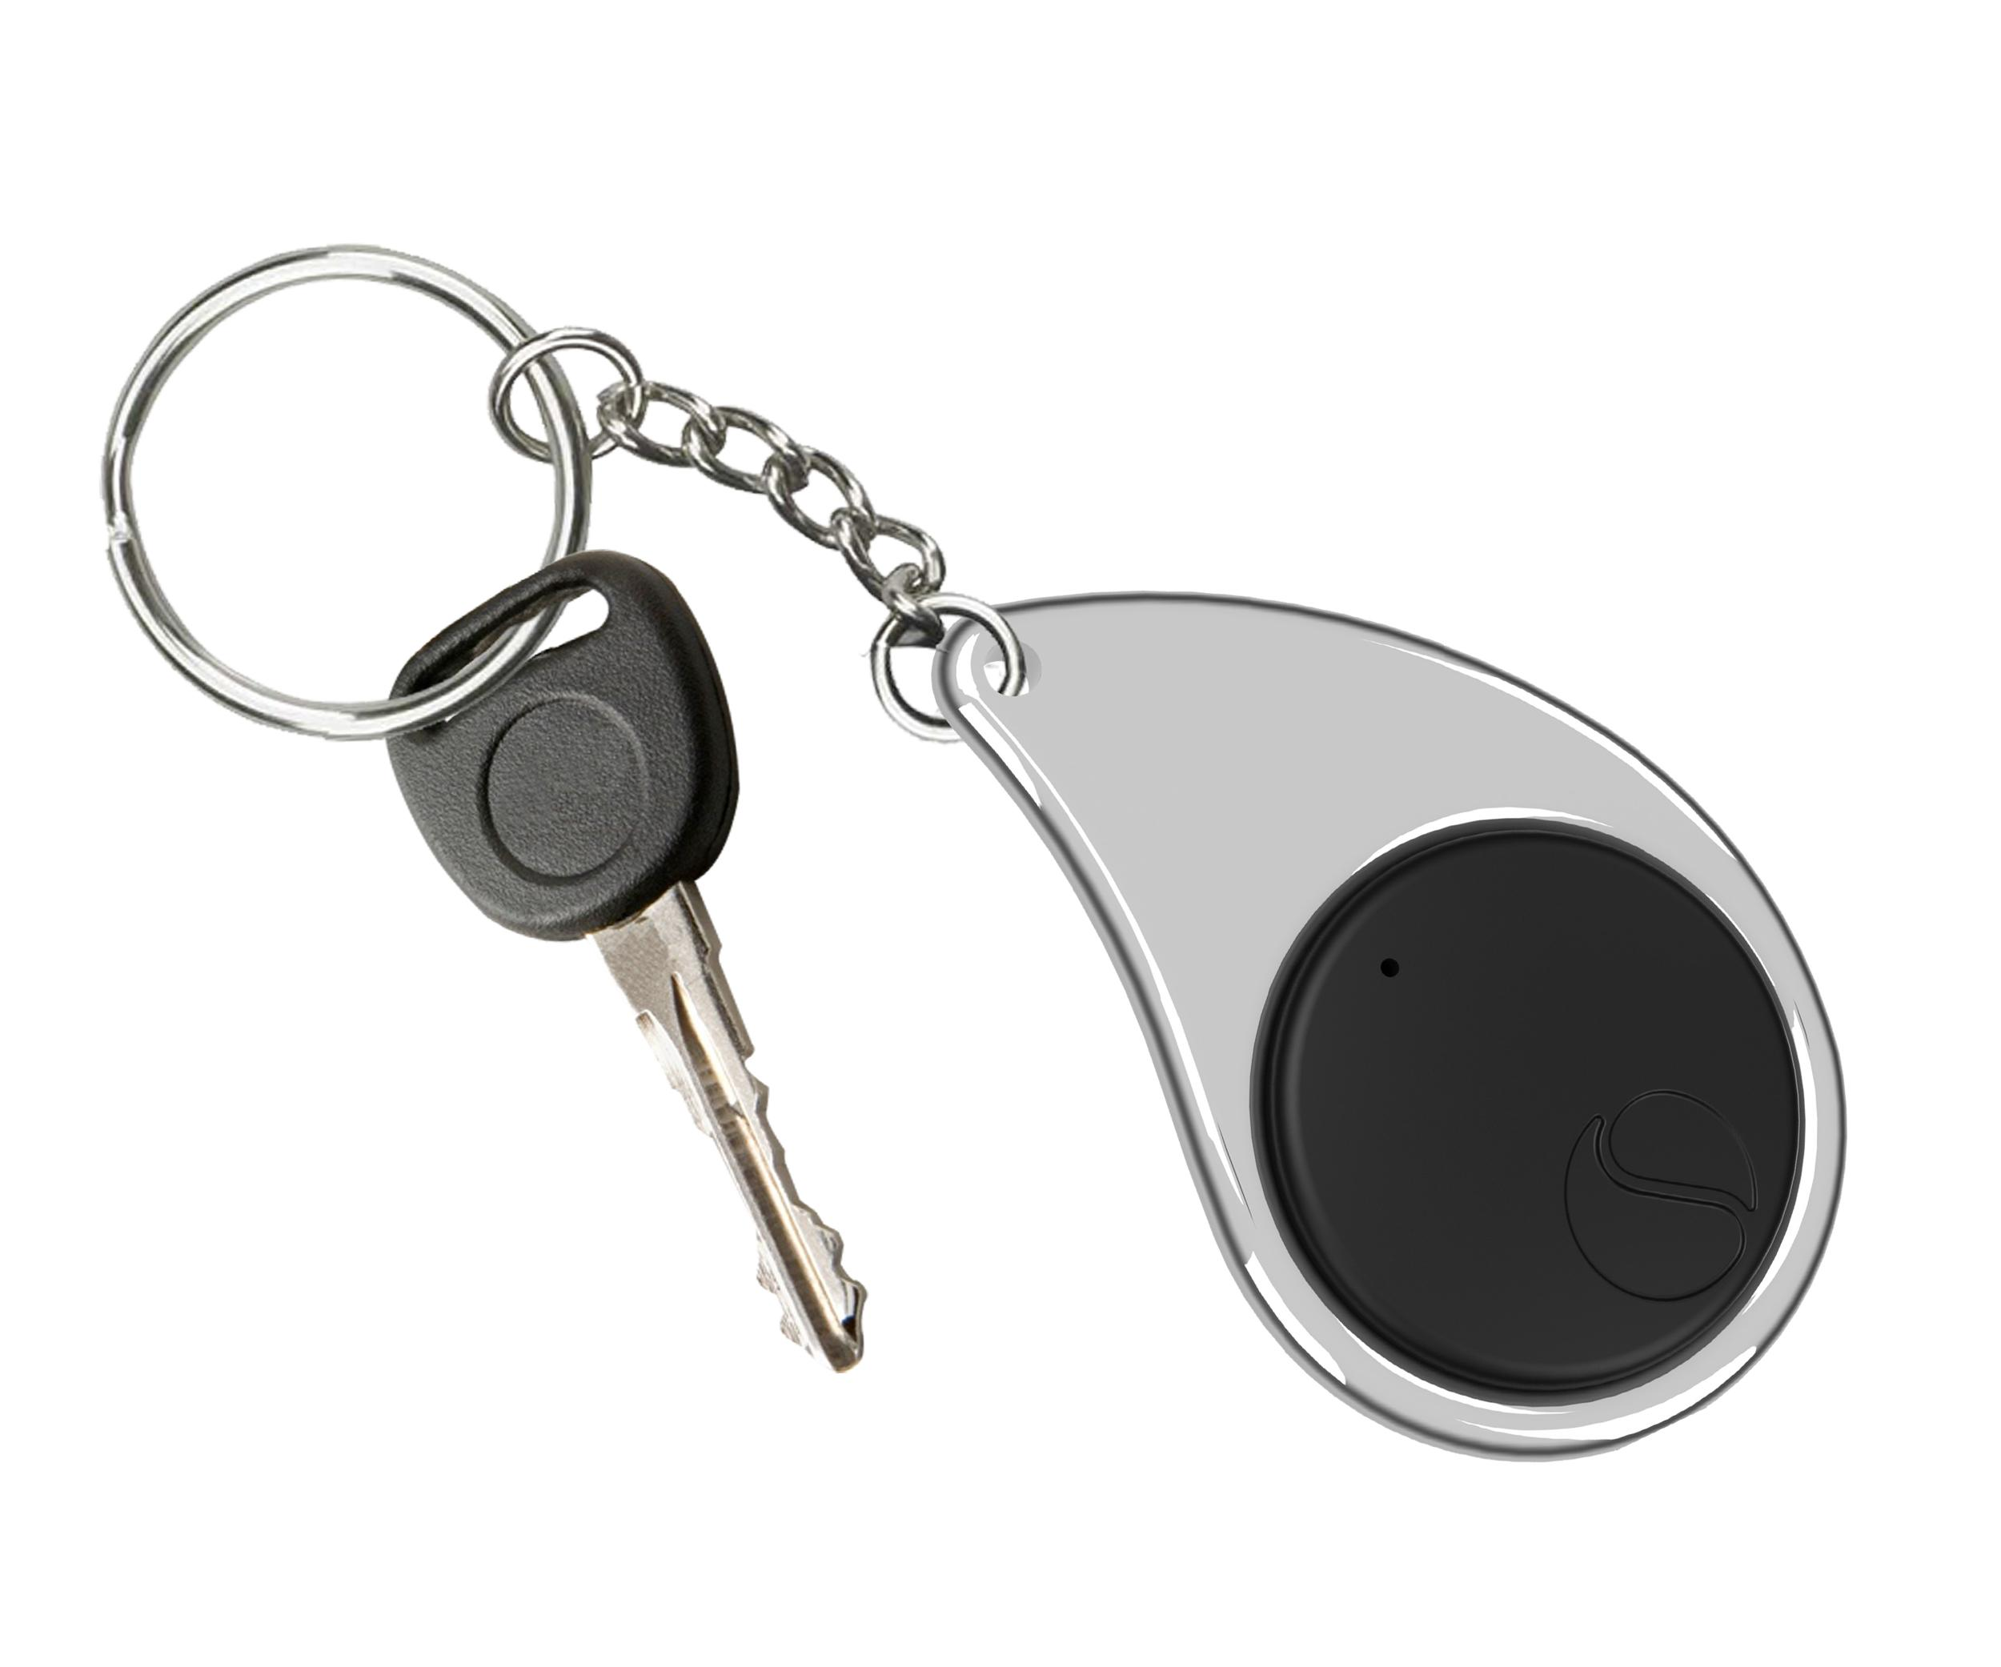

Revision 1

October 16th, 2019

ECE 497 Capstone Project Group 1

Sponsor: Laura Ochsner

[lauraochsner@hotmail.com](mailto:lauraochsner@hotmail.com)

Group Members: Jacob Cassady

Mason Gardone

Raley Suter

Table of Contents

1. System Description 4

1.1. System Interfaces 4

1.1.1. External Interfaces 4

1.1.2. Internal Interfaces 5

1.2. System Requirements 6

1.2.1. The system must be able to survive heat of 175 degrees. 6

1.2.2. The system must retain working power for 8 ± 1 days on a single full charge. 6

1.2.3. Key Fob Subsystem shall be no larger than 1.5”x3”x1”. 6

1.2.4. Car Seat Subsystem shall be no larger than 5”x5”x1.5”. 6

1.2.5. The system shall be disarmed by pressing the disarm button on the Car Seat Subsystem. 7

1.2.6. Key Fob Subsystem shall make audible sound and vibrations once the fob exits a 20ft ± 5ft perimeter around the car module before the alarm is disarmed. 7

1.2.7. The system’s alarm sound should reach 80dB ± 5dB. 7

1.2.8. Alarm shall rearm automatically when user re-enters the perimeter of 20ft ± 5ft from the Car Seat Subsystem. 7

1.2.9. The system shall alert the operator via low power LED. 7

1.2.10. The Key Fob Subsystem must operate with reduced functionality at low power. 7

1.3. Major Components 7

1.3.1. Hardware Components 8

1.3.2. Software Components 11

2. Detailed Design 13

2.1. Hardware Components 13

2.1.1. MicroPython pyboard v1.1 Development Board 13

2.1.2. Adafruit Ultimate GPS Breakout Module 14

2.1.3. Digi Xbee3 Zigbee 3.0 RF Module 15

2.1.4. Power Sources 17

2.1.5. Power Estimation Circuit 17

2.1.6. PCB 18

2.1.7. 3D Printed Case 18

2.1.8. Sixfab Internal Active GPS Patch Antenna 19

2.1.9. W24P-U OEM Wi-Fi Antenna 19

2.1.10. Cylindrical Core SMT Vibration Motor 20

2.1.11. Piezoelectric Buzzer PKB24SPCH3601-B0 21

2.2. Software Components 22

2.2.1. Model 22

2.2.2. Communication Parser 25

2.2.3. Power Estimator 26

2.2.4. Distance Calculator 26

3. Principles of Operation 27

3.1. General Use 27

3.2. Team Developed Hardware Components 27

3.2.1. Power Estimation Circuit 27

3.2.2. Printed Circuit Board (PCB) 27

3.2.3. 3D Printed Case 27

3.3. COTS Hardware Components 28

3.3.1. MicroPython pyboard v1.1 Development Board 28

3.3.2. Adafruit Ultimate GPS Breakout Module 28

3.3.3. Digi Xbee3 Zigbee 3.0 RF Module 28

3.3.4. Power Source 28

3.3.5. W24P-U OEM Wi-Fi Antenna 28

3.3.6. Sixfab Internal Active GPS Patch Antenna 29

3.3.7. Cylindrical core SMT Vibration Motor 29

3.3.8. Piezoelectric Buzzer PKB24SPCH3601-B0 29

4. Test Procedures 29

4.1. Temperature Test 29

4.1.1. 1.2.1 - The system must be able to survive heat of 175 degrees. 29

4.2. Longevity Test 29

4.2.1. 1.2.1 - The system must retain working power for 8 ± 1 days on a single full charge. 29

4.3. Sizing Test 29

4.3.1. 1.2.3 - Key Fob Subsystem shall be no larger than 1.5”x3”x1”. 30

4.3.2. 1.2.4 - Car Seat Subsystem shall be no larger than 5”x5”x1.5”. 30

4.4. Alarm Disarm Test 30

4.4.1. 1.2.6 - The system shall be disarmed by pressing the disarm button on the Car Seat Subsystem. 30

4.4.2. 1.2.7 - Key Fob Subsystem shall make audible sound and vibrations once the fob exits a 20ft ± 5ft perimeter around the car module before the alarm is disarmed. 30

4.5. Sound Test 30

4.5.1. 1.2.8 - The system’s alarm sound should reach 80dB ± 5dB. 30

4.6. Rearm Test 30

4.6.1. 1.2.9 - Alarm shall rearm automatically when user re-enters the perimeter of 20ft ± 5ft from the Car Seat Subsystem. 30

4.7. Low Power Test 30

4.7.1. 1.2.10 - The system shall alert the operator via low power LED. 31

4.7.2. 1.2.11 - The Key Fob Subsystem must operate with reduced functionality at low power. 31

5. Requirements Traceability Matrix 31

6. Documents/Standards 32

6.1. GPS Standard 32

6.2. Telemetry Standard 32

7. Appendices 32

# System Description

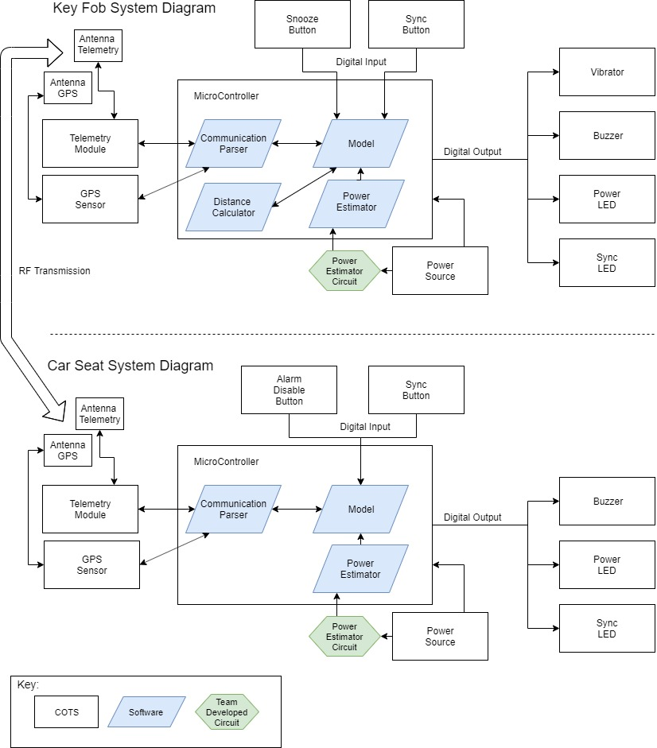

Figure 1 : System Diagram

## System Interfaces

### External Interfaces

#### Push Buttons

##### **Disarm Button**

The disarm push button is present only on the car seat subsystem. When pressed by the user, a digital signal will activate the Power LED to indicate the subsystem has power. When the disarm button is held for at least three seconds and the two subsystems are in range and synchronized, a high digital signal to the microcontroller will disarm the audible and vibration alarms on the key fob subsystem.

##### **Synchronize Button**

The synchronization push button is on both subsystems. When this button is pressed, a digital signal is sent to the microcontroller. The subsystem will enter synchronization mode for the duration of the button press. When the synchronize buttons on each subsystem are pressed and held simultaneously, the two subsystems will pair.

##### **Snooze Button**

The snooze push button is present solely on the key fob subsystem. When pressed, the snooze push button will send a digital signal to the microcontroller to silence the alarm for 2 minutes ± 10 seconds.

#### GPS Communication

The GPS chip on each subsystem will be used to measure the location of each subsystem. The GPS chip will use an internal antenna to broadcast radio waves.

#### Antennas

The antennas will be attached inside both subsystems’ chassis. The antennas will be receiving and transmitting information via radio waves. The GPS and RF telemetry chips will use different antennas.

#### LEDs

##### **Power LED**

This LED will be used to display information about power. Microcontroller sends a digital signal at a set duty cycle to make the LED blink or not blink.

##### **Sync LED**

The sync LED will flash when the system is in synchronization mode. The rate of flashing will be controlled by the microcontroller.

#### Power Source

The power source is a compact battery mounted inside the subsystems. Each subsystem will require a user to replace the batteries when power is low.

#### Vibrator

The vibrator will be mechanically attached to the 3D casing of the key fob subsystem. When the microcontroller activates the alarm it will turn on the vibrator to begin vibrating the subsystem.

### Internal Interfaces

#### Digital Outputs

Digital outputs are the data from the microcontroller to the LEDs, buzzer, vibration motor, GPS module, and RF telemetry module. The microcontroller will control the LEDs, the buzzer, and the vibration motor by sending a logic high to a switching device, allowing each of these end items to receive power. The GPS and RF integrated circuits (IC) will be sent data from the microcontroller using UART (Universal Asynchronous Receiver/Transmitter) and Rx/Tx connections.

#### Digital Inputs

The user will cause an input to the microcontroller to start a task via the on-board push buttons. The GPS and Telemetry ICs will send digital data via UART to the microcontroller.

#### Antenna to GPS and RF ICs

Signals received by the antenna will be directed to the GPS or RF telemetry modules. Each subsystem will have an antenna dedicated to the GPS module and an antenna dedicated to the RF telemetry module.

#### Power Source Connections

The power source will supply voltage to the microcontroller which supplies power to drive the other components. The power source feeds into the power estimation circuit through a high-side-driver-circuit which then feeds into an analog-to-digital converter (ADC) on the microcontroller.

## System Requirements

### The system shall survive temperatures up to 175 degrees Fahrenheit.

The Forget Me Not system is likely to endure high heat situations when kept inside a car. To account for this, the system must be tested to operate when exposed to temperatures 175 degrees Fahrenheit (80˚C) and below.

### The system shall retain working power for 8 ± 1 days on a single full charge.

The Forget Me Not system shall operate for several days of use. If the user is required to frequently change batteries on both subsystems, the benefit of the Forget Me Not system is greatly compromised. Both subsystems must remain operating after 8 ± 1 days of intermittent use.

### Key Fob Subsystem shall be no larger than 1.5”x3”x1”.

It is required that the key fob subsystem be designed such that it will fit on a keychain. The subsystem must be designed to be no larger than 1.5” in width, 3” in length, and 1” in thickness.

### Car Seat Subsystem shall be no larger than 5”x5”x1.5”.

It is required that the car seat subsystem be designed for storage in or under a car seat. The subsystem must be designed to be no larger than 5” in width, 5” in length, and 1.5” in thickness.

### The system shall be disarmed by pressing the disarm button.

The system shall enter the disarmed state when the disarm button is pressed. This button is located on the car seat subsystem. The disarm button shall disarm the system as long as a communication connection is available with the key fob subsystem.

### Key Fob Subsystem shall make audible sound and vibrations in triggered condition.

The key fob shall alarm the operator if they leave a 20ft ± 5ft perimeter around the car seat subsystem before disarming the system. This alarming will be performed with both sound and vibration.

### The system’s alarm sound shall reach 80dB ± 5dB.

The system must create an alarm sound that is both audible and non-damaging to the ears of any user. This value was chosen because 80dB ± 5dB is the threshold at which damage starts to occur to hearing.

### Alarm shall rearm automatically when user re-enters the perimeter of 20ft ± 5ft from the car seat subsystem.

The system shall enter the alarm state upon re-entry of the key fob into the alarm boundary. This is to ensure repeated working use of the system with no required user input outside of pairing the two subsystems and replacing batteries. This requirement can be validated by disarming the system, leaving the boundary, re-entering the boundary, and then leaving the boundary again. If this requirement is met, the alarm will sound.

### The system shall alert the operator of low power conditions using an LED indicator and an audible noise.

It is critical that the end-user be informed when the power for the system is almost depleted. This information is supplied to the user audibly and visually using a buzzer and an LED.

### The Key Fob Subsystem shall operate with reduced functionality at low power.

In the case of the key fob subsystem reaching a low power condition, it must turn off all power consuming systems except supply to the low power indicators described above in section 1.2.9. This is to extend battery life to increase the likelihood of the user noticing the low power condition.

## Major Components

The Forget Me Not system contains the following hardware components: two Microcontrollers, two GPS breakout modules, two RF telemetry modules, two different power sources, two power estimator circuits, two printed circuit boards (PCB), two different 3D printed cases, four antennas, four push buttons, four LEDs, two buzzers, and one vibrator motor. Each microcontroller will also have four software components: a communicate parser, a model, a power estimator, and a distance calculator.

### Hardware Components

#### Microcontroller

The microcontroller used will be the Micro Python pyboard v1.1. All the digital inputs and outputs will connect to the motherboard via I/O pins, Rx/Tx, and UART connections. The power estimation circuit will also input into the pyboard through an ADC. The pyboard also will be attached to the PCB and mounted inside the 3D case.

##### Allocated Functional Requirements

1.2.1 - System must be able to survive heat of 175 degrees.

1.2.2 - System must retain power for 8 ± 1 days on a single charge.

1.2.5 - The system shall be disarmed by holding the disarm button on the Car Seat Subsystem.

1.2.6 - Key Fob Subsystem shall make audible sound and vibrations when the fob is outside of 20ft ± 5ft from the car module before the alarm is disarmed.

1.2.8 - Alarm shall rearm automatically when user re-enters the perimeter of 20ft ± 5ft from the Car Seat Subsystem.

#### GPS Module

The Adafruit Ultimate GPS Breakout module will be used to determine the distance between the key fob and car seat subsystems. The GPS sensor will use an external Sixfab Active GPS Patch Antenna.

##### Allocated Functional Requirements

1.2.1 - System must be able to survive heat of 175 degrees.

1.2.2 - System must retain power for 8 ± 1 days on a single charge.

1.2.6 - Key Fob Subsystem shall make audible sound and vibrations when the fob is outside of 20ft ± 5ft from the car module before the alarm is disarmed.

1.2.8 - Alarm shall rearm automatically when user re-enters the perimeter of 20ft ± 5ft feet from the Car Seat Subsystem.

#### RF Telemetry Module

Each subsystem will have a Digi Xbee3 Zigbee 3.0 module responsible for facilitating communication between the subsystems. The telemetry module will communicate through radio waves via an antenna.

##### Allocated Functional Requirements

1.2.1 - System must be able to survive heat of 175 degrees.

1.2.2 - System must retain power for 8 ± 1 days on a single charge.

1.2.5 - The system shall be disarmed by holding the disarm button on the Car Seat Subsystem.

1.2.6 - Key Fob Subsystem shall make audible sound and vibrations when the fob is outside of 20ft ± 5ft from the car module before the alarm is disarmed.

1.2.8 - Alarm shall rearm automatically when user re-enters the perimeter of 20ft ± 5ft from the Car Seat Subsystem.

#### Power Source

A compact battery will be used in the subsystems to provide required voltage and current. Each subsystem has its own power source mounted using a commercial off the shelf (COTS) battery holder.

##### Allocated Functional Requirements

1.2.1 - System must be able to survive heat of 175 degrees.

1.2.2 - System must retain power for 8 ± 1 days on a single charge.

#### Power Estimator Circuit

The power estimator circuit is a high-side-driver circuit. A GPIO pin on the microcontroller will control the driver. With a voltage divider the battery voltage will be halved when connected to an ADC on the microcontroller.

##### Allocated Functional Requirements

1.2.2 - System must retain power for 8 ± 1 days on a single charge.

1.2.9 - The system shall alert the operator via low power LED.

#### Printed Circuit Board (PCB)

Printed circuit board will be two layers. The PCB will have the power estimator circuit soldered to one side. The other major components will be attached to the PCB with surface mount and thru hole connections.

##### Allocated Functional Requirements

1.2.1 - System must be able to survive heat of 175 degrees.

1.2.3 - Key Fob Subsystem shall be no larger than 1.5”x3”x1”.

1.2.4 - Car Seat Subsystem shall be no larger than 5”x5”x1.5”.

#### 3D Printed Case

Each subsystem will have a 3D printed case in which all components will be housed. The key fob and car seat subsystems have different features; therefore, the physical 3D designs will differ.

##### Allocated Functional Requirements

1.2.1 - System must be able to survive heat of 175 degrees.

1.2.3 - Key Fob Subsystem shall be no larger than 1.5”x3”x1”.

1.2.4 - Car Seat Subsystem shall be no larger than 5”x5”x1.5”.

#### Antennas

The Internal Active GPS Patch Antenna will be used by the GPS module. The telemetry module will use the W24P-U for its antenna. Both antennas will be mounted inside the 3D case of the subsystems.

##### Allocated Functional Requirements

1.2.6 - Key Fob Subsystem shall make audible sound and vibrations when the fob is outside of 20ft ± 5ft from the car module before the alarm is disarmed.

1.2.8 - Alarm shall rearm automatically when user re-enters the perimeter of 20ft ± 5ft from the Car Seat Subsystem.

#### Push Buttons

The subsystems will utilize the two push buttons present on the pyboard. The key fob subsystem will use one button for the snooze feature and the other button for entering the syncing state. The car module will have one button for syncing and one button for disabling the alarm.

##### Allocated Functional Requirements

1.2.1 - System must be able to survive heat of 175 degrees.

1.2.2 - System must retain power for 8 ± 1 days on a single charge.

1.2.5 - The system shall be disarmed by holding the disarm button on the Car Seat Subsystem.

#### LEDs

Two of the four LEDs on the pyboard are used for each subsystem. The LEDs are used as indicators to interface with the end user. One LED is used to indicate power status while the other is used to indicate the syncing state.

##### Allocated Functional Requirements

1.2.1 - System must be able to survive heat of 175 degrees.

1.2.2 - System must retain power for 8 ± 1 days on a single charge.

#### Buzzer

A Murata piezoelectric buzzer will be used to make the 80 ± 5 dB alarm that the system requires. The buzzer will be controlled by the microcontroller and mounted on the PCB.

##### Allocated Functional Requirements

1.2.1 - System must be able to survive heat of 175 degrees.

1.2.2 - System must retain power for 8 ± 1 days on a single charge.

1.2.6 - Key Fob Subsystem shall make audible sound and vibrations when the fob is outside of 20ft ± 5ft from the car module before the alarm is disarmed.

1.2.7 - The System’s alarm sound should reach 80dB ± 5dB.

#### Vibrator Motor

The vibrator will be a coin vibrator motor mounted and glued to the 3D case of the key fob system. The vibrator motor will be activated when the microcontroller triggers the alarm.

##### Allocated Functional Requirements

1.2.1 - System must be able to survive heat of 175 degrees.

1.2.6 - Key Fob Subsystem shall make audible sound and vibrations when the fob is outside of 20ft ± 5ft from the car module before the alarm is disarmed.

### Software Components

#### Model

The model component is included in both subsystems. The model is a data structure with associated functions responsible for keeping track of the system’s dynamic state including the status of subsystems synced to the model. This component is important for the program to understand the moving parts. This component will be the central interface for all other software components.

##### Allocated Functional Requirements

* + - * 1.2.5 - The system shall be disarmed by holding the disarm button on the Car Seat Subsystem.
      * 1.2.6 - Key Fob Subsystem shall make audible sound and vibrations when the fob is outside of 20ft ± 5ft from the car module before the alarm is disarmed.
      * 1.2.8 - Alarm shall rearm automatically when user re-enters the perimeter of 20ft ± 5ft from the Car Seat Subsystem.
      * 1.2.9 - System shall alert the operator of low power.
      * 1.2.10 - System must operate with reduced functionality at low power.

#### Communication Parser

The communication parser is included in both subsystems. The software module designed for communication parsing is important for packing data into a telemetry packet as well as unpacking data stored in a telemetry packet. The communication parser module will facilitate the encoding/decoding of data passed through the telemetry module. Also, the communication parser will be solely responsible for interfacing with the telemetry module.

##### Allocated Functional Requirements

1.2.5 - The system shall be disarmed by holding the disarm button on the Car Seat Subsystem.

1.2.6 - Key Fob Subsystem shall make audible sound and vibrations when the fob is outside of 20ft ± 5ft from the car module before the alarm is disarmed.

1.2.7 - The System’s alarm sound should reach 80 ± 5 dB.

#### Power Estimator

The power estimator is included in both subsystems. The power estimator software module receives data from the power supply and uses it to estimate the amount of remaining power in the power supply.

##### Allocated Functional Requirements

1.2.2 - System must retain power for 8 ± 1 days on a single charge.

1.2.9 - System shall alert the operator of low power.

1.2.10 - System must operate with reduced functionality at low power.

#### Distance Calculator

The distance calculator is the only software component native to the Key Fob Subsystem without being included in the Car Seat Subsystem. This distance calculator takes two parameters, the GPS coordinates from each subsystem, and calculates the difference between them.

##### Allocated Functional Requirements

1.2.6 - Key Fob Subsystem shall make audible sound and vibrations when the fob is outside of 20ft ± 5ft from the car module before the alarm is disarmed.

1.2.8 - Alarm shall rearm automatically when user re-enters the perimeter of 20ft ± 5ft from the Car Seat Subsystem.

# Detailed Design

## Hardware Components

### MicroPython pyboard v1.1 Development Board

The MicroPython pyboard v1.1 Development Board comes equipped with a large selection of hardware. It contains a STM32F405RG microcontroller, a 168 MHz Cortex M4 CPU with hardware floating point, 1024KiB flash ROM and 192KiB RAM, a Micro USB connector for power and serial communication, a Micro SD card slot (supporting standard and high capacity SD cards), a 3-axis accelerometer (MMA7660), a real time clock with optional battery backup, 31 GPIO, three 12-bit analog to digital converters (ADC) available on 16 pins, 4 of which have analog ground shielding, two 12-bit digital to analog (DAC) converters available on pins 5 and 6, 4 LEDs, a reset and a user switch, an on-board 3.3V LDO voltage regulator capable of supplying up to 250mA with input voltage range 3.6V to 16V, and a DFU bootloader in ROM for easy upgrading of firmware.

Of this included hardware, the pyboard holds the following classes for easy control: ADC, SPI, IC, DAC, SD card storage, and UART. The pinout for the Development board can be found in **Figure 2**. Power and ground will be supplied to the pyboard through V+ and GND pins, power supplied by the batteries within each subsystem. Two GPIO pins will also be used to operate the sounder and the vibration motor components. The voltage level remaining in the system battery will be measured using the Power Estimation Circuit described in section 2.1.5 and the analog signal will be fed into the microcontroller through one of the three ADCs. Both switches and two of the four LEDs will also be used and are described in sections 2.1.1.1 and 2.1.1.2. One set of Rx and Tx data pins will be used to communicate with the GPS Breakout Module and one set of UART pins will be used to communicate with the RF telemetry module. Both modules will be powered from the pyboard 3V3 regulated output pins.

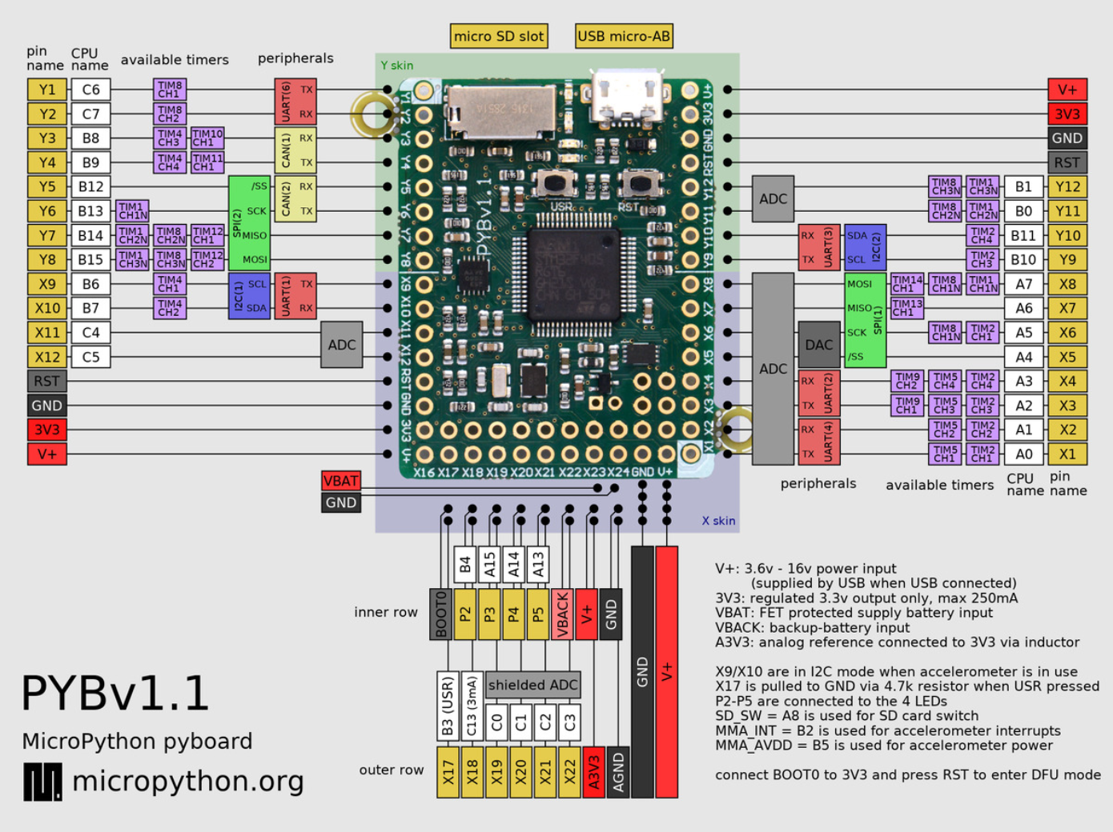

Figure 2 : MicroPython pyboard v1.1 Pinout

#### Push Buttons

The two pushbuttons, or switches, present on the pyboard are represented by their own class in MicroPython. This Switch class has three methods that allow the program to obtain the state of the switch or throw a flag when the state has been changed.

#### LEDs

There are four LEDs present on the pyboard. These LEDs work out of the box and can be controlled with a single function call. The fourth LED is blue and has an additional function associated with it to control its intensity. Only two of the LEDs will be used in either the Key Fob or Car Seat subsystem and these will merely be toggled on or off to indicate state.

### Adafruit Ultimate GPS Breakout Module

The Adafruit Ultimate GPS Breakout Module was designed to work easily with microcontrollers. It contains a built-in standard ceramic patch antenna that gives -165 dB sensitivity. For Projects in which the module may be enclosed in metal casing or not open to the sky, a uFL connection for an external antenna connection is also present. When a 3V external active GPS antenna is attached to this connection, the module automatically detects and switches to using the external antenna. The exterior antenna selected by the team is the Sixfab Internal Active GPS Patch Antenna, when attaching this antenna, a strain relief design must be used to prevent accidental removal of the fragile uFL connector. The Ultimate GPS Breakout Module requires 25mA of current when tracking and 20mA when navigating. As soon as the module is powered up and the Tx pin is connected, the microcontroller will receive data. The module immediately tries to find a fix in which the 2D (latitude and longitude) or 3D (latitude, longitude, and height) information is confirmed. This process can be a fast as 34 seconds under ideal circumstances but may take 30 minutes or longer in less ideal circumstances due to location, tall building, RF noise, and other factors. When a fix is obtained, this Adafruit module is position accurate to as little as 1.8 meters. There is also a small microcontroller with a small amount of flash memory present in the Ultimate GPS breakout module which can store up to 16 hours of data allowing the microcontroller to fall into low power mode and not be in constant communication with the GPS module. In this mode, the time, date, longitude, latitude, and height and logged every 15 seconds. The pinout for the GPS module is shown below in **Table 1**. Data is transmitted between the microcontroller and the GPS module via the TX and RX pins, and power and ground are supplied to the module via the VIN and GND pins, respectively.

Table 1 : Adafruit Ultimate GPS Breakout Pinout

|  |  |
| --- | --- |
| Pin | Purpose |
| 3.3V | Clean 3.3VDC, 100mA output. |
| EN | Enable pin. When pulled to ground, GPS module will turn off and in doing so will lose its fix. With no backup battery installed, finding the fix will take a long time. |
| VBAT | Input pin, connected to GPS real time clock battery backup. |
| FIX | When no fix, pulses up and down once per second. When there is a fix, the pin stays low (0V), pulses high for 200ms once every 15 seconds. |
| TX | Transmits data from GPS to microcontroller. 3.3V logic level, 9600 baud rate default. |
| RX | Transmits data to the GPS. 3.3V or 5V logic level, 9600 baud rate default. Requires checksummed NMEA sentences. |
| GND | Power and signal ground. Connect to microcontroller ground. |
| VIN | Power input, 3-5VDC |
| PPS | Pulses high (3.3V) once per second for 50-100ms. |

### Digi Xbee3 Zigbee 3.0 RF Module

The Digi Xbee3 Zigbee 3.0 RF Module comes in three styles, the selected style for the Forget Me Not device is the surface mount (SMT) style. The Digi Xbee3 modules are built support all protocols; the protocol being used by the team is the XBee 802.15.4. protocol. This module also is built to eliminate the need for an additional driving microcontroller and can create MicroPython smart end nodes. Technical specifications for the Digi Xbee3 can be seen below in **Table 2**. Characteristics related to system requirements in the below figure are range, transmit power, operating temperature, dimension, and supply voltage. The Xbee3 module will be mounted to the PCB using Samtec SMM-110-02-SM-S-TR header connectors. This will allow the Xbee3 to plug into the PCB rather than run the risk of damage during soldering. The pinout for the module is shown following in **Table 3**, pins vital for function are 1, 2, 3, and 10. These pins supply power and ground and provide the data path for sending and receiving from the other subsystem.

Table 2 : Digi Xbee 3 Technical Specifications

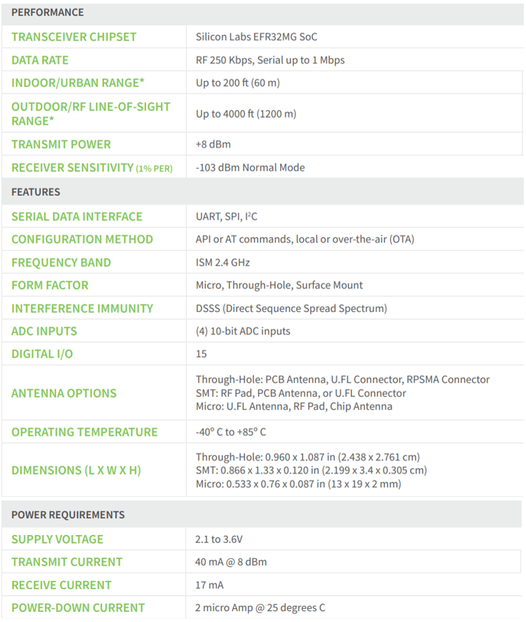

Table 3. Digi Xbee3 pinout.

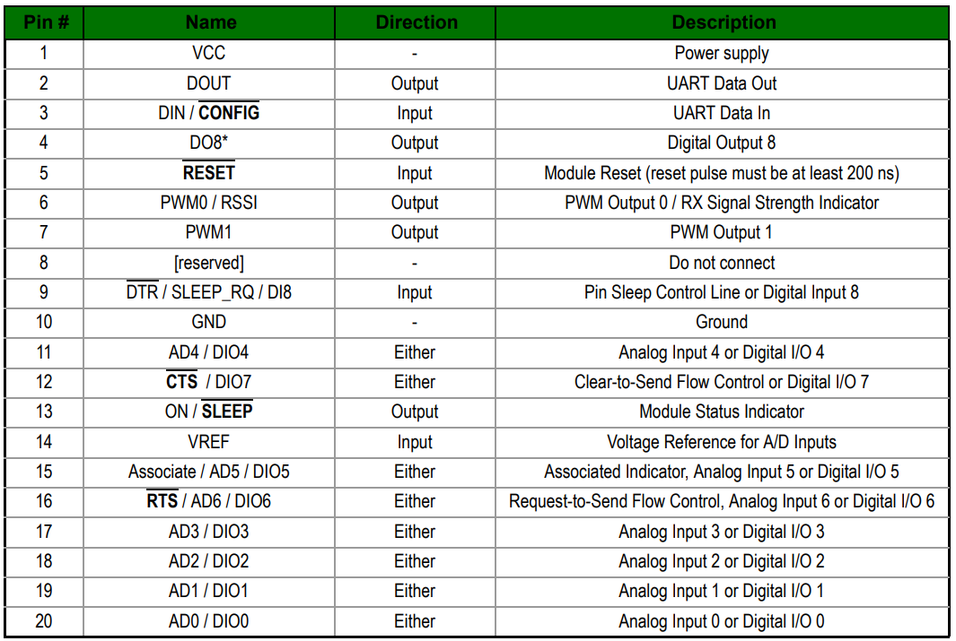

### Power Sources

The max load of the subsystems can reach 315mA. This number was found with the pyboard at full load and taking into count other components will not be driven constantly. Since the key fob subsystem has a size constraint of 1’’x 3’’ x 1.5’’ the batteries used had to be compact. The key fob subsystem has two CR2450 batteries connected in series to produce 6 volts and 620mAh to power the key fob for 2 hours at full load. The car seat subsystem is using 4 AA batteries in series to produce 6 volts and 2400mAh to power the system for 7.5 hours at full load. Both systems will have the batteries attached to the 3D case. The key fob will have two coin cell battery holders soldered directly to the PCB. The car seat subsystem will have a 4 cell battery holder with a cover.

### Power Estimation Circuit

To estimate the power of the system, the voltage of the battery will be measured via the ADC on the pyboard. The problem with the method is 300uA would be constantly drawn. So, a high-side driver circuit was implemented to stop the constant current draw. A GPIO pin on the pyboard will send a high signal to the NPN BJT. The BJT will pull the gate of the PMOS low allowing current to flow to the voltage divider circuit connected to the ADC of the pyboard. The voltage divider is set to halve Vin to 3V, which is safe for the VDC on the pyboard. The diode is added as fly back protection. The full circuit is shown in **Figure 3** and components are listed in **Table 4**. With this circuit when the GPIO pin is high there is a draw of 8.7mA. When the GPIO pin is low the current draw is 12.5nA which is 2400 times less than 300uA.

Table 4 : Power Estimation Circuit Components

|  |  |  |  |
| --- | --- | --- | --- |
| Part Number | Manufacturer | Description | Quantity |
| BSR17A | ON Semiconductor | Bipolar (BJT) Transistor NPN 40V 200mA 300MHz 350mW Surface Mount SOT-23-3 | 2 |
| BSH202,215 | Nexperia USA Inc. | P-Channel 30V 520mA (Ta) 417mW (Ta) Surface Mount TO-236AB | 2 |
| BAV19W-E3-08 | Vishay | Diode Standard 100V 250mA (DC) Surface Mount SOD-123 | 2 |
| MCT06030C1002FP500 | Vishay | 10 kOhms ±1% 0.125W, 1/8W Chip Resistor 0603 (1608 Metric) Anti-Sulfur Thin Film | 4 |
| MCT06030C1001FP500 | Vishay | 1 kOhms ±1% 0.125W, 1/8W Chip Resistor 0603 (1608 Metric) Anti-Sulfur Thin Film | 4 |

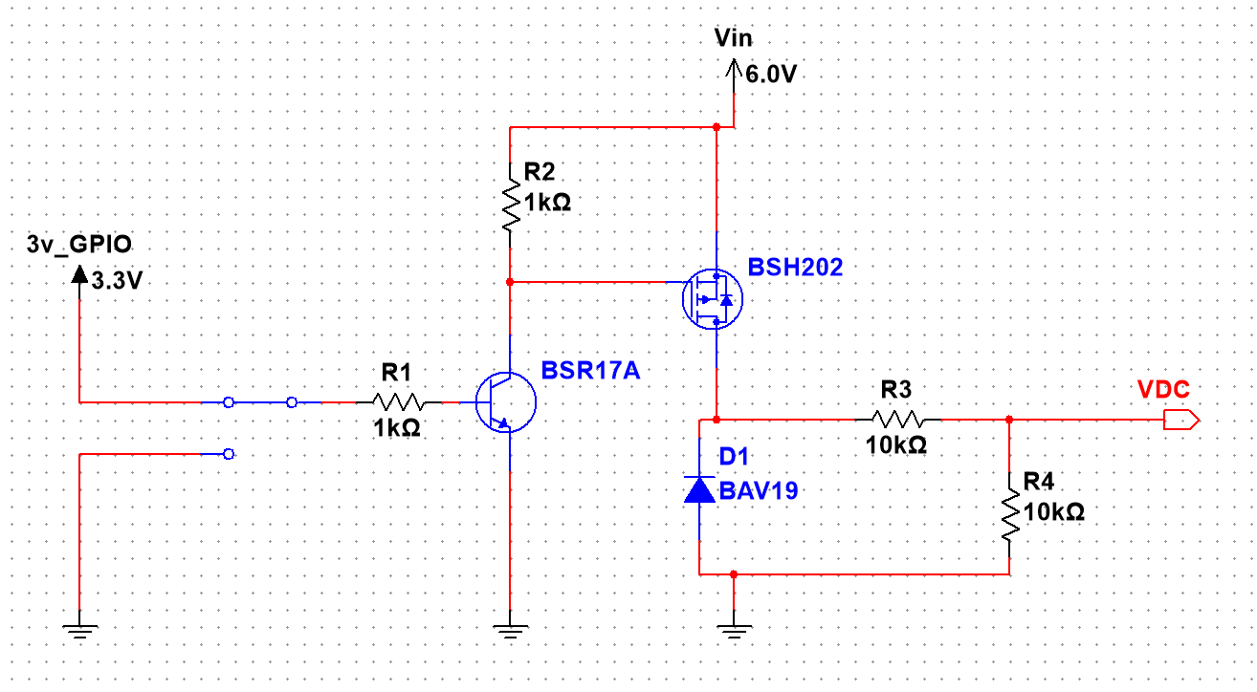

Figure 3 : Power Estimation Circuit Diagram

### PCB

The PCB is a team developed device which hosts many of the other major components and provides the electrical connections and physical structure to the inside of each of the key fob and car seat subsystems. Major components soldered directly to the PCB include the Adafruit GPS module, the Digi Xbee3 telemetry module, CR2450 coin battery holders, the Z4FC1B1301781 vibration motor, the piezoelectric sounder, and the power estimation circuit. The layout for the PCB has not yet been designed. Physical size a layout of parts in this design will be restricted by size constraints.

### 3D Printed Case

Size constraints and component lists vary slightly between the key fob and car seat subsystems. These differences will change the overall design of the casing, but critical pieces of the design - such as the mechanical design to connect the external push buttons with the pyboard push buttons and the location of the LED diffuser lenses – will not change.

#### Key Fob Casing

The key fob casing has critical dimensions of 1.5”x3”x1” inches. The design must incorporate exterior push buttons that will trigger the microcontroller pushbuttons. It must also have LED diffuser lenses set into place to allow the end user to see the state of the device based upon LED patterns. There must also be a battery hatch to allow easy replacement of the batteries as well as speaker holes to ensure the volume of the sounder is not dampened by the plastic casing. The dimension and design of the casing must be built around the interior layout of major components and how they are connected to the PCB.

#### Car Seat Casing

The car seat casing is not as critical in dimension as the key fob casing, with maximum dimensions of 5”x5”x1.5” inches. This casing must also contain two exterior push buttons, LED diffuser lenses, a battery hatch, and speaker holes. The batteries used in the car seat system, detailed in section 2.1.4, are different from those used in the key fob subsystem and therefore will require a different style of hatch. As this casing is developed, details and models will be placed in this section.

### Sixfab Internal Active GPS Patch Antenna

All the documented details provided by Sixfab about this antenna can be found below in **Table 5**. This antenna is designed to be easily implemented into any project. For the use in this project, it acts as a black box device with a single u.FL connection which plugs directly into the Adafruit ultimate GPS Breakout module described above. There are no configuration settings that require initialization or modification within this component. Signal and power are both provided through the single u.FL connector. This antenna also comes with an adhesive patch for easy mounting to an inside surface of the 3D printed cases described in section 2.1.5.

Table 5. Technical specifications for the Internal Active GPS Patch Antenna.

|  |  |
| --- | --- |
| Operating Current Draw | 5-12 mA |
| Operating voltage | 2.2-5 VDC |
| Dimensions | 25 X 25mm |
| Impedance | 50 Ω |
| Cable Length | 40mm |
| End Connection | u.FL |
| Polarization | RHCP |
| LNA Gain | 15+-2 dB |
| Noise Figure | 1.5 dB |
| Gain (Zenith) | 5 dBic |
| V.S.W.R. | < 2 |

### W24P-U OEM Wi-Fi Antenna

The W24P-U OEM Wi-Fi Antenna is the antenna used alongside the Digi Xbee3 Zigbee 3.0 RF Module for communication between the key fob and car seat subsystems. Technical specifications for this antenna can be found below in **Table 6**, and environmental operating conditions can be found below in **Table 7**. This antenna is a PCB antenna, selected for its compact size of 30 x 5 x 0.05mm. The W24P-U antenna has excellent sensitivity to consistently provide high signal reception efficiency. The antenna comes equipped with a 90mm cable and a u.FL connector on the end. This u.FL connector will plug directly into the Digi Xbee3. The range of frequencies supported by the W24P-U is 2400-2500 MHz so a frequency within this range must be selected for use in the Digi Xbee3.

Table 6. Technical specifications of the W24P-U Wi-Fi Antenna.

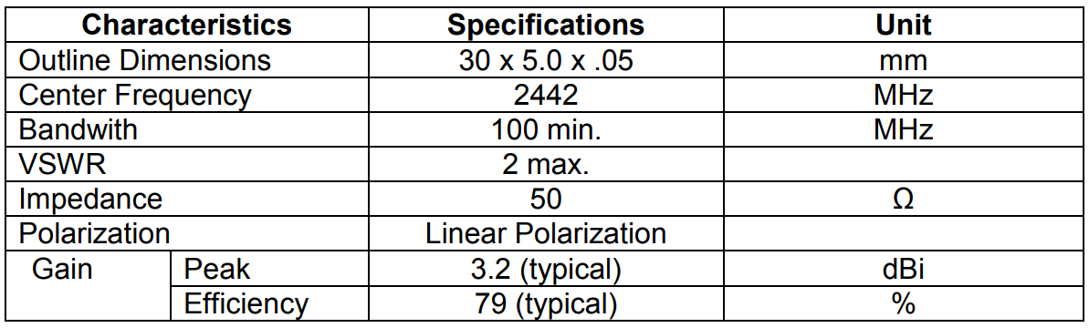

Table 7. Environmental Operation Ranges of the W24P-U Wi-Fi Antenna.

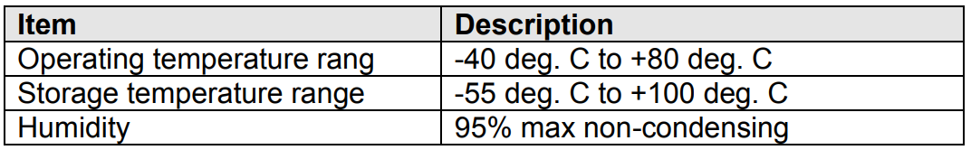

### Cylindrical Core SMT Vibration Motor

The major component vibration module is met using part Z4FC1B1301781 from JINLONG MACHINERY & ELECTRONICS CO., LTD. This part is a cylindrical core SMT Motor which rotates an unbalanced load causing the component to vibrate. Standard operating conditions and electrical characteristic can be found below in **Tables 8 and 9**. This component is a surface mount device with J-lead terminals to mount onto a PCB. This device contains a 2 pole inner magnet, and a metal brush and commutator rectifying method. No external circuitry is required to operate this vibration motor other than a 3V power supply. This component will be surface mounted onto the team developed PCB, described in section 2.1.4, supplied with power from the selected battery described in section 2.1.3 controlled through the pyboard microcontroller described in section 2.1.1.

Table 8. Standard operating Conditions

|  |  |
| --- | --- |
| Item | Specification |
| Rated Voltage | 3V |
| Rated Load | Eccentric weight (~.50g) |
| Rotation Direction | Clockwise |
| Motor Position | Any position |
| Voltage Range for use | 2.6-3.6 VDC |
| Operating Conditions | -20˚C-70˚C  0%-95%RH |
| Storage Conditions | -40˚C-85˚C  0%-95%RH |

Table 9. Electrical Characteristics.

|  |  |
| --- | --- |
| Item | Specification |
| Rated Current | 100mA max |
| Rated Speed | 10000 +- 2500 rpm |
| Stall Current | 130 mA max |
| Starting Voltage | 2.6 VDC max |
| Terminal Resistance | 26.0 OHM +- 15% OHM @20+-2˚C |
| Insulation Resistance | 1 MOHM Min |

### Piezoelectric Buzzer PKB24SPCH3601-B0

The PKB24SPCH3601-B0 is a unified piezoelectric sounder. The device can operate independently with no external driving circuit or frequency required other than a 3-15 VDC power supply. The sounder has three terminals to mount thru-hole onto a PCB. The sound emission design is contained within a plastic case specifically designed for sound resonation with a small sound emission hole in the top. This sound resonation may be compromised if the casing is burned during soldering or if pins are pushed up into the casing when mounting. Technical specifications of the PKB24SPCH3601-B0 can be seen below in **Table 10**. In the current as-built version of this device, this component does not meet the operating temperature requirement. According to **Figure 4** below, the sound pressure specification is met at even the lowest operating voltage of this device. The dimensions of this device can be seen below in **Figure 5**, these dimensions are used in the design of the subsystem casing for both the key fob and car seat subcomponents. The sound duration during operation must at least equal 200 ms.

Table 10. Technical Specifications of the selected Piezoelectric Buzzer.

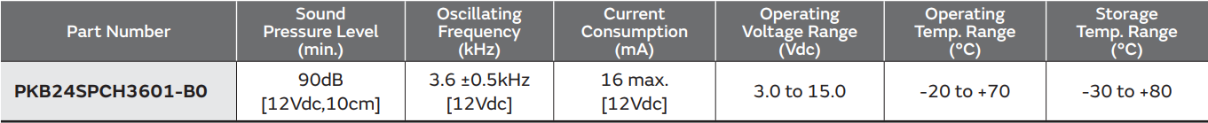

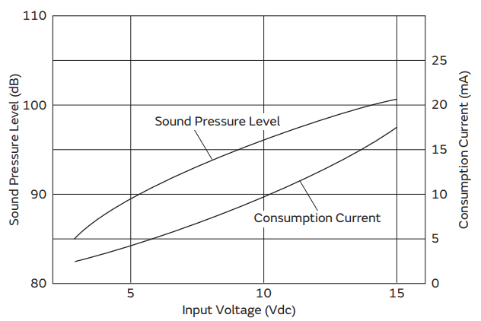

Figure 4. Input Voltage vs. Sound Pressure Level for the piezoelectric buzzer.

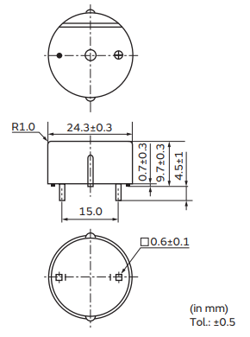

Figure 5. Physical Footprint of piezoelectric buzzer.

When implementing the buzzer onto the PCB, the following circuit diagrams are recommended for upstream current protection and volume control. **Figure 6** shows the recommended protection circuit to prevent inrush current damage with the presence of two Zener diodes. **Figure 7** shows the recommended circuit for volume control in which a 1 μF capacitor is placed in parallel with the device downstream from a resistor. Without the capacitor, the oscillation frequency will become unstable and affect sound quality.

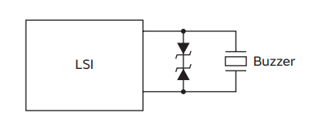

Figure 6. Overcurrent protection circuit.

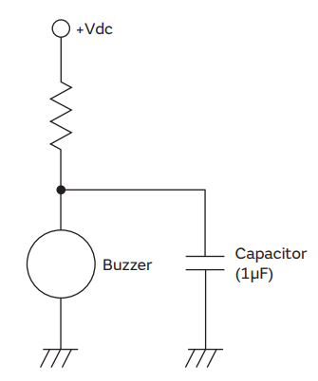

Figure 7. Volume control circuit.

## Software Components

All software components are designed as standalone threads to improve efficiency. The components with more intricate control flows have diagrams included in their sections. These diagrams all follow the same legend described in **Figure 8** below.

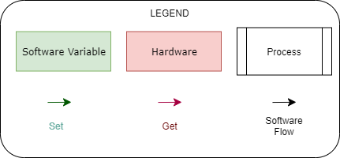

Figure 8 : Software Control Flow Legend

### Model

The software model is a class instantiation of an object class Model. This model takes one argument type to specify the attributes and functions it has access to. Both types of models use a communication parser to send/receive messages across their telemetry modules as well as receive location information from their GPS module. A table of common attributes held between both models can be found in **Table 11**. Attributes specific to each model can be found in their individual subheadings.

Table 11 : Common Model Attributes/Interfaces

|  |  |  |
| --- | --- | --- |
| Name | Attribute/Interface | Description |
| Communication Parser | Interface | Used to send/receive messages using the Telemetry Module or the GPS Module. |
| Power Estimator | Interface | Used to request current power level of battery. |
| Current Power | Attribute [Float] | An estimated percentage of remaining power. |
| Model ID | Attribute [unsigned 16-bit integer] | A random ID number assigned when the subsystem is turned on. |

#### Car Seat Model

The Car Seat Model holds all pertinent attributes and interfaces for the Car Seat Subsystem. The model uses only the common model attributes and interfaces described in **Table 11** above. Since the car seat will be constantly broadcasting its location to nearby key fobs, it does not need access to anything but its communication interfaces and an account of current power. For reference to software control flow diagram of the Car Seat Model, please see **Figure 9**.

Figure 9 : Car Seat Model Control Flow

#### Key Fob Model

The Key Fob Model holds all pertinent attributes and interfaces for the Key Fob Subsystem. The model uses additional attributes described in **Table 12**. The Key Fob Subsystem is constantly listening for nearby Car Seat Subsystems. The armed and communicating booleans are used to signal the need for an alarm. A truth table for these booleans as well as whether a resulting alarm event occurs is shown in **Table 13**.

Table 12 : Key Fob Model Specific Attributes/Interfaces

|  |  |  |
| --- | --- | --- |
| Name | Attribute/Interface | Description |
| Distance Calculator | Interface | Used to calculate the distance between two GPS coordinates. |
| Distance to Nearest Car Seat | Attribute [Float] | A floating point denoting the distance to the nearest car seat subsystem in feat. |
| Armed | Attribute [Boolean] | A Boolean signaling rather or not the system is armed. |
| Communicating | Attribute [Boolean] | A Boolean signaling rather or not there is communication between this key fob model and another car seat subsystem. |

Table 13 : Alarm Event Requirements

|  |  |  |  |
| --- | --- | --- | --- |
| Armed | Communicating | Car Seat within 25 feet? | Alarm Event |
| 0 | **0** | Unknown | None. |
| 0 | **1** | No | None. |
| 1 | **0** | Unknown | Alarm Sounded. |
| 1 | **1** | No | Alarm Sounded. |
| 0 | **1** | Yes | Alarm Armed. |
| 1 | **1** | Yes | None. |

For Reference to the full software control flow diagram of the Key Fob Model, please refer to **Figure 10** below.

Figure 10 : Key Fob Model Control Flow Diagram

### Communication Parser

The Communication parser handles the communication between the model and the peripheral models. The thread is constantly polling a message queue held by the model for any commands. If no commands are found, the thread will sleep for 200 milliseconds and search again. The Most Recent Location attribute can be polled from the model at any moment as well. For reference to the logical implementation of the Communication parser, please see the control flow diagram in **Figure 11**.

Figure 11 : Communication Parser Control Flow Diagram

### Power Estimator

The power estimator software module poles the power estimator circuit every 10 minutes to update its estimate of percentage of remaining power. It does this by first setting a GPIO pin high on the PyBoard 1.1, reading the number of counts in the ADC converter, and resetting the GPIO pin back to low. It first initializes a maximum number of counts at the start of its control flow. Then throughout operation it uses the current number of counts to determine the relative percentage of remaining power. Please refer to **Figure 12** for reference to the software control flow diagram for the power estimator. Please note, the setting low of the GPIO pin is left out to reduce clutter. It occurs right after reading the number of counts from the ADC converter.

Figure 12 : Power Estimator Software Control Flow

### Distance Calculator

The Distance Calculator software module is used for calculating the distance between two GPS coordinates. Each GPS coordinate is represented as a pair of latitude and longitude floating point values. The distance between these two coordinates is then calculated using the Haversine Formula described in **Equation 1** below where represents the latitude of a coordinate and λ represents the longitude.

Equation 1 : Haversine Formula



# Principles of Operation

## General Use

The Forget Me Not System is set up by placing the Car Seat Subsystem under or attached to the car seat of a child and powered on. The Key Fob Subsystem should be placed on the operator's key fob and powered on. When the Key Fob Subsystem is within a perimeter of 20 feet +/- 5 feet, an alarm is armed on the Key Fob Subsystem. This alarm will sound and vibrate when the Key Fob Subsystem exits the perimeter without disarming.

To disarm the alarm, the operator must press the disarm button until the alarm stops. This disarms the alarm while within the perimeter of 20 feet +/- 5 feet from the Car Seat Subsystem indefinitely. To rearm the system after disarming, the operator must first exit the perimeter of 20 feet +/- 5 feet, and then re-enter.

When the battery is low, the Key Fob Subsystem will operate with reduced functionality no longer communicating with the Car Seat Subsystem. When this occurs, the operator will see the low power LED blinking on the Key Fob Subsystem. The operator must replace the two watch batteries and restart the subsystem. If the Car Seat Subsystem is running low on battery, it will behave similarly. The operator must replace the 4 AAA batteries and restart the subsystem for the entire system's alarm to arm properly.

## Team Developed Hardware Components

### Power Estimation Circuit

The power estimation circuit is to be built on one side of the PCB. This circuit takes advantage of the analog to digital converter (ADC) built on the Micropython pyboard v1.1 Development Board. The circuit, when active, will supply the ADC with the present voltage level being supplied by the voltage source. The power estimation circuit contains a voltage divider circuit in order to reduce the voltage level to meet the specifications of the ADC on the pyboard. This circuit also contains a high-side driver using a PMOS transistor and an NPN BJT by a pin on the pyboard, see **Figure 3**  in section 2.1.5. This reduces the constant power consumption of the ADC and allows a software function to be written which controls when the ADC will receive a signal.

### Printed Circuit Board (PCB)

The printed circuit board developed by the team houses the power estimation circuit described above and provides a base for the connections between other major components.

### 3D Printed Case

The Casing component is the only major component that requires mechanical design in this system. The Casing is 3D printed plastic that contains all the rest of the major components. The 3D printed casing for the key fob subsystem will be different than that for the car seat subsystem. As seen in Figure 1, the system diagram detailing the two subsystems, they have slightly different requirements. The Casing operates to secure each major component in one location and houses the major exterior interfaces important to the end user. Light diffusing lenses will be set into the casing to allow the light from the pyboard built-in LEDs to be seen outside each subsystem. The casing also houses two buttons which mechanically press the pyboard built-in touch sensors. This allows each subsystem to operate as a “black box” system to the end user; each operator will only be required to interact with two labeled buttons, two LEDs which can be seen outside the casing, and a removable cover for battery replacement.

## COTS Hardware Components

### MicroPython pyboard v1.1 Development Board

The Micropython pyboard contains many hardware components unused by this system. The hardware components used include an ADC, GPIO pins, UART pins, on-board switches, and on-board LEDs. The ADC is used to estimate the remaining battery life alongside the power estimation circuit. The GPIO pins are used to control the on/off state of end components such as the vibration motor and the piezoelectric sounder. The UART pins are used to receive and transmit data to and from the GPS Breakout module and the RF telemetry module. The on-board switches and LEDs have built-in libraries to control and read state changes. Additional information regarding the MicroPython pyboard v1.1 Development Board can be found in the appendix.

### Adafruit Ultimate GPS Breakout Module

The Adafruit Ultimate GPS Breakout Module has very low power consumption an important feature for this project. The module also needs 3.3V which is compatible with the MircoPython pyboard v1.1. More information about the GPS Breakout module can be found in the appendix.

### Digi Xbee3 Zigbee 3.0 RF Module

The Xbee3 Zigbee is compact and has the features needed for wireless communication. The RF module uses the IEEE 802.15.4 networking protocol attach in the standards section. More information about the operation of the Digi Xbee3 Zigbee 3.0 RF Module can be found in the appendix.

### Power Source

The key fob subsystem will be powered with two CR2450 batteries connected in series to supply 6V at 620mAh. Two signal cell CR2450 battery holders will be soldered to the PCB to hold the batteries. The car seat subsystem will have four AA batteries in series to supply 6V a 2400mAh. The car seat subsystem will use an AA battery holder. More information about the batteries can be found in the appendix.

### W24P-U OEM Wi-Fi Antenna

The W24P-U OEM Wi-Fi antenna will work with 24000-2500 MHz signals. The antenna will plug directly into the U.FL port on the Xbee3 3.0 RF module as its antenna. More information about the W24P-U OEM Wi-Fi antenna can be found in its datasheet attached in the appendix.

### Sixfab Internal Active GPS Patch Antenna

This GPS Patch Antenna operates with a simple plug and play system. There is a u.FL connector which plugs directly into the Adafruit Ultimate GPS Breakout module. No additional circuitry or power is required to operate the antenna. This component also comes equipped with an adhesive pad for easy mounting within the subsystem casing. More information about the GPS patch antenna can be found in its datasheet attached in the appendix.

### Cylindrical core SMT Vibration Motor

The Cylindrical core SMT Vibration Motor is a DC driven device that vibrates when powered. The motor has an attached unbalanced cylindrical load which is rotated at high frequency. The unbalance load shakes the motor and ultimately causes the entire key fob subsystem to vibrate. More information about the vibration motor can be found in its datasheet attached in the appendix.

### Piezoelectric Buzzer PKB24SPCH3601-B0

The piezoelectric buzzer has a max decibel value of 90 dB and is rated for voltages ranging from 3 to 15 volts. The PKB24SPCH3601-B0 is also internally driven so no driver circuit is needed. More information about the Piezoelectric Buzzer can be found in its datasheet attached in the appendix.

# Test Procedures

## Temperature Test

The Temperature Test requires the system's communication to be tested while one of the subsystems is held in an environment with a temperature of 175 degrees. The system must be able to create an alarm event under these circumstances and successfully rearm itself after the user re-enter the perimeter.

### 1.2.1 - The system must be able to survive heat of 175 degrees.

## Longevity Test

The Longevity Test requires the system to operate properly for 8 ± 1 days with at least 2 alarm and rearm events occurring each day of operation. This ensures long duration working operation of the system.

### 1.2.1 - The system must retain working power for 8 ± 1 days on a single full charge.

## Sizing Test

The Sizing Test requires the system to be measured to assure each subsystem is within its dimensional requirements. The Key Fob Subsystem must measure to have a width less than 1.5”, a height of less than 3”, and a thickness of less than 1”. The Car Seat Subsystem must measure to have a width less than 5”, a height of less than 5”, and a thickness of less than 1.5”.

### 1.2.3 - Key Fob Subsystem shall be no larger than 1.5”x3”x1”.

### 1.2.4 - Car Seat Subsystem shall be no larger than 5”x5”x1.5”.

## Alarm Disarm Test

The Alarm Disarm Test validates the alarm is shut off when the disarm button is pressed. The operator must create a circumstance where an alarm event occurs by walking outside of a perimeter for 20 feet ± 5 feet from the car seat subsystem with the key fob subsystem while the alarm is armed.

### 1.2.6 - The system shall be disarmed by pressing the disarm button on the Car Seat Subsystem.

### 1.2.7 - Key Fob Subsystem shall make audible sound and vibrations once the fob exits a 20ft ± 5ft perimeter around the car module before the alarm is disarmed.

## Sound Test

The Sound Test ensures the alarm reaches an intensity level of 80dB ± 5dB. The intensity level must be measured from a distance of 1 meter from the system to account for the distance between the operator’s pocket and their ear. The intensity level will be checked using a microphone.

### 1.2.8 - The system’s alarm sound should reach 80dB ± 5dB.

## Rearm Test

The Rearm Test requires the operator to disarm an armed alarm while in the perimeter, walk outside of the perimeter of 20ft ± 5ft without an alarm event occurring, re-enter the perimeter, and then leave the perimeter with an alarm event occurring. This ensure that the subsystem properly rearmed itself after reentering the perimeter area.

### 1.2.9 - Alarm shall rearm automatically when user re-enters the perimeter of 20ft ± 5ft from the Car Seat Subsystem.

## Low Power Test

The Low Power Test requires the user to wait until a subsystem enters low power. Once at low power the subsystem must begin blinking its low power LED to warn the user. Additionally, the subsystem must stop utilizing its telemetry and GPS modules to ensure the warning LED stays on as long as possible. This can be tested by ensuring the broadcast from the subsystem stops once the LED begins to blink.

### 1.2.10 - The system shall alert the operator via low power LED.

### 1.2.11 - The Key Fob Subsystem must operate with reduced functionality at low power.

# Requirements Traceability Matrix

Table 14 : Requirements Traceability Matrix

|  |  |  |  |
| --- | --- | --- | --- |
| **Requirement** | **Requirement Description** | **Test** | **Pass/Fail** |
| 1.2.1 | The system must be able to survive heat of 175 degrees. | 4.1 | TBD |
| 1.2.2 | The system must retain working power for 8 ± 1 days on a single full charge. | 4.2 | TBD |
| 1.2.3 | Key Fob Subsystem shall be no larger than 1.5”x3”x1”. | 4.3 | TBD |
| 1.2.4 | Car Seat Subsystem shall be no larger than 5”x5”x1.5”. | 4.3 | TBD |
| 1.2.5 | The system shall be disarmed by pressing the disarm button on the Car Seat Subsystem. | 4.4 | TBD |
| 1.2.6 | Key Fob Subsystem shall make audible sound and vibrations once the fob exits a 20ft ± 5ft perimeter around the car module before the alarm is disarmed. | 4.4 | TBD |
| 1.2.7 | The system’s alarm sound should reach 80dB ± 5dB. | 4.5 | TBD |
| 1.2.8 | Alarm shall rearm automatically when user re-enters the perimeter of 20ft ± 5ft from the Car Seat Subsystem. | 4.6 | TBD |
| 1.2.9 | The system shall alert the operator via low power LED. | 4.7 | TBD |
| 1.2.10 | The Key Fob Subsystem must operate with reduced functionality at low power. | 4.7 | TBD |

Table 15 : Validation Table

|  |  |  |
| --- | --- | --- |
| **Test Number** | **Tests** | **Requirement Fulfilled** |
|  |  |  |
|  |  |  |
|  |  |  |
|  |  |  |

# Documents/Standards

## GPS Standard

United States, A. F. (2017, 8 22). *GPS Performance Standards and Specifications*. Retrieved 9 17, 2019, from Official U.S. government information about the Global Positioning System (GPS) and related topics: <https://www.gps.gov/technical/ps/>

## Telemetry Standard

IEEE 802.15.4 - <http://www.ieee802.org/15/pub/TG4.html>

# Appendices

## MicroPython pyboard v1.1 Development Board:

<http://docs.micropython.org/en/latest/pyboard/quickref.html>

## Adafruit Ultimate GPS Breakout Module:

<https://learn.adafruit.com/adafruit-ultimate-gps/downloads>

## Digi Xbee3 Zigbee 3.0 RF Module:

<https://www.mouser.com/datasheet/2/111/ds_xbee-3-zigbee-3-1288823.pdf>

## Power Source

### CR2450

<https://b2b-api.panasonic.eu/file_stream/pids/fileversion/3648>

### CR2450 Holder

<http://www.memoryprotectiondevices.com/datasheets/BU2450SM-JJ-GTR-datasheet.pdf>

### LR6XWA/B

<https://b2b-api.panasonic.eu/file_stream/pids/fileversion/3678>

### LR6XWA/B Holder

<https://www.digikey.com/product-detail/en/mpd-memory-protection-devices/SBH341A/SBH341A-ND/2439569>

## Power Estimation Circuit

### BSR17A

<https://www.onsemi.com/pub/Collateral/BSR17A-D.pdf>

### BSH202,215

<https://assets.nexperia.com/documents/data-sheet/BSH202.pdf>

### BAV19W-E3-08

<http://www.vishay.com/docs/85725/bav19w.pdf>

### MCT06030C1002FP500

<http://www.vishay.com/docs/28705/mcx0x0xpro.pdf>

### MCT06030C1001FP500

<http://www.vishay.com/docs/28705/mcx0x0xpro.pdf>

## Sixfab Internal Active GPS Patch Antenna

<https://sixfab.com/product/internal-active-gps-antenna-15db-25mm-x-25mm-u-fl-plug/?utm_medium=ppc&utm_campaign=US+Smart+Shopping&utm_term=&utm_source=adwords&hsa_src=u&hsa_net=adwords&hsa_kw=&hsa_tgt=pla-293946777986&hsa_ad=355845382964&hsa_grp=78850140224&hsa_mt=&hsa_acc=6308888758&hsa_ver=3&hsa_cam=2037647658&gclid=Cj0KCQjw3JXtBRC8ARIsAEBHg4mSzIN8WAyl86ccdp28ZW-_khK69C30LfbSgaW_Ql739PRHlUxMxKoaArKoEALw_wcB>

## W24P-U OEM Wi-Fi Antenna

<https://www.inventeksys.com/wp-content/uploads/W24P-U_2.4Ghz_-Antenna_Specification.pdf>

## Cylindrical Core SMT Vibration Motor

<http://www.vibration-motor.com/wp-content/themes/vibration-motors/dk-pdf/products/download/Z4FC1B1301781.pdf>

## Piezoelectric Buzzer PKB24SPCH3601-B0

<https://www.murata.com/~/media/webrenewal/support/library/catalog/products/sound/p37e.ashx?la=en-us>