1. Based on the following copy Turing machine, give the sequence of tape
changes on input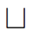aa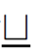 .
Note: This Turing machine is given on page 52 of the PPT for Chapter 2.

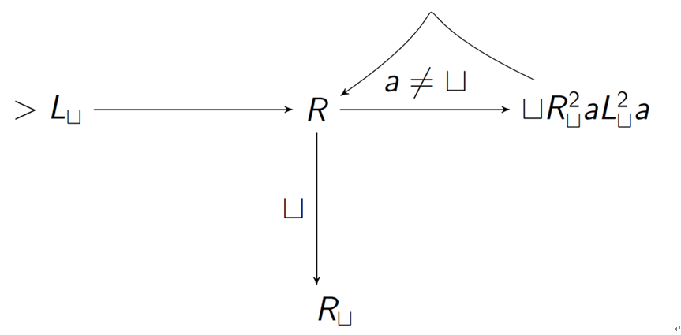

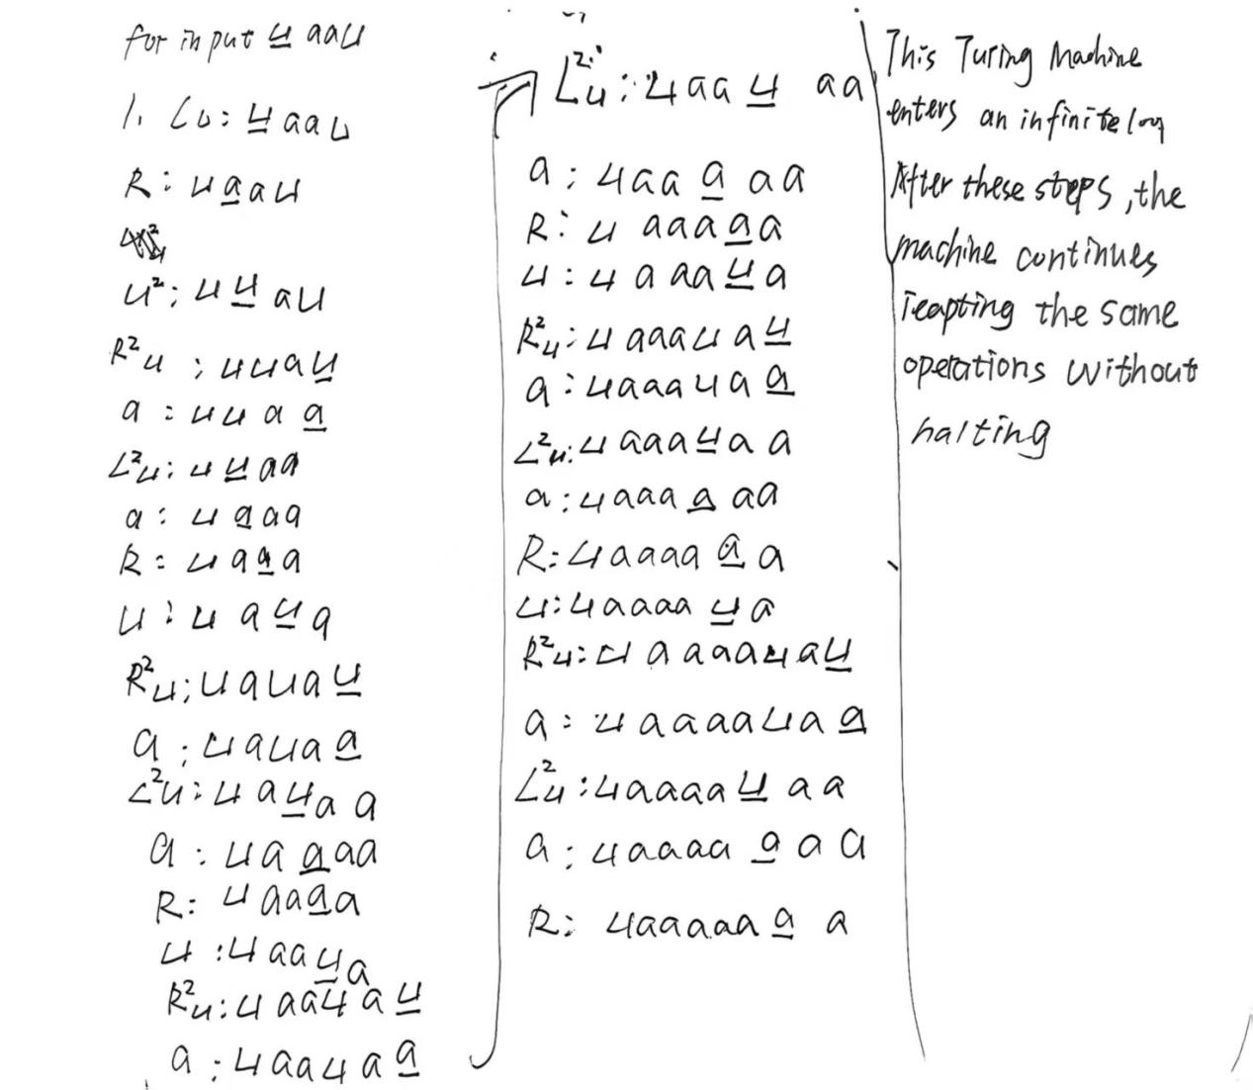

2. Based on the following left-shifting machine, give the sequence of tape changes
on input aa .
Note: This Turing machine is given on page 53 of the PPT for Chapter 2.
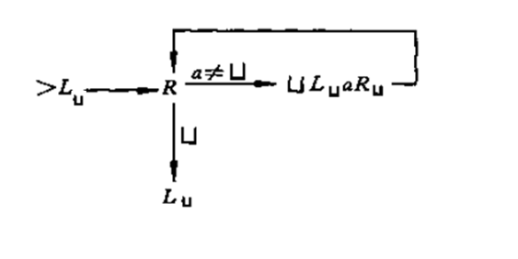
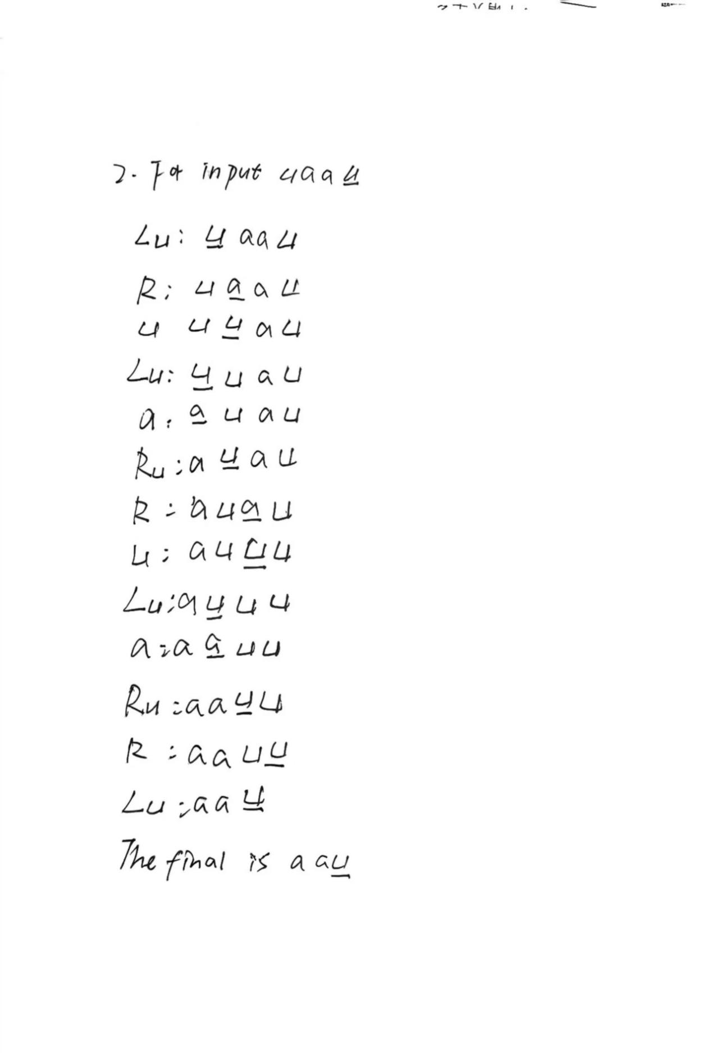

3. Answer the following questions given in the book “ Introduction to the Theory
of Computation by Michael Sipser”. (Pages 159-161)
Note:Although the solutions are given in the book, you are required to give the
detailed solution by yourself. Copying the solution in the book will lead to zero
marks.
3.1 a.-c.
Note: using the configuration format given in the class, such as (q1, w1a1v1).

