- Show that HALTTM is undecidable. (Assume we know ATM is undecidable, you are required to reduce ATM to HALTTM. )
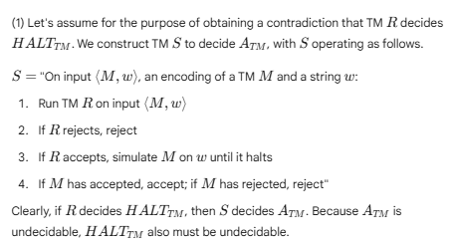
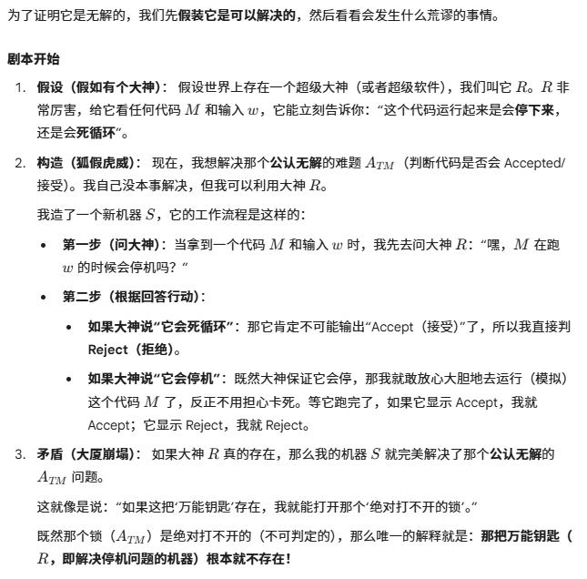

- Show that A language is decidable iff it is Turing-recognizable and co-Turing-recognizable. 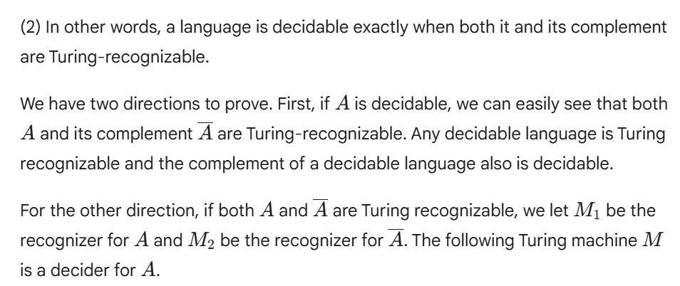
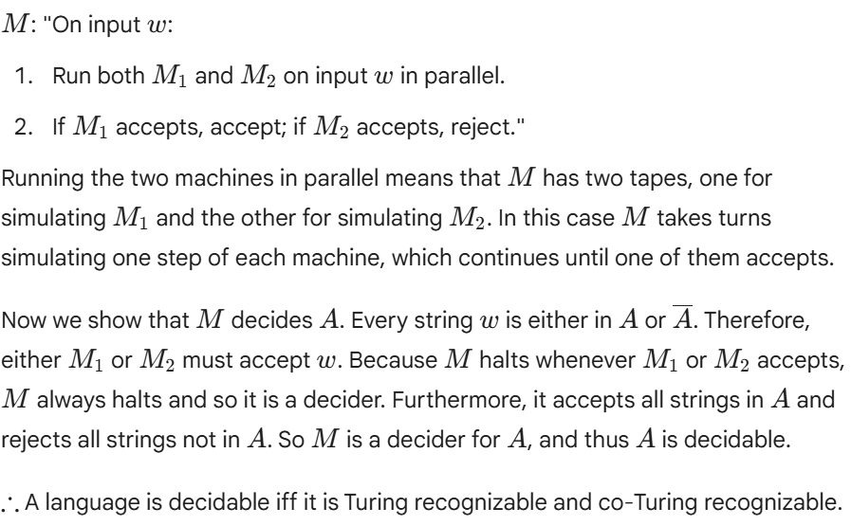
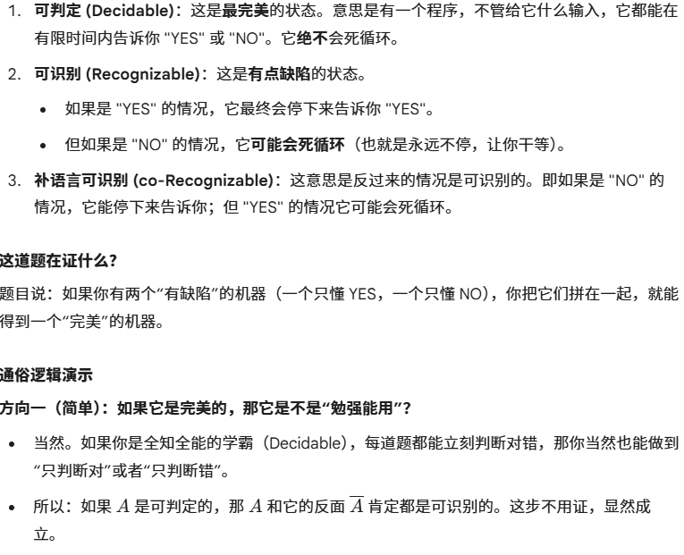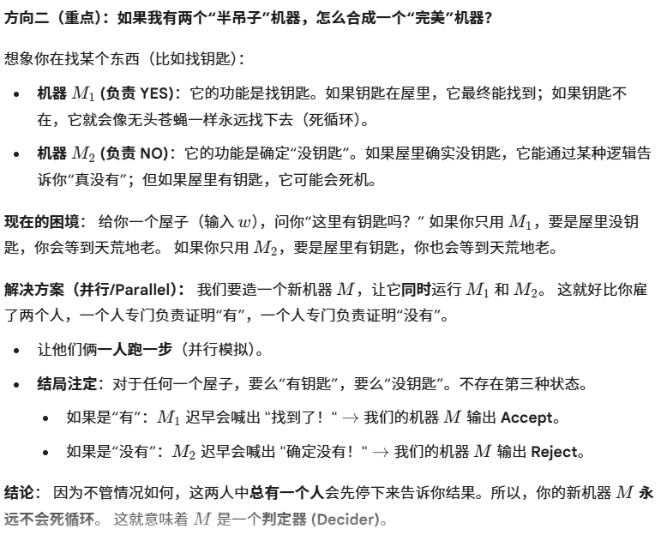
(3) Give the definition of the following concept: Language A is mapping reducible to
language B. 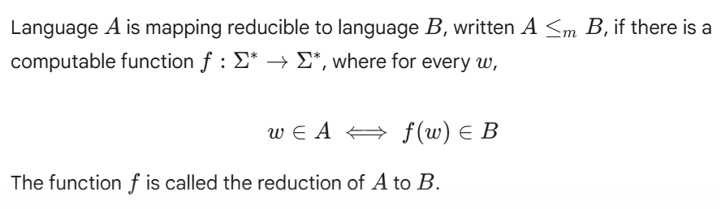
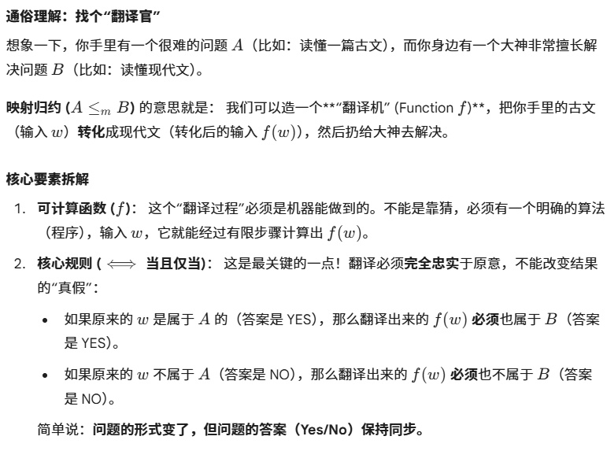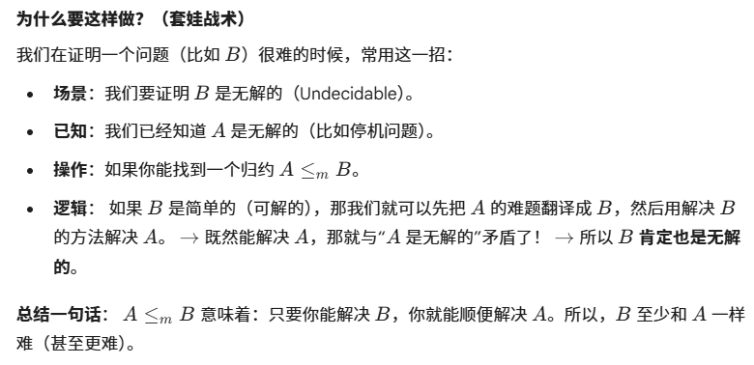

- Show that ATM ≤m HALTTM.
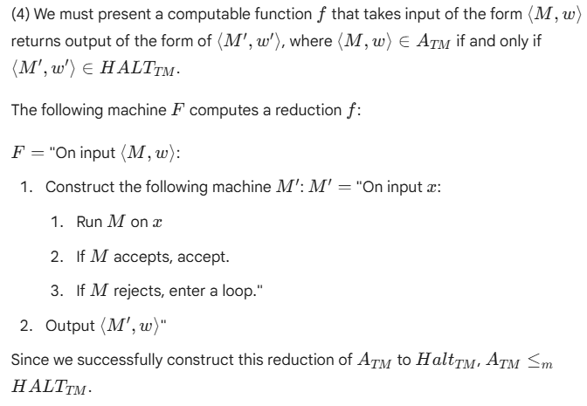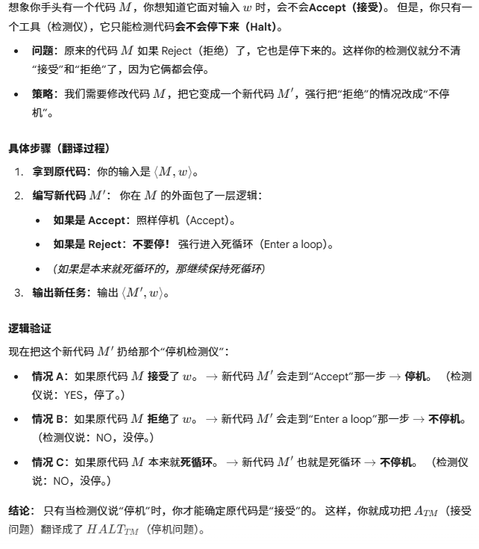

(5) Difinition: A linear bounded automaton (LBA) is a restricted type of Turing machine wherein the tape head isn't permitted to move off the portion of the tape containing the input. If the machine tries to move its head off either end of the input, the head stays where it is, in the same way that the head will not move off the left-hand end of an ordinary Turing machine's tape.
(a) Proof that: Let M be an LBA with q states and g symbols in the tape alphabet. There are exactly qngn distinct configurations of M for a tape of length n.
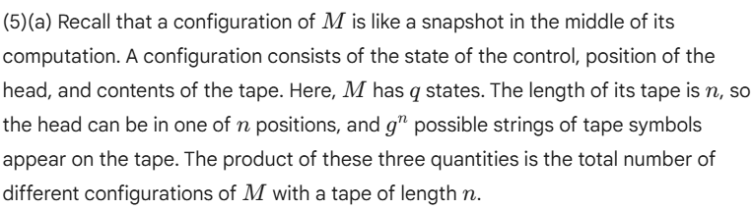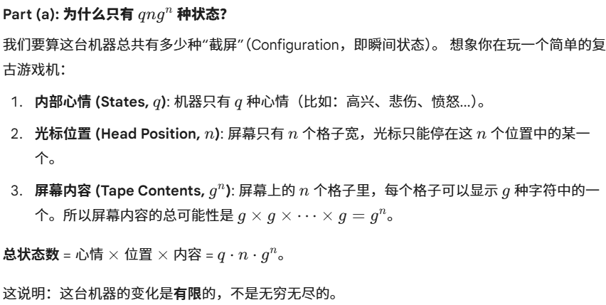

(b) Let Let ALBA = {<M,w>|M is an LBA that accepts input w}. Proof that ALBA is decidable.