Ex1: Make the link below go to www.fzu.edu.cn,and open in a new window; name the html file as agn3_ex1.html

<!DOCTYPE html>
<html>
<body>
<a>Visit FUZHOU UNIVERSITY.</a>
</body>
</html>

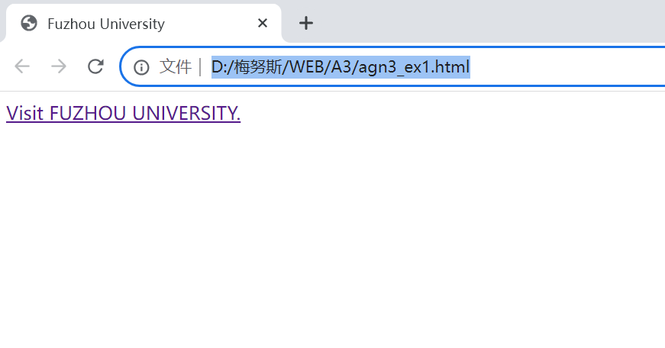

Ex2: use the image file 'smiley.gif' as the link (make it open "www.fzu.edu.cn" in a new window if you click on it), set the width and height of the image to 42 pixels;
set the tooltip text as "fuzhou university" when you move your mouse over the image; name the html file as agn3_ex2.html. Hint: put smiley.gif in the same folder of the html file ;

<!DOCTYPE html>
<html>
<body>
<a>
<img >
</a>
</body>
</html>
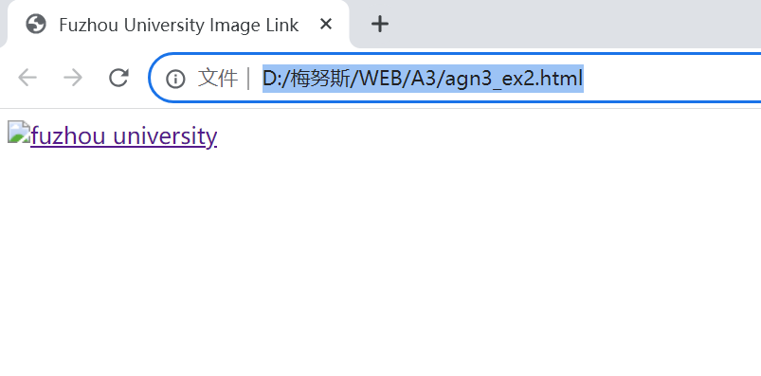

ex3:Double the width and height of the image below. name the fie as agn3_ex3.html.

<!DOCTYPE html>
<html>
<body>
<img src="html5.gif" alt="HTML5 Icon" style="width:128px;height:128px">
</body>
</html>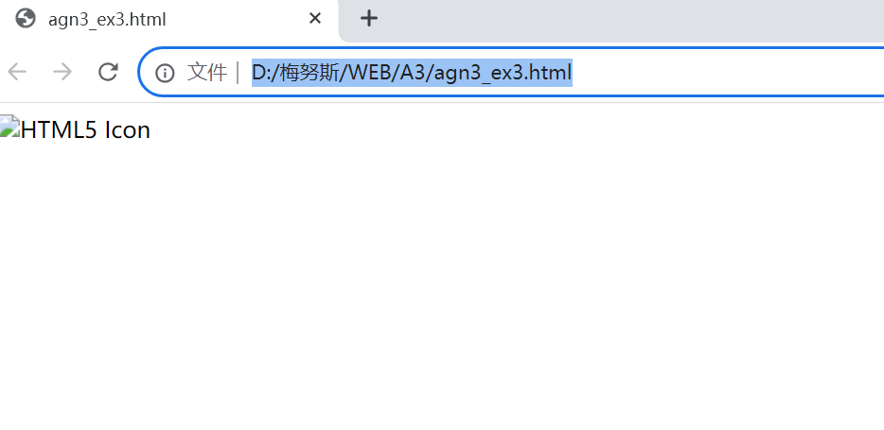

ex4:Make the image below float to the left of the paragraph. name the fie as agn3_ex4.html

<!DOCTYPE html>
<html>
<body>
<p>
<img src="smiley.gif" alt="Smiley face" style="width:42px;height:42px">
A paragraph with an image. A paragraph with an image.
A paragraph with an image. A paragraph with an image.
A paragraph with an image. A paragraph with an image.
</p>
</body>
</html>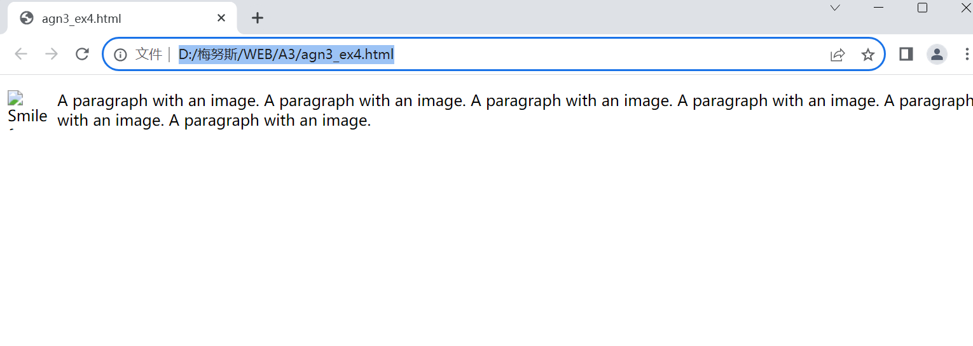

Ex5:The image below is unavailable on purpose. Specify an alternate text of "fuzhou university" to be used, name the fie as agn3_ex5.html

<!DOCTYPE html>
<html>
<body>
<img src="1.gif" width="135" height="50">
</body>
</html>
