ex1:Add the "cities" class to the <div> element, name the file as agn6_ex1.html.

<!DOCTYPE html>
<html>
<head>
<style>
.cities {
background-color:black;
color:white;
margin:20px;
padding:20px;
}
</style>

</head>
<body>

<div>
<h2>London</h2>

<p>London is the capital city of England. It is the most populous city in the United Kingdom, with a metropolitan area of over 13 million inhabitants.</p>

<p>Standing on the River Thames, London has been a major settlement for two millennia, its history going back to its founding by the Romans, who named it Londinium.</p>
</div>

</body>
</html>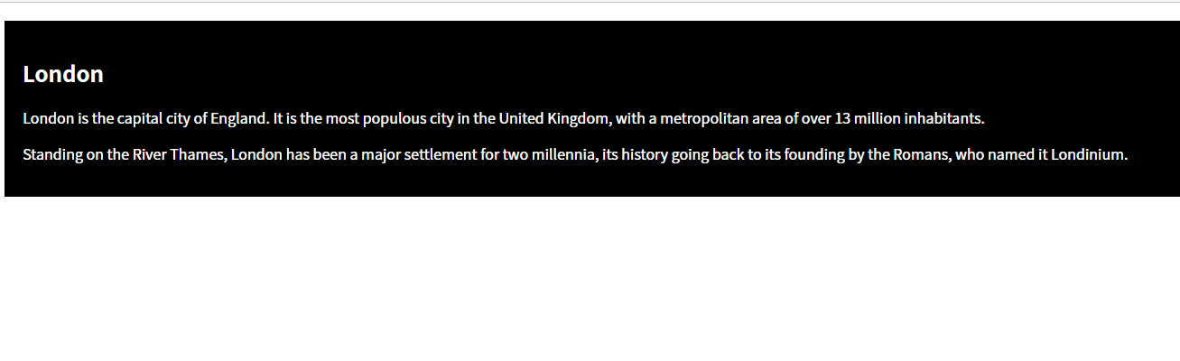

ex2:
Create a class selector named "special".
Add the color property with the value "red" inside "special".
At last, add the "special" class to <span> and <p>. name the file as agn6_ex2.html.

<!DOCTYPE html>
<html>
<head>
<style>

</style>

</head>
<body>

<h1>My <span>Important</span> Heading</h1>

<p>My important paragraph.</p>

</body>
</html>
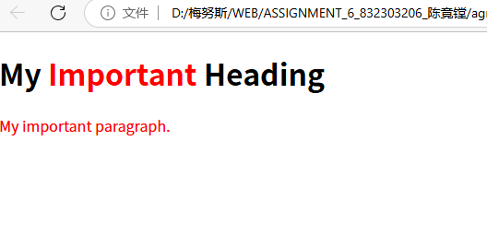
ex3:
Create a class selector named "cities". Add the following styles:
black background color
white text color
20 pixels padding and margin
Add the class "cities" to the <div> element. name the file as agn6_ex3.html.

<!DOCTYPE html>
<html>
<head>

</head>
<body>

<div>
<h2>London</h2>

<p>London is the capital city of England. It is the most populous city in the United Kingdom, with a metropolitan area of over 13 million inhabitants.</p>

<p>Standing on the River Thames, London has been a major settlement for two millennia, its history going back to its founding by the Romans, who named it Londinium.</p>
</div>

</body>
</html>
