- Set the text color for the page to "red", and the text color for <h1> to "blue". Name the html file as agn8_ex1.html;


- Center align the <h1> element. Name the html file as agn8_ex2.html;


- Remove the underline from the link. Name the html file as agn8_ex3.html;


- Style text in <h1> to uppercase letters, and text in <p> to capitalized letters. Name the html file as agn8_ex4.html;

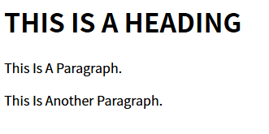
- Set the font family for the page to "Courier New", and the font family for <h1> to "Verdana". Name the html file as agn8_ex5.html;
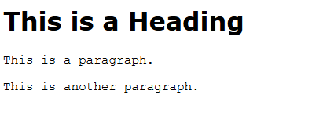
- Show <p> elements as "italic" text. Name the html file as agn8_ex6.html;


- Set the font size for the page to "20px", and the font size for <h1> to "3em". Name the html file as agn8_ex7.html;


- Show <p> elements as "bold" text. Name the html file as agn8_ex8.html;


- With the font property: Set the <p> to "italic", "20px" and "Verdana". Name the html file as agn8_ex9.html;
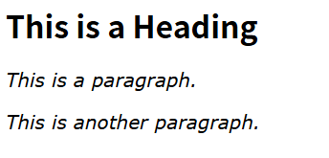

- Set the color for links to "green". Name the html file as agn8_ex10.html;
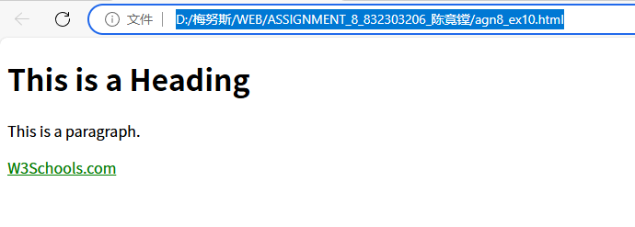
- Set the color for unvisited links to "red", and the color for visited links "blue". Name the html file as agn8_ex11.html;

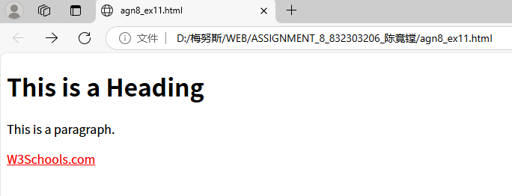
- Remove underlines for visited and unvisited links, and specify "underline" for the hover and active link states. Name the html file as agn8_ex12.html;

- Set the background color for visited and unvisited links to "lightblue", and the background color for the hover and active link states to "yellow". Name the html file as agn8_ex13.html;


- Set the list style for unordered lists to "square", and the list style for ordered lists to "upper-roman". Name the html file as agn8_ex14.html;

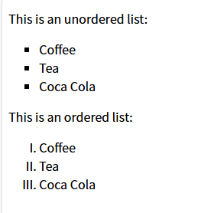

15: Use JavaScript to change the HTML content of the <p> element to "Hello World!", set the text size of the <p> element to 40 pixels, add a red background color to the <p> element, name the file as agn8_ex15.html;


ex16:Use JavaScript to change the image (the src attribute) to a new image called "pic_mountain.jpg"，name the file as agn8_ex16.html;

