Maynooth International Engineering College

CS240 Operating Systems
Class Test 1

Q1a) List 5 different companies or organizations that produce computer operating systems, and an operating system each produces.

(10 marks)
b) Describe briefly the kernel of an operating system.
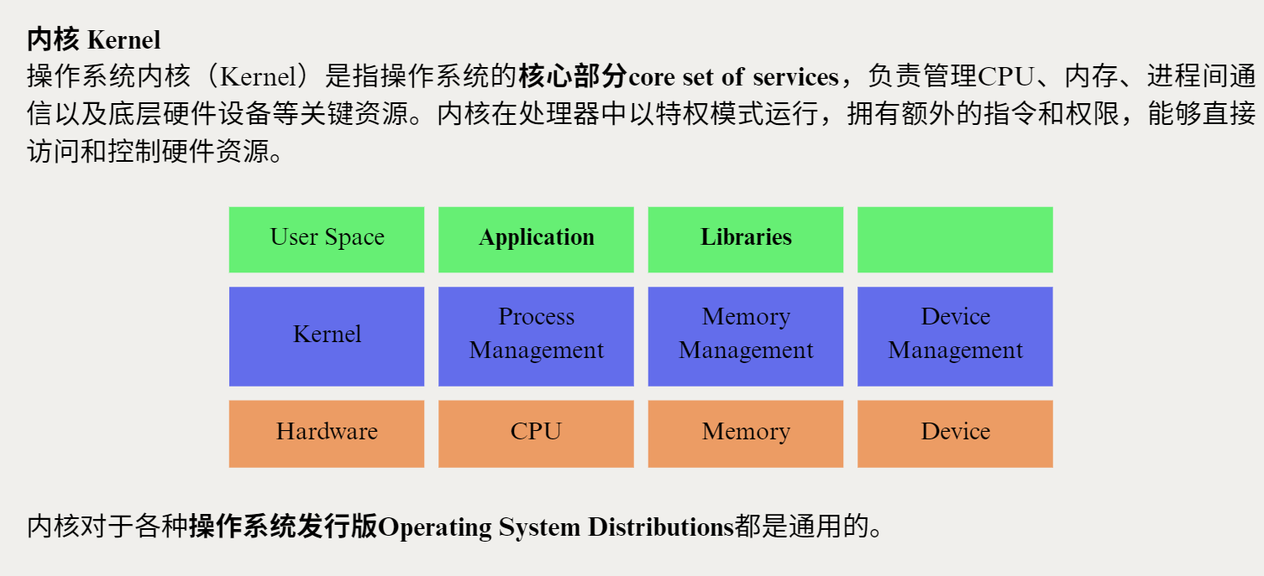

(5 marks)
c) List 5 other components that an operating system has, besides the kernel. (10 marks)

Sure! Besides the kernel, an operating system typically includes these five other components:
Component | Description
File System | Manages how data is stored, organized, and accessed on storage devices (like hard drives, SSDs).
Device Drivers | Special programs that allow the OS to communicate with hardware devices (like printers, keyboards, network cards).
User Interface (UI) | Provides ways for users to interact with the system, either through a Graphical User Interface (GUI) or a Command-Line Interface (CLI).
System Utilities | Tools and programs that help users manage, monitor, and maintain the computer (e.g., disk cleanup, task managers).
Process Management System | Handles the creation, scheduling, and termination of processes (running programs) to ensure efficient CPU use and multitasking.
Would you also like a quick diagram showing how they all fit together? 📈🎯
It can make it even clearer!

Q2a) Briefly describe the difference between
i) a computer programme file and an executable programme file (5 marks)
ii) a running process and a blocked process (5 marks)
iii) a queued process and a zombie process (5 marks)
b) What is the use of a Process Control Block? (5 marks)
c) What is meant by a computer system changing context when running several processes? (5 marks)

Q3. When several processes run on a single CPU, some algorithms have to be used to share CPU time between different processes.
a) i) What is the disadvantage of First Come First Served (FCFS)? (5 marks)
ii) What is the disadvantage of Shortest Job First (SJF)? (5 marks)
iii) How does Highest Response Ratio Next (HRN) overcome these disadvantages?
(5 marks)
b) Suppose HRN is used in a multi-tasking OS system. Five jobs arrive at the system in the following times:
Arrival Job Burst Time
0 P1 12
0 P2 3
1 P3 5
6 P4 4
8 P5 2
i) Calculate the turnaround time of P1. (5 marks)
ii) Calculate the average waiting time of the 5 jobs. (5 marks)
iii) Calculate the system throughput for these 5 jobs. (5 marks)

Q4. A lift at a metro station serves two levels, the ground and the train levels. Passengers arrive at the lift waiting area at both the ground and train levels at the same rate of λ_{m} per minute in a Poisson process. It takes the lift 10 seconds to go from ground to train level, and also 10 seconds to go from train to ground level. The lift can hold a maximum of 15 people.
a) Assuming that λ_{m} = 5, what is the probability that exactly 2 people arrive at the ground level waiting area in 10 seconds? (10 marks)
b) What is the maximum possible λ_{m} so that the queue of people waiting for the lift at the ground level will not keep increasing? (10 marks)

Given: Probability that there are exactly k events in an interval is
$P\left(k\right)=\frac{λ^{k}e^{−λ}}{k!}$ for Poisson process
if the average number of events in the interval is λ.

