Task1
Terminal 1

Open server and client
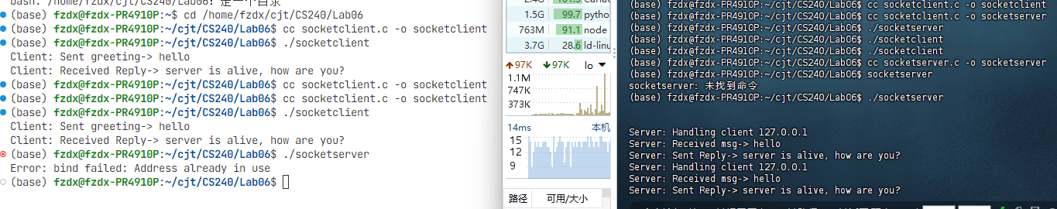

Terminal2
Reopen server and form error
Task2

JAVA1
Open client and server
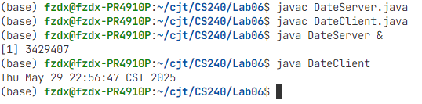

Task3

Java2 terminal1

Java2 terminal2

Java2 terminal3
