Task1
Java1
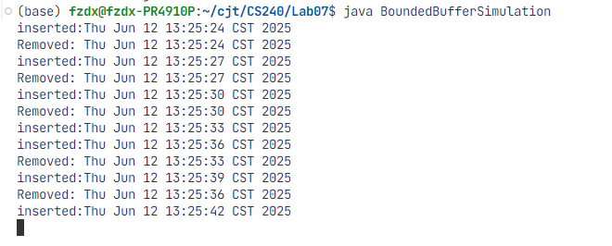

Task2
Java2
// Save this as "Producer.java"
import java.util.Date;

public class Producer implements Runnable {

private Buffer buffer;
private int id;

public Producer(Buffer buffer, int id) {
this.buffer = buffer;
this.id = id;
}

public void run() {
Date message;

while (true) {
message = new Date(); // produce an item
try {
Thread.sleep(1000); // sleep for 1000 ms
} catch (InterruptedException e) {}

buffer.insert(message);

System.out.println("Producer " + id + " Inserted " + message);
}
}
}
// Save this as "Consumer.java"
import java.util.Date;

public class Consumer implements Runnable {

private Buffer buffer;
private int id;

public Consumer(Buffer buffer, int id) {
this.buffer = buffer;
this.id = id;
}

public void run() {
Date message;

while (true) {
try {
Thread.sleep(1000); // sleep for 1000 ms
} catch (InterruptedException e) {}

message = (Date) buffer.remove(); // consume the item

System.out.println("Consumer " + id + " Removed " + message);
}
}
}
// Save this as "BoundedBufferSimulation.java"
public class BoundedBufferSimulation {

public static void main(String args[]) {
Buffer buffer = new Buffer();

Thread producer1 = new Thread(new Producer(buffer, 1));
Thread producer2 = new Thread(new Producer(buffer, 2));
Thread consumer1 = new Thread(new Consumer(buffer, 1));
Thread consumer2 = new Thread(new Consumer(buffer, 2));

producer1.start();
producer2.start();
consumer1.start();
consumer2.start();
}
}

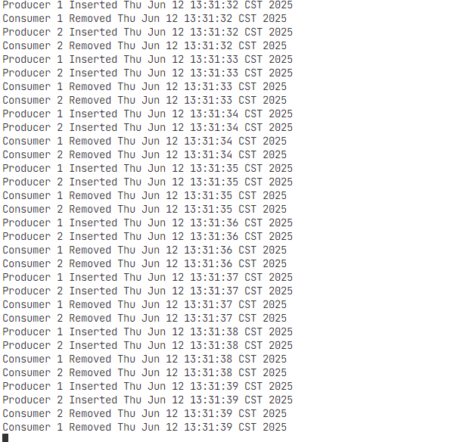

Task3
C
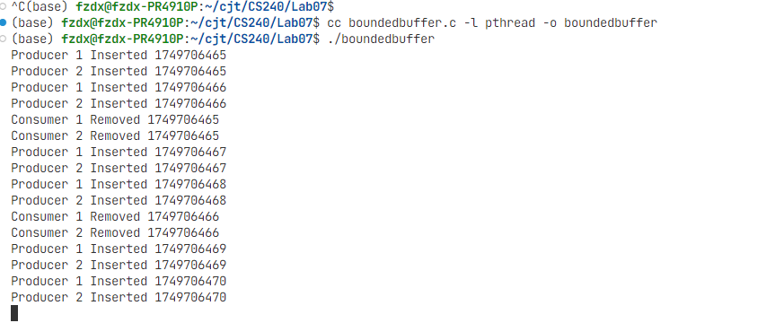

Task4

Initial Phase: Fast Production 🚀
At the start, the buffer is empty. The producers are fast (adding an item every 1 second ) and can add items to the buffer without waiting. This results in a rapid succession of "Inserted" messages.

Transition Phase: Buffer Fills Up 📦
Because the producers are faster than the consumers (who wait 2 seconds in the C version ), the shared, finite-sized buffer quickly becomes full.

Final Phase: Slower, Synchronized Rate 🐢
Once the buffer is full, the producers are forced to wait. A producer can only add a new item after a consumer removes one, freeing up a space. The overall speed of the system is now dictated by the rate of the slowest component—the consumers. Therefore, the rate of both "Inserted" and "Removed" messages slows down and synchronizes to the consumers' slower pace.

