Task1
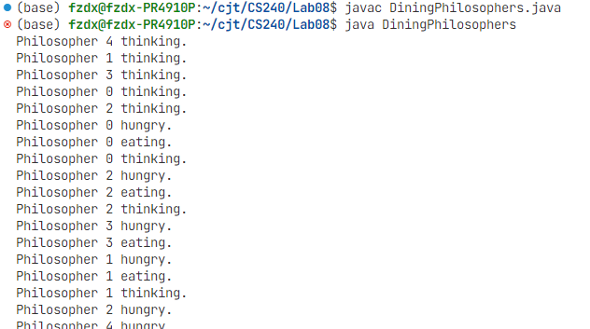

Task2

Solution 1: Resource Hierarchy (DiningPhilosophers1.java)
This approach prevents deadlock by having one philosopher (the last one) pick up their chopsticks in the reverse order (left then right), which breaks the circular wait condition.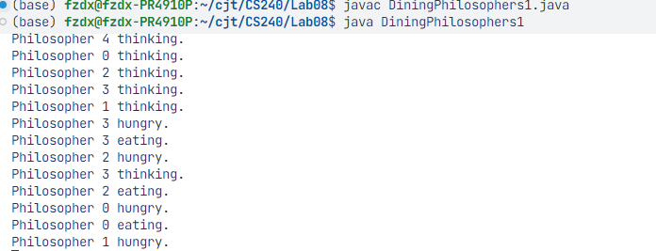
// This is the file DiningPhilosophers1.java

import java.util.concurrent.Semaphore;

// The class DiningPhilosophers1 contains the main program
class DiningPhilosophers1 {
public static void main(String args[]) {
// Create an array of five Semaphore Object Reference Handles
Semaphore chopSticks[] = new Semaphore[5];

// Create five Binary Semaphore Objects and assign to the array
for (int i = 0; i < 5; i++) {
chopSticks[i] = new Semaphore(1); // Semaphore initial value=1
}

// Create an array of five Philosopher Thread Object Reference Handles
Philosopher workerThread[] = new Philosopher[5];

// Create and initiate five Philosopher Thread Objects
for (int i = 0; i < 5; i++) {
workerThread[i] = new Philosopher(i, chopSticks);
workerThread[i].start();
}
}
}

// The Philosopher class implements a run() method defining the behaviour of a Philosopher thread
class Philosopher extends Thread {
private int myName;
private Semaphore chopSticks[];

// This is the constructor function
public Philosopher(int myName, Semaphore chopSticks[]) {
this.myName = myName;
this.chopSticks = chopSticks;
}

// This is what each philosopher thread executes
public void run() {
while (true) {
System.out.println("Philosopher " + myName + " thinking.");
try {
sleep((int) (Math.random() * 20000));
} catch (InterruptedException e) {}

System.out.println("Philosopher " + myName + " hungry.");

try {
if (myName == 4) { // Last philosopher breaks the cycle
chopSticks[(myName + 1) % 5].acquire(); // Acquire left
chopSticks[myName].acquire(); // Acquire right
} else { // All other philosophers
chopSticks[myName].acquire(); // Acquire right
chopSticks[(myName + 1) % 5].acquire(); // Acquire left
}
} catch (InterruptedException e) {}

System.out.println("Philosopher " + myName + " eating.");
try {
sleep((int) (Math.random() * 10000)); // Simulate eating activity
} catch (InterruptedException e) {}

chopSticks[myName].release(); // Release right
chopSticks[(myName + 1) % 5].release(); // Release left
}
}

Task3

This approach uses an additional semaphore, acting as a "waiter," to limit the number of philosophers who can try to pick up chopsticks at the same time. By initializing the waiter semaphore to 4, it's impossible for all five philosophers to be holding one chopstick simultaneously.

// This is the file DiningPhilosophers2.java

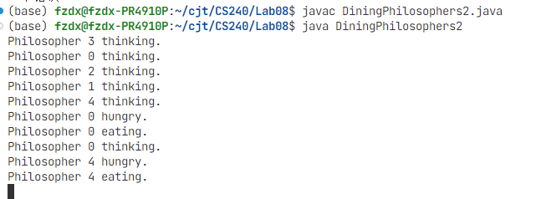import java.util.concurrent.Semaphore;

// The class DiningPhilosophers2 contains the main program
class DiningPhilosophers2 {
public static void main(String args[]) {
// Create an array of five Semaphore Object Reference Handles
Semaphore chopSticks[] = new Semaphore[5];

// Create five Binary Semaphore Objects and assign to the array
for (int i = 0; i < 5; i++) {
chopSticks[i] = new Semaphore(1); // Semaphore initial value=1
}

// Create a waiter semaphore to allow only four philosophers to eat at a time
Semaphore waiter = new Semaphore(4);

// Create an array of five Philosopher Thread Object Reference Handles
Philosopher2 workerThread[] = new Philosopher2[5];

// Create and initiate five Philosopher Thread Objects
for (int i = 0; i < 5; i++) {
workerThread[i] = new Philosopher2(i, chopSticks, waiter);
workerThread[i].start();
}
}
}

// The Philosopher2 class implements a run() method defining the behaviour of a Philosopher thread
class Philosopher2 extends Thread {
private int myName;
private Semaphore chopSticks[];
private Semaphore waiter;

// This is the constructor function
public Philosopher2(int myName, Semaphore chopSticks[], Semaphore waiter) {
this.myName = myName;
this.chopSticks = chopSticks;
this.waiter = waiter;
}

// This is what each philosopher thread executes
public void run() {
while (true) {
System.out.println("Philosopher " + myName + " thinking.");
try {
sleep((int) (Math.random() * 20000));
} catch (InterruptedException e) {}

System.out.println("Philosopher " + myName + " hungry.");

// *** FIX IS HERE: Added try-catch block ***
try {
waiter.acquire(); // Ask waiter for permission

chopSticks[myName].acquire(); // Acquire right
chopSticks[(myName + 1) % 5].acquire(); // Acquire left
} catch (InterruptedException e) {
// This block handles the error.
}

System.out.println("Philosopher " + myName + " eating.");
try {
sleep((int) (Math.random() * 10000)); // Simulate eating activity
} catch (InterruptedException e) {}

chopSticks[myName].release(); // Release right
chopSticks[(myName + 1) % 5].release(); // Release left

waiter.release(); // Release permission to waiter
}
}
}

