Task1

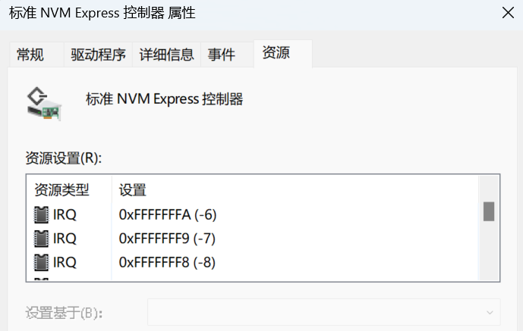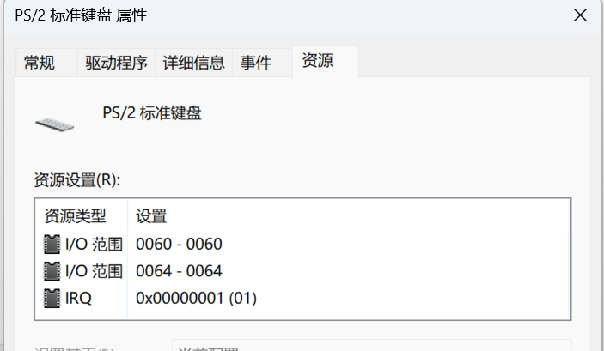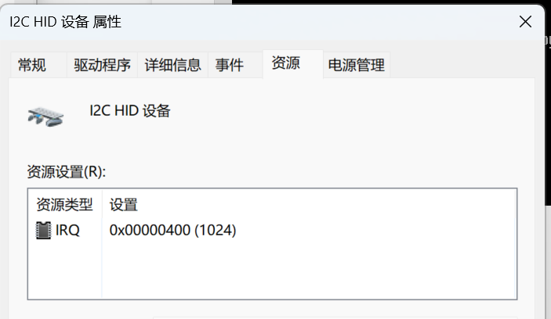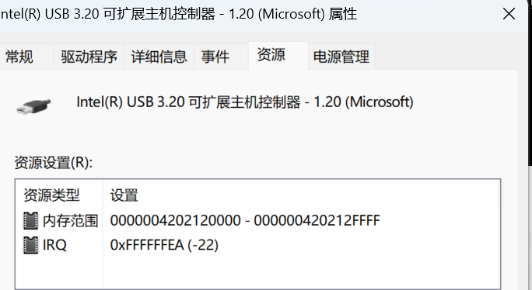

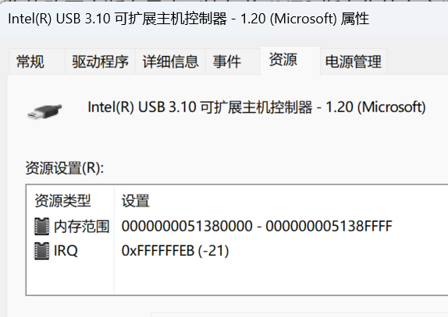

Task2

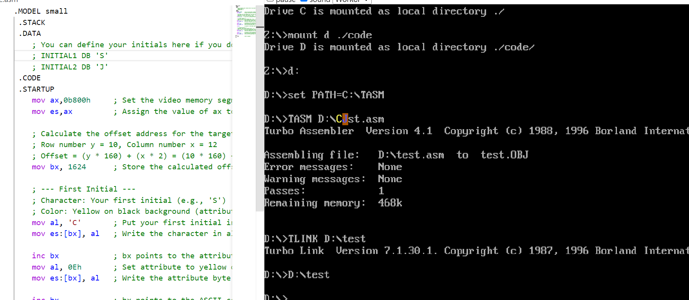
.MODEL small
.STACK
.DATA
; You can define your initials here if you don't want to hardcode them in the code
; INITIAL1 DB 'S'
; INITIAL2 DB 'J'
.CODE
.STARTUP
mov ax,0b800h ; Set the video memory segment address to ax
mov es,ax ; Assign the value of ax to the es register, es now points to the video memory segment

; Calculate the offset address for the target position (row 10, column 12)
; Row number y = 10, Column number x = 12
; Offset = (y * 160) + (x * 2) = (10 * 160) + (12 * 2) = 1600 + 24 = 1624 (decimal) = 658h
mov bx, 1624 ; Store the calculated offset address in bx

; --- First Initial ---
; Character: Your first initial (e.g., 'S')
; Color: Yellow on black background (attribute 0Eh)
mov al, 'C' ; Put your first initial into the al register (please replace 'S')
mov es:[bx], al ; Write the character in al to the current video memory location (es:bx)

inc bx ; bx points to the attribute byte location of the first character
mov al, 0Eh ; Set attribute to yellow on black (yellow foreground E, black background 0)
mov es:[bx], al ; Write the attribute byte to video memory

inc bx ; bx points to the ASCII code location of the second character

; --- Second Initial ---
; Character: Your second initial (e.g., 'J')
; Color: Bright blue on yellow background (attribute 69h)
mov al, 'J' ; Put your second initial into the al register (please replace 'J')
mov es:[bx], al ; Write the character in al to the current video memory location (es:bx)

inc bx ; bx points to the attribute byte location of the second character
mov al, 69h ; Set attribute to bright blue on yellow (bright blue foreground 9, yellow background 6)
mov es:[bx], al ; Write the attribute byte to video memory

quit:
.EXIT ; End of program
END
Task3

3.1 k1.asm
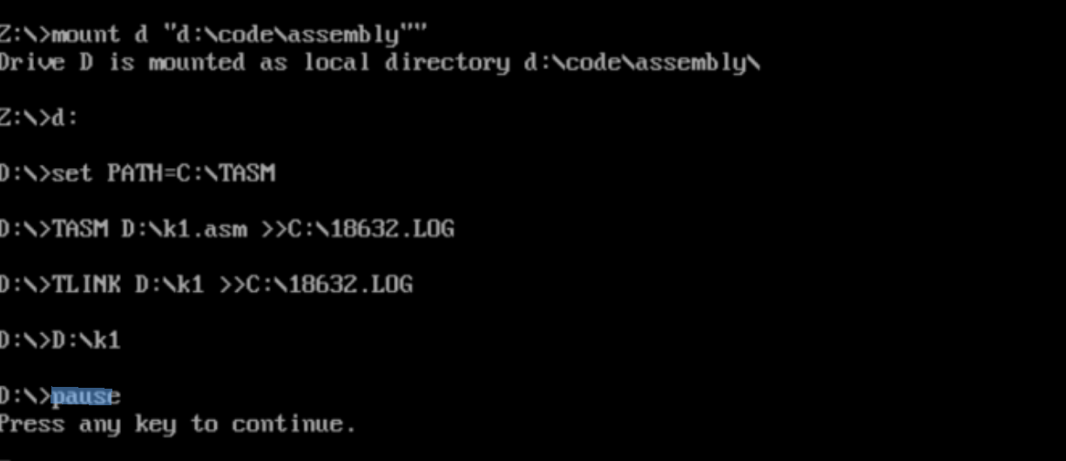* k1.asm Detects keypress from the keyboard */
;/* If the key presses is 'h' or'H' */
;/* the routine prints 'Hello' on the screen */
; By C.Markham
; Revised March 2016

.MODEL small
.STACK
.DATA ; DS will may change when TSR operates
.CODE
.STARTUP
push es ; Save existing value of ES.
mov ax, 0000h ; Set ES (extra segment) to page 0
mov es, ax ; Note page 0 is vector address table
mov bx, 024h ; Vector address for keyboard INT 9, IRQ1
mov ax, es:[bx] ; ax=[0000:0020], CS to jump to at end of our new ISR
mov vtabip, ax ; Store the CS, 1st two bytes of table
inc bx
inc bx
mov ax, es:[bx] ; ax=[0000:0020], IP to jump to
mov vtabcs, ax ; Store the IP, 2nd two bytes
pop es ; Restore the value of es

push es ; Change vector address to ISR routine
mov ax, 0000h ; Vector address table segment
mov es, ax
mov bx, 024h
mov ax, OFFSET isr ; Set IP of vector table to new ISR
mov es:[bx], ax
inc bx
inc bx
mov ax, cs ; The ISR is in the same segment as the program.
mov es:[bx], ax ; New CS in vector table is the code segment of
pop es ; this program.

mov ah, 031h ; TSR Entry code ah=31h,al=0h
mov al, 00h
mov dx, 1024 ; DX=no of bytes to remain resident
int 021h ; Terminate and stay resident.

jmp quit ; Historic code, never reached

isr: push ax ; Start of code you wish to call ever 50mS (18ms PC).
push bx ; Interrupts don’t store general registers, you must.
push cx
push dx
push di
push si
push bp
push es
push ds

mov dx, 60h ; Read the last scan code
in al, dx
and al, 127 ; Mask MSB 1=Key Down, 0=Key Up remove if just up or down
cmp al, 23h ; Was a h/H pressed on the XT keyboard
jnz ovr1

; Change to
; <space> scan
; code rather
; than ‘h’.
; Remove the
; ‘and al,127’
mov ax, 0b800h ; Base address of screen memory
mov es, ax
mov bx, 140 ; Screen position (1,70)

mov al, 'H' ; Print 'Hello' on the screen
mov es:[bx], al

inc bx
inc bx
mov al, 'e'
mov es:[bx], al

inc bx
inc bx
mov al, 'l'
mov es:[bx], al

inc bx
inc bx
mov al, 'l'
mov es:[bx], al

inc bx
inc bx
mov al, 'o'
mov es:[bx], al

jmp ovr2

ovr1: mov ax, 0b800h ; If not an H overwrite top right with ' '
mov es, ax
mov bx, 140 ; Screen position (1,70)
mov cx, 5
again: mov al, ' '
mov es:[bx], al
inc bx
inc bx
loop again

ovr2: mov dx, 020h ; Non Specific end of interrupt command
mov al, 020h ; to sent 8259 #1 controller.
out dx, al
pop ds ; Restore all registers previously save on
pop es ; the stack.
pop bp
pop si
pop di
pop dx
pop cx
pop bx
pop ax

db 0EAh ; jump far (instruction created on the fly...)
vtabip dw 0 ; IP offset
vtabcs dw 0 ; CS segment

quit: .EXIT ; Historic code, never reached

END

3.2 t1.asm
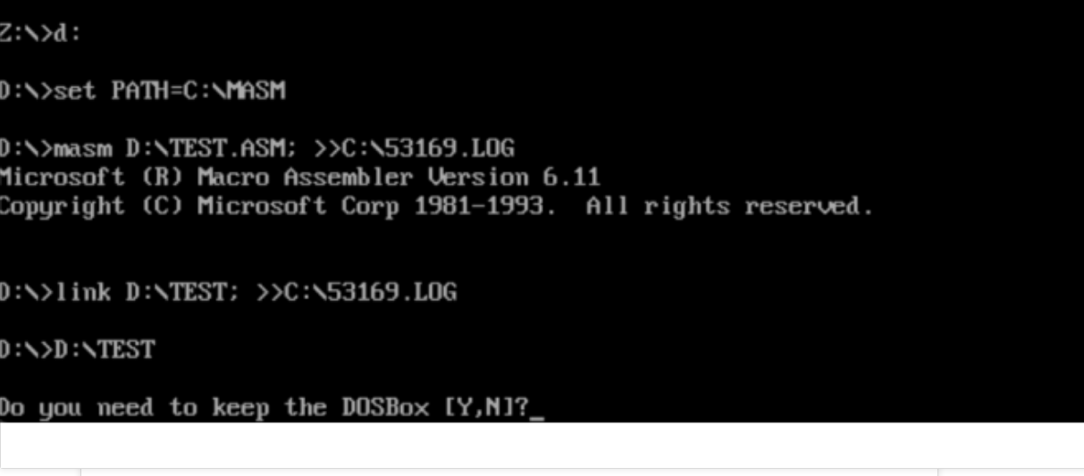

.MODEL small
.STACK
.DATA

.CODE

.STARTUP

push es
mov ax, 0000h
mov es, ax
mov bx, 024h ; INT 9 vector offset

mov ax, es:[bx] ; Old IP

mov cs:[OFFSET vtabip_label], ax

inc bx
inc bx
mov ax, es:[bx] ; Old CS
mov cs:[OFFSET vtabcs_label], ax ;
pop es

mov ah, 031h
mov al, 00h
mov dx, OFFSET EndResidentPart ;
sub dx, OFFSET isr ;
shr dx, 4
inc dx
int 021h

jmp quit ;

isr:
;
push cs
pop ds ;

db 0EAh ;
vtabcs_label dw 0 ;

quit:
EndResidentPart LABEL BYTE ;
.EXIT

END

3.3 Kt1
.MODEL small
.STACK 100h

.DATA
; No data section for TSR

.CODE
ORG 100h ; COM file format

;-------------------------------------------------------------------------------
; Data definitions (stored in code segment for TSR)
;-------------------------------------------------------------------------------
CounterValue db '0','0','0','0' ; Counter ASCII characters
OldKeyIP dw ? ; Save old keyboard ISR IP
OldKeyCS dw ? ; Save old keyboard ISR CS

MyProg PROC FAR
; Initialize
push cs
pop ds ; DS = CS for COM program

; --- Save old keyboard interrupt vector (INT 9) ---
push es
xor ax, ax
mov es, ax ; ES = 0000h
mov bx, 9 * 4 ; INT 9 vector address

mov ax, es:[bx]
mov cs:[OldKeyIP], ax
mov ax, es:[bx+2]
mov cs:[OldKeyCS], ax
pop es

; --- Set new keyboard interrupt vector ---
cli ; Disable interrupts
push es
xor ax, ax
mov es, ax
mov bx, 9 * 4

mov ax, OFFSET KeyISR
mov es:[bx], ax
mov ax, cs
mov es:[bx+2], ax
pop es
sti ; Enable interrupts

; --- Initialize counter display ---
call DisplayCounter

; --- TSR exit, stay resident ---
mov dx, OFFSET EndResidentPart
add dx, 15 ; Round up to paragraph boundary
shr dx, 4 ; Convert to paragraphs
mov ax, 3100h ; TSR function, return code 0
int 21h

MyProg ENDP

;-------------------------------------------------------------------------------
; Keyboard Interrupt Service Routine (ISR)
;-------------------------------------------------------------------------------
KeyISR PROC FAR
push ax
push bx
push cx
push dx
push si
push di
push ds
push es
push bp

; Set DS to code segment
push cs
pop ds

; Read keyboard scan code
in al, 60h

; Check if Enter key (scan code 1Ch)
cmp al, 1Ch
je IsEnterKey

; Check if Space key (scan code 39h)
cmp al, 39h
je IsSpaceKey

; Not our key, chain to original handler
jmp ChainToOriginal

IsSpaceKey:
; Increment counter
mov cx, 4
mov si, OFFSET CounterValue + 3 ; Start from least significant digit
IncrementLoop:
mov al, [si]
inc al
cmp al, '9' + 1
jne StoreDigit
mov al, '0' ; Carry, set current digit to 0
mov [si], al
dec si
loop IncrementLoop
jmp UpdateDone

StoreDigit:
mov [si], al
UpdateDone:
call DisplayCounter
jmp SendEOI

IsEnterKey:
; Reset counter to 0
mov byte ptr [CounterValue], '0'
mov byte ptr [CounterValue+1], '0'
mov byte ptr [CounterValue+2], '0'
mov byte ptr [CounterValue+3], '0'
call DisplayCounter

SendEOI:
; Send EOI to 8259A interrupt controller
mov al, 20h
out 20h, al

; Restore registers and return
pop bp
pop es
pop ds
pop di
pop si
pop dx
pop cx
pop bx
pop ax
iret ; Interrupt return

ChainToOriginal:
; Restore registers
pop bp
pop es
pop ds
pop di
pop si
pop dx
pop cx
pop bx
pop ax
; Jump to original keyboard handler
jmp dword ptr cs:[OldKeyIP]

KeyISR ENDP

;-------------------------------------------------------------------------------
; Display counter subroutine
;-------------------------------------------------------------------------------
DisplayCounter PROC NEAR
push ax
push bx
push cx
push dx
push si
push ds
push es

; Set DS to code segment
push cs
pop ds

; Set ES to video memory
mov ax, 0B800h
mov es, ax

; Screen position (row 0, column 0)
mov bx, 0 ; (0 * 80 + 0) * 2

; Display 4 digits
mov cx, 4
mov si, OFFSET CounterValue
DisplayLoop:
mov al, [si] ; Get character
mov es:[bx], al ; Write character
inc bx
mov byte ptr es:[bx], 07h ; White on black attribute
inc bx
inc si
loop DisplayLoop

pop es
pop ds
pop si
pop dx
pop cx
pop bx
pop ax
ret
DisplayCounter ENDP

EndResidentPart LABEL BYTE ; TSR end marker

END MyProg
