Task1
void setup() {
// initialize digital pin LED_BUILTIN as an output.
pinMode(LED_BUILTIN, OUTPUT);
}

// the loop function runs over and over again forever
void loop() {
digitalWrite(LED_BUILTIN, HIGH); // turn the LED on (HIGH is the voltage level)
delay(1000); // wait for a second
digitalWrite(LED_BUILTIN, LOW); // turn the LED off by making the voltage LOW
delay(1000); // wait for a second
}

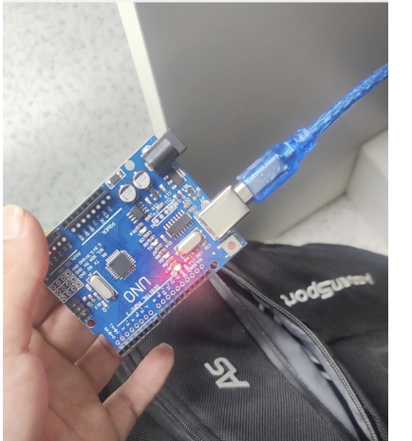
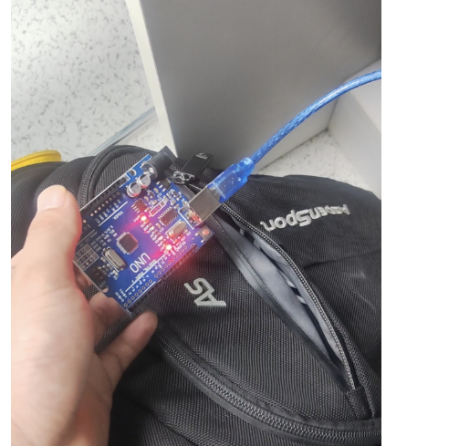

Task2

// 定义变量来追踪按钮和LED的状态
int newState = HIGH, oldState = HIGH, ledState = LOW;

void setup() {
pinMode(3, OUTPUT); // 设置引脚3（LED）为输出模式
pinMode(2, INPUT); // 设置引脚2（按钮）为输入模式
}

void loop() {
// 读取按钮引脚的当前状态
newState = digitalRead(2);

// 检查按钮是否刚刚被按下（从高电平变为低电平）
if ((oldState == HIGH) && (newState == LOW)) {
// 短暂延迟以消除“接触点抖动”
delay(20);
// 检查LED当前的状态
if (ledState == HIGH) {
// 如果LED是亮的，就把它熄灭
digitalWrite(3, LOW);
ledState = LOW; // 更新LED状态变量
} else {
// 如果LED是灭的，就把它点亮
digitalWrite(3, HIGH);
ledState = HIGH; // 更新LED状态变量
}
}

// 更新旧状态，为下一次循环做准备
oldState = newState;
}

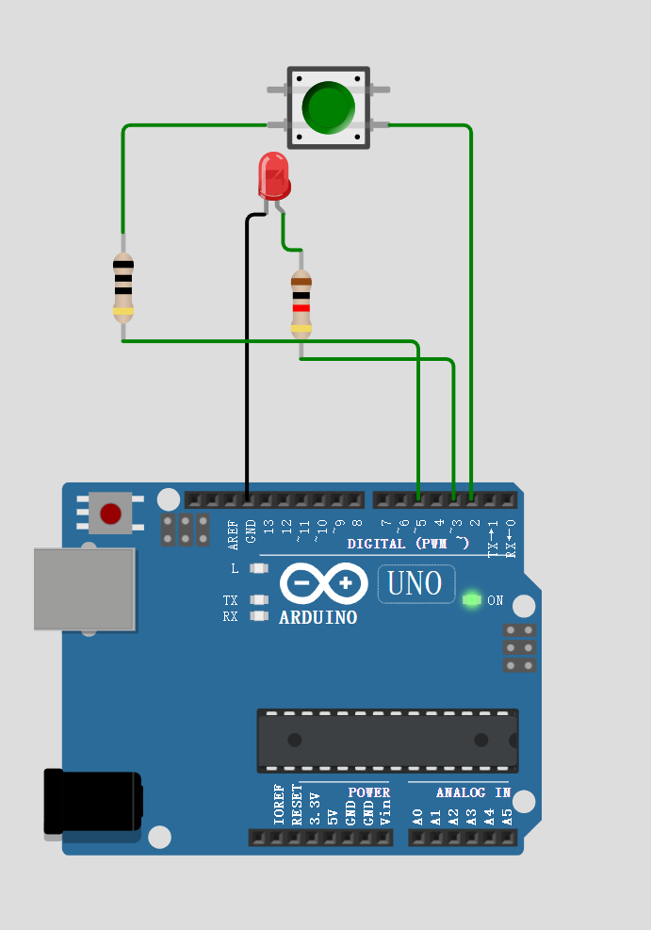

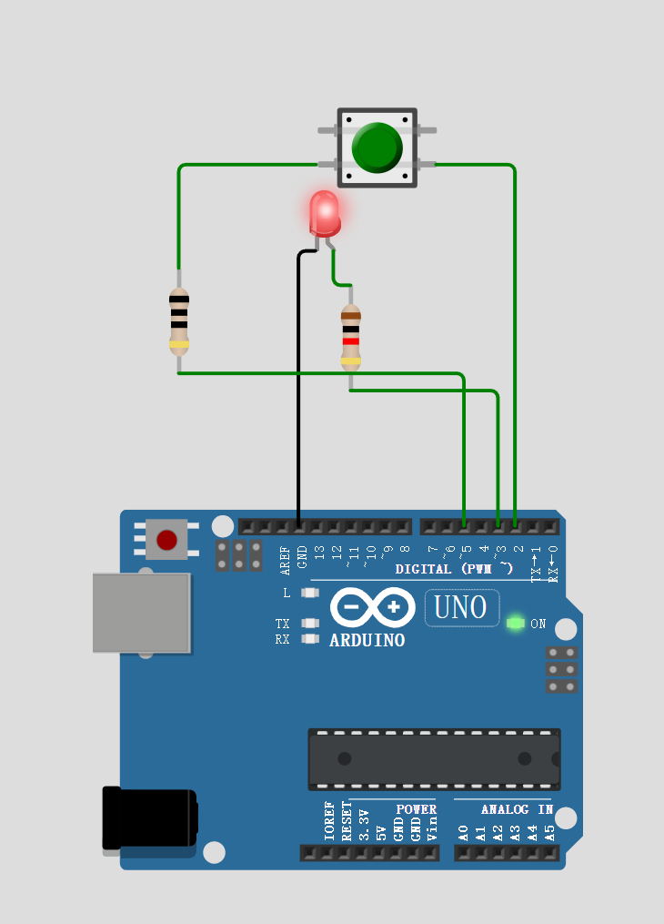

Task3

int sensorValue;

void setup() {
Serial.begin(9600);
}

void loop() {
sensorValue = analogRead(A0);
Serial.println(sensorValue);
delay(10);
}

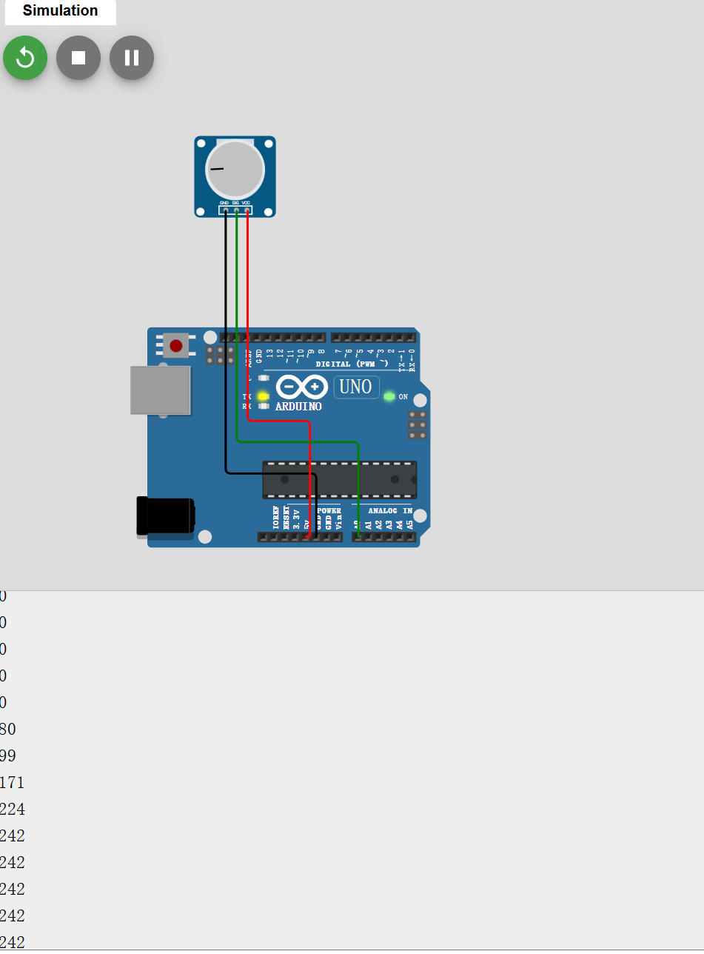

Task4

#include <LiquidCrystal.h>

int sensorValue;
int wiperPosition;
// LiquidCrystal lcd(Reset, Enable, D4, D5, D6, D7)
LiquidCrystal lcd(7, 10, 8, 11, 9, 12);

void setup() {
lcd.begin(16, 2);
}

void loop() {
lcd.setCursor(0, 0);

sensorValue = analogRead(A0);

wiperPosition = map(sensorValue, 0, 1023, 0, 270);

// 在 LCD 上打印文本和变量
lcd.print("Pos: ");
lcd.print(wiperPosition);

lcd.print(" ");

delay(10);
}

