Task1
Try1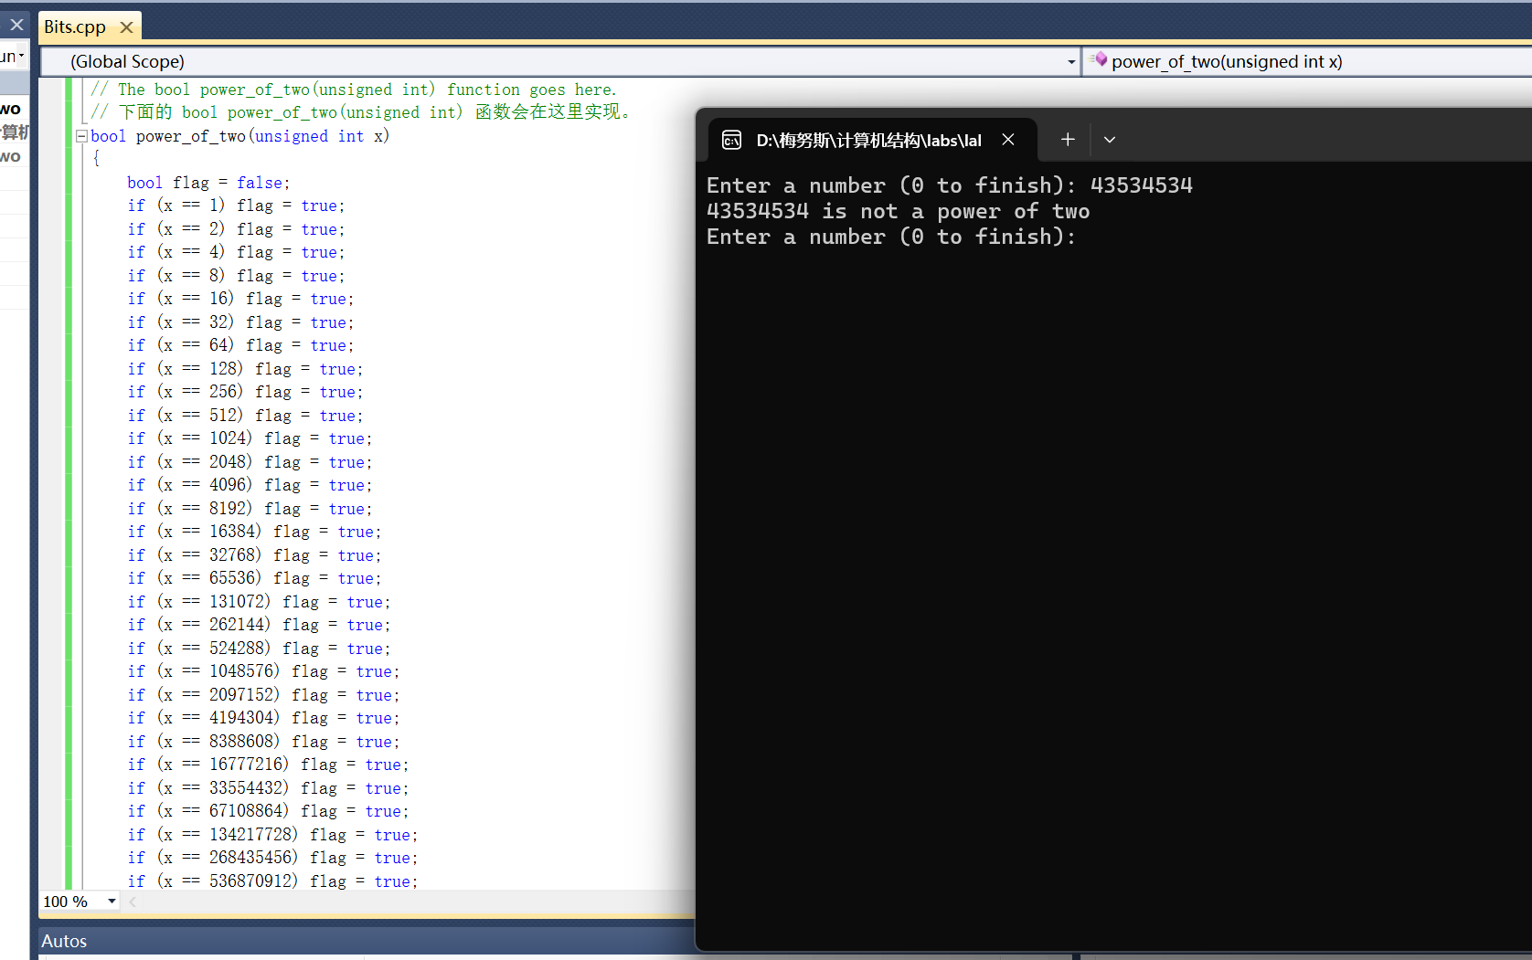
Try2
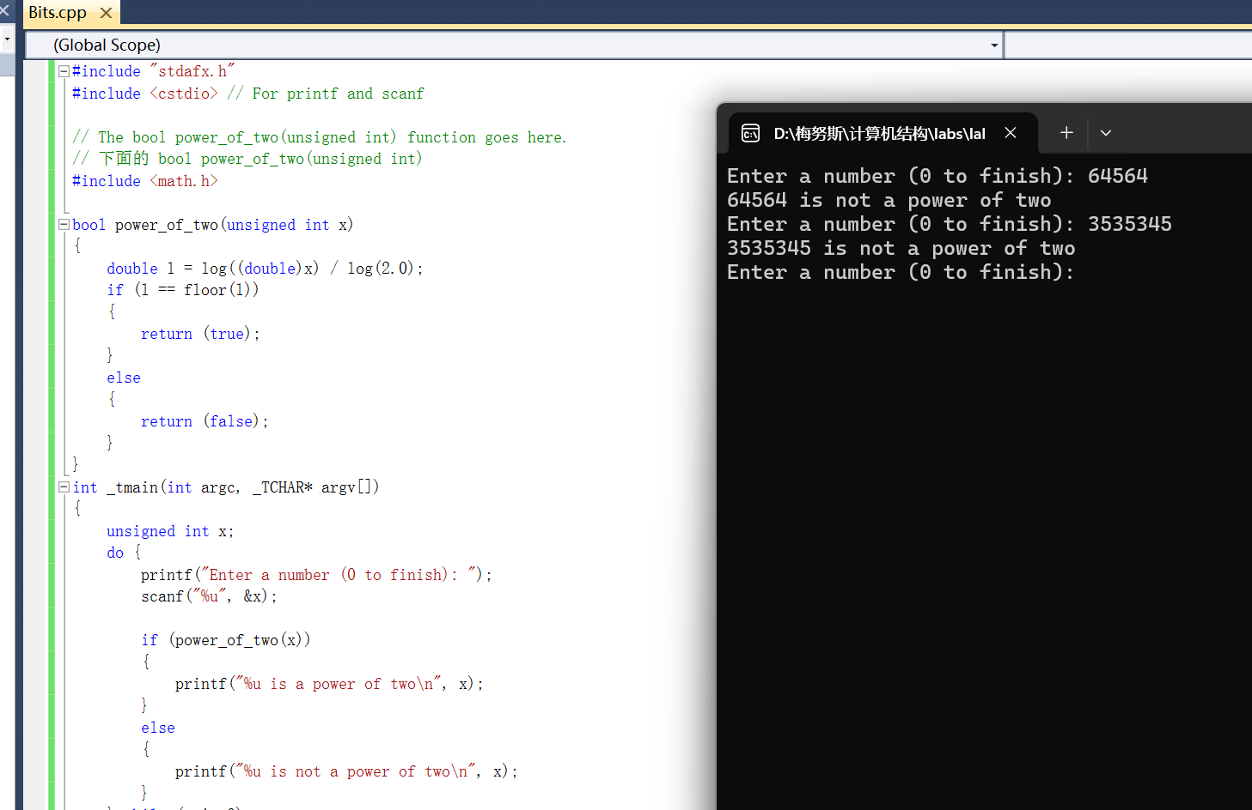
Try3
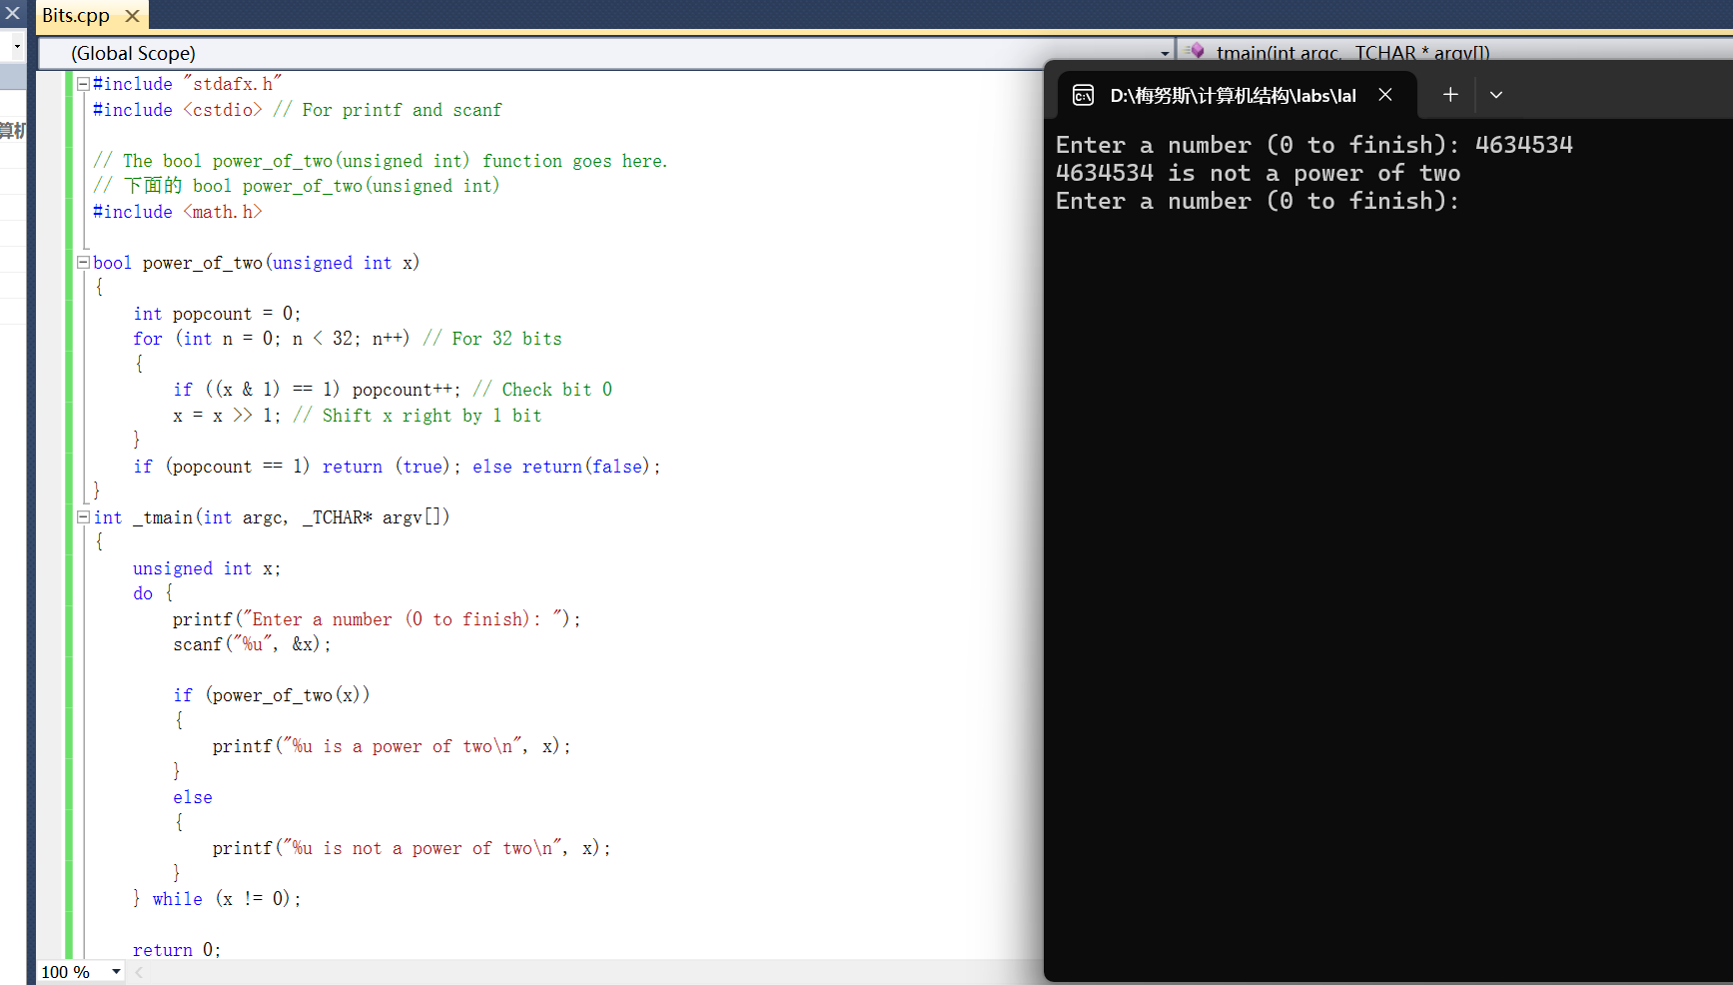
Try4
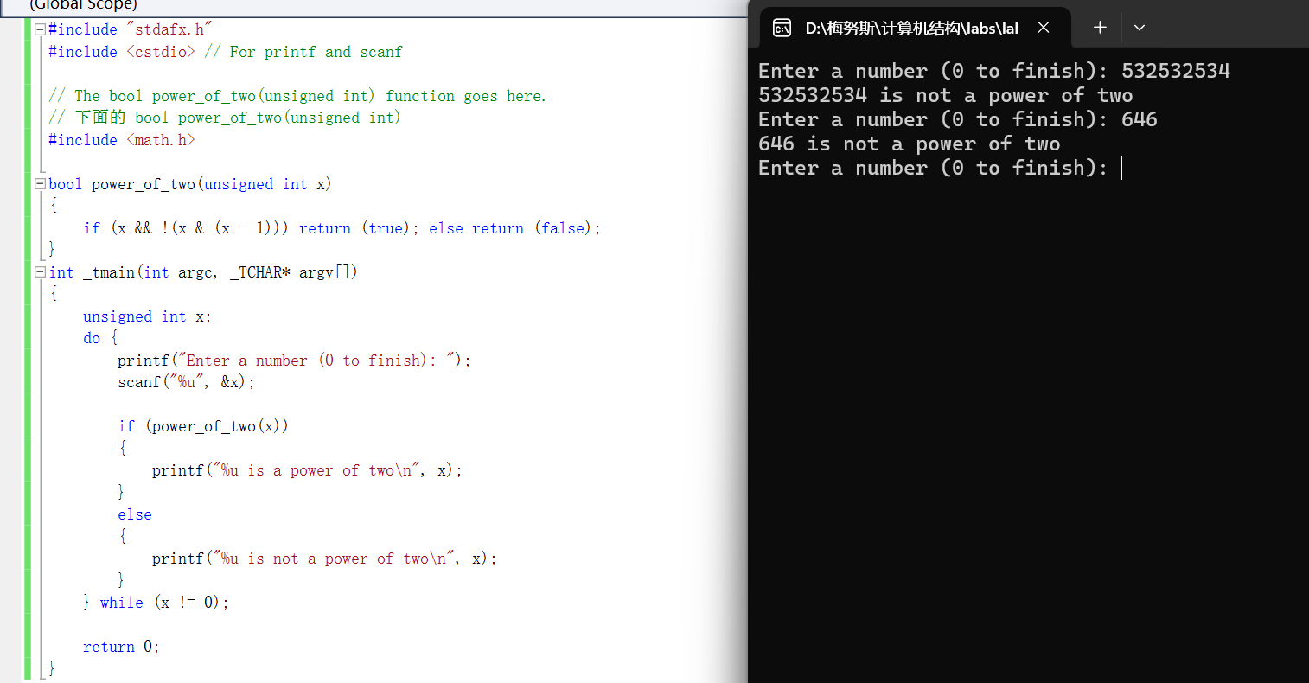
Try5
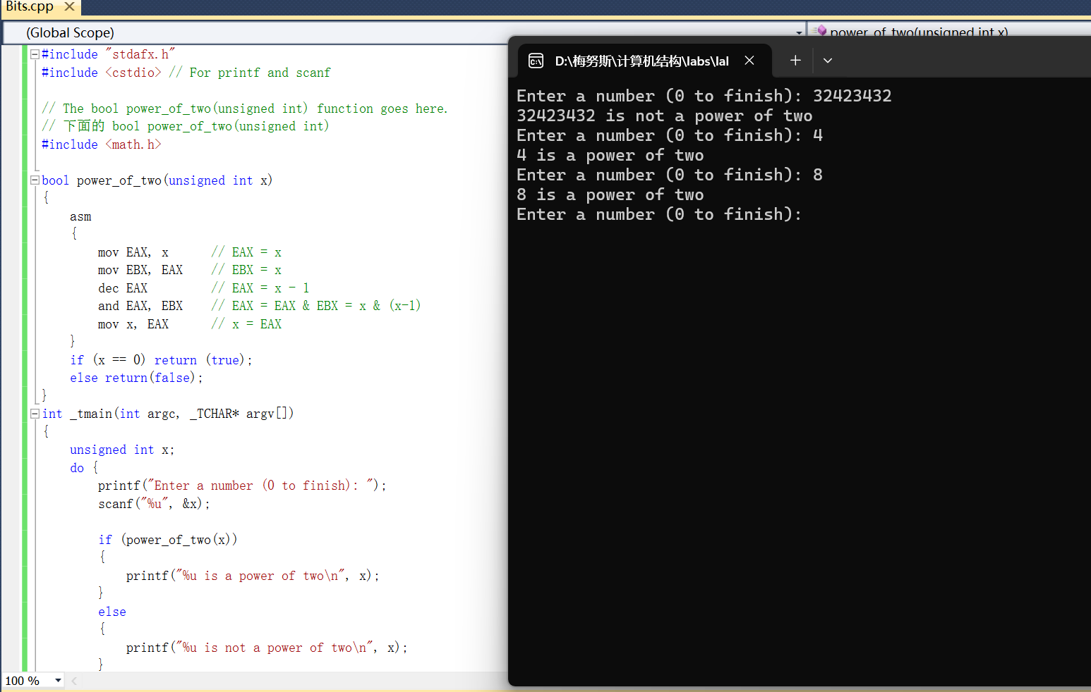
Try6
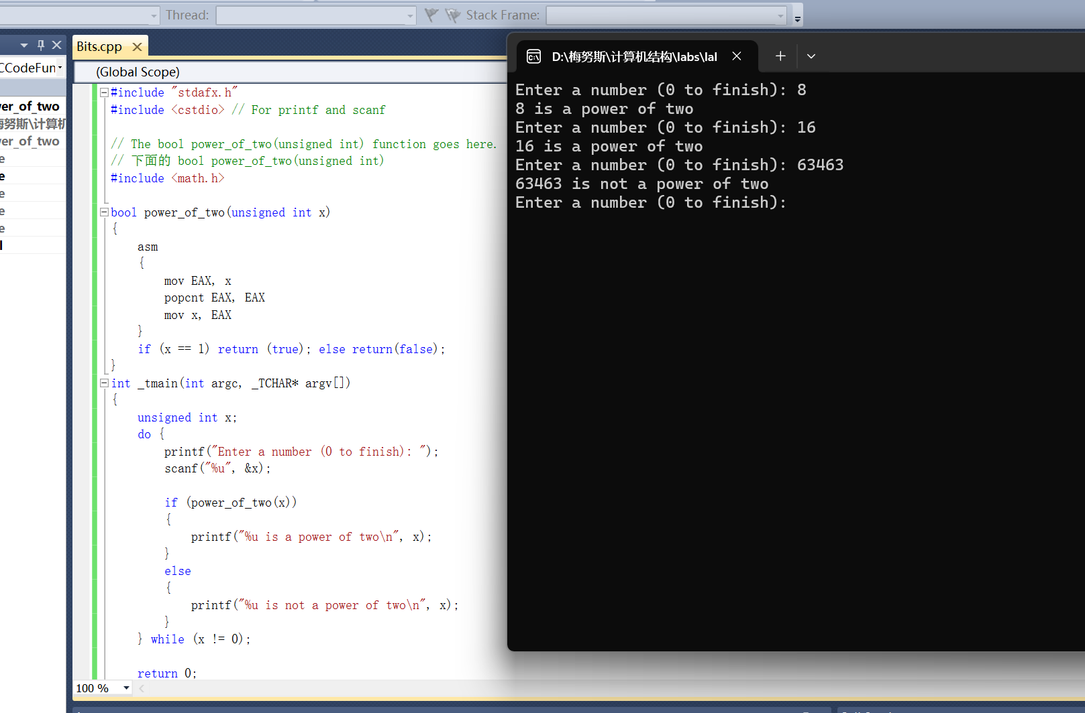

Task2

x = x & 255;
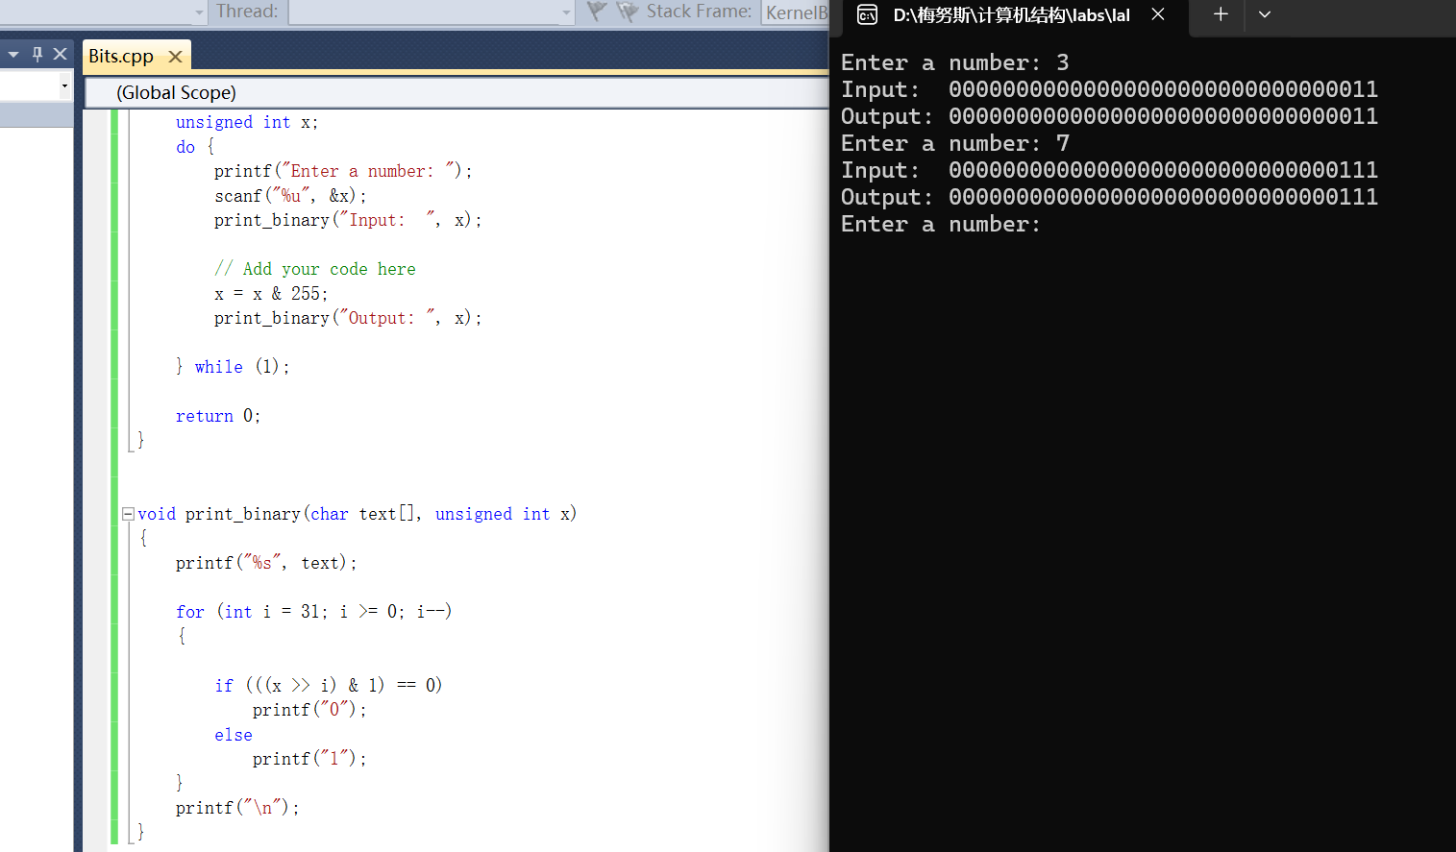
x = x ^ 255;
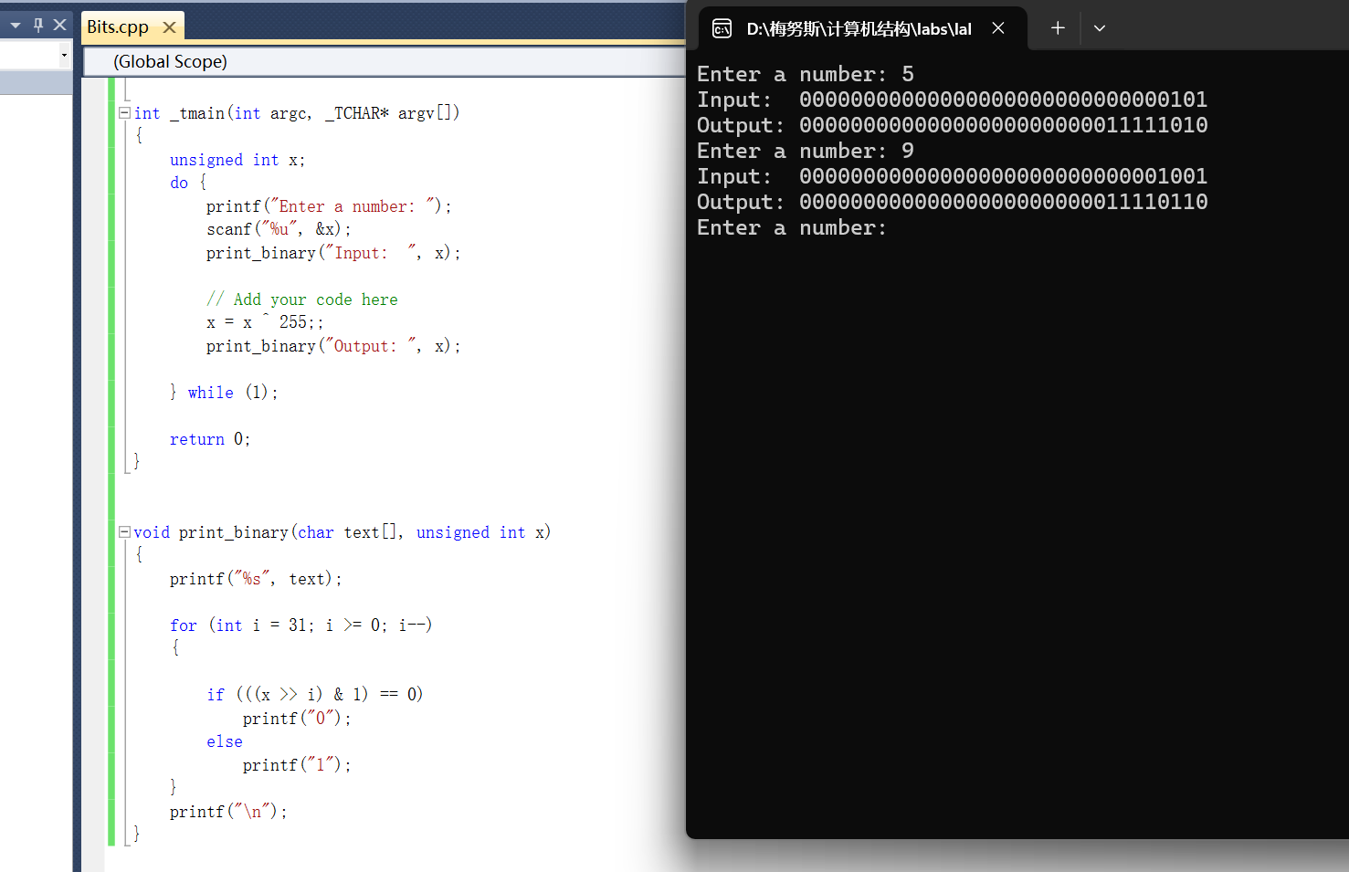
x = x | 255

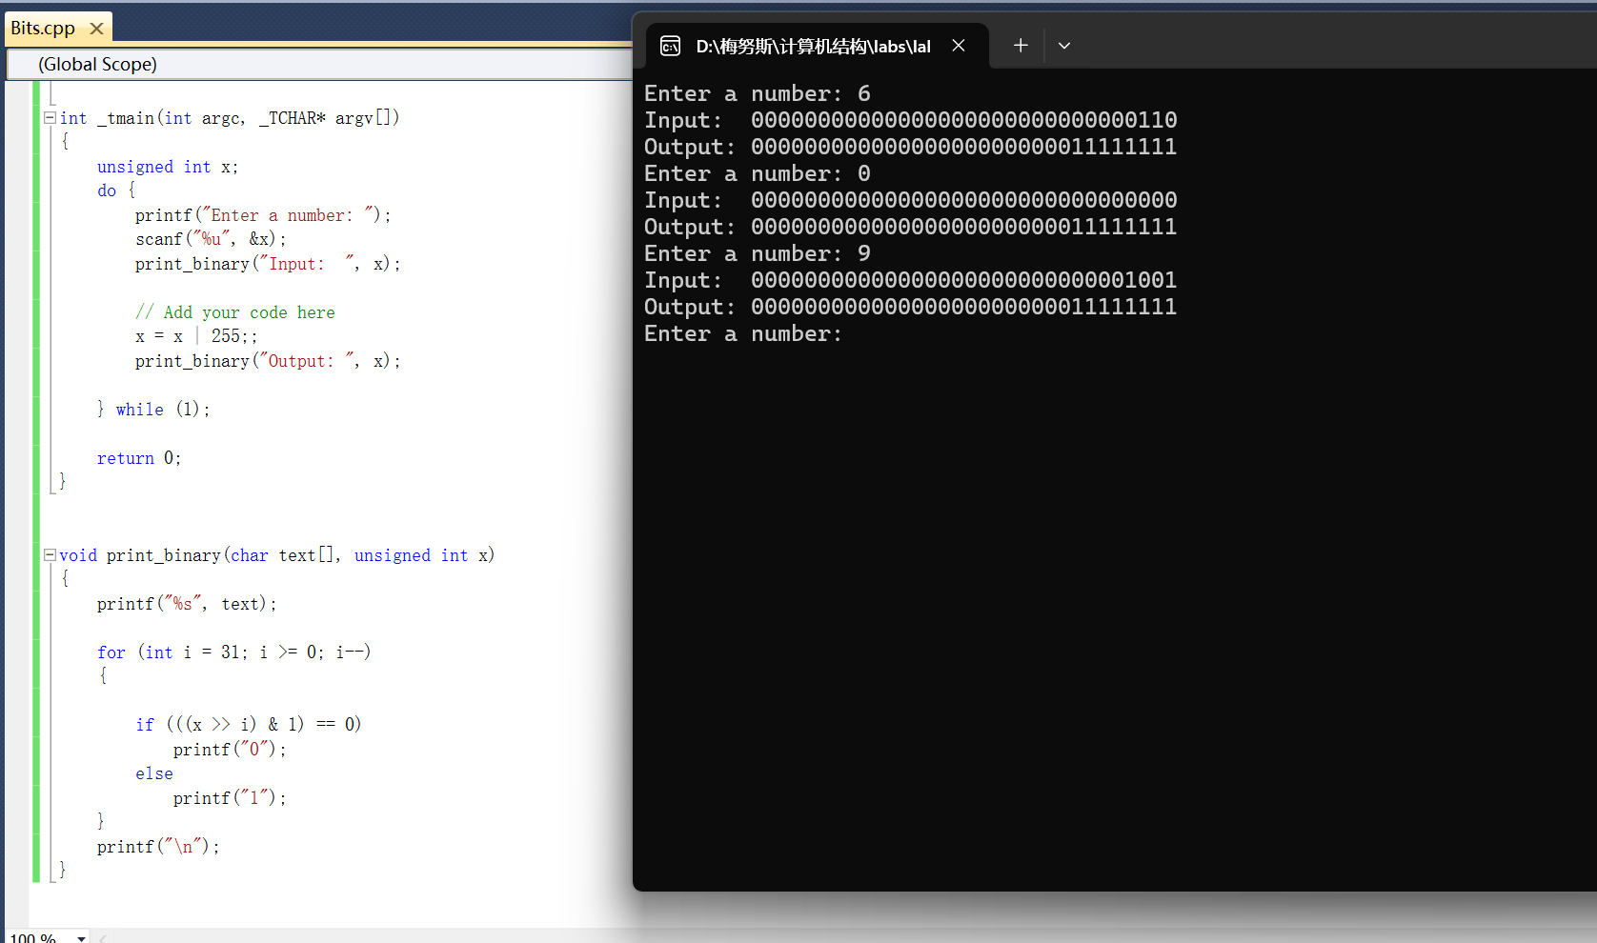

Task3

Exchange
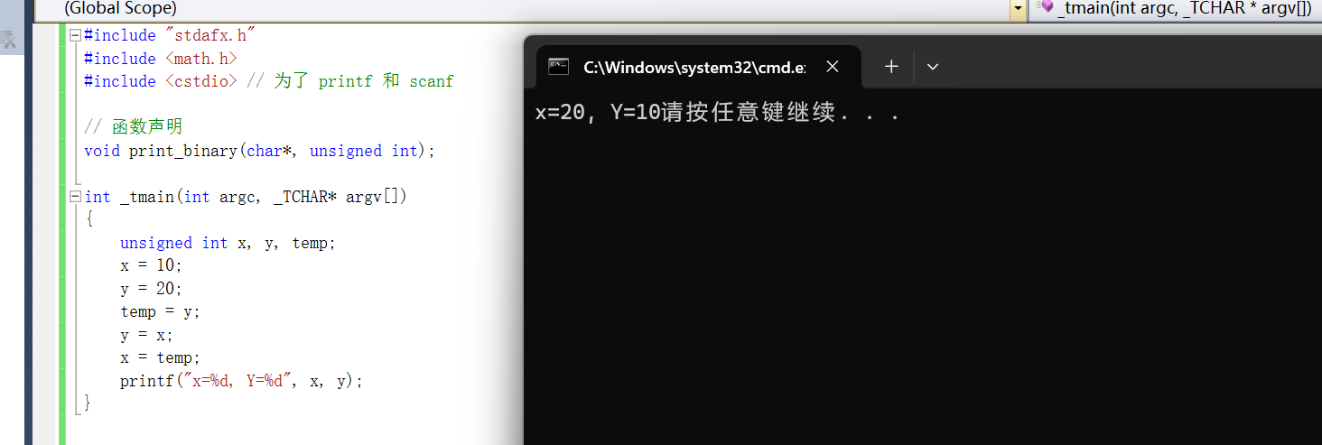
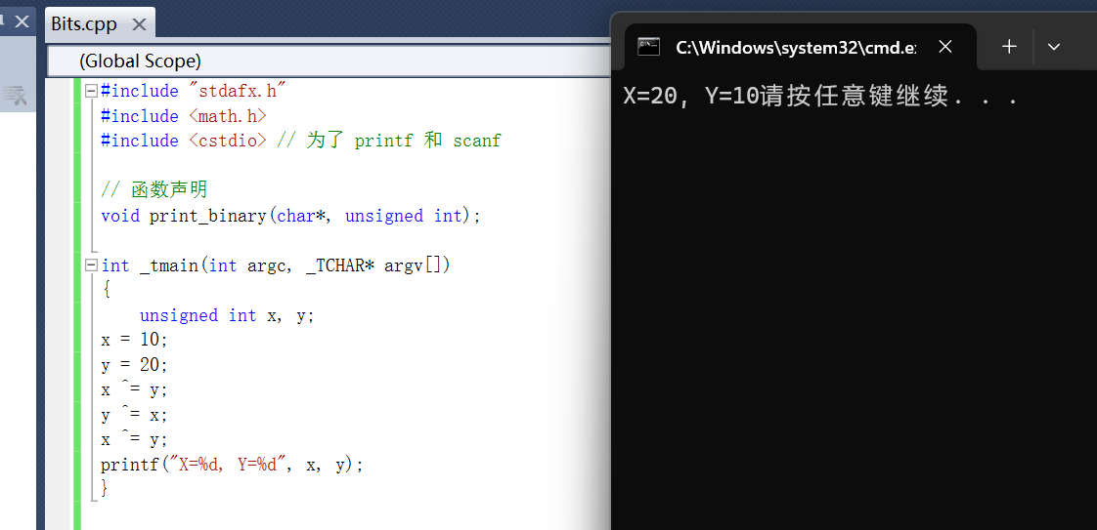

Fast Mutipl

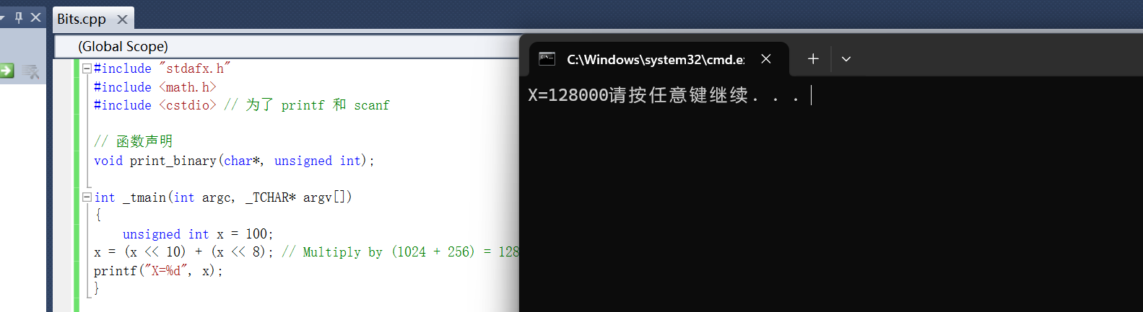

Challenge1

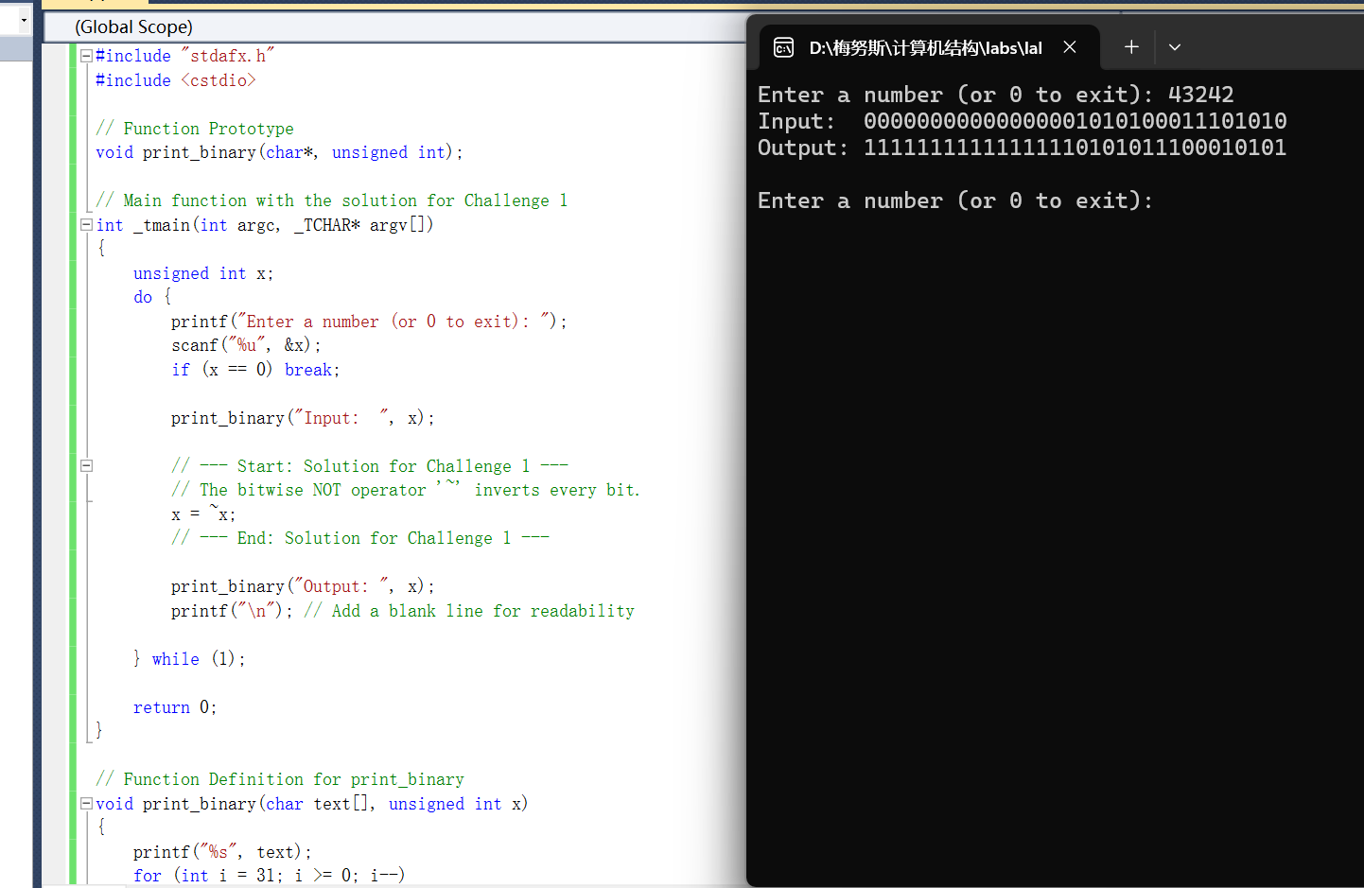
#include "stdafx.h"
#include <cstdio>

// Function Prototype
void print_binary(char*, unsigned int);

// Main function with the solution for Challenge 1
int _tmain(int argc, _TCHAR* argv[])
{
unsigned int x;
do {
printf("Enter a number (or 0 to exit): ");
scanf("%u", &x);
if (x == 0) break;

print_binary("Input: ", x);

// --- Start: Solution for Challenge 1 ---
// The bitwise NOT operator '~' inverts every bit.
x = ~x;
// --- End: Solution for Challenge 1 ---

print_binary("Output: ", x);
printf("\n"); // Add a blank line for readability

} while (1);

return 0;
}

// Function Definition for print_binary
void print_binary(char text[], unsigned int x)
{
printf("%s", text);
for (int i = 31; i >= 0; i--)
{
if (((x >> i) & 1) == 0) printf("0"); else printf("1");
}
printf("\n");
}

Challenge2

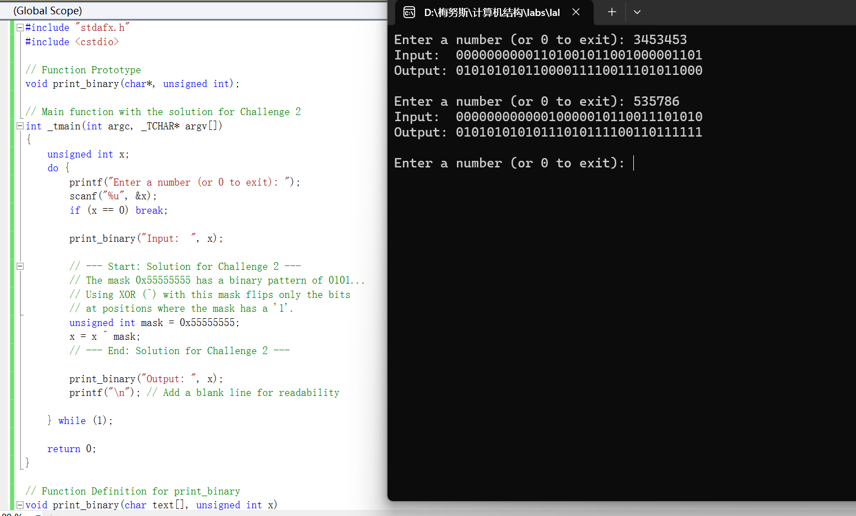
#include "stdafx.h"
#include <cstdio>

// Function Prototype
void print_binary(char*, unsigned int);

// Main function with the solution for Challenge 2
int _tmain(int argc, _TCHAR* argv[])
{
unsigned int x;
do {
printf("Enter a number (or 0 to exit): ");
scanf("%u", &x);
if (x == 0) break;

print_binary("Input: ", x);

// --- Start: Solution for Challenge 2 ---
// The mask 0x55555555 has a binary pattern of 0101...
// Using XOR (^) with this mask flips only the bits
// at positions where the mask has a '1'.
unsigned int mask = 0x55555555;
x = x ^ mask;
// --- End: Solution for Challenge 2 ---

print_binary("Output: ", x);
printf("\n"); // Add a blank line for readability

} while (1);

return 0;
}

// Function Definition for print_binary
void print_binary(char text[], unsigned int x)
{
printf("%s", text);
for (int i = 31; i >= 0; i--)
{
if (((x >> i) & 1) == 0) printf("0"); else printf("1");
}
printf("\n");
}

Challenge3
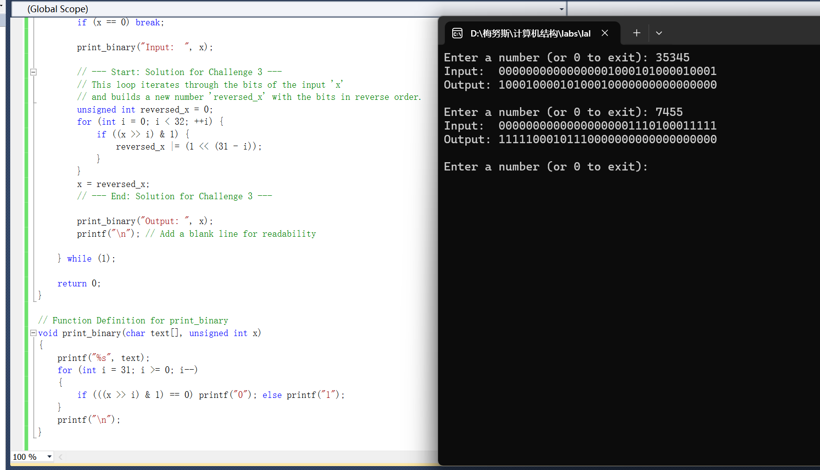

#include "stdafx.h"
#include <cstdio>

// Function Prototype
void print_binary(char*, unsigned int);

// Main function with the solution for Challenge 3
int _tmain(int argc, _TCHAR* argv[])
{
unsigned int x;
do {
printf("Enter a number (or 0 to exit): ");
scanf("%u", &x);
if (x == 0) break;

print_binary("Input: ", x);

// --- Start: Solution for Challenge 3 ---
// This loop iterates through the bits of the input 'x'
// and builds a new number 'reversed_x' with the bits in reverse order.
unsigned int reversed_x = 0;
for (int i = 0; i < 32; ++i) {
if ((x >> i) & 1) {
reversed_x |= (1 << (31 - i));
}
}
x = reversed_x;
// --- End: Solution for Challenge 3 ---

print_binary("Output: ", x);
printf("\n"); // Add a blank line for readability

} while (1);

return 0;
}

// Function Definition for print_binary
void print_binary(char text[], unsigned int x)
{
printf("%s", text);
for (int i = 31; i >= 0; i--)
{
if (((x >> i) & 1) == 0) printf("0"); else printf("1");
}
printf("\n");
}

