
SEMESTER 2
2020-2021

CS253FZ

Computer Architecture 2
Dr. Fook-Loong Lo, Dr. Joseph Timoney, Dr. Meriel Huggard

Time allowed: 2 hours Answer four questions
Complete Question 1, which is worth 40 marks. Choose 3 from the remaining 4 Questions, each of which is worth 20 marks.

Instructions

 | Yes | No
Log Books allowed |  | X
Formula Tables allowed |  | X
Other allowed (enter details) Scientific calculator | X
General (Enter Details)

Parts (a) to (e) refers to the assembly listing shown below.
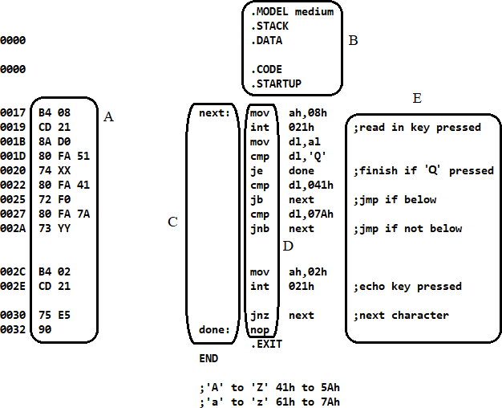

(a) | Give the names of the items shown in the boxes  (i) A (ii) B (iii) C (iv) D (v) E | (5 marks)
(b) | What is the main difference between assembler directives and assembly  language instructions? | (5 marks)
(c) | Only certain characters will be displayed when keys are pressed. What  are these characters? | (5 marks)
(d) | The hexadecimal values in locations 21h and 2Bh have been replaced  with XX and YY. Write out these values. | (5 marks)
(e) | When ‘Q’ is typed to terminate the program, explain if it will be echoed  on the screen before the program returns control to the operating system. | (5 marks)
(f) | Both the bipolar junction transistor (BJT) and the junction field effect transistor (JFET) allow current flow to be controlled by a signal. Briefly  explain the difference in operation between these two devices. | (5 marks)
(g) | Briefly explain the differences between the operation of a complex  instruction set computer (CISC) and a reduced instruction set computer (RISC). Give one advantage of each. | (5 marks)
(h) | Both microcontrollers and FPGAs can be used during the design process for a system. Explain briefly why FPGAs are preferred over microcontrollers when prototyping mass consumer products like  microwave ovens and washing machines. | (5 marks)

The block of code shown below uses Pythagoras theorem to calculate the distance in two dimensions of a point (x, y), with values stored as short reals in SX and SY, from the origin (0, 0), and put it in short real format at the location pointed by SD.
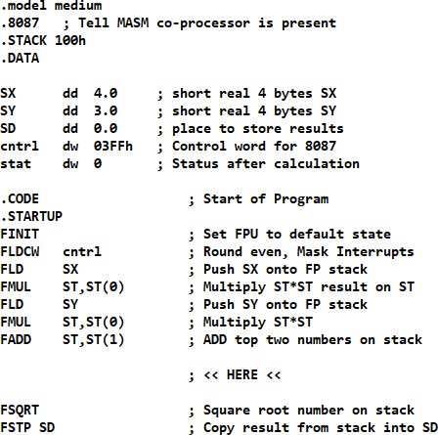

(a) | With SX and SY given values of 4.0 and 3.0, the answer generated in  short real format is 40A0 0000 in hex. Show that the result is correct. | (5 marks)
(b) | It can be shown that Pythagoras Theorem holds in three dimensions:  𝑥² + 𝑦² + 𝑧² = 𝑑²  Write a few lines of codes in the space pointed out by <<HERE<< to find the distance of a point (x, y, z) from the origin. You can assume that SX, SY and SZ have been properly initialized. | (10 marks)
(c) | If SX, SY and SZ have been given the values 8.0, 9.0 and 12.0 respectively, determine the output stored in the location SD after running  the code. Give your answer in hex format. | (5 marks)

Examine the block of code below which will display the binary contents of the register BX.
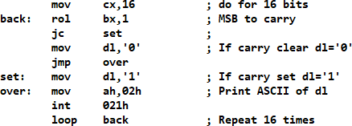

(a) | The decimal number 2,345 is stored in register BX as binary coded  decimal (BCD). Write out the binary contents of BX. | (3 marks)
(b) | Write a block of x86 assembly code which will display the BCD  contents of BX. | (7 marks)
(c) | Convert 2,345 from decimal to hexadecimal. If this number is stored in  BX, show the binary contents of BX. | (4 marks)
(d) | Write a block of x86 assembly code which will display the contents of  BX in hexadecimal. For example, if BX contains 3ACh, the code should display 03AC. | (6 marks)

QUESTION 4
The block of code below is used to create a delay. The number of machine cycles required to complete each of the instructions is given in the comments. For the loops, one number shows number of cycles needed for doing the loop, the other shows the number needed to get out of the loop.
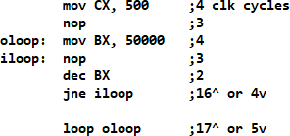

(a) | How many machine cycles are needed to complete the execution of the  code? | (4 marks)
(b) | It was found that the code takes 25 seconds to run in the DOSbox  emulator. What is the average speed of the emulated clock in DOSbox? | (4 marks)
(c) | Should a similar block of code be run on a modern CPU, it is very likely that the time taken to run it will not match the required time calculated. This is due to modern CPUs using different techniques to speed up the average processing time of instructions. Give three examples of these  techniques, and briefly explain each. | (12 marks)

(a) | (i) | List the 3 types of interrupts, and briefly explain why they are  used. | (6 marks)
 | (ii) | Explain briefly the actions the CPU will take when attending to  an interrupt,
(b) | Give two advantages and two disadvantages of dynamic RAM over  static RAM. |  | (4 marks)
(c) | A hard-disk drive (HDD) contains 16,383 cylinders and 16 heads. Each track has 63 sectors, with each sector holding 512 bytes. What is the  total capacity of this HDD? |  | (4 marks)
(d) | Give two advantages and two disadvantages of solid-state drive (SSD)  compared to HDD. |  | (6 marks)

