
SEMESTER 2
2022-2023

CS253FZ

Computer Architecture 2
Dr. Fook-Loong Lo, Dr. Joseph Timoney, Dr. Michael English

Time allowed: 2 hours Answer four questions
Complete question 1, which is worth 40 marks. Choose 3 from the remaining 4 questions, each of which is worth 20 marks.

Instructions

 | Yes | No
Log Books allowed |  | X
Formula Tables allowed |  | X
Other allowed (enter details) Scientific calculator | X
General (Enter Details)

An ASCII Table is provided at the end of the paper.

Parts (a) to (e) refers to the assembly listing shown below.
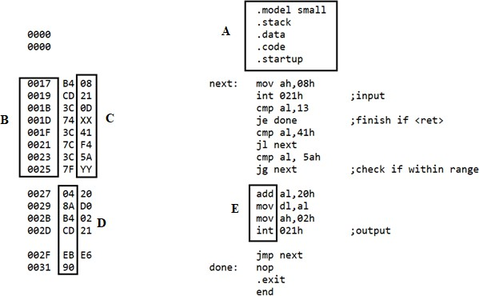

(a) | Match the following: assembler directives, opcodes, operands, offset, and mnemonics to the items in the boxes  (i) A (ii) B (iii) C (iv) D (v) E | (5 marks)
(b) | What is the main difference between items in box D and those in box E? | (5 marks)
(c) | If the following keys are typed when the programme is running: abc123ABC890XYZpqr  show what will appear on the screen. | (5 marks)
(d) | The hexadecimal values in locations 1Eh and 26h have been replaced with XX and YY. Write out these values. | (5 marks)
(e) | Suppose the CS contains 12EFh. What is the starting address in main memory of the instruction cmp al,13 ? | (5 marks)
(f) | A computer uses a 32-bit address bus to obtain data from main memory. How big is the main memory? | (5 marks)
(g) | Most modern laptops use Solid-state Drive (SSD) instead of Hard-disk drive (HDD) as tertiary storage. Give two advantages of SSD over HDD and two disadvantages. | (5 marks)
(h) | When entering an interrupt service routine (ISR), contents of registers are normally pushed onto the stack, and retrieved only at the end of the  ISR. Briefly explain why this is done. | (5 marks)

The CPUs generally run faster than external peripherals such as hard disks and serial communication ports. To generate delays, a short routine, such as the one below, can be used:
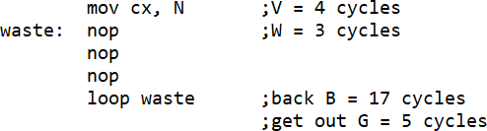

Let the machine cycles for the following operations be represented as: V: overhead B: loop back G: get out of loop W: no operation and the number of loops be represented by N.
(a) | Obtain an expression relating D, the desired delay in machine cycles, in terms of V, B, G, W and N. | (6 marks)
(b) | If N is set to be 30,000, what will be the delay generated in terms of machine cycles? | (4 marks)
(c) | Suppose the CPU is running at 100MHz, and a delay of 500 ms is required, what should be the value of N? | (4 marks)
(d) | What is the maximum delay in machine cycles that can be generated by the piece of code shown above? | (4 marks)
(e) | If more delay is desired, describe briefly one way to obtain it. | (2 marks)

Write a section of code, following the suggestions below, to output the 4 hex digits in register AX.

(a) | Set loop counter bx to 4 for 4 nibbles Clear carry for rotate | (4 marks)
(b) | Again: set loop counter to 4 for 4 bits in nibble Clear dl for output | (2 marks)
(c) | Nib: rotate through carry  highest nibble of ax to lowest nibble of bx | (4 marks)
(d) | Check if nibble is 0-9 If so, go to deci  Otherwise adjust for ‘A’ to ‘F’ | (4 marks)
(e) | Deci: change value in dl to ASCII Save ax  Output dl Retrieve ax  Jump back to again | (6 marks)

QUESTION 4
The 34000 series logic gates belong to the Complementary Metal Oxide Semiconductor (CMOS) family, where pairs of n- and p-channel MOS field effect transistors (MOSFET) are arranged to obtain the various gate operations required.

(a) | Sketch the structure of an n-channel MOSFET and briefly explain how it can be used as a voltage-controlled switch. | (6 marks)
(b) | 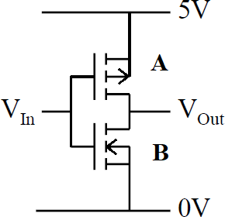
 | (i) A simple CMOS gate is shown above. What gate is this? | (3 marks)
 | (ii) Which is the p-channel MOSFET, A or B? | (2 marks)
 | (iii) Briefly explain how this gate functions. | (5 marks)
(c) | Give 2 advantages of CMOS gates compared to Transistor-Transistor Logic (TTL) gates built using bipolar transistors (BJT). | (4 marks)

All CPUs allow for interrupts from external devices. Most CPUs, like the 8086, also allow for software interrupts.

(a) | Why are external interrupts so important? | (3 marks)
(b) | Explain briefly the main difference between hardware and software interrupts. | (3 marks)
(c) | Give two uses of software interrupts. | (4 marks)
(d) | The location of the interrupt vector table is from 00000h to 003ffh.  - What is the use of the interrupt vector table?  - Print screen activates interrupt number 5. From where does the 8086 fetch the start address of the print screen interrupt service routine? | (4 marks)
(e) | Assume that the registers AX, BX, CX and DX contain the hex values 1234, 4567, 789A and ABCD at the instant an interrupt routine is called, and the values of these registers are pushed onto the stack sequentially. Suppose SP contains 1000h. Show how the values will be stored in the stack. Remember that 8086 uses little-endian notation. | (6 marks)

ASCII Table
