Ollscoil Mhá Nuad Maynooth University


SEMESTER 2
2023-2024

CS253FZ
Computer Architecture 2

Dr. Fook-Loong Lo, Dr. Joseph Timoney, Dr. Michael English

Time allowed: 2 hours

Answer four questions
Complete question 1, which is worth 40 marks. Choose 3 from the remaining 4 questions, each of which is worth 20 marks.

Instructions

 | Yes | No
Log Books allowed |  | X
Formula Tables allowed |  | X
Other allowed (enter details) Scientific calculator | X
General (Enter Details)
An ASCII table is attached to the end of the paper.

Parts (a) to (d) refers to the assembly listing shown below.
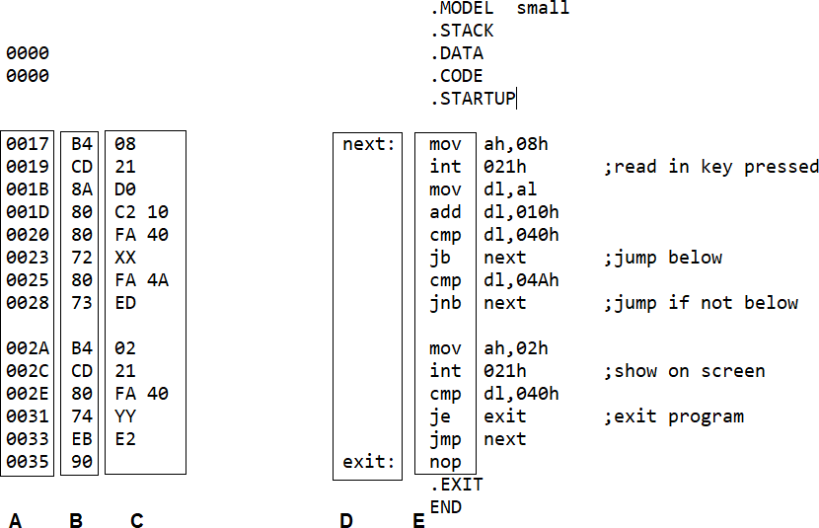

(a) | Choose the names of the items shown in the boxes from the following: labels, mnemonics, opcodes, operands and offsets.  (i) A (ii) B (iii) C (iv) D (v) E | (5 marks)
(b) | If the code segment register contains the value 26AE hex, what is the  address in main memory pointed out by the label exit? | (5 marks)
(c) | Only certain characters will be displayed when keys are pressed. What  are these characters? | (5 marks)
(d) | The hexadecimal values in locations 24h and 32h have been replaced  with XX and YY. Write out these values. | (5 marks)
(e) | If abcABC123xyzXYZ890 is typed when the program is running, what  will appear on the screen before the program terminates? | (5 marks)
(f) | - What is the main difference between a latch and a flip-flop?  - What is the main difference between a level-triggered and an edge- triggered flip-flop? | (2 marks)  (3 marks)
(g) | RISC computers often perform faster than CISC computers when  running most programmes. Briefly explain why this can happen, and also when a CISC computer may perform better. | (5 marks)
(h) | Outputs to bi-directional data buses are often connected through tri-state  buffers. Briefly explain why this is necessary. | (5 marks)

Metal Oxide Semiconductor (MOS) Field Effect Transistors (FETs) can be used to make different digital components. The two main types of FETs are the N-type and P-type FETs. N-type FETs are turned on with a positive voltage at the gate, and P-type FETs are turned on when a 0 voltage is applied at the gate. A positive voltage is taken as logic 1 and 0 voltage is taken as logic 0.
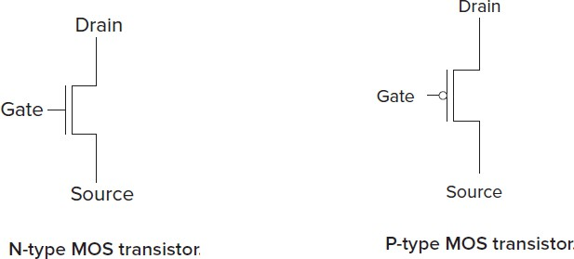

Consider the two digital components shown below:
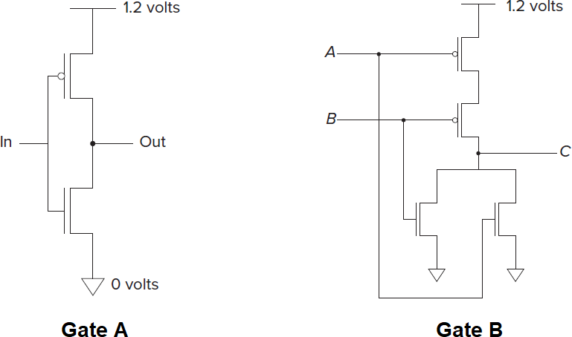

(a) | What type of logic gate is Gate A? | (4 marks)
(b) | (i) Write out the truth table of Gate B.  (ii) What type of logic gate is Gate B? | (4 marks)  (2 marks)
(c) | Using 2 N-type FETs and 2 P-type FETs, design a circuit that performs  the NAND function. | (5 marks)
(d) | Any digital circuits that produce an output which can be described by a sum-of-products or product-of-sums expression can be built using only AND, OR and NOT gates. NAND gates can be used to build all three gates and therefore are often called the universal gate.  (i) Use one NAND gate to build a NOT gate.  (ii) Use 2 NAND gates to build an AND gate.  (ii) Use 3 NAND gates to build an OR gate. | (1 mark)  (2 marks)  (2 marks)

A certain CPU uses 16-bit machine instructions with the bits assigned as shown below. It uses 8 registers, R0 to R7.
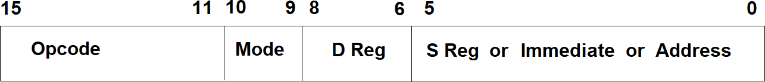
Bits 11 – 15: opcode of the instruction
Bits 10 – 9: addressing mode for source operand
00: operand from source register specified in value of bits 0 – 5 01: immediate, operand as 2’s complement value in bits 0 – 5 10: offset address of operand as signed value in bits 0 – 5
11: full address of operand formed from bits 0-5 shifted 16 bits left and added to the 16-bit value following the instruction
Bits 8 – 6: destination register number
Bits 5 – 0: source operand to be fetched according to mode

(a) | How many possible opcodes are there for this CPU? | (3 marks)
(b) | What is the range of values that can be moved to the destination register  if immediate addressing mode is used? | (3 marks)
(c) | What is the size of main memory for this CPU? | (3 marks)
(d) | - If the MOV instruction has opcode 01001, and the decimal number negative twelve (-12) is to be moved into R5, work out the machine code. Give your answer in hex.  - What is the machine code if the contents of R3 is to be moved to R0? Give your answer in hex. | (3 marks)  (3 marks)
(e) | What is the maximum increment that the instruction pointer will  undergo after fetching an instruction? | (5 marks)

Examine the subroutine Print below which will display the decimal contents of the register AX.
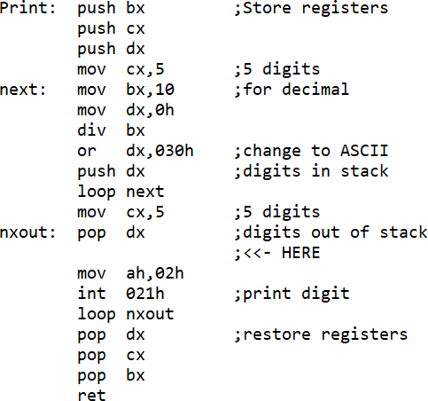

(a) | If AX contains 12,345 decimal, what will be printed out by the  subroutine? | (3 marks)
(b) | If AX contains 678 decimal, what will be printed out by the subroutine? | (3 marks)
(c) | If AX contains 13AC hexadecimal, what will be printed out by the  subroutine? | (3 marks)
(d) | A student wishes to modify the subroutine to print out contents of AX  in hexadecimal. She changes mov bx,10 at label next to mov bx,16. What will be displayed if AX contains 13ACh? | (6 marks)
(e) | To make the subroutine display the correct hexadecimal contents of  AX, add a few lines of code at the location marked HERE. | (5 marks)

QUESTION 5

(a) | The data section of an x86 assembly language program is shown:  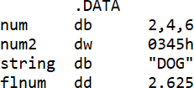  - How many bytes are used to store these pieces of data?  - If the label num points to location 10000h of main memory, show the contents of the following byte locations which contain the data. Remember that x86 uses little-endian convention. | (2 marks)  (6 marks)
(b) | The stack in a computer working with a FILO order is especially suited for storing return addresses of interrupt routines.  - Briefly explain what is meant by FILO.  - Briefly explain why it is especially suited for storing return addresses of interrupt routines. | (2 marks)  (4 marks)
(c) | Briefly explain the main difference between vector processing and pipelining, two different ways of speeding up computation. | (2 marks)

(d) | The contents of the first few locations in the vector table of an x86 machine are shown:  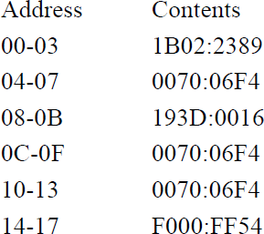  The print screen interrupt has interrupt number 5. Find the full address of the start of the print screen interrupt service routine. | (4 marks)

ASCII Table
