Maynooth International Engineering College

CS253FZ Computer Architecture 2
Class Test
Q1. Study the block of 8086 assembly language code below and answer the following questions.
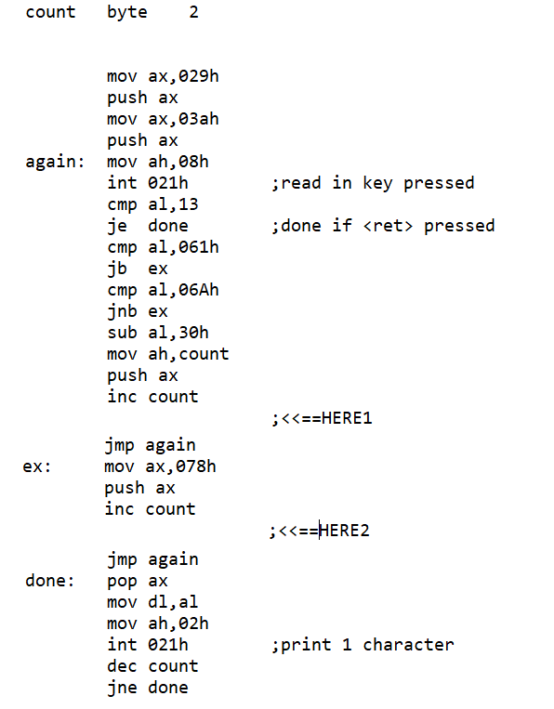
This block of code takes in characters typed on the keyboard, converts them to ASCII codes, pushes them into stack, and when <ret> is pressed, pops the contents of stack and displays the characters onto the screen.
- What will be displayed on the screen if a1b2c3 followed by <ret> is typed into the computer? (10 marks)
- If the string typed in is dcba4321 followed by <ret>, what will be echoed on the screen? (5 marks)

- Assuming SS:SP points to 01000h at the beginning of the program, fill in the contents of the stack space when a1b2c3 is typed in but before <ret> is pressed.
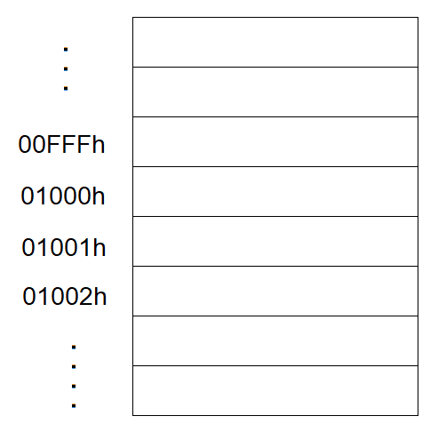
(20 marks)
- Add instructions at each of the two locations marked <<==HERE1 and <<==HERE2 so that the code will accept at most 10 characters, meaning that the program will exit the input loop after 10 characters even though the <ret> key is not pressed.
(15 marks)

Q2. You are to write a block of code following the suggestions given below in the space provided in the answer script. The code will output the contents of ax in decimal to the screen.
label | Assembly code | marks
 | .DATA
count  ten | byte 5 ;used for counting number of digits  dw 10 ;for 32 bit division | (5 marks)
.CODE
.STARTUP
 | Put 10,000 into bx for first division  Put a number into ax | (5 marks)
again: | Divide dx:ax by bx  Quotient in al is changed to ASCII and displayed  Divide bx by 10  Decrement count  Do this 5 times | (5 marks)  (10 marks)  (5 marks)  (10 marks)

What will be shown on the screen if ax contains:
- ABCh (5 marks)
- 123h (5 marks)

[ Total: 100 marks]

