Maynooth International Engineering College
CS253FZ Computer Architecture II
Class Test 2022
Suggested Solutions
Q1. a) x3x2x1:) (10 marks)
b) xxxx4321:) (5 marks)
c)
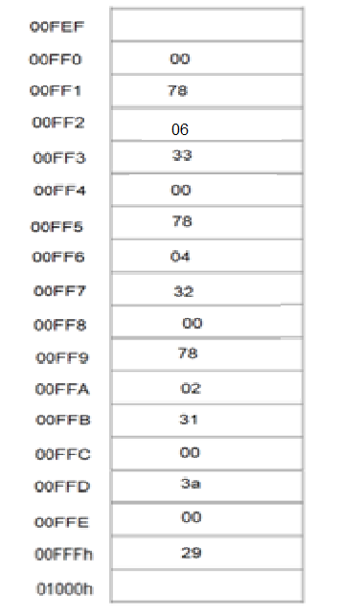
(20 marks)
d)
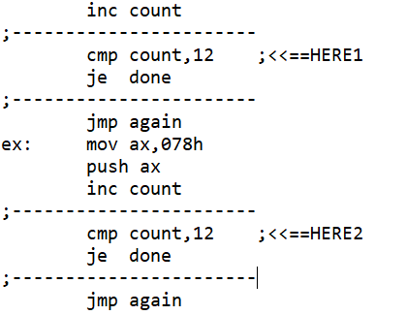 (15 marks)

Q2.
label | Assembly code | marks
 | .DATA
count  ten | byte 5 ;used for counting number of digits  dw 10 ;for 32 bit division | (5 marks free)
.CODE
.STARTUP
 | mov bx,10000  mov ax,01234h | (5 marks)
again: | mov dx,0h  div bx ;divide dx:ax by 10000 1st time,  ;quotient into ax, remainder in dx  add al,030h ;change to ASCII  push dx ;save remainder  mov dl,al  mov ah,02h  int 021h ;print 1 decimal digit  mov dx,0h  mov ax,bx  div ten  mov bx,ax ;bx divided by 10  pop dx  mov ax,dx ;retrieve remainder and put in ax  dec count  jne again  .EXIT  END | (5 marks)  (10 marks)  (5 marks)  (10 marks)

a) 02748 (5 marks)

b) 00291 (5 marks)

