- Initialization interface


- Login interface: Log in successfully by entering the username and password
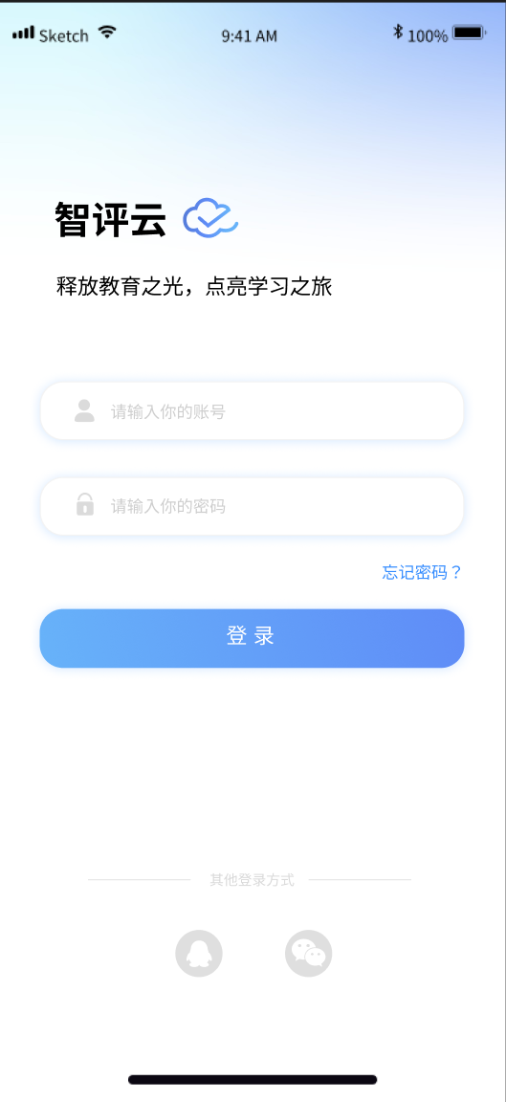

- Personal Settings interface: By clicking on each TAB, detailed information about each part of the user can be displayed
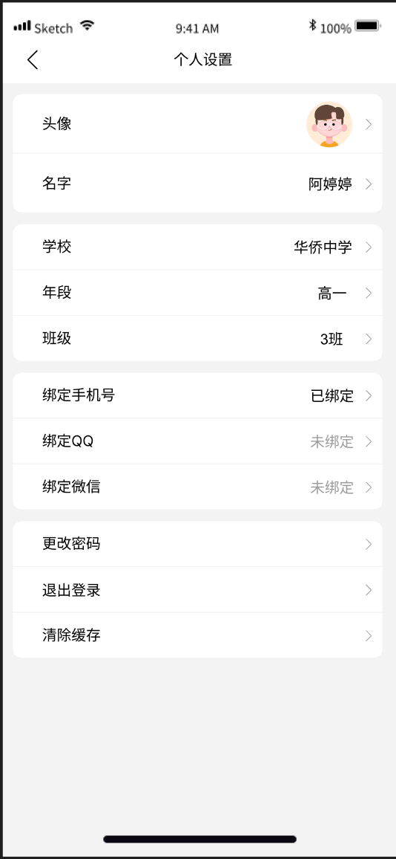

- Student grade inquiry: You can view the statistical results of students' grades, rankings, and strengths and weaknesses in each subject
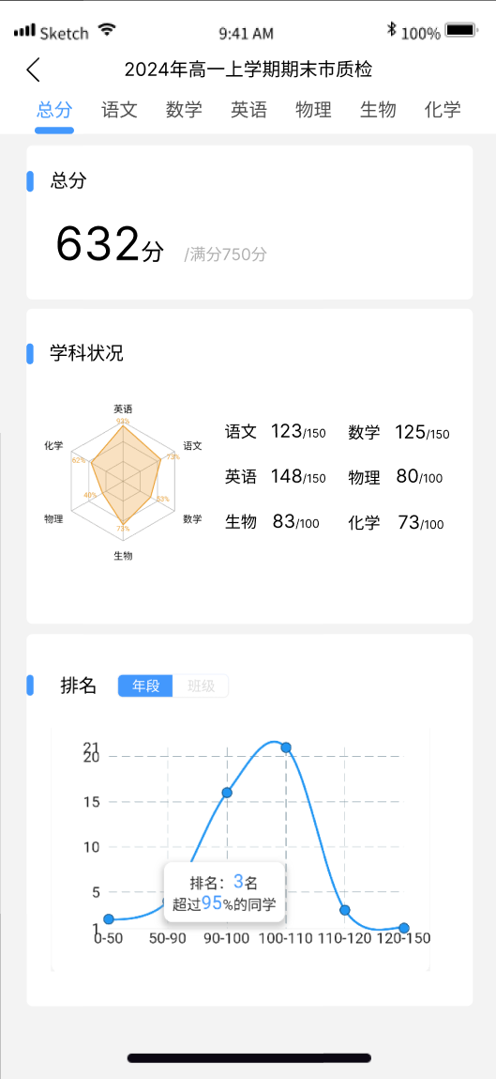

- Student examination report inquiry: You can select students' previous examination reports for inquiry
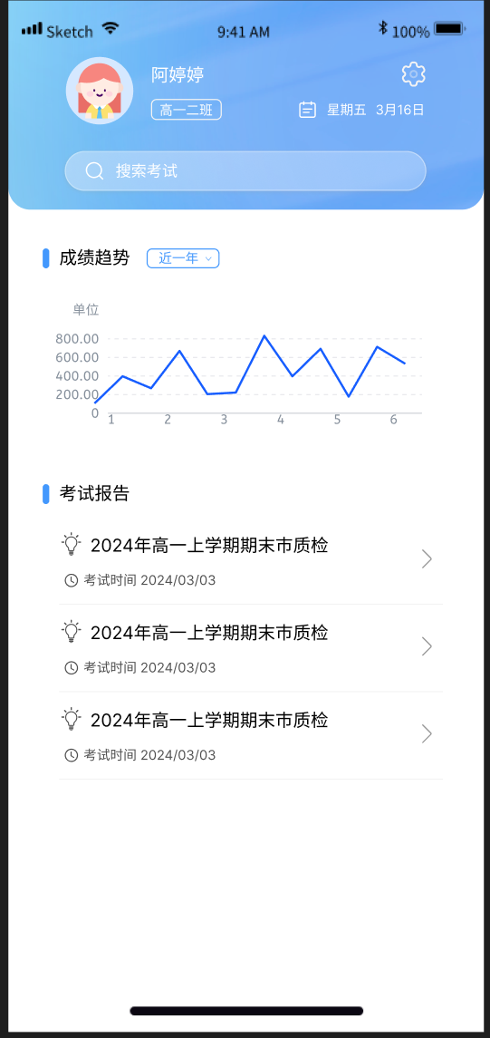

- Student performance details and teacher evaluations
