Result 
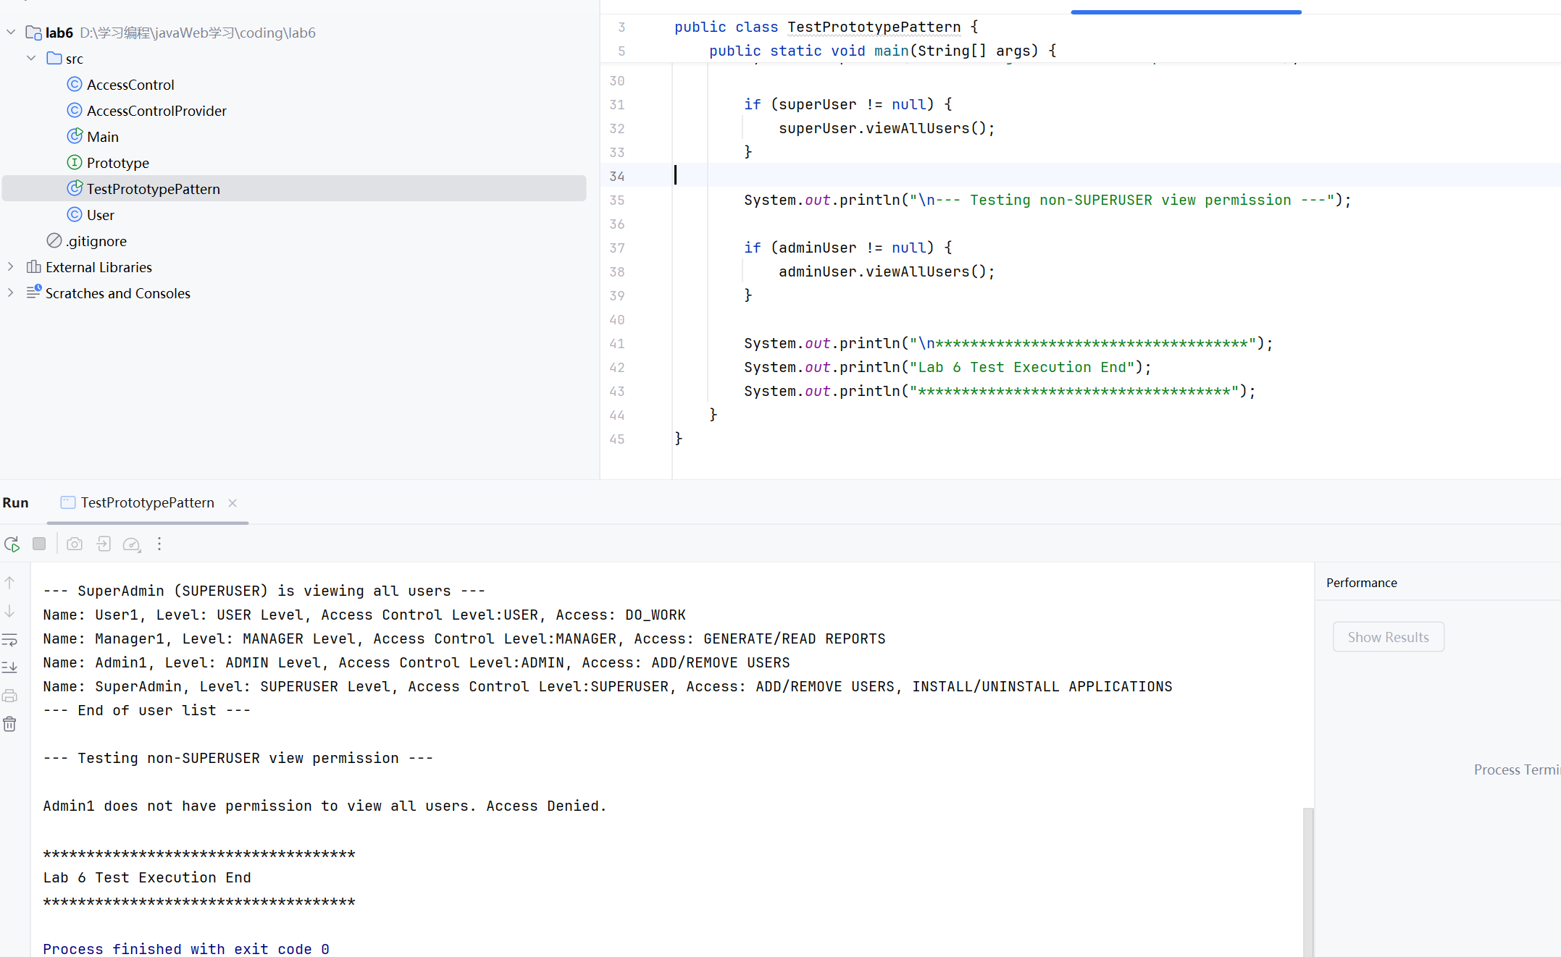

Code changed

Class AccessControlProvider
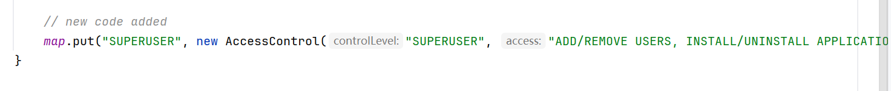
Add method
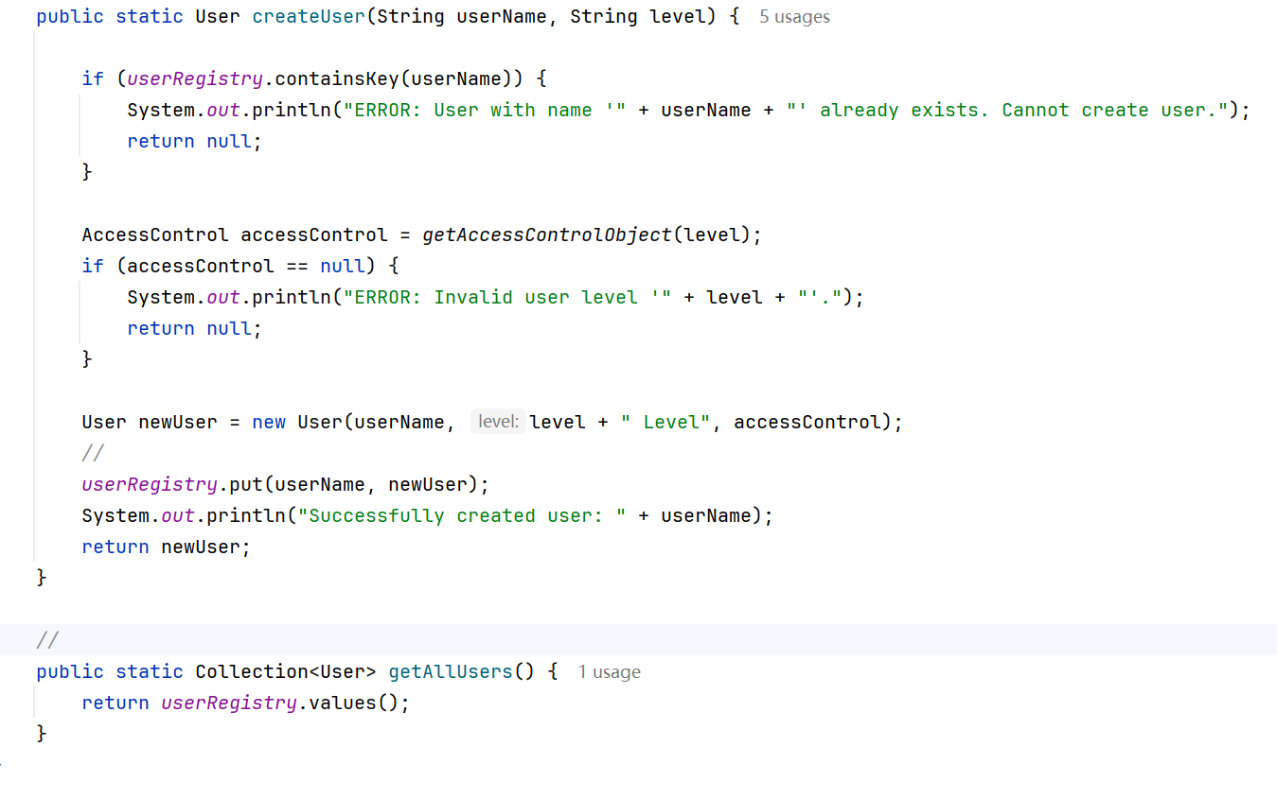

In User Class
Add method
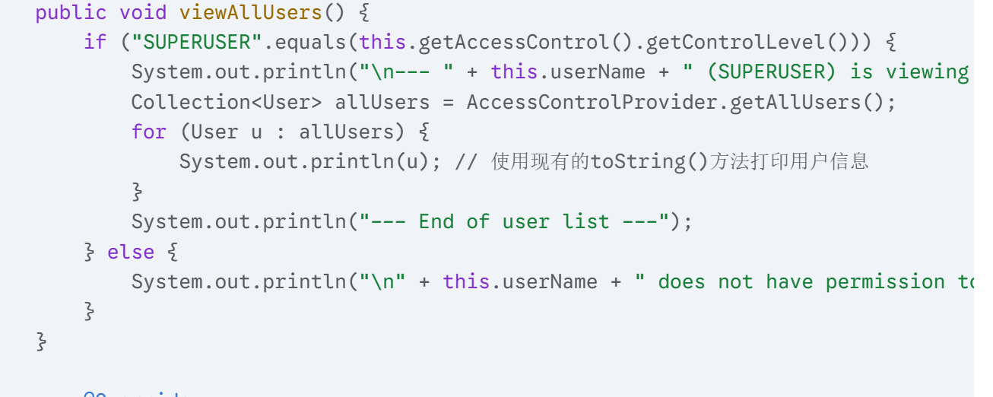

Test Code

// TestPrototypePattern.java
public class TestPrototypePattern {
public static void main(String[] args) {
System.out.println("************************************");
System.out.println("Lab 6 Test Execution Start");
System.out.println("************************************\n");
User superUser = AccessControlProvider.createUser("SuperAdmin", "SUPERUSER");
User adminUser = AccessControlProvider.createUser("Admin1", "ADMIN");
User managerUser = AccessControlProvider.createUser("Manager1", "MANAGER");
User basicUser = AccessControlProvider.createUser("User1", "USER");
System.out.println("\n--- Initial Users ---");
System.out.println(superUser);
System.out.println(adminUser);
System.out.println(managerUser);
System.out.println(basicUser);
System.out.println("---------------------\n");
System.out.println("--- Testing unique username constraint ---");
AccessControlProvider.createUser("Admin1", "USER");
System.out.println("----------------------------------------\n");
System.out.println("--- Testing SUPERUSER view permission ---");
if (superUser != null) {
superUser.viewAllUsers();
}
System.out.println("\n--- Testing non-SUPERUSER view permission ---");
if (adminUser != null) {
adminUser.viewAllUsers();
}
System.out.println("\n************************************");
System.out.println("Lab 6 Test Execution End");
System.out.println("************************************");
}
}

