Recursion theorem
Let T be a TM that computes a function t: Σ* × Σ* → Σ*. There is a TM R that computes a function r: Σ* → Σ*, where for every w, r(w) = t(<R>, w), which means every TM can obtain its own description and then compute with it.

If A ≤T B and B is decidable, then A is decidable.
If B is decidable, then we may replace the oracle for B by an actual procedure that decides B. Thus we may replace the oracle TM that decides A by an ordinary TM that decides A.

LBA: A linear bounded automaton（LBA） is a restricted type of Turing machine wherein the tape head isn't permitted to move off the portion of the tape containing the input
线性有界自动机（LBA）是一种受限类型的图灵机，其中磁带头不允许移出包含输入的磁带部分。

Church-Turing Thesis: An algorithm is a Turing machine that halts on all inputs. Any effectively calculable process or algorithm can be carried out by a Turing machine.

TIME(t(n))
Let t: N → R+ be a function. TIME(t(n)) to be the collection of all languages that are decidable by an O(t(n)) time TM

NTIME(t(n))
NTIME(t(n)) = {L | L is the language decided by a O(t(n)) time nondeterninistic TM}

If A ≤P B and B ∈ P, then A ∈ P
Let M be the polynomial time algorithm deciding B and f be the polynomial time reduction from A to B. We describe a polynomial time algorithm N deciding A as follows.
N = “On input w:
1. Compute f(w).
2. Run M on input f(w) and output whatever M outputs.”

Cook-Levin thereom: SAT ∈ P iff P = NP

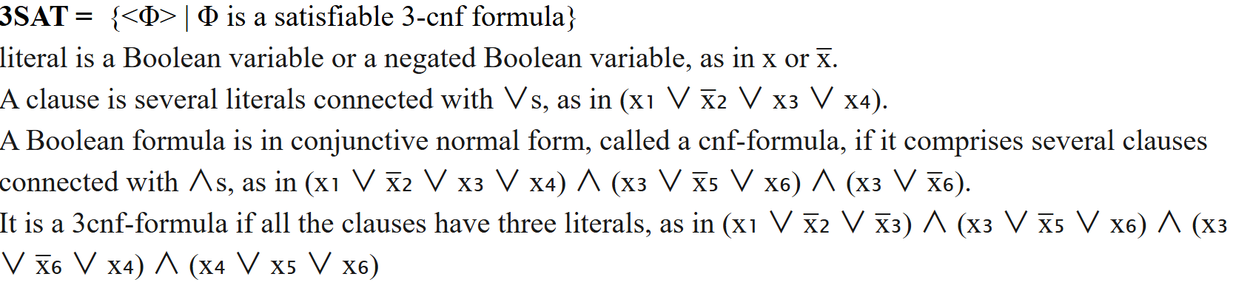

VERTEX-COVER = {<G, k> | G is an undirected graph that has a k-node vertex cover}.
If G is an undirected graph, a vertex cover of G is a subset of the nodes where every edge of G touches one of those nodes. A k-node vertex cover is a vertex cover that contains k nodes.

Computation Histories for a Turing machine
It’s the sequence of configurations that the machine goes through as it processes the input. It is a complete record of the computation of this machine.

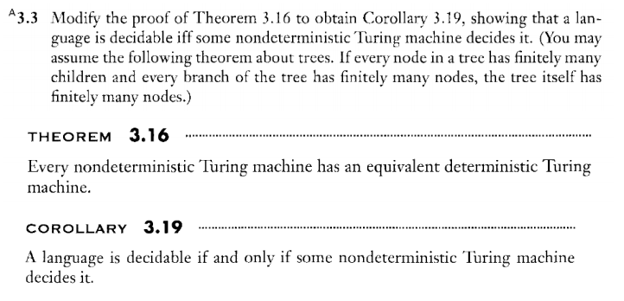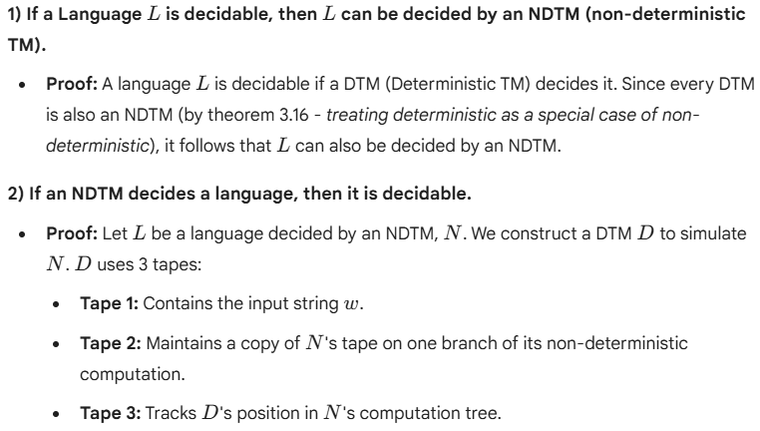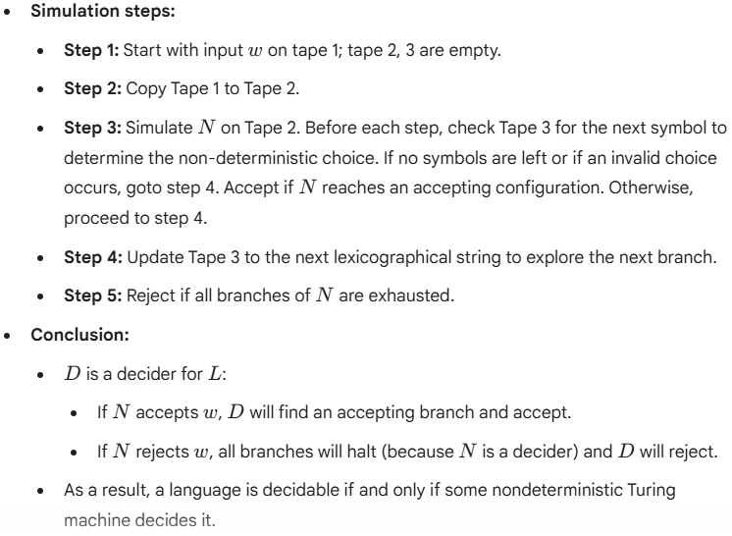

证明：一种语言是可判定的，当且仅当存在某种非确定性图灵机能够判定该语言。
从左向右：DTM 本身就是 NTM 的一种特例，结论自然成立
从右向左：构造一个像上面一样的DTM D2

1. 将磁带 1 复制到磁带 2 上。
2. 在磁带 2上以输入 w 来模拟 N。如果接受，则接受；拒绝则去3
3. 将磁带 3 上的字符串替换为下一条路径。重复步骤2.如果所有分支都已经探索完，
则拒绝（这样保证他是个判定器）

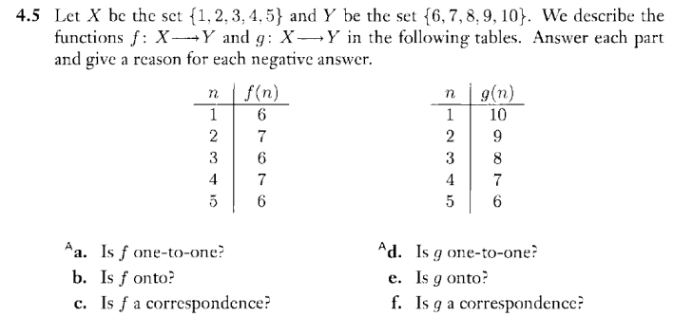

理解了

One 2 one 就是 X 只能有一个Y

Onto 就是 每个Y 至少都有一个X

Correspondence 就是 一对一

