- The boss of the company thought that programmer Lee was very excellent, so he decided to let him have multiple jobs and let him go to PS and test.

Class Diagram :
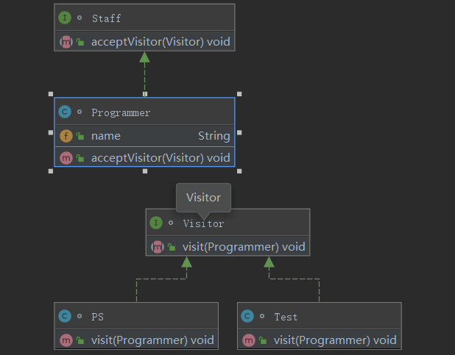
Test code:
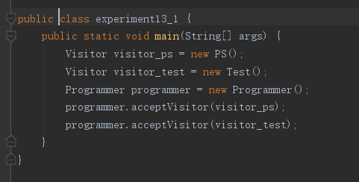

- Lao Wang is a master of animal training. He keeps three animals, a lion, tiger, and horse. One day Lao Wang wants to train his animals to jump and squat.
Class Diagram :
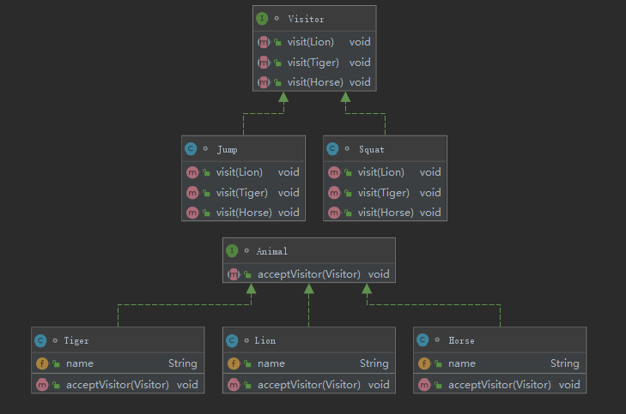
Test code:
