- A software company developed a set of sales management system for a shopping mall. When analyzing and designing the system, the developers found that it was often necessary to traverse the commodity data and customer data in the system. Please use iterator mode to design the sales management system.The UML diagram of the pattern is as follows:
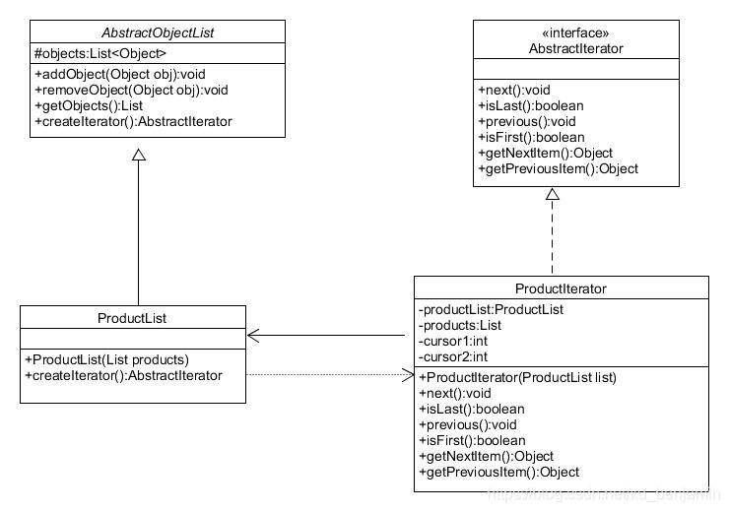
The method and description are shown in the table below:
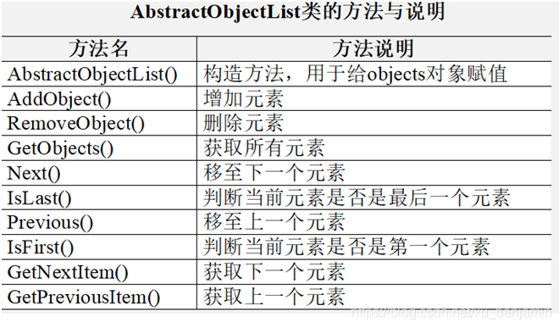

- Suppose the process of exchanging points for gifts depends on three subsystems in a shopping website, including payment subsystem, integral calibration subsystem,logistics subsystem. The functions of these subsystems are deduct points,verify whether the points pass and enter the distribution process respevtively. The name of the facade class is GiftExchangeService,and the name of client program is Test.
（Hint：Use PointsGift as a gift entity)

