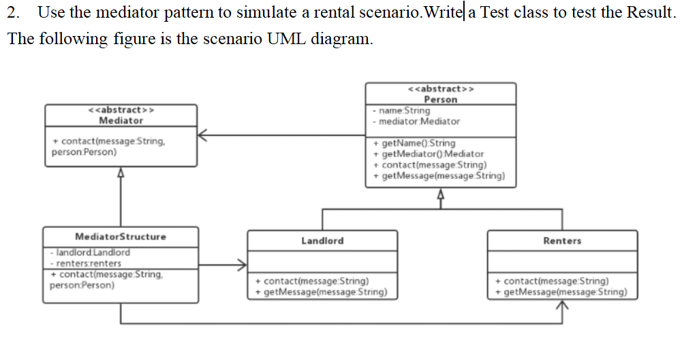
Landlord
package experiment21_2;
class Landlord extends Person{
public Landlord(String name, Mediator mediator){
super(name, mediator);
}
@Override
public void contact(String message) {
System.out.println("Landlord " + name + " sends message: " + message);
mediator.contact(message, this);
}
@Override
public void getMessage(String message) {
System.out.println("Landlord " + name + " gets message: " + message);
}
}
Mediator
package experiment21_2;
abstract class Mediator {
public abstract void contact(String message, Person person);
}
MediatorStructure
package experiment21_2;
class MediatorStructure extends Mediator{
private Landlord landlord;
private Renters renters;
public void setLandlord(Landlord landlord) {
this.landlord = landlord;
}
public void setRenters(Renters renters) {
this.renters = renters;
}
@Override
public void contact(String message, Person person) {
if(person == landlord){
renters.getMessage(message);
}else if(person == renters){
landlord.getMessage(message);
}
}
}
Person
package experiment21_2;
abstract class Person {
protected String name;
protected Mediator mediator;
public Person(String name, Mediator mediator){
this.name = name;
this.mediator = mediator;
}
public String getName(){
return name;
}
public Mediator getMediator(){
return mediator;
}
public abstract void contact(String message);
public abstract void getMessage(String message);
}
Renters
package experiment21_2;
class Renters extends Person{
public Renters(String name, Mediator mediator){
super(name, mediator);
}
@Override
public void contact(String message) {
System.out.println("Renter " + name + " sends message: " + message);
mediator.contact(message, this);
}
@Override
public void getMessage(String message) {
System.out.println("Renter " + name + " gets message: " + message);
}
}
Test
package experiment21_2;
public class Test {
public static void main(String[] args) {
MediatorStructure mediatorStructure = new MediatorStructure();
Landlord landlord = new Landlord("Lucy", mediatorStructure);
Renters renter = new Renters("Jack", mediatorStructure);
mediatorStructure.setLandlord(landlord);
mediatorStructure.setRenters(renter);
renter.contact("I want to rent a house.");
landlord.contact("Ok, 2000 yuan per month");
}
}
Output
