- You need to create a Shape interface and concrete class Circle implementing the Shape interface. A factory class ShapeFactory is defined as a next step. ShapeFactory has a HashMap of Circle having key as color of the Circle object. Whenever a request comes to create a circle of particular color to ShapeFactory, it checks the circle object in its HashMap, if object of Circle found, that object is returned otherwise a new object is created, stored in hashmap for future use, and returned to client. Test class will use ShapeFactory to get a Shape object. It will pass information (red / green / blue/ black / white) to ShapeFactory to get the circle of desired color it needs.
1. 您需要创建一个Shape接口，并定义实现该接口的具体类Circle。下一步将定义工厂类ShapeFactory。ShapeFactory包含一个HashMap，其中Circle对象的键为其颜色属性。当ShapeFactory接收到创建特定颜色圆形的请求时，会检查其HashMap中的圆形对象。若找到Circle对象则直接返回，否则创建新对象并存储在哈希表中以备后续使用，最后将对象返回给客户端。Test类将通过ShapeFactory获取Shape对象，并向其传递颜色信息（红色/绿色/蓝色/黑色/白色）以获取所需颜色的圆形。

Class Diagram :
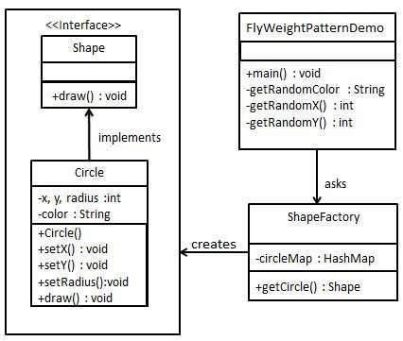
Test code:
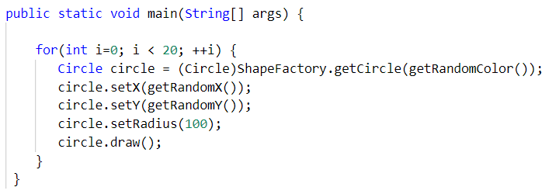

- You need to implement the creation of Terrorists and Counter Terrorists in the game. So we have 2 classes one for Terrorist(T) and other for Counter Terrorist(CT). Whenever a player asks for a weapon we assign him the asked weapon. In the mission, terrorist’s task is to plant a bomb while the counter terrorists have to diffuse the bomb. Here ‘task’ is an intrinsic state for both types of players, since this is always same for T’s/CT’s. Weapon is an extrinsic state since each player can carry any weapon of his/her choice which needs to be passed as a parameter by the client itself.

1. 您需要在游戏中实现恐怖分子与反恐部队的创建机制。因此我们设置两个角色类：恐怖分子（T）和反恐部队（CT）。当玩家请求武器时，系统将分配其指定的武器。在任务中，恐怖分子的目标是放置炸弹，而反恐部队则需拆除炸弹。此处“任务”属于玩家的内在状态，因其对T/CT始终固定不变。武器则属于外在状态，因每位玩家可携带任意自选武器，该武器需由客户端作为参数传递。

Class Diagram :
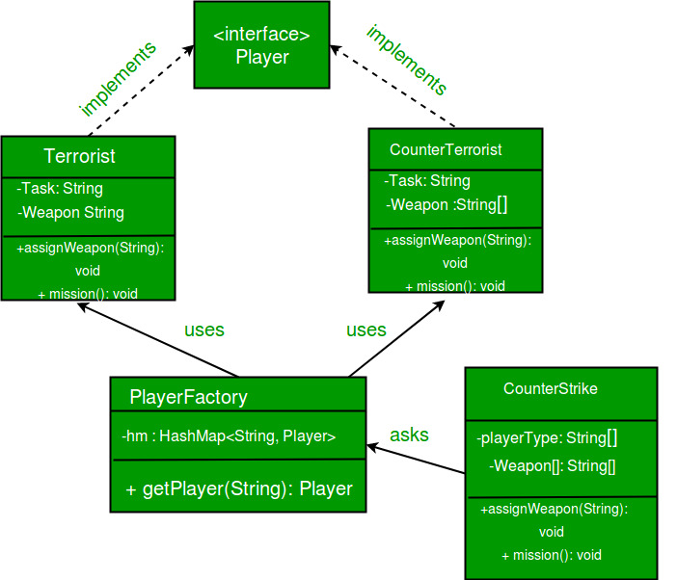
Test code:
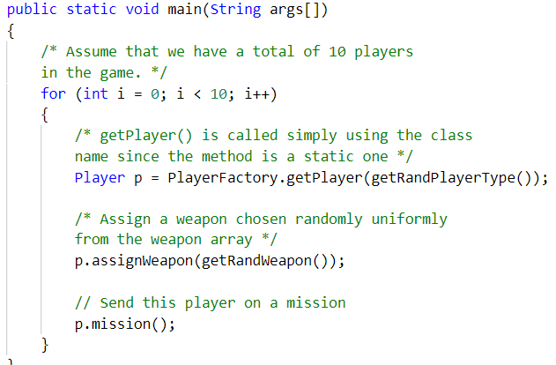
Hint: Here we use the Fly Weight design pattern, since here we need to reduce the object count for players. Now we have n number of players playing, if we do not follow the Flyweight Design Pattern then we will have to create n number of objects, one for each player. But now we will only have to create 2 objects one for terrorists and other for counter terrorists, we will reuse then again and again whenever required.

