- You need to create a Shape interface and concrete class Circle implementing the Shape interface. A factory class ShapeFactory is defined as a next step. ShapeFactory has a HashMap of Circle having key as color of the Circle object. Whenever a request comes to create a circle of particular color to ShapeFactory, it checks the circle object in its HashMap, if object of Circle found, that object is returned otherwise a new object is created, stored in hashmap for future use, and returned to client. Test class will use ShapeFactory to get a Shape object. It will pass information (red / green / blue/ black / white) to ShapeFactory to get the circle of desired color it needs.
Class Diagram :
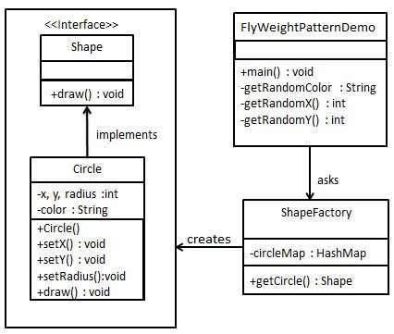
Test code:
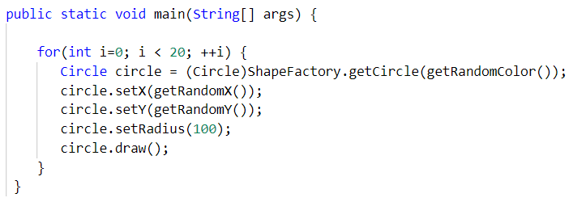

- You need to implement the creation of Terrorists and Counter Terrorists in the game. So we have 2 classes one for Terrorist(T) and other for Counter Terrorist(CT). Whenever a player asks for a weapon we assign him the asked weapon. In the mission, terrorist’s task is to plant a bomb while the counter terrorists have to diffuse the bomb. Here ‘task’ is an intrinsic state for both types of players, since this is always same for T’s/CT’s. Weapon is an extrinsic state since each player can carry any weapon of his/her choice which needs to be passed as a parameter by the client itself.
Class Diagram :
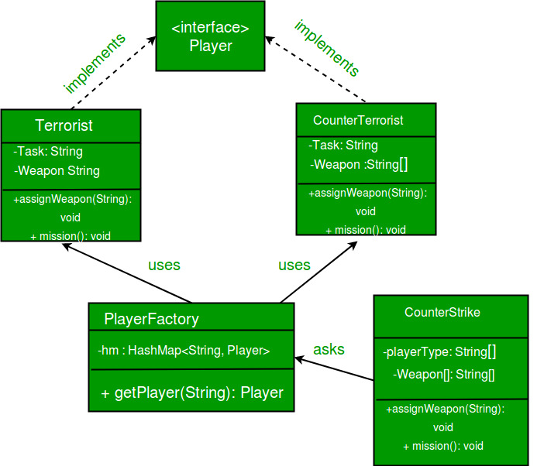
Test code:
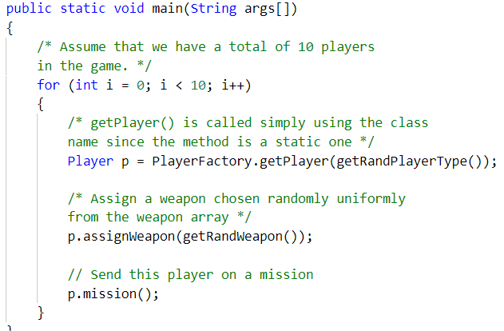
Hint: Here we use the Fly Weight design pattern, since here we need to reduce the object count for players. Now we have n number of players playing, if we do not follow the Flyweight Design Pattern then we will have to create n number of objects, one for each player. But now we will only have to create 2 objects one for terrorists and other for counter terrorists, we will reuse then again and again whenever required.

