- The following figure describes the relationship between the headquarter, branches, and departments in large enterprises. When the headquarters issues a notice, it needs to go through each branch to reach each sub-department. This structure is similar to the tree structure:

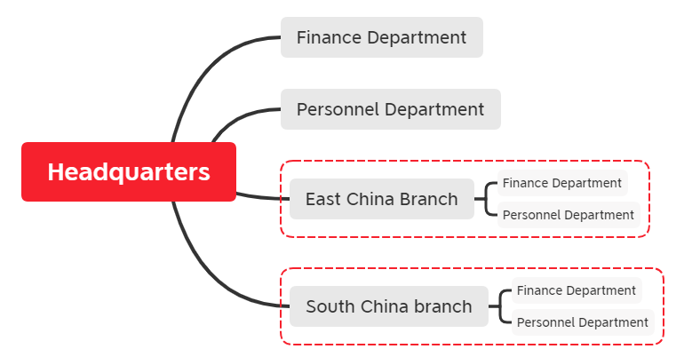
After careful observation of the above tree organization chart, it is found that it should look like the following after simplification:
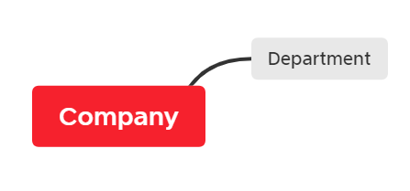
The company and department here should be two different manifestations of a class, so they can be abstracted as an abstract class Unit. Take Unit as the abstract class, Headquarters as the company class and Department as the department class.
Please write the code to implement the pattern.
UML diagram:
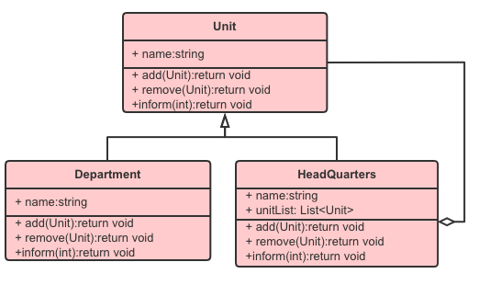

- Write a program to display the department structure of a school: the demand is that the Department composition of the school should be displayed on one page. A school has multiple colleges and a college has multiple departments. As shown in the figure:
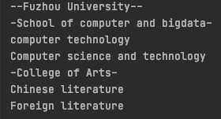
Please use Composite Pattern to realize the above demand.
TestClass：
package ex2;
public class Client {
public static void main(String[] args) {
OrganizationComponent university = new University("--Fuzhou University--", "211");

OrganizationComponent college = new College("-School of computer and bigdata-", "Computer related major");
OrganizationComponent college2 = new College("-College of Arts-", "Literature and history major");

college.add(new Department("computer technology","Specialized master"));
college.add(new Department("Computer science and technology","Academic master"));

college2.add(new Department("Chinese literature","traditional culture"));
college2.add(new Department("Foreign literature","Foreign culture"));

university.add(college);
university.add(college2);

university.print();
}
}

