832303206
陈竟镗
- Give the statement of Rice’s Theorem.
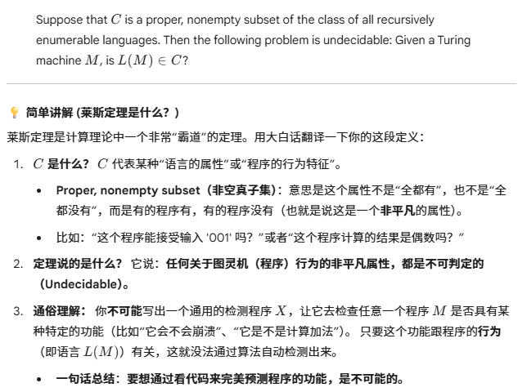
- Prove Rice’s Theorem (you can use the recursion theorem).

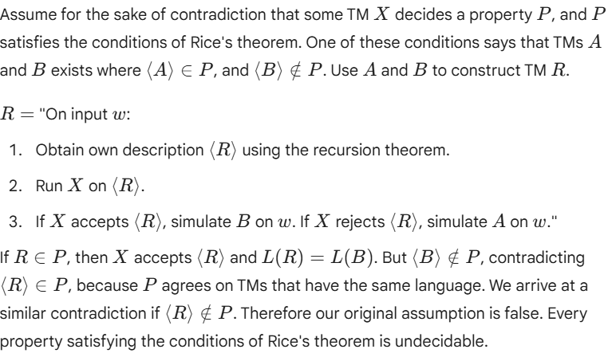
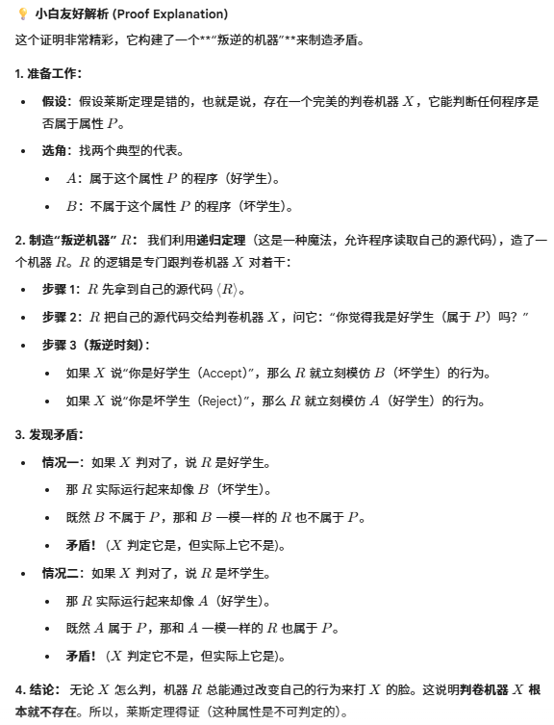
(3) Use Rice’s theorem to show that: C is a proper, nonempty subset of the class of all recursively
enumerable languages. Then the following problem is undecidable: Given a Turing machine M, is
L(M) ∊C?
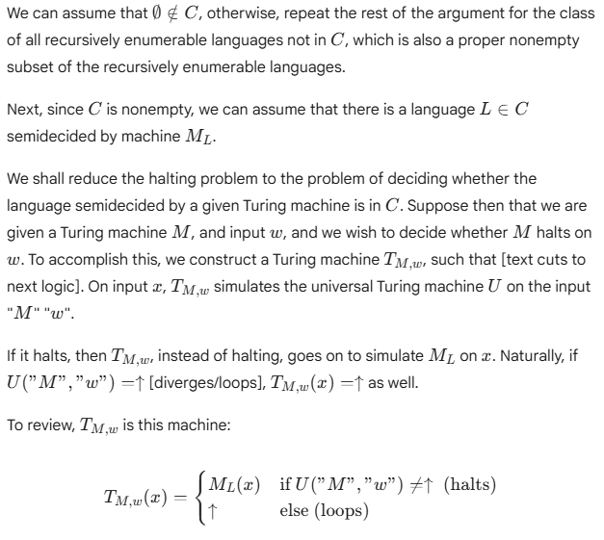
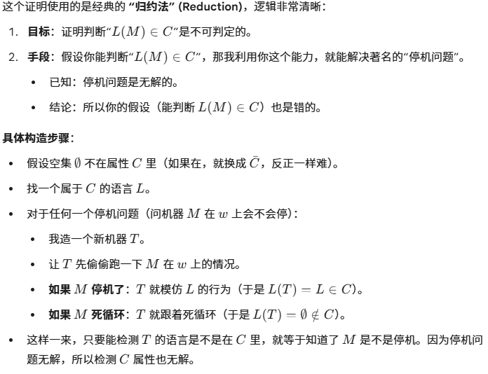
(4) Give self-contained definitions of the following concept: an oracle TM, and Language A is
Turing reducible to language B.

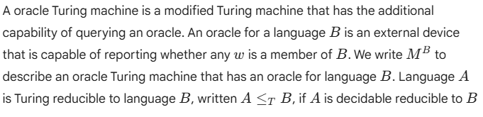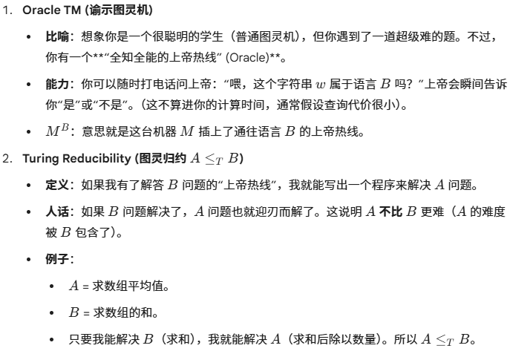
- Show that ETM <=T ATM
