

SEMESTER 1
2021-2022

CS370FZ

Computation and Complexity
Dr. Niu Yuzhen, Dr. J. Timoney, Dr. M. Huggard Time allowed: 2 hours
Answer all three questions

All three questions carry equal marks

Instructions

 | Yes | No
Log Books Allowed |  | ✓
Formula Tables Allowed |  | - ”
Other Allowed (enter details) |  | - ”

General (enter details)
[25 marks]
1
(a) | Give self-contained definitions of the following languages/sets: ATM  (the acceptance problem), HaltTM (the halting problem), and TM M decides Language L. | [9 marks]
(b)  (c) | Show that ATM is recognizable (construct a recognizer for it).  Show that ATM is undecidable. (You are required to use the diagonalization technique) | [4 marks]  [8 marks]
(d) | Is 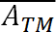 recognizable? Explain your answer. | [4 marks]

[25 marks]
2
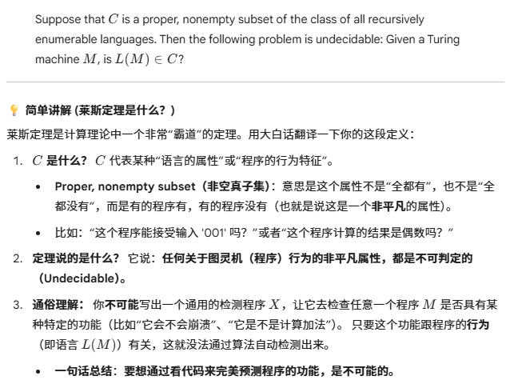(a) | Give the statement of Rice’s Theorem. | [5 marks]
(b)  (c)  (d) | Prove Rice’s Theorem (you can use the recursion theorem).  Give the definitions of the following concepts: (1) Language A is mapping reducible to language B. (2) Language A is Turing reducible to language B.  Show that ATM ≤m HALTTM. | [8 marks]  [6 marks]  [6 marks]

[25 marks]
3
(a) | Give the definitions of the following classes: Class P and Class NP. | [4 marks]
(b)  (c)  (d) | Give the definitions of the following sets: PATH, SAT, and CLIQUE. Your definition should be self-contained (e.g. for CLIQUE, explain what a k-clique is).  Show that CLIQUE is in NP (give a verifier or a nondeterministic polynomial time Turing machine that decides CLIQUE).  Recall the proof 3SAT is polynomial time mapping reducible to VERTEX-COVER (3SAT≤P VERTEX-COVER). From the following ϕ construct the associated graph G. Explain how to obtain an 8-vertex- cover for G from a satisfying assignment for ϕ. | [6 marks]  [5 marks]  [10 marks]

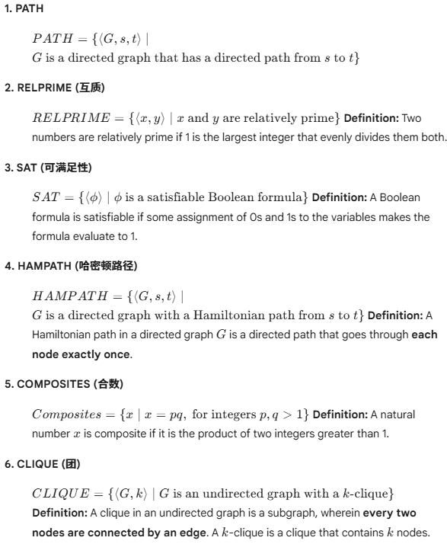

2
(A)


(B)
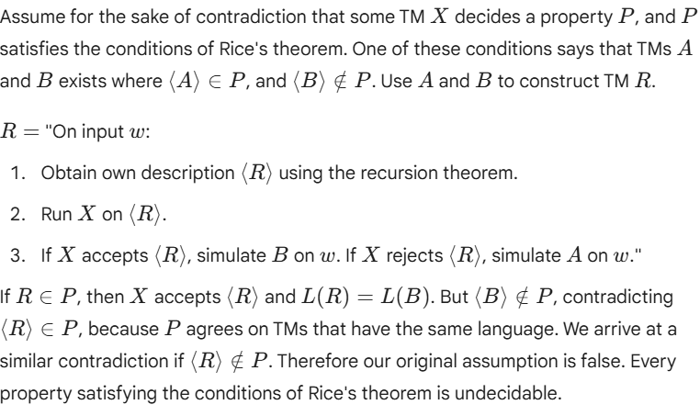

(C)

(1)
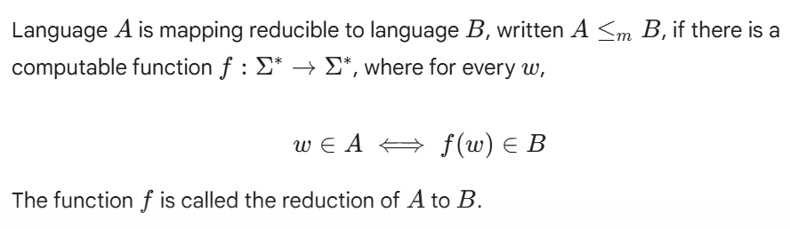

(2)
Language A is Turing reducible to B written as A<= TB,if A is decidable reducible to B

(D)

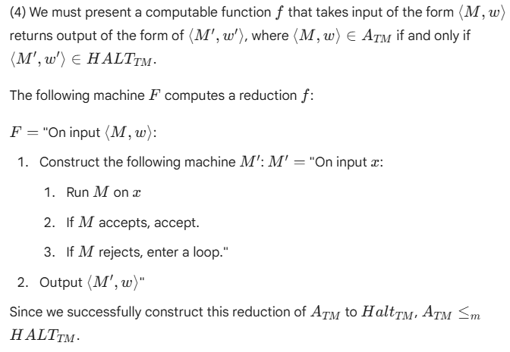

<MODULE CODE> Page 1 of 1 <EXAM PERIOD>

