- Lee, an employee of the company, wants to buy a Mac laptop. This matter needs the approval of leaders. Each leader has different authorities, and the maximum amount that can be approved is limited. Lee first applied to the group leader, but because the amount was too large, it exceeded the approval authority of the group leader. So the group leader went to his leader, the Department Manager. But the Department Manager still doesn't have enough power. So the Department Manager found the CFO, who had enough power to pass the application. Finally, Lee received a grant to buy a Mac laptop. (note: The amount approved by the group leader is within 1000, the amount approved by the Department Manager is within 10000, the amount approved by the CFO is within 50000, and the price of the computer purchased by Lee is 11000)
Class diagram:
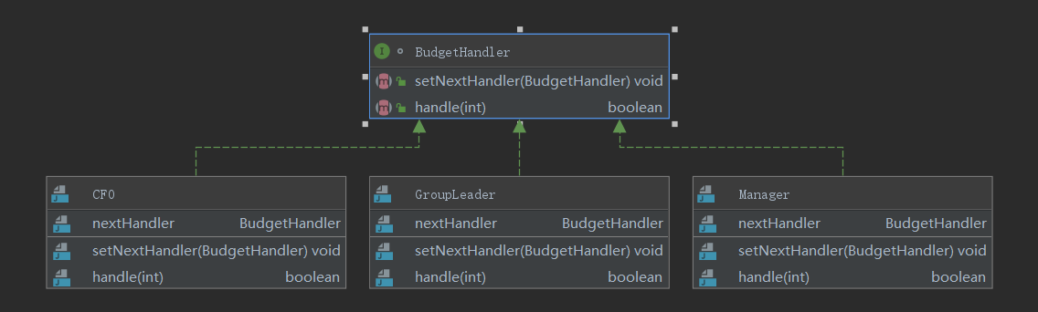
Test code:
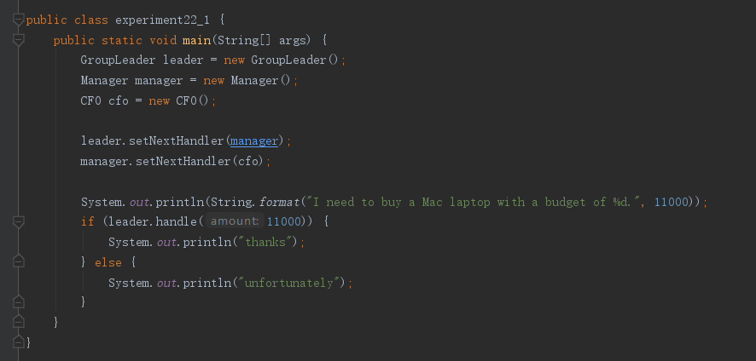
- Simulate the following scenario: the programmer submits the function to the tester. When the tester thinks there is no problem, he submits it to the technical director. When the technical director thinks there is no problem, he will notify the boss. After the boss is satisfied, the function can be online. the handle() method can be written like this:
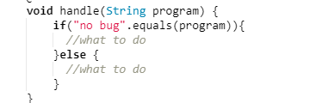
Please use the simple descriptive output to make the program clearer.
Class diagram:
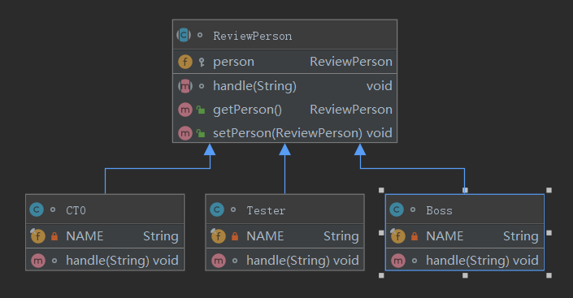
Test code:
