- Suppose that there are two mobile phone brands, A and B. Each brand has its own software, address list and game. The run() function needs to output descriptive statements, such as A/B brand mobile phone or running a game/address list. You can use interfaces or abstract classes.
Class Diagram :
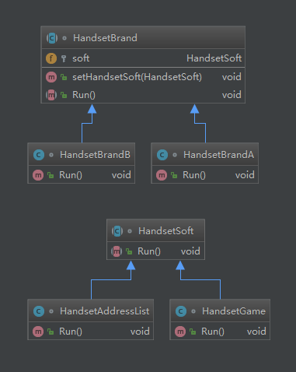
Test code:
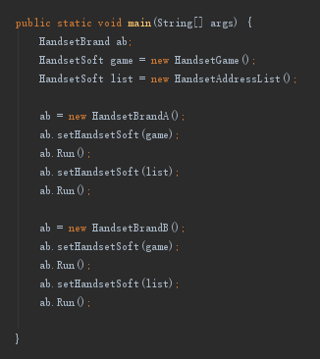
- Suppose that the implementation sends common, urgent, and special urgent messages in different forms. Forms include email and SMS. You can use interfaces or abstract classes. The send() function can be written as follows:
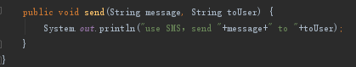
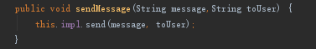
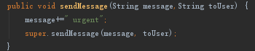
Class Diagram :
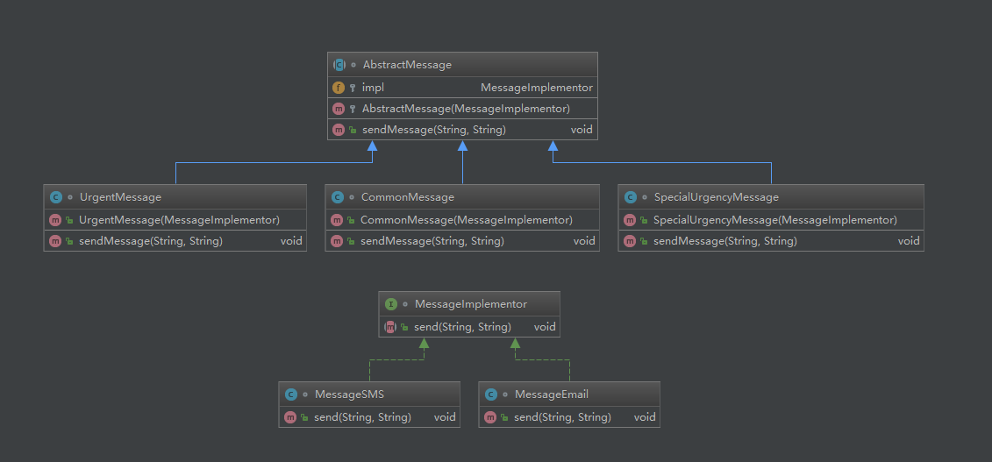
Test code:
