- A software company developed a set of sales management system for a shopping mall. When analyzing and designing the system, the developers found that it was often necessary to traverse the commodity data and customer data in the system. Please use iterator mode to design the sales management system.The UML diagram of the pattern is as follows:
1、一家软件公司为一家购物中心开发了一套销售管理系统。在对该系统进行分析和设计时，开发人员发现经常需要遍历系统中的商品数据和客户数据。请使用迭代器模式来设计该销售管理系统。该模式的 UML 图如下所示：
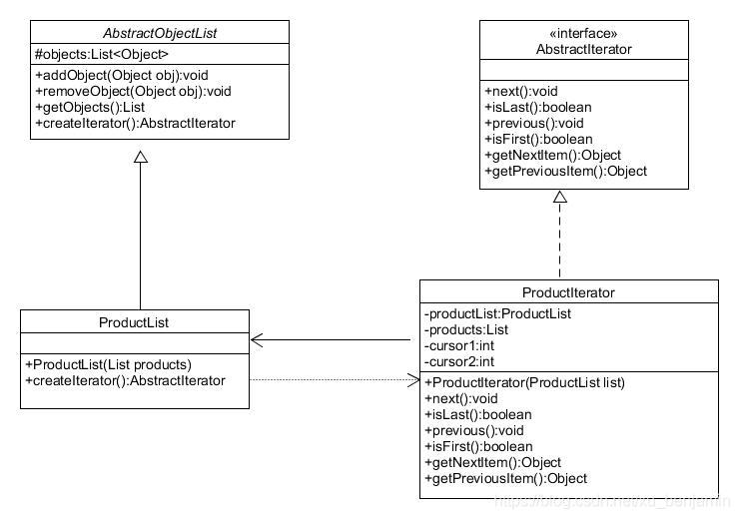
The method and description are shown in the table below:
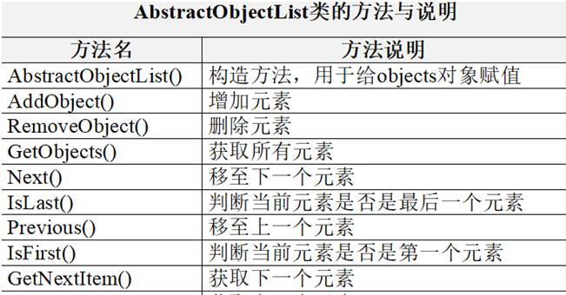

- Suppose we are developing a music playlist application. The application has a playlist that contains multiple music tracks. We want to implement the functionality to iterate over the tracks in the playlist, allowing users to play each track one by one, skip tracks, and get the current track information. The playlist has three main components: the MusicPlaylist class which manages the collection of tracks, the Track class representing each individual music track with properties like title, artist, and duration, and the MusicPlaylistIterator class which is the iterator for traversing the playlist. The client program is named PlaylistTester.
（Hint：The MusicPlaylistIterator should provide methods such as hasNext() to check if there is a next track, next() to move to the next track and return it, and reset() to start the iteration from the beginning. The MusicPlaylist class should have methods to add tracks and get the iterator.）

2.假设我们正在开发一个音乐播放列表应用程序。该应用程序有一个包含多个音乐曲目的播放列表。我们想要实现这样的功能：遍历播放列表中的曲目，让用户逐个播放每首曲目、跳过曲目，并获取当前曲目的信息。播放列表有三个主要组成部分：MusicPlaylist 类用于管理曲目的集合，Track 类用于表示每个单独的音乐曲目，具有诸如标题、艺术家和时长等属性，以及 MusicPlaylistIterator 类作为遍历播放列表的迭代器。客户端程序名为 PlaylistTester。
（提示：MusicPlaylistIterator 应该提供诸如 hasNext() 以检查是否有下一个曲目、next() 以移动到下一个曲目并返回它，以及 reset() 以从开头开始迭代等方法。MusicPlaylist 类应该具有添加曲目和获取迭代器的方法。）

