- You need to create a Shape interface and concrete class Circle implementing the Shape interface. A factory class ShapeFactory is defined as a next step. ShapeFactory has a HashMap of Circle having key as color of the Circle object. Whenever a request comes to create a circle of particular color to ShapeFactory, it checks the circle object in its HashMap, if object of Circle found, that object is returned otherwise a new object is created, stored in hashmap for future use, and returned to client. Test class will use ShapeFactory to get a Shape object. It will pass information (red / green / blue/ black / white) to ShapeFactory to get the circle of desired color it needs.

1.您需要创建一个“Shape”接口以及一个实现该接口的具体类“Circle”。接下来定义一个工厂类“ShapeFactory”。ShapeFactory 包含一个“HashMap”，其中颜色作为键，键的值为“Circle”对象。每当有请求要求“ShapeFactory”创建具有特定颜色的圆时，它会检查其“HashMap”中的圆对象，如果找到了“Circle”对象，则返回该对象，否则会创建一个新的对象，将其存储在“HashMap”中以备将来使用，并返回给客户端。测试类将使用“ShapeFactory”来获取一个“Shape”对象。它会向“ShapeFactory”传递信息（红色/绿色/蓝色/黑色/白色），以获取所需颜色的圆。
Class Diagram :
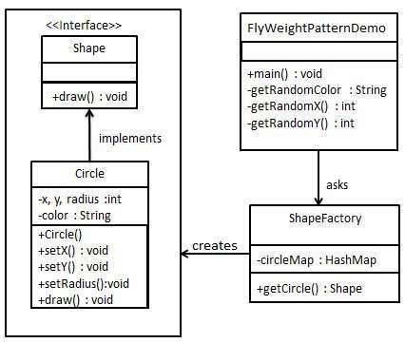
Test code:
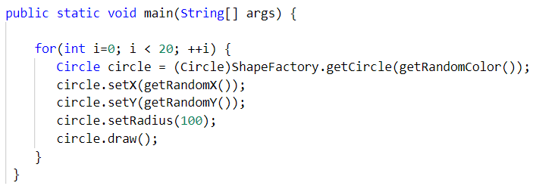

- You need to implement the creation of Terrorists and Counter Terrorists in the game. So we have 2 classes one for Terrorist(T) and other for Counter Terrorist(CT). Whenever a player asks for a weapon we assign him the asked weapon. In the mission, terrorist’s task is to plant a bomb while the counter terrorists have to diffuse the bomb. Here ‘task’ is an intrinsic state for both types of players, since this is always same for T’s/CT’s. Weapon is an extrinsic state since each player can carry any weapon of his/her choice which needs to be passed as a parameter by the client itself.
2.您需要在游戏中实现恐怖分子和反恐人员的设定。因此，我们有两类角色，一类是恐怖分子（T），另一类是反恐人员（CT）。每当玩家要求获得武器时，我们就为其分配所要求的武器。在任务中，恐怖分子的任务是放置炸弹，而反恐人员则需要拆除炸弹。这里的“任务”对于这两种类型的玩家来说都是内在状态，因为这对恐怖分子和反恐人员来说始终是相同的。武器则是外在状态，因为每个玩家都可以携带自己选择的任何武器，而这些武器需要由客户端自行作为参数传递给系统。
Class Diagram :
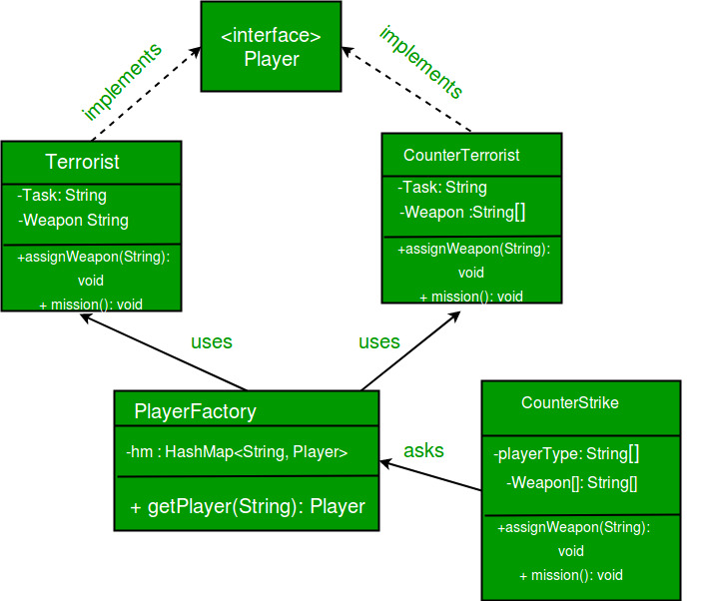
Test code:
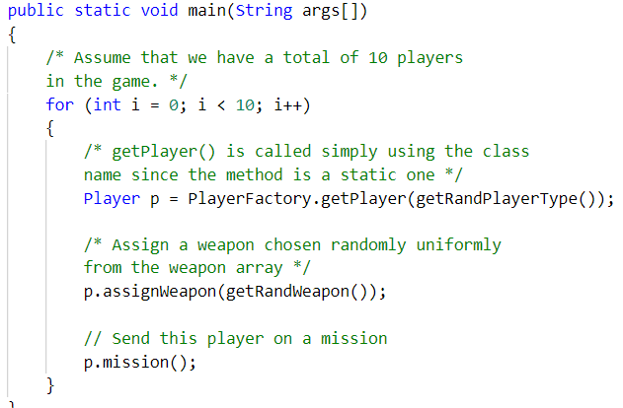
Hint: Here we use the Fly Weight design pattern, since here we need to reduce the object count for players. Now we have n number of players playing, if we do not follow the Flyweight Design Pattern then we will have to create n number of objects, one for each player. But now we will only have to create 2 objects one for terrorists and other for counter terrorists, we will reuse then again and again whenever required.

