ex1:Change the background color of the page below to yellow, name the html file as agn1_ex1.html;

<!DOCTYPE html>
<html>
<head>
<style>
body {background-color:lightgrey}
h1 {color:blue}
p {color:black}
</style>
</head>
<body>
<h1>This is a Heading</h1>
<p>This is a paragraph.</p>
</body>
</html>

Answer：
<!DOCTYPE html>
<html>
<head>
<style>
body {background-color:yellow}
h1 {color:blue}
p {color:black}
</style>
</head>
<body>
<h1>This is a Heading</h1>
<p>This is a paragraph.</p>
</body>
</html>
Result:
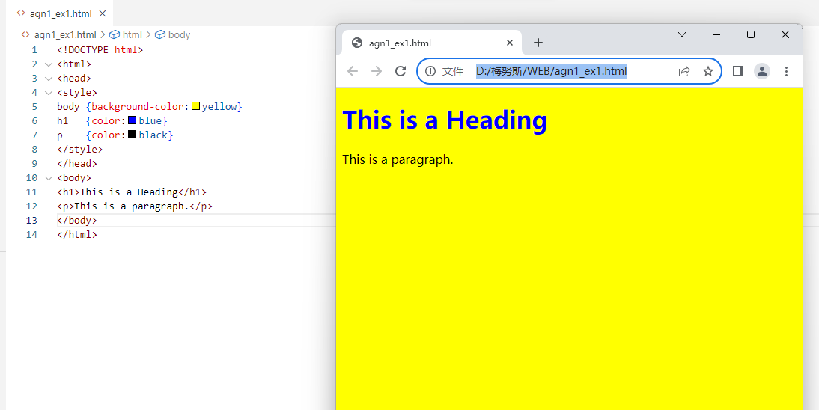

ex2:Change the font of both the h1 and the p element to "courier". name the html file as agn1_ex2.html;

<!DOCTYPE html>
<html>
<head>
<style>
body {background-color:lightgrey}
h1 {color:blue}
p {color:black}
</style>
</head>
<body>
<h1>This is a Heading</h1>
<p>This is a paragraph.</p>
</body>
</html>

Answer：

<!DOCTYPE html>
<html>
<head>
<style>
body {
background-color: lightgrey;
}
h1 {
color: blue;
font-family: "Courier", monospace;
}
p {
color: black;
font-family: "Courier", monospace;
}
</style>
</head>
<body>
<h1>This is a Heading</h1>
<p>This is a paragraph.</p>
</body>
</html>
Result:

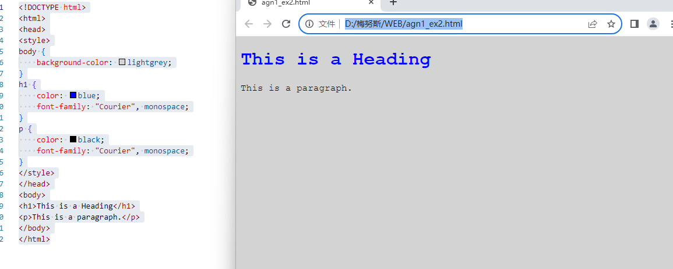

ex3:Change the color of all paragraphs in the page below. name the html file as agn1_ex3.html;

<!DOCTYPE html>
<html>
<head>
<style>
body {background-color:lightgrey;color=yellow}
</style>
</head>
<body>
<h1>This is a Heading</h1>
<p>This is a paragraph.</p>
<p>This is also paragraph.</p>
<p>This is a third paragraph.</p>
</body>
</html>

Answer：

<!DOCTYPE html>
<html>
<head>
<style>
body {background-color:lightgrey}
p {color:red} /* Changed color to red for all paragraphs */
</style>
</head>
<body>
<h1>This is a Heading</h1>
<p>This is a paragraph.</p>
<p>This is also paragraph.</p>
<p>This is a third paragraph.</p>
</body>
</html>
Result:

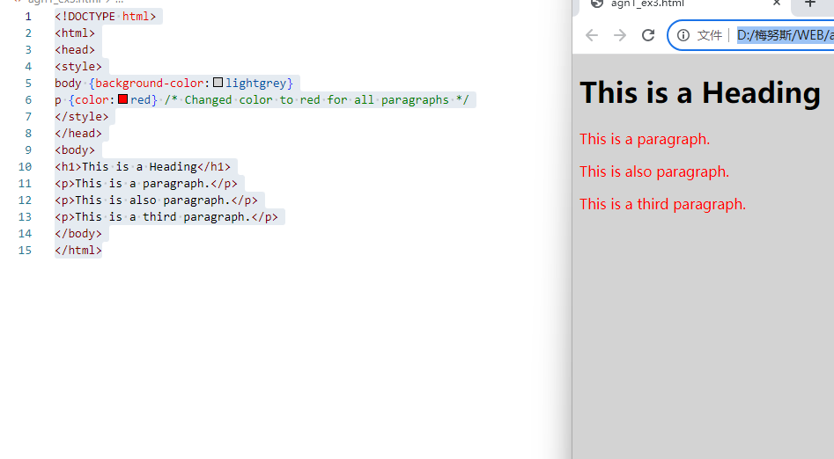

ex4:Add a red border to all paragraphs; name the html file as agn1_ex4.html;

<!DOCTYPE html>
<html>
<head>
<style>
body {background-color:lightgrey}
h1 {color:blue}
p {color:black}
</style>
</head>
<body>
<h1>This is a Heading</h1>
<p>This is a paragraph.</p>
<p>This is a paragraph.</p>
<p>This is a paragraph.</p>
<p>This is a paragraph.</p>
</body>
</html>

Answer：

<!DOCTYPE html>
<html>
<head>
<style>
body {background-color:lightgrey}
h1 {color:blue}
p {color:black; border: 2px solid red;} /* Added red border */
</style>
</head>
<body>
<h1>This is a Heading</h1>
<p>This is a paragraph.</p>
<p>This is a paragraph.</p>
<p>This is a paragraph.</p>
<p>This is a paragraph.</p>
</body>
</html>
Result:

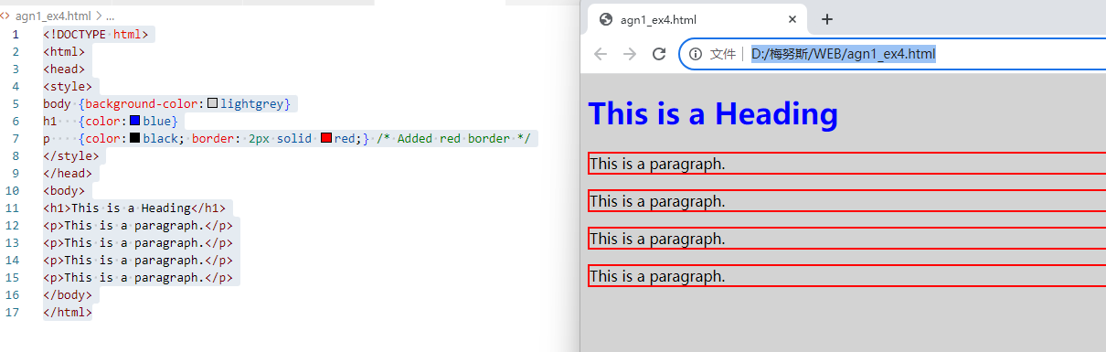

ex5:Add an id with the value "special" to the last paragraph. name the html file as agn1_ex5.html;

<!DOCTYPE html>
<html>
<head>
<style>
p#special {
background-color:black;
color:white;
}
</style>

</head>
<body>
<h1>This is a heading</h1>
<p>This is a paragraph.</p>
<p>This is also paragraph.</p>
<p>I want to be a special paragraph!</p>
</body>
</html>
Answer：

<!DOCTYPE html>
<html>
<head>
<style>
p#special {
background-color:black;
color:white;
}
</style>
</head>
<body>
<h1>This is a heading</h1>
<p>This is a paragraph.</p>
<p>This is also paragraph.</p>
<p id="special">I want to be a special paragraph!</p> <!-- Added id="special" -->
</body>
</html>
Result:

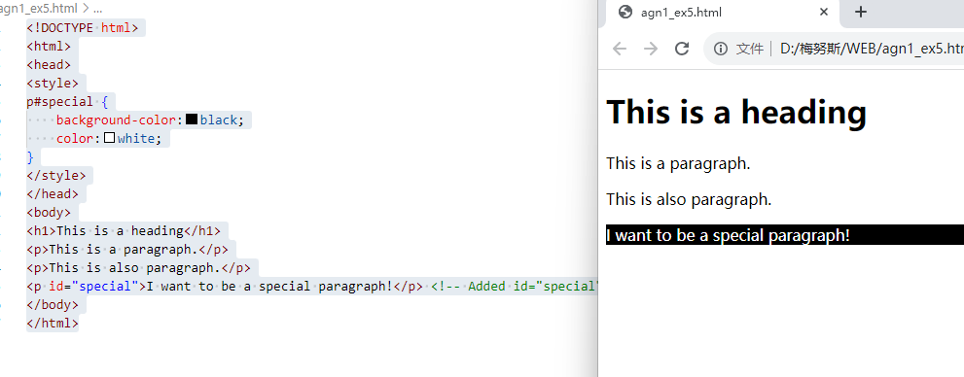

ex6:Add the "intro" class to all <p> elements. name the html file as agn1_ex6.html;

<!DOCTYPE html>
<html>
<head>
<style>
p.intro {
background-color:black;
color:white;
border:1px solid grey;
padding:10px;
margin:30px;
font-size:150%;
}
</style>
</head>
<body>
<h1>This is a heading</h1>
<p>This is a paragraph.</p>
<p>This is a paragraph.</p>
<p>This is a paragraph.</p>
</body>
</html>

Answer：

<!DOCTYPE html>
<html>
<head>
<style>
p.intro {
background-color:black;
color:white;
border:1px solid grey;
padding:10px;
margin:30px;
font-size:150%;
}
</style>
</head>
<body>
<h1>This is a heading</h1>
<p class="intro">This is a paragraph.</p> <!-- Added class="intro" -->
<p class="intro">This is a paragraph.</p> <!-- Added class="intro" -->
<p class="intro">This is a paragraph.</p> <!-- Added class="intro" -->
</body>
</html>

Result:

