ex1: add some codes to the following html file that shows a table, the background color of this table is black, the text color is white,
the text in the table cell is left aligned, the padding between table cells is 5 pixels. the border is 1 px solid black.
(the table is shown in the image file table.png). name the html file as agn4.ex1.html

<!DOCTYPE html>
<html>
<head>
<style>
table, th, td {

}
tr {

}
</style>

</head>
<body>

<table style="width:100%">
<tr>
</tr>
<tr>
</tr>
<tr>
</tr>
</table>

</body>
</html>
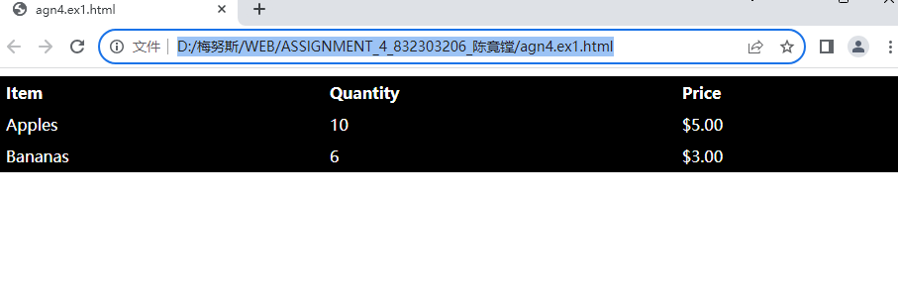

Ex2: Add a list item with the text "Coffee" inside <ul>. name the html file as agn4_ex2.html

<!DOCTYPE html>
<html>
<body>

<ul>
</ul>

</body>
</html>
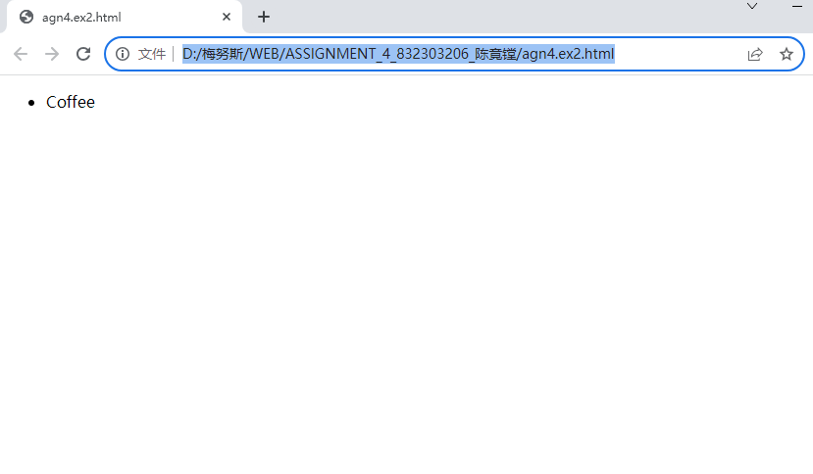
Ex3:Change the list below to an ordered list. name the html file as agn4_ex3.html
<!DOCTYPE html>
<html>
<body>

<ul>
<li>Coffee</li>
<li>Tea</li>
<li>Milk</li>
</ul>

</body>
</html>
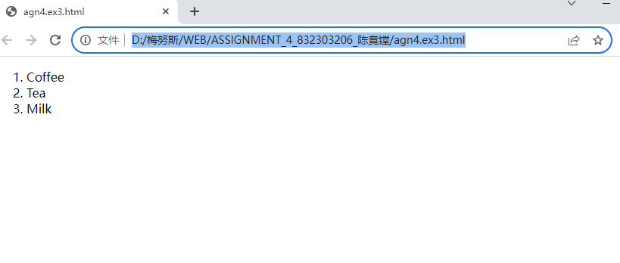
Ex4:Change the list below to display squares instead of bullets. name the html file as agn4_ex4.html

<!DOCTYPE html>
<html>
<body>

<ul>
<li>Coffee</li>
<li>Tea</li>
<li>Milk</li>
</ul>

</body>
</html>

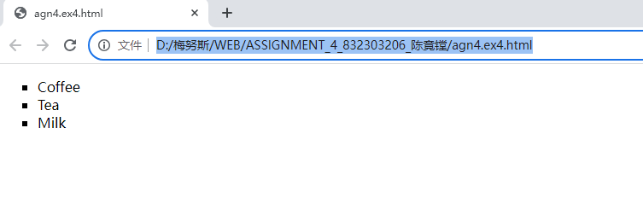

Ex5: Change the list below to display letters instead of numbers. name the html file as agn4_ex5.html
<!DOCTYPE html>
<html>
<body>

<ol>
<li>Coffee</li>
<li>Tea</li>
<li>Milk</li>
</ol>

</body>
</html>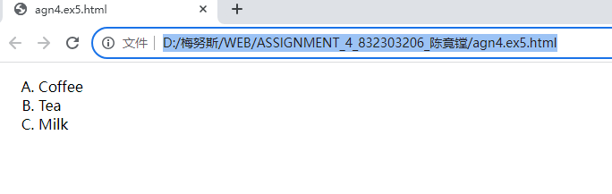

Ex6: Make the list below display horizontally. name the html file as agn4_ex6.html
<!DOCTYPE html>
<html>
<head>
<style>
ul#menu li {
display:inline;
}
</style>

</head>
<body>

<ul>
<li>Apples</li>
<li>Bananas</li>
<li>Lemons</li>
<li>Oranges</li>
</ul>

</body>
</html>

