ex1: make a HTML form,
add 2 radio buttons to the form. One for "male", and one for "female", both with name="gender",
add an input element with type=text and name = "name",
add a drop down list with name="cars" to the form. Include the following options: "volvo", "ford", "fiat", and "audi".
add a text area with name="note" to the form,
add a button, set the display text of the <button> to: "Click Me!", and add the onclick event for this button, which will show a messagebox with "hello world" when it is clicked,
add a submit button to the form, and specify that the form should go to "action_page.html" (hint: create an empty html file to simulate),
specify that the form is submitted using the "post" method.
name the file as agn5_ex1.html;

<!DOCTYPE html>
<html lang="en">
<head>
<meta charset="UTF-8">
<title>agn5_ex1.html</title>
</head>
<body>
<form action="action_page.html" method="post">
<!-- 性别单选 -->
<p>
Gender:
<input type="radio" id="male" name="gender" value="male">
<label for="male">Male</label>
<input type="radio" id="female" name="gender" value="female">
<label for="female">Female</label>
</p>

<!-- 文本输入 -->
<p>
Name:
<input type="text" name="name">
</p>

<!-- 下拉列表 -->
<p>
Select a car:
<select name="cars">
<option value="volvo">Volvo</option>
<option value="ford">Ford</option>
<option value="fiat">Fiat</option>
<option value="audi">Audi</option>
</select>
</p>

<!-- 多行文本 -->
<p>
Note:
<textarea name="note" rows="4" cols="50"></textarea>
</p>

<!-- 普通按钮 -->
<p>
<button type="button" onclick="alert('hello world');">
Click Me!
</button>
</p>

<!-- 提交按钮 -->
<p>
<input type="submit" value="Submit">
</p>
</form>
</body>
</html>

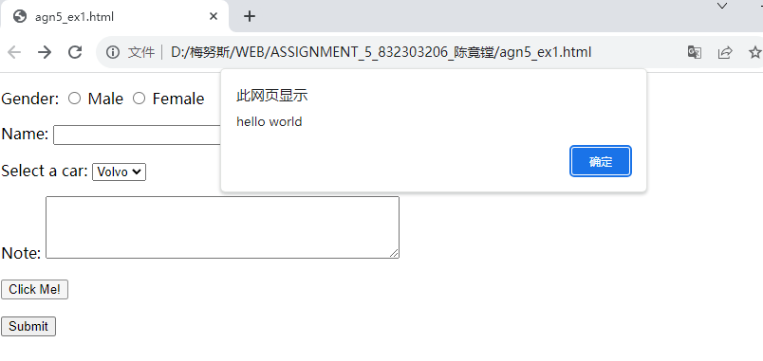
ex2:
create an input field for text.
create two radio buttons and place them inside the form element, under the text "Favorite color".
add the name attribute with a value of "color" to both radio buttons.
also add a value attribute and specify "blue" for the first and "red" for the second.
lastly, specify some text that corresponds with the values.
create an input field that should only contain a numeric value, and place it inside the <form> element.
add the name attribute with a value of "quantity" to the input element.
set restrictions on the input field to only accept numbers between 1 and 5.
create a submit button and place it inside the form element,
specify that the form should go to "action_page.html"
name the html file as agn5_ex2.html.

<!DOCTYPE html>
<html lang="en">
<head>
<meta charset="UTF-8">
<title>agn5_ex2.html</title>
</head>
<body>
<form action="action_page.html">
<!-- 文本输入字段 -->
<p>
Enter text:
<input type="text" name="textfield">
</p>

<!-- 单选按钮：Favorite color -->
<p>Favorite color:</p>
<p>
<input type="radio" id="color_blue" name="color" value="blue">
<label for="color_blue">Blue</label>
<input type="radio" id="color_red" name="color" value="red">
<label for="color_red">Red</label>
</p>

<!-- 数值输入字段（只接受 1–5 之间的数字） -->
<p>
Quantity (1–5):
<input type="number" name="quantity" min="1" max="5">
</p>

<!-- 提交按钮 -->
<p>
<input type="submit" value="Submit">
</p>
</form>
</body>
</html>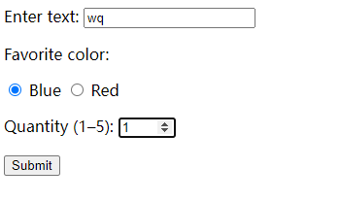
ex3:
Specify an initial value of "John" for the input field.
Disable the input field.
Change the size of the input field to display up to 40 characters.
name the html file as agn5_ex3.html.
<!DOCTYPE html>
<html>
<head>
<title>agn5_ex3.html</title>
</head>
<body>

<form action="action_page.php">
First name:
<input type="text" name="firstname" value="John" disabled size="40">
<input type="submit">
</form>

</body>
</html>
