CS240FZ Class Test 1 2024
Solutions
A1. a) i) Microsoft MS-DOS, Windows
ii) Google Chrome, Android
iii) Huawei Harmony OS
iv) Apple MacOS, iOS
v) Bell Labs Unix
vi) Canonical Ubuntu
vii) SUN Solaris
viii) DEC VMS
ix) Xiaomi HyperOS, MIUI
x) Linus Torvalds Linux
b) The Kernel of an operating system refers to the core set of services associated with managing the CPU, the electrical memory, basic inter-process communication and low-level hardware devices.
c) i) File System ii) Database Engine iii) Network Communication Suite
iv) Graphics and Media functions v) Web Server
vi) User Interface GUI vii) Security and Authentication elements
viii) Device Drivers

A2) a) i) A computer program file, whether written in assembly or high-level language, will be readable by humans, as they use commands that closely resemble English words. An executable file consists of strings of 1’s and 0’s that instruct the CPU what to do, and will not be easily understood by humans.
ii) A running process is a group of instructions being executed by the CPU. A blocked process is a process that has been stopped by the OS because its quantum is up, or because it is waiting for some resources, like the printer.
iii) A queued process is one which is waiting for its turn to run on the CPU. A zombie process is one which has terminated, but its resources, like memory and stack, has not been reclaimed by the OS.
b) When a process is stopped by the OS, in order for it to continue running normally again once it reaches the head of the queue, the memory used to store code, data and stack must be saved, together with the program counter, the stack pointer, and the values in the registers and status and control words. Other things, like resources it is allowed to use, like printers or pipes must also be preserved. All this is written in its PCB.
c) When a process is stopped by the OS, and another process is loaded using the data contained in the PCB, the CPU is said to have changed context as it will be running a different set of instructions.

A3) a) i) When an OS uses FCFS, very long jobs that appear early will occupy a lot of the CPU time, making short jobs wait in the queue for a very long time.
ii) When SJF is used, longer jobs may have to wait a very long time to get to the CPU if most of the jobs appearing in the queue are short ones.
iii) With the use of HRN, a number called the response ratio, which is the ratio of waiting time divided by burst time for each job, is used to determine the priority of the job. The higher the response ratio, the higher is the priority of the job. Short jobs naturally have higher response ratio, but when waiting time becomes very long, the response ratio of long jobs will become high and the long jobs will also get a chance to run in the CPU.
b) At 0: P1:18,P2:3 At 1: P3:5; At 6: P4:4; At 8: P5:2
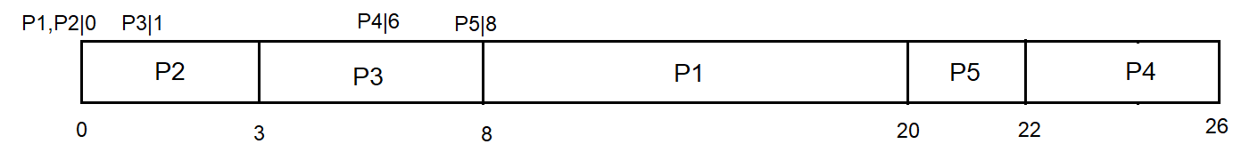
At t = 0, R1 = 0⁺/12 R2 = 0⁺/3
At t = 3, R1 = 3/12 =1/4 = 5/20 R3 = 2/5 = 8/20
At t = 8, R1 = 8/12 = 2/3 R4 = 2/4 R5 = 0/2
At t = 20 R4 = 14/4 R5 = 12/2
i) Turnaround time of P1 = time P1 done – time P1 submitted
= 20 – 0 = 20
ii) Wait times of P1 = 8, of P2 = 0, of P3 = 2, of P4 = 16, of P5 = 12
Therefore average waiting time is (8+0+2+16+12)/5 = 7.6
iii) System throughput = no. of jobs/total time = 5/26 = 0.19

A4) a) Given λ = 5/min, or 5/6 per 10 seconds.
Therefore P(exactly 2 people in 10 seconds) = $\frac{{\left(5/6\right)}^{2}e^{-5/6}}{2!}$ = 0.1509
b) For the queue not to keep on growing, the arrival rate of passengers at the ground level must be fewer than 15 per 20 seconds, or 45 per minute. Hence for the queue not to keep on growing, max $λ_{m}=45$.

