Task1
Result
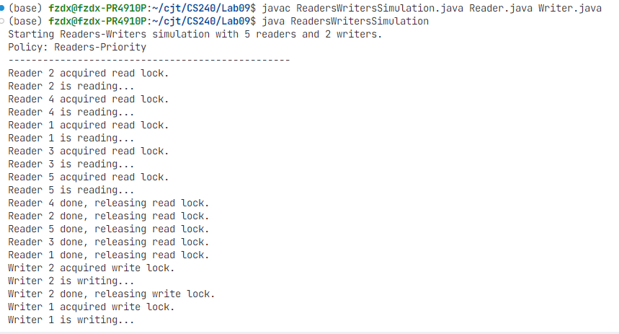

Implement the Classs
public class ReadersWritersSimulation {

public static void main(String[] args) {
// Create a single DataAccessPolicyManager object shared by all threads
DataAccessPolicyManager lockManager = new DataAccessPolicyManager();

// Define the number of readers and writers
int numReaders = 5;
int numWriters = 2;

System.out.println("Starting Readers-Writers simulation with " + numReaders + " readers and " + numWriters + " writers.");
System.out.println("Policy: Readers-Priority");
System.out.println("-------------------------------------------------");

// Create and start writer threads
for (int i = 1; i <= numWriters; i++) {
Writer writer = new Writer(lockManager, i);
writer.start();
}

// Create and start reader threads
for (int i = 1; i <= numReaders; i++) {
Reader reader = new Reader(lockManager, i);
reader.start();}

Implement Reader

class Reader extends Thread {
private DataAccessPolicyManager lockManager;
private Random random = new Random();
private int readerId;

// Constructor: receives a DataAccessPolicyManager instance
public Reader(DataAccessPolicyManager lockManager, int readerId) {
this.lockManager = lockManager;
this.readerId = readerId;
}

@Override
public void run() {
while (true) {
try {
// Sleep for a random time before starting the next read
Thread.sleep(random.nextInt(2000) + 1000);

lockManager.acquireReadLock();
System.out.println("Reader " + readerId + " acquired read lock.");

// Simulate reading activity
System.out.println("Reader " + readerId + " is reading...");
Thread.sleep(random.nextInt(1500) + 500);

System.out.println("Reader " + readerId + " done, releasing read lock.");
lockManager.releaseReadLock();

} catch (InterruptedException e) {
Thread.currentThread().interrupt();
}
}
}
}

}
}

Implement writter

import java.util.Random;
class Writer extends Thread {
private DataAccessPolicyManager lockManager;
private Random random = new Random();
private int writerId;

// Constructor: receives a DataAccessPolicyManager instance
public Writer(DataAccessPolicyManager lockManager, int writerId) {
this.lockManager = lockManager;
this.writerId = writerId;
}

@Override
public void run() {
while (true) {
try {
// Sleep for a random time before starting the next write
Thread.sleep(random.nextInt(3000) + 2000);

lockManager.acquireWriteLock();
System.out.println("Writer " + writerId + " acquired write lock.");

// Simulate writing activity
System.out.println("Writer " + writerId + " is writing...");
Thread.sleep(random.nextInt(2500) + 1000);

System.out.println("Writer " + writerId + " done, releasing write lock.");
lockManager.releaseWriteLock();

} catch (InterruptedException e) {
Thread.currentThread().interrupt();
}
}
}
}

Implement DadaAccessPolicyManager

class DataAccessPolicyManager {
private int readerCount;
private Semaphore mutex; // To protect readerCount
private Semaphore wrt; // To control write access

public DataAccessPolicyManager() {
readerCount = 0;
mutex = new Semaphore(1);
wrt = new Semaphore(1);
}

public void acquireReadLock() {
mutex.acquire();
readerCount++;
if (readerCount == 1) { // If this is the first reader
wrt.acquire(); // it needs to acquire the write lock to block writers
}
mutex.release();
}

public void releaseReadLock() {
mutex.acquire();
readerCount--;
if (readerCount == 0) { // If this is the last reader
wrt.release(); // it needs to release the write lock to allow writers
}
mutex.release();
}

public void acquireWriteLock() {
wrt.acquire();
}

public void releaseWriteLock() {
wrt.release();
}
}

Task2

Result

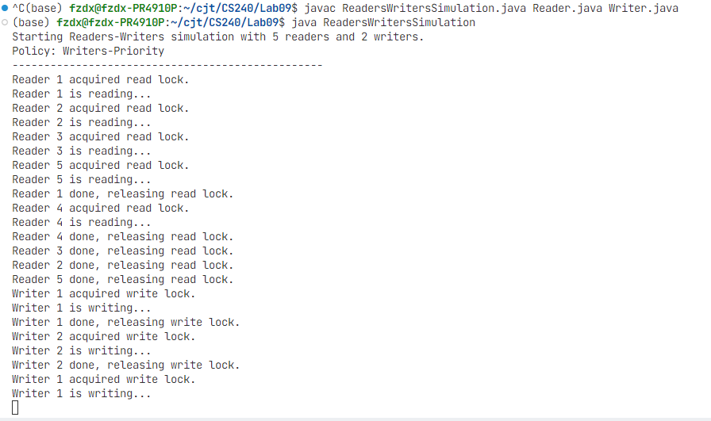
Implement DadaAccessPolicyManager2

Then change the Class implementation DadaAccessPolicyManager2 within other java codes
class DataAccessPolicyManager2 {
private int readerCount;
private int writerCount;
private Semaphore mutex1; // Protects readerCount
private Semaphore mutex2; // Protects writerCount
private Semaphore wrt; // Common for readers and writers
private Semaphore readLock; // For blocking readers

public DataAccessPolicyManager2() {
readerCount = 0;
writerCount = 0;
mutex1 = new Semaphore(1);
mutex2 = new Semaphore(1);
wrt = new Semaphore(1);
readLock = new Semaphore(1);
}

public void acquireReadLock() {
readLock.acquire(); // Lock to prevent readers if a writer is waiting
mutex1.acquire();
readerCount++;
if (readerCount == 1) { // First reader
wrt.acquire(); // Lock out writers
}
mutex1.release();
readLock.release(); // Release the read lock for other readers
}

public void releaseReadLock() {
mutex1.acquire();
readerCount--;
if (readerCount == 0) { // Last reader
wrt.release(); // Allow writers
}
mutex1.release();
}

public void acquireWriteLock() {
mutex2.acquire();
writerCount++;
if (writerCount == 1) { // First writer
readLock.acquire(); // Lock out readers
}
mutex2.release();
wrt.acquire();
}

public void releaseWriteLock() {
wrt.release();
mutex2.acquire();
writerCount--;
if (writerCount == 0) { // Last writer
readLock.release(); // Allow readers
}
mutex2.release();
}
}

