从历年卷整理考点

24年

An operating system for a single user machine, like a PC, and for a multiuser computer, like a mainframe, will not have the same process scheduling algorithms. Briefly explain the reason for this.

What is the difference between a process and a computer program?

A program is a collection of
instructions specifying a defined
sequence of execution. It is the
translation of an algorithm into a
programming language.

程序是一组指令的集合，指定了一个定义的执行顺序。它是将算法翻译成编程语言。

A user will interact with the operating system of a computer through a
command-line or graphical user interface. What is the difference
between them?
(5 marks)

• CLI: 用户通过键盘输入特定格式的文本命令来指示操作系统执行任务。交互是基于文本的，需要用户记住命令及其语法。
• GUI: 用户通过使用鼠标、触摸板或触摸屏等指点设备，与屏幕上的图形元素（如图标、窗口、菜单、按钮）进行交互。操作包括点击、双击、拖放等。

• CLI: 输出主要是文本形式。结果、错误消息和提示都以字符显示在屏幕上。
• GUI: 信息以图形和文本结合的方式呈现。用户可以看到窗口、文件图标、进度条、菜单选项等视觉元素，使得状态和选项更直观。

• Interaction Method:
- • CLI: The user interacts by typing specific text commands using a keyboard to instruct the operating system to perform tasks. Interaction is text-based, requiring the user to remember commands and their syntax.
- GUI: The user interacts with graphical elements on the screen (like icons, windows, menus, buttons) using pointing devices such as a mouse, trackpad, or touchscreen. Actions include clicking, double-clicking, dragging, etc.
• Information Presentation:
- • CLI: Output is primarily in text format. Results, error messages, and prompts are displayed as characters on the screen.
- GUI: Information is presented using a combination of graphics and text. Users see visual elements like windows, file icons, progress bars, and menu options, making status and choices more intuitive.

A user of a computer with just one CPU, which can execute only one
instruction at a time, may run several apps on it, like Word, Excel and
Firefox, at the same time. How does the operating system make this
possible?

• 分时 (Time-Sharing): 操作系统将 CPU 的使用时间划分成非常短的时间段，称为 时间片 (Time Slice) 或 时间量 (Quantum)，通常只有几毫秒到几十毫秒。
• 进程调度 (Process Scheduling): 操作系统内部有一个 调度程序 (Scheduler)。调度程序负责决定在下一个时间片内，哪个应用程序（在操作系统内部表示为 进程 Process 或 线程 Thread）可以使用 CPU。它会根据一定的调度算法（如轮转、优先级等）来选择。
• 上下文切换 (Context Switching): 当一个进程的时间片用完，或者有更高优先级的进程需要运行时，操作系统会执行 上下文切换。这个过程包括：
- 保存当前进程的状态： 保存当前正在运行进程的所有关键信息，如程序计数器（下一条要执行的指令地址）、寄存器中的值、内存管理信息、打开的文件列表等。这些信息通常保存在该进程的 进程控制块 (Process Control Block, PCB) 中。
- 加载下一个进程的状态： 从下一个要运行进程的 PCB 中加载其之前保存的状态到 CPU 的寄存器和相关控制结构中。
• 快速切换: 这个保存和加载状态（上下文切换）的过程发生得非常快（通常在微秒或毫秒级别）。

• Time-Sharing: The operating system divides the CPU's execution time into very short intervals known as time slices or quanta, typically lasting only a few milliseconds to tens of milliseconds.
• Process Scheduling: The operating system contains a component called the Scheduler. The scheduler's job is to decide which application (represented internally by the OS as a Process or Thread) gets to use the CPU during the next time slice. It uses specific scheduling algorithms (like Round Robin, priority-based, etc.) to make this selection.
• Context Switching: When a process's time slice expires, or when a higher-priority process becomes ready to run, the operating system performs a context switch. This involves:
- Saving the current process's state: Preserving all critical information about the currently running process, such as the program counter (address of the next instruction), values in CPU registers, memory management details, list of open files, etc. This information is typically stored in the process's Process Control Block (PCB).
- Loading the next process's state: Restoring the previously saved state of the next process scheduled to run from its PCB into the CPU's registers and relevant control structures.
• Rapid Switching: This process of saving and loading states (context switching) happens extremely quickly (often in microseconds or milliseconds).

A hard-disk with tracks numbered 0 to 200 has the following track
requests in its queue:
43, 95, 134, 12, 49, 38, 185, 78, 23.
The read head is right now on track 65.
(i) How would the requests be serviced if the First Come First Served
algorithm is used?
(ii) How would the requests be serviced if the SCAN algorithm is used?
(iii) How would the requests be serviced if the LOOK algorithm is used?

中文回答：
磁头当前在65号轨道，请求队列是：
43, 95, 134, 12, 49, 38, 185, 78, 23

(i) 如果使用 先来先服务（FCFS） 算法：
按请求到达的顺序处理轨道请求：
顺序为：
65 → 43 → 95 → 134 → 12 → 49 → 38 → 185 → 78 → 23
移动情况（轨道移动量）：
- 65 → 43 （22）
- 43 → 95 （52）
- 95 → 134 （39）
- 134 → 12 （122）
- 12 → 49 （37）
- 49 → 38 （11）
- 38 → 185 （147）
- 185 → 78 （107）
- 78 → 23 （55）

(ii) 如果使用 电梯算法（SCAN）：
假设磁头先向外（高号轨道）方向移动。
步骤：
- 从65向上移动，服务大于65的请求：78、95、134、185
- 到达边界200（假设SCAN会扫到最远端，即200轨道）
- 然后反向移动，服务小于65的请求：49、43、38、23、12
移动顺序：
65 → 78 → 95 → 134 → 185 → 200 → 49 → 43 → 38 → 23 → 12
注意：如果系统设计为到最后一个请求再掉头（而不是扫到200），则200可以省略（参见LOOK算法）。

(iii) 如果使用 LOOK算法（也是一种优化的SCAN）：
LOOK算法不会扫到磁盘边界，而是只移动到最远的请求。
步骤：
- 从65向上移动，服务78、95、134、185（最大的请求185）
- 然后掉头，向下移动，服务49、43、38、23、12
移动顺序：
65 → 78 → 95 → 134 → 185 → 49 → 43 → 38 → 23 → 12
和SCAN相比，不去到200，只扫到最大请求185。

Processes often use threads to carry out different tasks, rather than create
child processes to carry out these tasks. Give two advantages of using
threads instead of spawning child processes.

中文回答：
使用**线程（threads）而不是创建子进程（child processes）**来执行不同任务，有以下两个主要优势：
资源开销小：
  - 线程共享同一进程的内存空间和资源（如文件描述符、堆等），而子进程需要独立的内存空间和资源。
  - 创建、销毁和切换线程的开销远小于进程，效率更高。
更快的通信（更容易的通信）：
  - 由于线程共享同一地址空间，它们之间的数据交换可以直接通过共享变量进行，无需像进程间通信（IPC）那样依赖复杂的机制（如管道、消息队列、共享内存）。
  - 这使得线程之间的通信更快、更简单。

English Answer:
Using threads instead of spawning child processes to perform different tasks offers two major advantages:

Lower resource overhead:

  - Threads share the same memory space and resources (such as file descriptors, heap, etc.) of the parent process, whereas child processes require separate memory and resources.
  - Creating, destroying, and switching between threads is much cheaper and faster than between processes.

Faster (and easier) communication:
  - Since threads share the same address space, they can communicate simply by reading and writing shared variables, without needing complex inter-process communication (IPC) mechanisms like pipes, message queues, or shared memory setups.
  - This makes communication between threads faster and simpler.

(i) Does the OS have control over the CPU cache memory? If not, briefly
explain why

Briefly explain the difference between running processes, blocked
processes and zombie processes.

Blocked Processes

中文回答：
运行中（Running）进程、阻塞（Blocked）进程和僵尸（Zombie）进程的区别：

运行中（Running）进程：

  - 进程正在使用CPU执行指令。
  - 也包括就绪（Ready）状态的进程（即准备执行，只是暂时没有分配到CPU）。

阻塞（Blocked）进程：

  - 进程因为等待某个事件（如I/O操作完成、锁释放）而暂停执行。
  - 在事件未发生之前，进程不能继续执行，即使有CPU也不能运行。

僵尸（Zombie）进程：

  - 进程已经完成执行（终止了），但其退出信息（如退出码）仍未被父进程读取。
  - 僵尸进程仍保留在系统的进程表中，占用少量系统资源，直到父进程调用wait()或类似函数获取其状态。

English Answer:
The difference between running, blocked, and zombie processes:
Running process:
  - A process that is currently executing instructions on the CPU.
Also includes processes in the ready state (ready to run but waiting for CPU allocation).

Blocked process:
  - A process that is paused because it is waiting for some event (e.g., I/O completion, a lock to be released).
  - It cannot continue execution even if the CPU is available, until the awaited event occurs.
Zombie process:
  - A process that has finished execution (terminated) but whose exit status has not been collected by its parent process.
  - It remains in the system's process table, consuming a small amount of system resources, until the parent process calls wait() or a similar function to read its status.

(f) When messages are passed between two processes running on different hosts, the bits making up the messages travel through copper wires, optical fibres, or through space using microwaves or satellite links from one location to another. Messages may become lost or errors may occur. Explain three different ways TCP/IP can use to help overcome this and make messaging more reliable.

中文回答：
当两台不同主机的进程通过网络通信时，TCP/IP协议提供了多种机制来提高通信的可靠性，包括：
确认（Acknowledgment, ACK）：
  - 接收端在成功收到数据后，会发送一个**确认消息（ACK）**回给发送端。
  - 如果发送端在一定时间内没有收到ACK，它会自动重传丢失的数据包。
校验和（Checksum）：
  - 每个TCP段都包含一个校验和字段，用于检测在传输过程中是否出现了比特错误。
  - 如果接收端计算的校验和与发送端的不一致，接收端会丢弃该数据包，发送端随后会重传。
数据排序（Sequencing）：
  - TCP给每个数据包分配一个序列号（Sequence Number），以确保数据能按正确顺序重组。
  - 即使数据包乱序到达，TCP也可以通过序列号重新排列它们，保证数据的完整性和顺序性。

English Answer:
When messages are passed between two processes running on different hosts, TCP/IP uses several techniques to improve reliability, including:
Acknowledgment (ACK):
  - The receiver sends an acknowledgment message (ACK) back to the sender after successfully receiving data.
  - If the sender does not receive an acknowledgment within a certain time, it will automatically retransmit the missing data.
Checksum:
  - Each TCP segment includes a checksum field to detect errors that may occur during transmission.
  - If the checksum at the receiver does not match the checksum calculated by the sender, the receiver discards the corrupted data, prompting a retransmission.
Sequencing:
  - TCP assigns a sequence number to each data packet to ensure that data can be reassembled in the correct order.
  - Even if packets arrive out of order, TCP uses sequence numbers to reorder them properly, ensuring data completeness and order.

Briefly explain the difference between running processes, blocked
processes and zombie processes

Blocked processes can be divided into two main groups. What is the
difference between them?

中文回答：
阻塞（Blocked）进程可以分为两大类，区别如下：

等待I/O（I/O-bound blocking）：

  - 进程正在等待输入/输出操作完成，比如读取磁盘文件、接收网络数据或用户输入。
  - 这种阻塞是被动等待外部设备完成操作，通常I/O设备比CPU慢，所以进程必须暂停直到I/O完成。

同步/互斥等待（Synchronization blocking）：

  - 进程正在等待同步事件，比如等待锁（lock）、信号量（semaphore）或条件变量（condition variable）。
  - 这种阻塞主要用于进程或线程之间的协调，防止数据竞争或保证某种执行顺序。

English Answer:
Blocked processes can be divided into two main groups, with the following differences:

I/O-bound blocking:

  - The process is waiting for an input/output operation to complete, such as reading from a disk, receiving network data, or waiting for user input.
  - This is a passive wait for an external device, which is typically slower than the CPU, so the process must pause until the I/O operation finishes.

Synchronization blocking:

  - The process is waiting for a synchronization event, such as acquiring a lock, waiting on a semaphore, or waiting for a condition variable.
  - This kind of blocking is used for coordination between processes or threads, to prevent race conditions or enforce execution order.

Explain the difference between preemptive and non-preemptive
scheduling algorithms.

当然！以下是中文和英文的双语回答：

中文回答：
抢占式（Preemptive） 和 非抢占式（Non-preemptive） 调度算法的区别：

抢占式调度（Preemptive Scheduling）：

  - 操作系统可以强制中断正在运行的进程，把CPU分配给另一个更高优先级或更需要CPU的进程。
  - 进程不会一直占用CPU，系统可以根据调度策略随时剥夺它的执行权。
  - 例子：抢占式优先级调度（Priority Scheduling）、轮转调度（Round Robin）。

非抢占式调度（Non-preemptive Scheduling）：
  - 一旦某个进程获得了CPU，它就会一直运行，直到主动释放CPU（如完成任务或进入等待状态）。
  - 操作系统不能中断正在运行的进程，只能等它自己让出CPU。
  - 例子：先来先服务（FCFS）、非抢占式优先级调度。
总结：
- 抢占式：系统可以中断进程。
- 非抢占式：进程自己释放CPU。

English Answer:
The difference between preemptive and non-preemptive scheduling algorithms:

Preemptive Scheduling:

  - The operating system can interrupt a running process and reassign the CPU to another process that has higher priority or needs it more urgently.
  - A process does not keep the CPU indefinitely; the system can forcibly take control according to scheduling rules.
  - Examples: Preemptive Priority Scheduling, Round Robin (RR).

Non-preemptive Scheduling:

  - Once a process is assigned the CPU, it continues to run until it voluntarily releases the CPU (e.g., by completing its task or entering a waiting state).
  - The operating system cannot forcibly interrupt a running process.
  - Examples: First-Come, First-Served (FCFS), Non-preemptive Priority Scheduling.
Summary:
- Preemptive: The system can interrupt a running process.
- Non-preemptive: The process must release the CPU by itself.

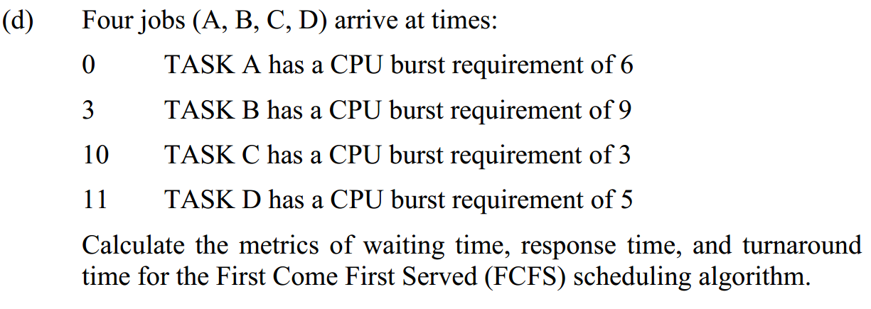
好的！让我们一步步来解决这个问题。

题目总结
- 调度算法：FCFS（First Come First Served）
- 任务到达与CPU需求如下：
任务 | 到达时间 | CPU Burst 时间
A | 0 | 6
B | 3 | 9
C | 10 | 3
D | 11 | 5

第一步：确定执行顺序和完成时间
按照到达顺序处理，FCFS中，先到先执行，即使任务到达时CPU空闲，也要等。

详细执行过程
TASK A：
  - 到达时间：0
  - 开始执行时间：0
  - 完成时间：0 + 6 = 6

TASK B：

  - 到达时间：3（但是要等TASK A完成）
  - 开始执行时间：6
  - 完成时间：6 + 9 = 15

TASK C：

  - 到达时间：10（在TASK B执行时到达）
  - 开始执行时间：15
  - 完成时间：15 + 3 = 18

TASK D：

  - 到达时间：11（也在TASK B执行时到达）
  - 开始执行时间：18
  - 完成时间：18 + 5 = 23

第二步：计算等待时间、响应时间、周转时间
任务 | 到达时间 | 开始时间 | 完成时间 | CPU Burst | 等待时间 (开始时间 - 到达时间) | 响应时间 (等待时间) | 周转时间 (完成时间 - 到达时间)
A | 0 | 0 | 6 | 6 | 0 | 0 | 6
B | 3 | 6 | 15 | 9 | 3 | 3 | 12
C | 10 | 15 | 18 | 3 | 5 | 5 | 8
D | 11 | 18 | 23 | 5 | 7 | 7 | 12

最终答案总结

等待时间（Waiting Time）：

  - A: 0
  - B: 3
  - C: 5
  - D: 7

响应时间（Response Time）（在FCFS中，响应时间 = 等待时间）：

  - A: 0
  - B: 3
  - C: 5
  - D: 7

周转时间（Turnaround Time）：

  - A: 6
  - B: 12
  - C: 8
  - D: 12

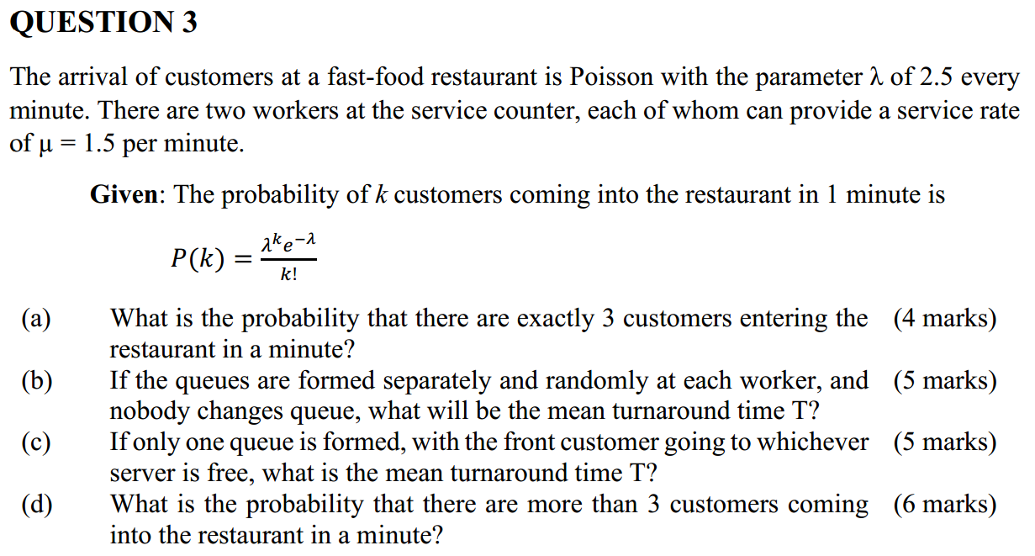

Quest4 往后没用到

23年 只有 1 3

QUESTION 1

What is a process control block(PCB)? Present the 3 typical parts of a PCB
and summarize each content. （进程控制块）

A Process Control Block is used to keep track of the
execution context (all resource information about the
process and its activity) that can be used for independent
scheduling of that process onto any available processor.
Process Identification Data
Processor State
Process Control Data
进程控制块用于跟踪执行上下文（关于进程及其活动的所有资源信息），该上下文可用于将该进程独立调度到任何可用处理器上。

(10 marks)

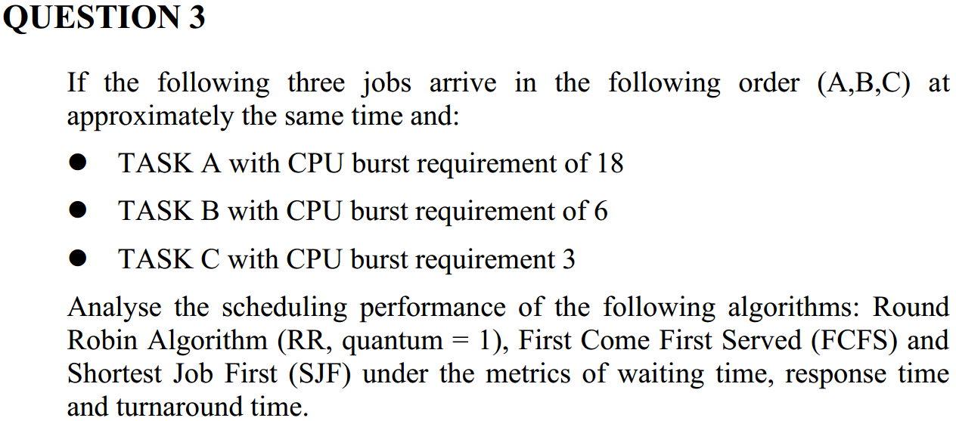

进程调度

2022 只有一和三

操作系统的任务

State five main tasks that an operating system performs.

进程调度算法
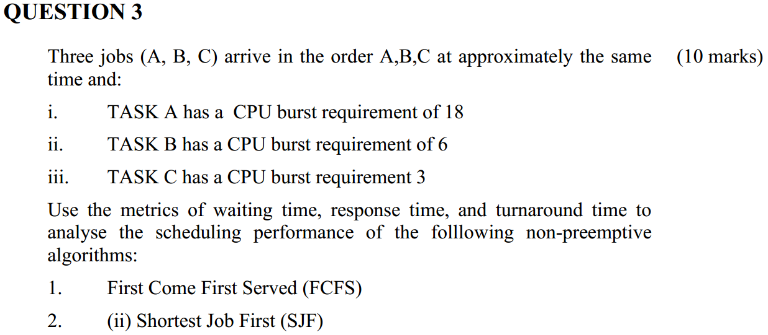

2021

QUESTION 1 What is a process control block(PCB)? Summarize the typical content of a PCB. (10 marks)

QUESTION 2 Compare and contrast the two Unix interprocess communication mechanisms:- message queues and pipes.

QUESTION 4 Disk Head Scheduling Policy determines the amount of movement incurred by the disk head when servicing requests. Assuming the disk head is at track 53, compare the head movement incurred by the C-LOOK algorithm versus the SCAN algorithm and SSTF algorithm for the following series of track requests:- 96, 100, 183, 23, 122, 14, 124, 65, 67

QUESTION 6 Write a note on socket communication over TCP/IP, and explain what the TCP three way handshake is.

QUESTION 8 Describe the generic design requirements of a File System. List and explain some of the basic system calls typically provided for accessing and organising files.

