

CS211FZ (Algorithms & Data Structures 2)

CA1 – this lab is worth 5% of the module marks and is marked out of 100 Due: Friday 4th April. 1pm

This is an open-book, graded assignment. Please cite all references as comments in your submissions. You cannot directly reuse a solution from online sources. You must not engage with another student, in person or electronically (via phone, social media, etc.), to secure assistance with this Assignment. If you do so (even for only one of the questions), you will receive an automatic failure (0%), and it will also be reported to the Executive Vice-Dean of MIEC and/or Maynooth University Plagiarism board. We will perform similarity checks on submitted assignments to check for collaborative efforts. The lecturer reserves the right to interview you about your submission in special cases.
IMPORTANT: You must demonstrate your software to a TA and answer any questions before the end of the lab session to get the Programming Marks. So it is suggested you do the final 2 programming questions first. Software templates are available on Moodle but you don’t have to use them. You must also submit your programs in the pdf submission, submitted as one Class.

Question 1-1 What is the smallest value of n such that an algorithm whose running time is 50n 2 runs faster than an algorithm whose running time is 2 n on the same machine? [5 marks]

When n=13 50·13² = 50·169 = 8450 and 2¹³ = 8192. Since 8450 > 8192, the inequality is not satisfied.
For n = 14: 50·14² = 50·196 = 9800 and 2¹⁴ = 16384. Here 9800 < 16384, so the inequality holds.
Thus, the smallest value of n for which 50n² runs faster than 2ⁿ is 14.

Question 1-2

Comparison of running times
For each function f(n) and time t in the following table, determine the largest size n of a problem that can be solved in LESS THAN time t, assuming that the algorithm to solve the problem takes f(n) seconds. Small errors are acceptable. (Hint: You could solve these mathematically or write java code to solve them. Question 1-12 requires this so it may be useful to check that question first). [20 Marks]
(lg n is log to the base 2 of n) (a month is 30 days)
(a year is 365 days)

 | 1 second | 1 Minute | 1 Hour | 1 Day | 1 Month | 1 Year
lg n | 1 | 2^60 | Overflow | Overflow | Overflow | Overflow
√𝑛 | 0 | 3599 | 12959999 | Overflow | Overflow | Overflow
n | 0 | 59 | 3,599 | 86,399 | 2.591,999 | 31535999
nlg n | 0 | 15 | 414 | 6786 | 150687 | 1534638
n2 | 0 | 7 | 59 | 293 | 1609 | 5615
n3 | 0 | 3 | 15 | 44 | 137 | 315
2n | 0 | 5 | 11 | 16 | 21 | 24
n! | 0 | 4 | 6 | 8 | 9 | 10

Question 1-3
Express the function (n³/1000−100n²−100n + 3) in terms of Θ-notation and explain why. [5 marks]

We consider the following function:
f(n) = n³/1000 – 100·n² – 100·n + 3
Note that this is a cubic polynomial. As n tends to infinity, the highest-order term n³/1000 dominates, and the lower-order terms (n², n, and the constant) become negligible in comparison to n³.
We can rewrite f(n) as:
f(n) = n³ · (1/1000 – 100/n – 100/n² + 3/n³)
As n approaches infinity, the terms 100/n, 100/n², and 3/n³ all tend to 0. Thus, we have
lim (n→∞) f(n)/n³ = 1/1000 > 0
According to the definition of Ω-notation, if there exists a positive constant c and a number n₀ such that for all n ≥ n₀ the inequality f(n) ≥ c·n³ holds, then we say that f(n) ∈ Ω(n³).
Therefore, we can choose an appropriate constant c (for example, c = 1/2000) and a sufficiently large n₀ so that for all n ≥ n₀, it holds that
f(n) ≥ (1/2000)·n³
This demonstrates that f(n) is bounded below by a constant multiple of n³, which means
f(n) ∈ Ω(n³)
In summary, the function f(n) is in Ω(n³).

Question 1-4 Ordering by asymptotic growth rates
Rank the following functions by order of growth. That is, find an arrangement 𝑔1, 𝑔2, … , 𝑔30 of the functions satisfying 𝑔1 = Ω(g2), 𝑔2 = Ω(g3), … , 𝑔29 = Ω(g30). Partition your list into equivalence classes such that functions 𝐹(𝑛) and 𝑔(𝑛) belong to the same class if and only if
𝑓(𝑛) = Θ(𝑔(𝑛)). [15 Marks]
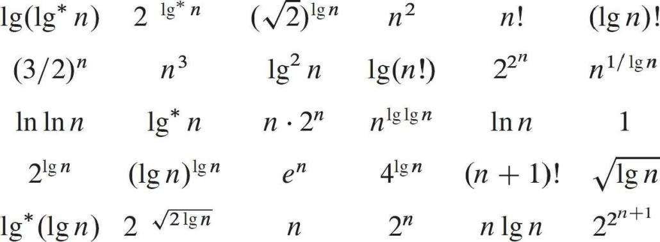

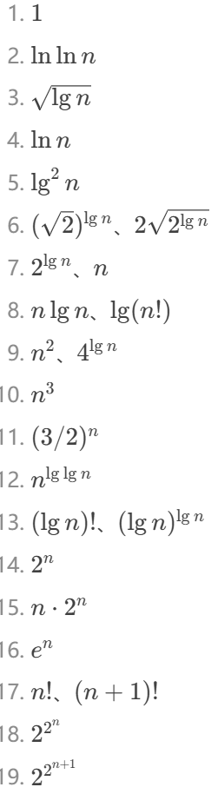

Question 1-5
Let f(n) and g(n) be asymptotically nonnegative functions. Using the basic definition of Θ-notation, explain in simple terms why max(f(n), g(n)) = Θ(f(n) + g(n)). [5 Marks)

Question 1-5
max(f(n),g(n))≤f(n)+g(n)≤2max(f(n),g(n))，SO max(f,g)=Θ(f+g)

Question 1-6
- Is 2^{n+1} = O(2^{n})?
- Is 2^{2n} = O(2^{n})?

a) Yes, 2^(n+1) = O(2^n).
Explanation: 2^(n+1) can be rewritten as 2 · 2^n. Since big-O notation ignores constant factors, there exists a constant C = 2 such that for all n, 2^(n+1) ≤ C · 2^n. Hence, 2^(n+1) is O(2^n).
b) No, 2^(2n) is not O(2^n).
Explanation: Notice that 2^(2n) equals (2^n)^2. If we take the ratio 2^(2n) / 2^n, we get 2^n, which grows without bound as n increases. Because there isn’t a constant C that can bound 2^n for all sufficiently large n, 2^(2n) is not O(2^n).

[5 marks]

Question 1-7
Explain why o(g(n)) ∩ ω(g(n)) is the empty set.

[5 marks)
By definition, a function f(n) belongs to o(g(n)) if
limₙ→∞ [f(n)⁄g(n)] = 0
meaning that f(n) grows strictly slower than g(n). On the other hand, f(n) belongs to ω(g(n)) if
limₙ→∞ [f(n)⁄g(n)] = ∞
meaning that f(n) grows strictly faster than g(n).
Clearly, no function f(n) can have its ratio f(n)/g(n) tend to both 0 and ∞ as n increases. Therefore, there is no function that simultaneously satisfies the conditions for being in o(g(n)) and in ω(g(n)). Consequently, the intersection o(g(n)) ∩ ω(g(n)) is empty.

Programming Questions Question 1-8
You may find it helpful to use the Java templates supplied on Moodle
Create a simple Higher or Lower game in Java. You code should
- Create a random integer between 1 and 10,000.
- Ask the user to input a number as their guess.
- If the user's guess matches the random number, it displays 'Correct' and stops.
- If the user's guess is higher than the random number, it displays 'Lower' and prompts for another guess.
- If the user's guess is lower than the random number, it displays 'Higher' and prompts for another guess."
Code template in moodle as Guess_template.java

import java.util.Random;
import java.util.Scanner;
public class Guess_template {
public static void main(String[] args) {
// 创建 Random 和 Scanner 对象
Random random = new Random();
Scanner scanner = new Scanner(System.in);
// 生成1到10000之间的随机数
int randomNumber = random.nextInt(10000) + 1;
while (true) {
// 提示用户输入猜测
System.out.println("Enter your guess (between 1 and 10000):");
int guess = scanner.nextInt();
// 检查猜测并提供反馈
if (guess == randomNumber) {
System.out.println("Congratulations! You guessed the correct number.");
break; // 猜对后退出循环
} else if (guess < randomNumber) {
System.out.println("Your guess is too low.");
} else {
System.out.println("Your guess is too high.");
}
}
// 关闭 Scanner
scanner.close();
}
}

[20 marks)

Question 1-9
Revisit question 1-2 and write a java program that solves n*log₂(n) < t for any value of t. You will need to use binary search since there's no simple closed-form solution.

[20 marks]

Important submission details
Please indicate the Operating System (Linux/Windows/MacOS/Online), IDE (e.g. Eclipse, Visual Studio Code), and Java SDK version used for testing in your submission. If you use an online IDE, please specify the IDE (http://repl.it) and provide a link where possible.
All work must be submitted via Moodle (see "Assignments" section for submission). Work submitted via other means will not be accepted unless you have prior arrangements with the lecturer. All work MUST be submitted by the due date deadline. Late submissions will not be accepted.
Your submission should be one single PDF file, including also your Java codes. Submitting in any other format cannot be accepted.

public class SimpleProblemSize {
// Method to find the largest n where n * log2(n) < t
public static double findLargestN(double t) {
// Handle invalid input: if t is 0 or negative, return 0
if (t <= 0) {
return 0;
}
// Initialize binary search boundaries
double left = 1; // Lower bound starts at 1
double right = t; // Upper bound starts at t
// First phase: Find an upper bound by exponentially increasing right
// Continue until we overshoot the target value, i.e., f(right) = right * log2(right) >= t.
while (right * log2(right) < t) {
left = right;
right *= 2;
}
// Second phase: Binary search to narrow down the exact value
double epsilon = 0.001; // Precision threshold for stopping.
// The epsilon is needed to determine when the interval [left, right] is sufficiently small.
while (right - left > epsilon) {
double mid = (left + right) / 2.0;
if (mid * log2(mid) < t) {
left = mid; // If mid is still below target, increase the lower bound
} else {
right = mid; // Otherwise, decrease the upper bound
}
}
// Return the floor of left bound as the final answer.
// This ensures we get the largest integer n that satisfies n*log₂(n) < t.
return Math.floor(left);
}
// Helper method to calculate logarithm base 2
private static double log2(double n) {
// Use the change-of-base formula: log2(n) = ln(n)/ln(2)
return Math.log(n) / Math.log(2);
}
// Main method to test the functionality
public static void main(String[] args) {
double t = 31536000; // Test value representing time or resource limit
double n = findLargestN(t); // Calculate largest valid n
// Print results
System.out.println("For t = " + t + ":");
System.out.println("Largest n = " + n);
}
}

