CS253: Laboratory session 2, Typing tutor and Speed Test
Preamble: Many instructions require extra data to operate. For example, the ADD AX, operation needs to know what to add to AX so as to work. The extra data (operand) can come from many sources. The sources include another register, data in the code following the instruction, data specified by an address and data identified by a register acting as a pointer. The various methods used by an instruction/CPU to locate data (for reading or writing) are known as addressing modes. The four main addressing modes available on most CPUs are as follows.

Immediate Addressing: The operand (data) appears in the instruction.
e.g. mov ax,10
Register Addressing: The operand is contained in another register.
e.g. mov ax,bx
Direct Addressing: Specifies location in memory (address) where data is to
be found. e.g. mov ax,DS:Count
Register Indirect Addressing: A register is used to provide an offset address in a
segment from which the data is obtained (or written to). e.g. mov ax,[bx]

Look at both the machine code and the MASM code of the following listing and located the operator and operand. Note the addressing mode, see code comments.
Microsoft (R) Macro Assembler Version 6.00
.model small
.stack
0000 .data
0000 09 ct1 db 9
0001 0203 ct2 dw 515

0000 .code
.startup

;Address MachineCode ASM code ; Immediate Addressing
001A | B8 | 05 68 | back: | mov ax,568h
001D | B2 | 08 |  | mov dl,8
001F | 72 | F9 |  | jc back
0021 | B0 | 41 |  | mov al,'A'
0023 | 83 | F8 0A |  | cmp ax,10
0026 | D1 | DA |  | rcr dx,1

; Register Addressing
0028 8B C3 mov ax,bx
002A 22 C2 and al,dl
002C 03 C3 add ax,bx
; Direct Addressing
002E 2E: A0 0000 R mov al,ct1 ; Contains 9 at run time
0032 A1 0001 R mov ax,DS:ct2 ; Contains 515 at run time

; Register Indirect
0035 8B 07 mov ax,[bx]
.exit

Symbols:
END

N a m e Type Value Attr

back . . . . . . . . . . . . . . L Near 001A _TEXT
ct1 . . . . . . . . . . . . . . Byte 0000 _TEXT
ct2 . . . . . . . . . . . . . . Word 0001 _TEXT

Instruction Format: A binary number represents each machine code instruction, typically two bytes. At first sight it would appear that there is no correlation between the number and the instruction however this is not the case. Each binary digit in the number carries information about the instruction. The first 6 bits specifies the instruction type (e.g. mov, jmp, rol, etc). The following 12 bits specify the addressing mode, source or destination, data size (byte or word) etc.
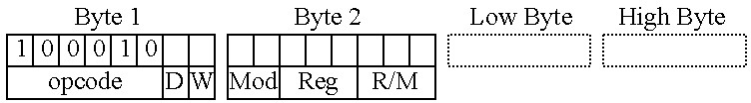

opcode specifies the function in this case MOV
D gives direction, From Register D=0, To Register D=1
Reg: Used to identify the register e.g. dl,dx=010, ah,sp=100, dl,dx=010 etc.
W=0 To move a word (e.g. AX) W=1 To move a byte (e.g. BL)
Mod: Addressing mode, offset information
R/M: Addressing mode, the register
To aid understanding, look at the binary code of each of the instructions in the hello world programme listed below, note how the D and W columns work.
Machine Code (Binary) Machine Code(HEX) MASM Code Opcode D W Mod Reg R/M
[101110,1,1] | [00,000,000] [0000,0000] | [0000,0000] BB 0000 R | mov bx,OFFSET msg1
[100010,1,1] | [00,010,111] | 8B 17 | back: mov dx,[bx]
[100000,0,0] | [11,111,010] [0010,0100] | 80 FA 24 | cmp dl,'$'
[011101,0,0] | [00,000,111] | 74 07 | jz done
[101101,0,0] | [00,010,010] | B4 02 | mov ah,02h
[110011,0,1] | [00,100,001] | CD 21 | int 021h
[010000,1,1] |  | 43 | inc bx
[111010,1,1] | [11,110,010] | EB F2 | jmp back

In the early days of assembly language programming you would write out the program in assembly language and then use a large table to look up the machine code (numbers) that corresponds to each line of assembly language (mnemonics). After that you would fill in all the absolute and relative jumps (operand data). Assemblers have simplified the task of creating machine code but have slightly distanced us from the code and how it works. Perhaps we should compile one program by hand sometime during the course.

ASCII: A 7-bit (0-127) number is used to represent the characters printed to the screen or returned by the keyboard. In most cases the number used is 8-bit and the character set is extended to 256 characters (0-255). ASCII (pronounced ASK-KEY) is the most popular standard for coding alphanumeric information. ASCII stands for American Standard Code for Information Interchange. Note that carriage return is coded as 13 decimal and line feed as 10 decimal and escape as 27 decimal, see table later in handout.

Part 1: Get the typing tutor code working using DOSBox at the start.
Enter the following code into a Notepad++ file called typer.asm. Save the file in your
X:\CS253 folder (or C:\temp), cut and paste could give problems with “’” etc.

.MODEL medium
.STACK ; Stack default size 1024 bytes
.DATA ; Data segment (for variables)

.CODE ; Run-able code goes in code segment
.STARTUP ; Handover code from OS call to typer.exe
nextc: mov ah,8 ; Call int21 with ah=8 returns with
int 021h ; al equal to the ASCII character pressed mov dl,al ; dl is assigned value in al, dl=al

mov ah,02h ; Call int21 with ah=2 prints ASCII int 021 ; character represented by value in dl

cmp dl,'q' ; compare dl with ASCII ‘q’=
jnz nextc ; if key pressed was not a ‘q’ go back

.EXIT ; Terminate and return control to OS END ; End of file (for compiler)

Modify the typing tutor program so that it will only let you type characters 0 to 9 to the screen. You should try using jc and jnc instructions to achieve this goal, don’t use Intel’s greater than and less than instructions they prevent an understanding of the C (carry) and Z (zero) flags.

Many uP only have C and Z based jumps. Assembly language is different for each type of processor; it is not a portable language like C or Java that can run on most devices. We are learning a subset of the, x86, assembly language that will give you a good understanding of all the different assembly languages that exist.
The jnz (jump if not zero) and jz (jump if zero) work with cmp (compare) to test equivalence (A==B or A!=B etc) and jc (jump if carry) and jnc (jump if no carry) work to test magnitude (A>B or A<=B etc). Make sure the program still terminates when you press ‘q’ without echoing it to the screen and that the code works correctly for “9” and “0”.
Note the instruction cmp dl,40 would take 40 away from the value in dl and then change the zero and carry flags based on the result of the calculation. The value in dl remains unchanged.

For the record the instruction sub dl,40 takes 40 away from dl (i.e. it changes dl) and also changes the Z and C flags,

The following algorithm could be used to achieve your goal.
- Start
- Read an ASCII character from the keyboard in to dl
- If the character code is 133 or a ‘q’ then goto quit
- Check if character is less than ASCII code 48, ‘0’, go back to the start
- Check if character is greater than ASCII code 57, ‘9’, go back to the start
- Print the character to the screen
- Go back to the Start
- Quit
The ASCII table shown below should be of help.
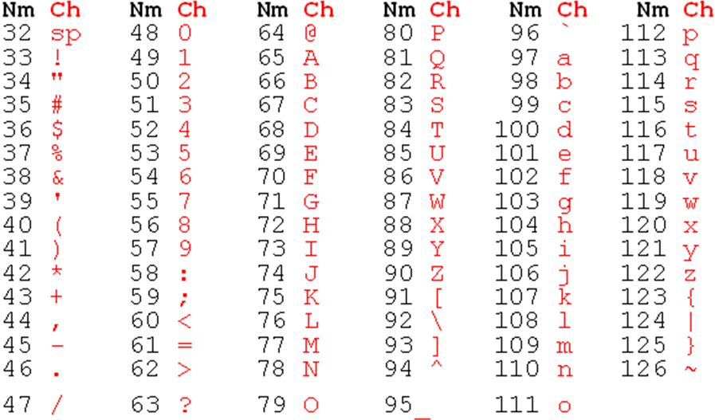
Note: <escape> is ASCII 27 decimal or 1B in HEX.

You should be able to type a string such as “abc123ABC456xyq” into you program from the keyboard and it should display the following text on the screen “123456”. Take care that it works properly for both ‘0’ and ‘9’.

Submit the final working version of your code via the VPL (Virtual Programming Lab) interface.
Well done you have just worked out how assembly language manages magnitude and equivalence tests.

Use the VPL (Virtual programming Laboratory) to build and run your keyboard code. Cut and paste (or retype) the code into the VPL Edit window (maker sure the file is saved as typer.asm).
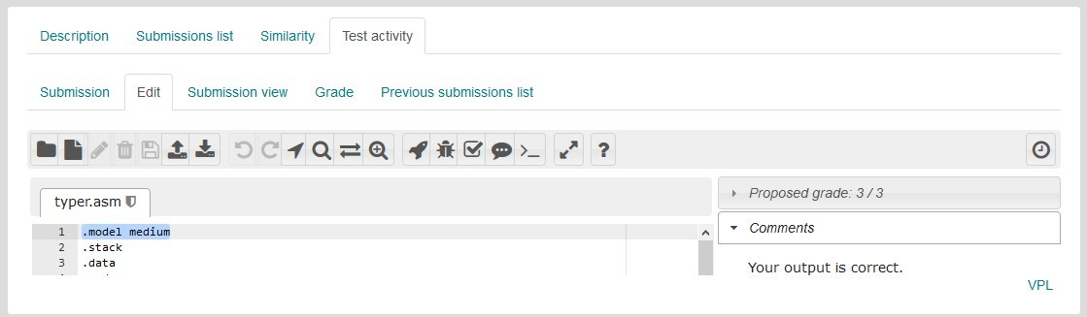
You can click the Run tab (rocket circled in red) and VPL will compile, link and run the program for you (I think this is easier than DOSBox). If you click inside the console window you can check your program by typing characters from the keyboard, your code is running on a server in the machine room. You can even quit and type typer and press <return> to restart the program. We have set a time limit of 60 seconds to do this before the server times out. You could re-run if you wish.

Click in this window and type “abc1234567890DEFq” from the keyboard to see what we mean; you should see something similar to that shown below.
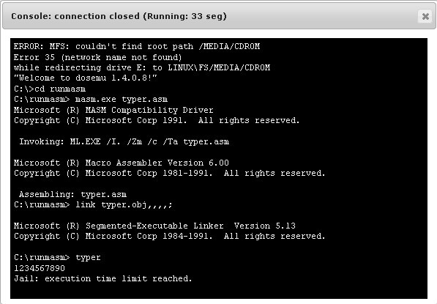
Use the VPL to obtain a grade for your assignment using Evaluate, (tick box circled in blue). Evaluate uses the test case of “ADB0123456789cdeq” as an input to test your program. If you did not get full marks try modifying your code to meet all the criteria of the assignment, you may Evaluate your submission multiple times.

Answer:
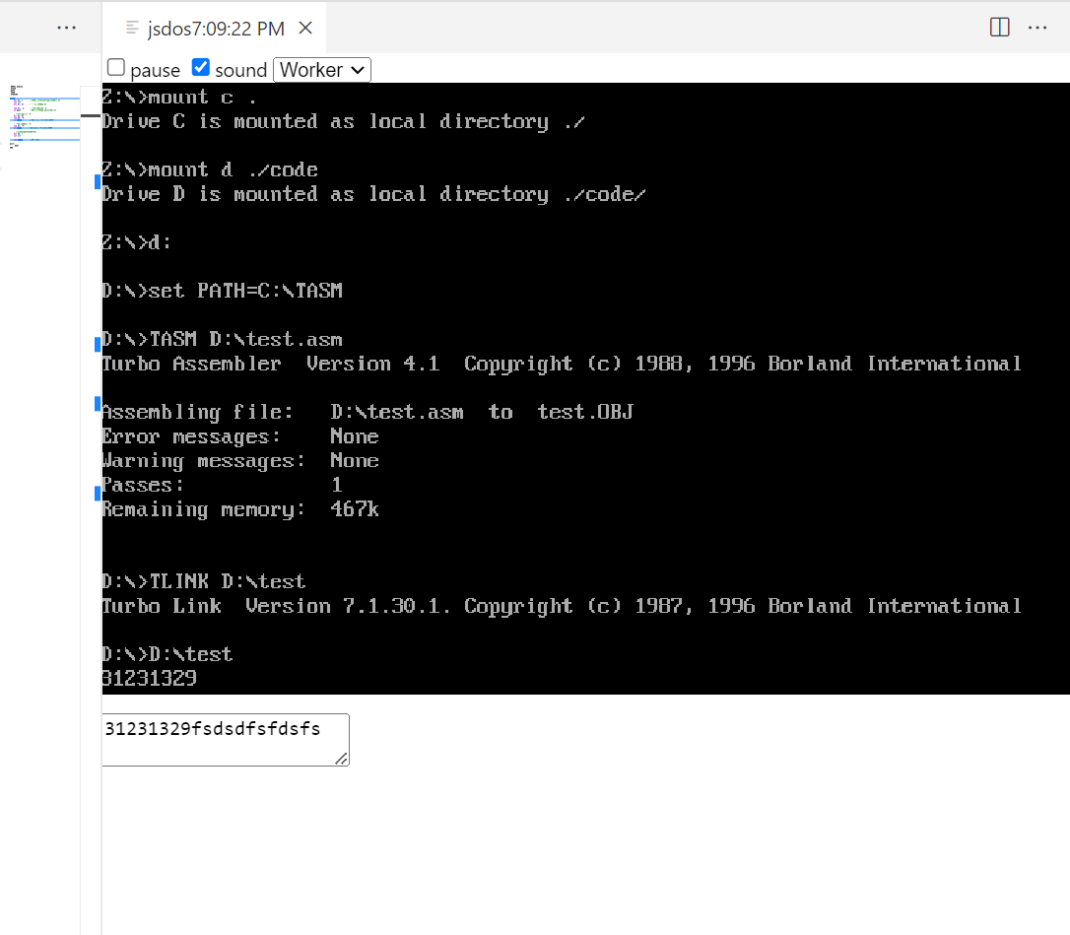
Code:

.MODEL medium
.STACK
.DATA
.CODE
.STARTUP

nextc:
mov ah, 8
int 21h
mov dl, al

cmp dl, 'q'
je quit

mov ah, dl
cmp ah, '0'
jc nextc

cmp dl, '9'
ja nextc

mov ah, 2
int 21h

jmp nextc

quit:
.EXIT
END

Part 2: Copy and paste your working typer.asm program to a new file called alpha.asm. Create this file in the second VPL assignment (if it doesn’t exist already).
Modify the code so that it prints all characters typed to the screen. Alphabetical characters should only appear as capitals.

The character code for ‘A’ is 65 and the character code ‘a’ is 97. This means that to convert a lowercase character into an upper character you need to subtract (97- 65)=32 from the character code.

The assembly language mnemonic for subtraction is sub dl,123.
Your program should terminate when the <escape> key is pressed. This key press should not be echoed to the screen.
The following figure shows the code output when the following string was entered from the keyboard
123abc456XYZ<escape>
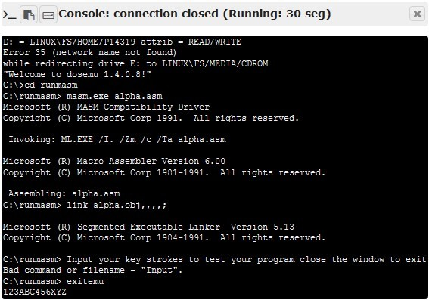

Answer:
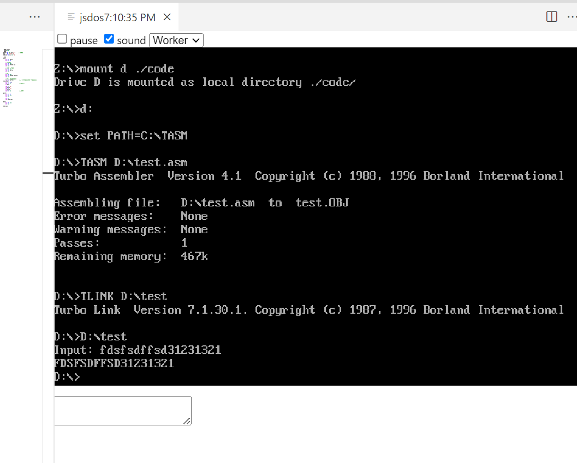

Code:

.MODEL small
.STACK 100h
.DATA
buffer db 100 dup('$')
msg db 'Input: $'
newline db 13, 10, '$'

.CODE
main:
mov ax, @data
mov ds, ax

mov ah, 09h
mov dx, offset msg
int 21h

mov ah, 0Ah
lea dx, buffer
int 21h

mov ah, 09h
mov dx, offset newline
int 21h

lea si, buffer+2
next_char:
mov al, [si]
cmp al, 13
je done

cmp al, 'a'
jb print
cmp al, 'z'
ja print
sub al, 32

print:
mov dl, al
mov ah, 02h
int 21h

inc si
jmp next_char

done:
mov ah, 4Ch
int 21h

END main

Part 3: Bench mark your computer, MASM speed test.
Enter the following program into your computer and then compile it using MASM within DOSBox as before.

.MODEL medium
.STACK
.DATA
.CODE

.STARTUP
mov ah,02 ;Print S mov dl,'S'
int 021h
 | mov | bx, 65000 | ;4
back2: back1: | mov nop loop | cx, 64000  back1 | ;4  ;3  ;17^or5v
 | dec jnz | bx back2 | ;2  ;16^or4v

Treat inner loop as a single instruction that takes CI clock cycles to complete.
CI = CStart + N (CBack ) – (J Back – J Forward )
CI = 4 + 64,000(17 + 3) – (17 – 5)
CI = ?
mov ah,02 ;Print F mov dl,'F'
int 021h
Calculate total number of clock cycles required to complete code.
CTotal = CStart + N (CBack ) – (JBack – JForward )
CTotal = 4 + 65,000(16 + 2 + CI ) – (16 – 4)
CTotal = ?

.EXIT END

However this time we wish to run the code created on the Windows machine rather than the emulator (DosBox), which is slow and not representative of the machines true speed. Open a command prompt by clicking on the Windows start button then enter “command” into “Search program and files” and press return (or All program – Accessories – Command prompt). On lab machines just click on command prompt (black rectangle icon) on start bar.
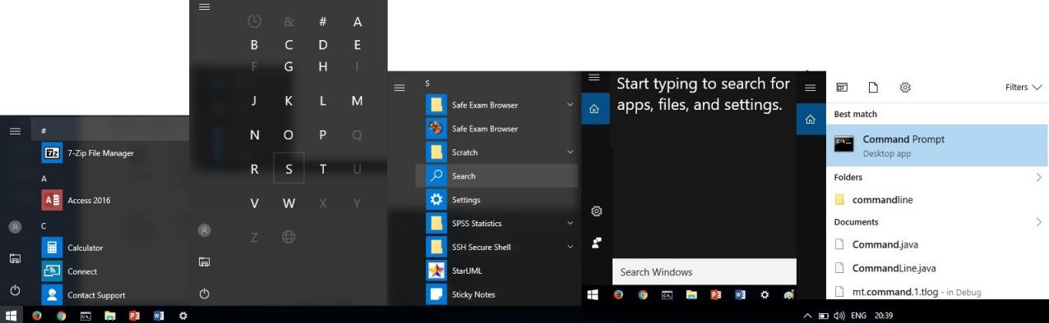
Click on Window button, then the #, then S, select Search, enter “Command”, then run Command prompt, also good to find (MS_Paint and the Control panel etc).

Change the path to the MASM bin folder and run the program by entering speed and pressing return.
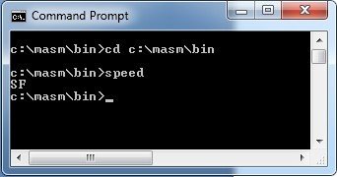

Measure the time between the “S” (for Start) and “F” (for Finish) appearing on screen, use a stopwatch. If you want more precision, you should create the following batch file in Notepad++. The batch can be run by typing its name at the command prompt; it displays the time before and after the program runs; call the file time_it.bat when you save it. The batch file should be in same folder as speed.exe.

@echo off
echo Start Time: %time% echo.
speed.exe echo. echo.
echo Finish Time: %time%
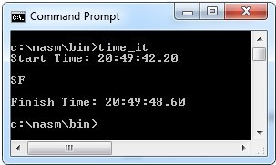

Repeat your timing measurement about 5 times and calculate the average run time in seconds, TAvg. Are the times consistent?
CPU _ Clock _ rate = CTotal
TAvg
Note the computer in the laboratory contains an i3-4160 processor running at
3.6GHz but don’t expect your answer to be the same.
To record your calculation of the speed of your PC answer the MASM speed test quiz

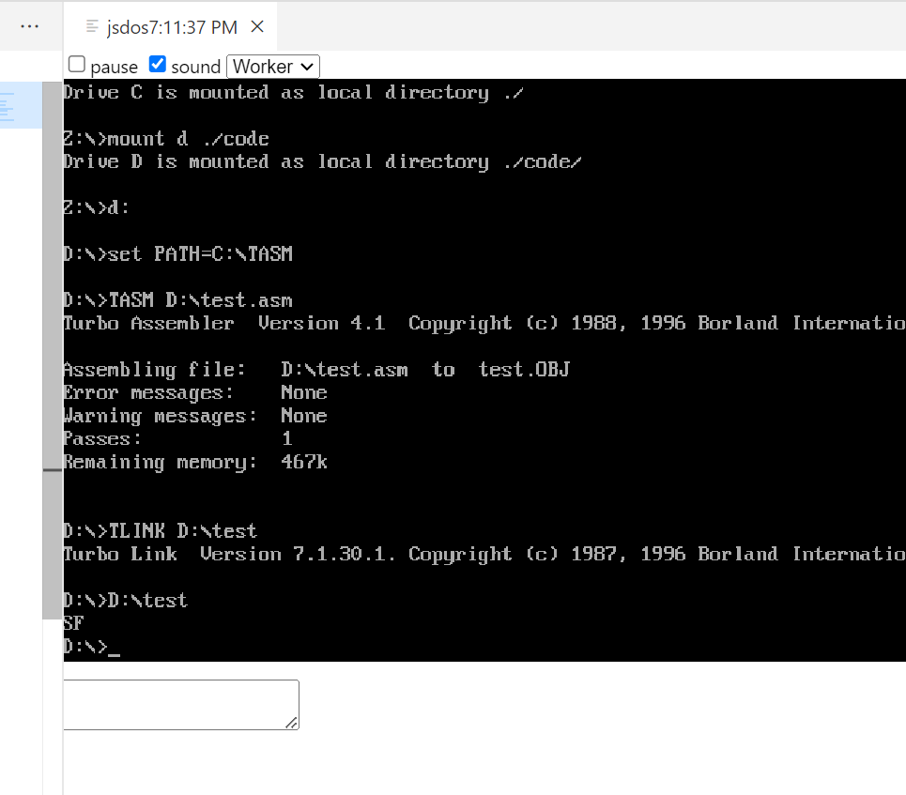

Code:

.MODEL medium
.STACK
.DATA
.CODE
.STARTUP

mov ah, 02h
mov dl, 'S'
int 21h

mov bx, 6500
back2:
mov cx, 6400
back1:
nop
loop back1

dec bx
jnz back2

mov ah, 02h
mov dl, 'F'
int 21h

.EXIT
END

CPU _ Clock _ rate =30Mhz
Time : 27s

Part 4: Complete the general quiz.

