CS253 Laboratory session 3

Part 1: Evaluating floating point expressions using the maths co-processor.

CODE:
.286
.model medium
.8087
.stack 100h

.DATA
SX dd 3.0 ;
SY dd 4.0 ;
cntrl dw 03FFh ;
stat dw 0 ;
INTG dw 0 ;
CRLF db 0Dh,0Ah,'$' ;

.CODE
.STARTUP
FINIT
FLDCW cntrl

;—— HY = sqrt(SX² + SY²) ——————————————————
FLD SX
FMUL ST,ST(0) ; ST0 = SX*SX
FLD SY
FMUL ST,ST(0) ; ST0 = SY*SY
FADD ST,ST(1) ; ST0 = SX²+SY²
FSQRT ; ST0 = √(SX²+SY²)
FSTSW stat
mov ax,stat
and al,0BFh
jnz DONE
FSTP HY ;

—
mov bx,OFFSET HY
add bx,2
mov ax,[bx]
mov bx,ax
mov cx,16
_P_HIGH:
rol bx,1
jc _H1
mov dl,'0'
jmp _H2
_H1:
mov dl,'1'
_H2:
mov ah,02h
int 21h
loop _P_HIGH

mov bx,OFFSET HY
mov ax,[bx]
mov bx,ax
mov cx,16
_P_LOW:
rol bx,1
jc _L1
mov dl,'0'
jmp _L2
_L1:
mov dl,'1'
_L2:
mov ah,02h
int 21h
loop _P_LOW

mov dx,OFFSET CRLF
mov ah,09h
int 21h
————————————
fld HY
fistp word ptr INTG ; INTG ← 5

mov ax,INTG
xor dx,dx
mov bx,10
div bx
cmp ax,0
je _PRINT_REM
add al,'0'
mov dl,al
mov ah,02h
int 21h
_PRINT_REM:
add dl,'0'
mov ah,02h
int 21h

mov dl,'.'
mov ah,02h
int 21h
mov dl,'0'
mov ah,02h
int 21h

DONE:
.EXIT
END
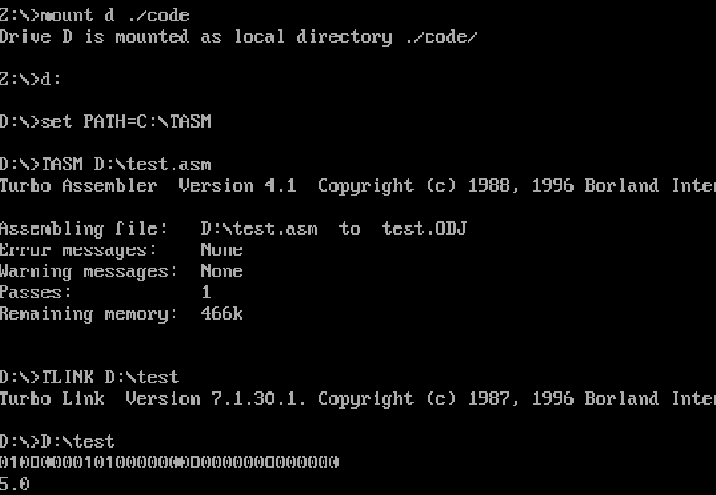

Part 2: So far we have created and compiled a number of assembly language programs using the Microsoft assembler (MASM). Writing a big program using MASM is probably impractical. However, you can embed assembly language in your C\C++ programs. This is something that you could do in practice so as to optimise a piece of code or make use of instructions that are not accessible via the standard libraries (such a MMX, multimedia extension).
This approach has the benefit of allowing you to write the input and output in C/C++ and use the assembly language for high speed calculation.

It should be said that in practice compilers are so good that it is very difficult to write better machine code than they can generate.

CODE
// MASM_FP.cpp : Defines the entry point for the console application. #include "stdafx.h"
#include <stdio.h>

void test(void); // Function prototype (description) int _tmain(int argc, _TCHAR* argv[])
{
test(); return 0;
}
// Put our unmanaged asm code in here void test()
{
unsigned short num1; unsigned short num2; unsigned short result;
printf("Enter first number: "); scanf(" %hd",&num1); printf("Enter second number: "); scanf(" %hd",&num2);

asm
{

}

mov ax, num1 ; Direct addressing to access num1 mov bx, num2 ; put value in num2 into bx
add ax, bx ; ax=ax+bx
mov result,ax; ; put value into result

printf("%hd",result); // Display result

// Wait for enter to be pressed before terminating while(getchar()!=10); // Clear buffer of previous <ret> while(getchar()!=10); // Wait for a new <ret>
}

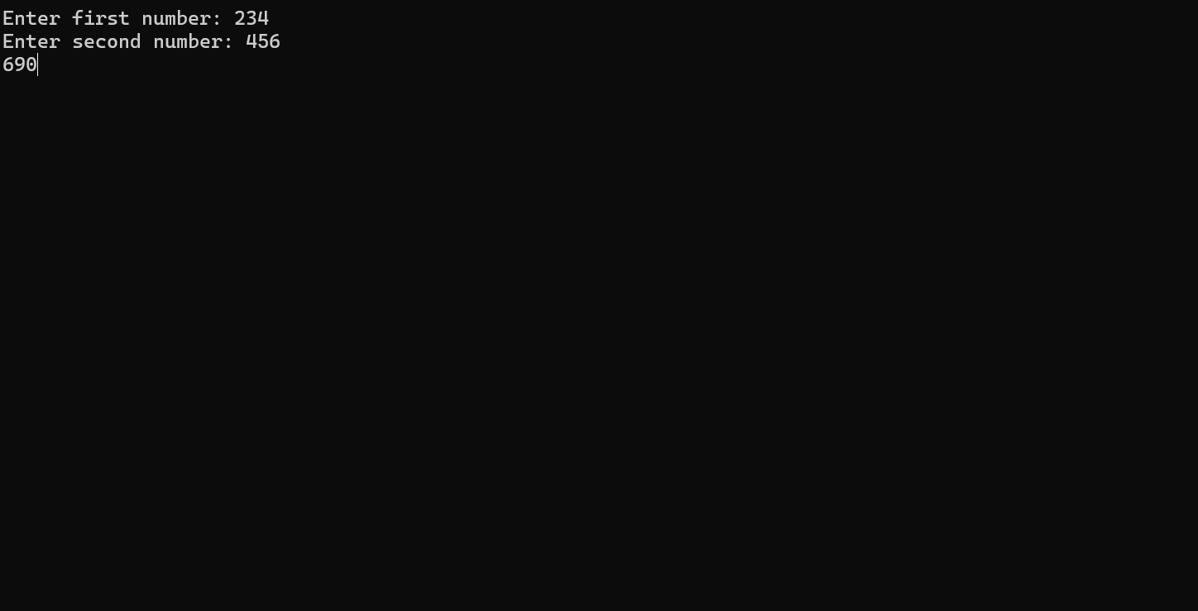

Part 3: Use the sample code on the next page to generate a suitable frame work for creating code to implement a floating point calculation using Assembly Language from within a C++ program. The program puts the contents of variables on the floating stack and then takes the value on the floating point stack and puts it back into the variable C.
Program 2
// MASM_FP.cpp : Defines the entry point for the console application. #include "stdafx.h"
#include <stdio.h>
void test(void); // Function prototype (description) int _tmain(int argc, _TCHAR* argv[])
{
test(); return 0;
}
void test()
{
float A=2,C=0;
unsigned short cntrl=0x3FF,stat;
asm
{
FINIT
FLDCW cntrl ; Round even, Mask Interrupts FLD A ; Push SX onto FP stack

FSTSW stat ; Load FPU status into [stat]
FSTP C ; Copy result from stack into HY
}

// Binary representation of the 4 bytes, (32 bits) coding HY printf("Binary:");
unsigned char byt; for(int x=3;x>=0;x--)
{
byt=*((unsigned char *)&C+x); for(int y=128;y>0;y/=2)
{
if ((y&byt)==0) printf("0"); else printf("1");
}
}
// Decimal format printf("\nDecimal: %3.0f",C);
// Hex format printf("\nHex:"); for(int x=3;x>=0;x--)
{
byt=*((unsigned char *)&C+x);
printf("%x",(unsigned int)byt);
}

// Decimal 4 byte format printf("\nDecimal (4bytes):"); for(int x=3;x>=0;x--)
{
byt=*((unsigned char *)&C+x); printf("%d,",(unsigned int)byt);
}
// while(getchar()!=10); while(getchar()!=10);
}

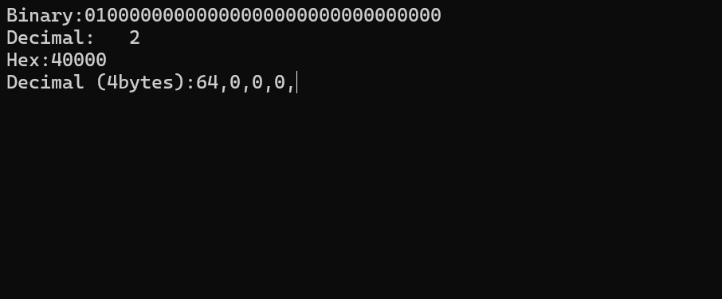

Part 4: The aim of the next section is to show how it possible using assembly language to directly access CPU instructions that are not directly available when you use a higher level language.

#include "stdafx.h"
#include <stdio.h>

void test(void); /

int _tmain(int argc, _TCHAR* argv[])
{
test();
return 0;
}

void test()
{
//
union mmx_word {
unsigned char byte[8];
unsigned __int64 value;
};

mmx_word NUM1 = { 0,1,2,3,4,5,6,7 };
mmx_word NUM2 = { 1,1,1,1,1,1,1,1 };

__asm {
//
movq mm0, NUM1
movq mm1, NUM2

paddb mm0, mm1

movq NUM1, mm0

emms
}

printf("Result bytes: ")
for (int i = 0; i < 8; i++) {
printf("%u", (unsigned int)NUM1.byte[i]);
if (i < 7) printf(",");
}
printf("\n");

/
while (getchar() != '\n');
while (getchar() != '\n');
}

