Q1

(base) PS D:\梅努斯\计算机结构\labs> ndisasm -e217h -b16 "D:\梅努斯\计算机结构\labs\lab4\Lab04-ABC-files\A.EXE"
00000000 9BDBE3 finit
00000003 9BD92E0E00 wait fldcw [0xe]
00000008 9BD9060200 wait fld dword [0x2]
0000000D 9BD8C8 wait fmul st0
00000010 9BD9060600 wait fld dword [0x6]
00000015 9BD8C8 wait fmul st0
00000018 9BD8C1 wait fadd st1
0000001B 9BD9FA wait fsqrt
0000001E 9BDD3E1000 fstsw [0x10]
00000023 A11000 mov ax,[0x10]
00000026 24BF and al,0xbf
00000028 7505 jnz 0x2f
0000002A 9BD91E0A00 wait fstp dword [0xa]
0000002F 90 nop
00000030 BB0A00 mov bx,0xa
00000033 43 inc bx
00000034 43 inc bx
00000035 8B07 mov ax,[bx]
00000037 8BD8 mov bx,ax
00000039 B91000 mov cx,0x10
0000003C D1C3 rol bx,1
0000003E 7204 jc 0x44
00000040 B230 mov dl,0x30
00000042 EB02 jmp short 0x46
00000044 B231 mov dl,0x31
00000046 B402 mov ah,0x2
00000048 CD21 int 0x21
0000004A E2F0 loop 0x3c
0000004C BB0A00 mov bx,0xa
0000004F 8B07 mov ax,[bx]
00000051 8BD8 mov bx,ax
00000053 B91000 mov cx,0x10
00000056 D1C3 rol bx,1
00000058 7204 jc 0x5e
0000005A B230 mov dl,0x30
0000005C EB02 jmp short 0x60
0000005E B231 mov dl,0x31
00000060 B402 mov ah,0x2

00000062 CD21 int 0x21
00000064 E2F0 loop 0x56
00000066 B44C mov ah,0x4c
00000068 CD21 int 0x21
0000006A 0000 add [bx+si],al
0000006C 00804000 add [bx+si+0x40],al
00000070 004040 add [bx+si+0x40],al
00000073 0000 add [bx+si],al
00000075 0000 add [bx+si],al
00000077 FF03 inc word [bp+di]
00000079 0000 add [bx+si],al

Answer:
This is corresponding to “floating point calculation”

(base) PS D:\梅努斯\计算机结构\labs> ndisasm -e217h -b16 "D:\梅努斯\计算机结构\labs\lab4\Lab04-ABC-files\B.EXE"
00000000 BB0000 mov bx,0x0
00000003 8B17 mov dx,[bx]
00000005 80FA24 cmp dl,0x24
00000008 7407 jz 0x11
0000000A B402 mov ah,0x2
0000000C CD21 int 0x21
0000000E 43 inc bx
0000000F EBF2 jmp short 0x3
00000011 90 nop
00000012 90 nop
00000013 90 nop
00000014 B44C mov ah,0x4c
00000016 CD21 int 0x21
00000018 004865 add [bx+si+0x65],cl
0000001B 6C insb
0000001C 6C insb
0000001D 6F outsw
0000001E 20576F and [bx+0x6f],dl
00000021 726C jc 0x8f
00000023 64 fs
00000024 24 db 0x24

Answer:
This is corresponding to “Hello world”

(base) PS D:\梅努斯\计算机结构\labs> ndisasm -e217h -b16 "D:\梅努斯\计算机结构\labs\lab4\Lab04-ABC-files\C.EXE"
00000000 B408 mov ah,0x8
00000002 CD21 int 0x21
00000004 8AD0 mov dl,al
00000006 80FA51 cmp dl,0x51
00000009 7406 jz 0x11
0000000B B402 mov ah,0x2
0000000D CD21 int 0x21
0000000F 75EF jnz 0x0
00000011 90 nop
00000012 B44C mov ah,0x4c
00000014 CD21 int 0x21
Answer:
This is corresponding to “typing tutor”

Ques2

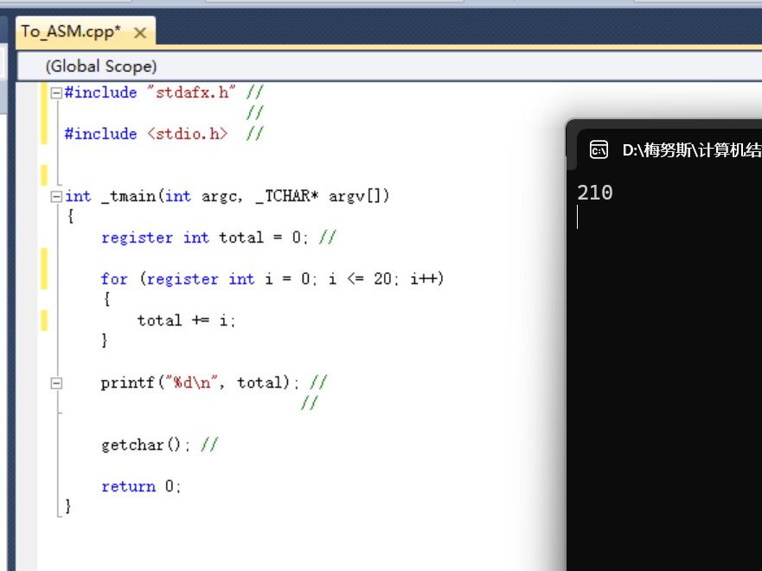

To_ASM.cod
; Listing generated by Microsoft (R) Optimizing Compiler Version 16.00.30319.01

TITLE D:\÷Ŭ˹\������ṹ\labs\lab4\To_ASM\To_ASM\To_ASM.cpp
.686P
.XMM
include listing.inc
.model flat

INCLUDELIB MSVCRTD
INCLUDELIB OLDNAMES

PUBLIC ??_C@_03PMGGPEJJ@?$CFd?6?$AA@ ; `string'
PUBLIC _wmain
EXTRN __imp__getchar:PROC
EXTRN __imp__printf:PROC
EXTRN __RTC_CheckEsp:PROC
EXTRN __RTC_Shutdown:PROC
EXTRN __RTC_InitBase:PROC
; COMDAT ??_C@_03PMGGPEJJ@?$CFd?6?$AA@
; File d:\÷Ŭ˹\������ṹ\labs\lab4\to_asm\to_asm\to_asm.cpp
CONST SEGMENT
??_C@_03PMGGPEJJ@?$CFd?6?$AA@ DB '%d', 0aH, 00H ; `string'
CONST ENDS
; COMDAT rtc$TMZ
rtc$TMZ SEGMENT
__RTC_Shutdown.rtc$TMZ DD FLAT:__RTC_Shutdown
rtc$TMZ ENDS
; COMDAT rtc$IMZ
rtc$IMZ SEGMENT
__RTC_InitBase.rtc$IMZ DD FLAT:__RTC_InitBase
; Function compile flags: /Odtp /RTCsu /ZI
rtc$IMZ ENDS
; COMDAT _wmain
_TEXT SEGMENT
_i$5260 = -20 ; size = 4
_total$ = -8 ; size = 4
_argc$ = 8 ; size = 4
_argv$ = 12 ; size = 4
_wmain PROC ; COMDAT

; 9 : {

00000 55 push ebp
00001 8b ec mov ebp, esp
00003 81 ec d8 00 00
00 sub esp, 216 ; 000000d8H
00009 53 push ebx
0000a 56 push esi
0000b 57 push edi
0000c 8d bd 28 ff ff
ff lea edi, DWORD PTR [ebp-216]
00012 b9 36 00 00 00 mov ecx, 54 ; 00000036H
00017 b8 cc cc cc cc mov eax, -858993460 ; ccccccccH
0001c f3 ab rep stosd

; 10 : register int total = 0; //

0001e c7 45 f8 00 00
00 00 mov DWORD PTR _total$[ebp], 0

; 11 : // ʹ�� for ѭ������ 0 �� 20 �ĺ�
; 12 : for (register int i = 0; i <= 20; i++) // �����Ĵ������ͱ��� i ��Ϊѭ��������

00025 c7 45 ec 00 00
00 00 mov DWORD PTR _i$5260[ebp], 0
0002c eb 09 jmp SHORT $LN3@wmain
$LN2@wmain:
0002e 8b 45 ec mov eax, DWORD PTR _i$5260[ebp]
00031 83 c0 01 add eax, 1
00034 89 45 ec mov DWORD PTR _i$5260[ebp], eax
$LN3@wmain:
00037 83 7d ec 14 cmp DWORD PTR _i$5260[ebp], 20 ; 00000014H
0003b 7f 0b jg SHORT $LN1@wmain

; 13 : {
; 14 : total += i; // �� i ��ֵ�ۼӵ� total

0003d 8b 45 f8 mov eax, DWORD PTR _total$[ebp]
00040 03 45 ec add eax, DWORD PTR _i$5260[ebp]
00043 89 45 f8 mov DWORD PTR _total$[ebp], eax

; 15 : }

00046 eb e6 jmp SHORT $LN2@wmain
$LN1@wmain:

; 16 :
; 17 : printf("%d\n", total); //

00048 8b f4 mov esi, esp
0004a 8b 45 f8 mov eax, DWORD PTR _total$[ebp]
0004d 50 push eax
0004e 68 00 00 00 00 push OFFSET ??_C@_03PMGGPEJJ@?$CFd?6?$AA@
00053 ff 15 00 00 00
00 call DWORD PTR __imp__printf
00059 83 c4 08 add esp, 8
0005c 3b f4 cmp esi, esp
0005e e8 00 00 00 00 call __RTC_CheckEsp

; 18 : //
; 19 :
; 20 : getchar(); //

00063 8b f4 mov esi, esp
00065 ff 15 00 00 00
00 call DWORD PTR __imp__getchar
0006b 3b f4 cmp esi, esp
0006d e8 00 00 00 00 call __RTC_CheckEsp

; 21 :
; 22 : return 0;

00072 33 c0 xor eax, eax

; 23 : }

00074 5f pop edi
00075 5e pop esi
00076 5b pop ebx
00077 81 c4 d8 00 00
00 add esp, 216 ; 000000d8H
0007d 3b ec cmp ebp, esp
0007f e8 00 00 00 00 call __RTC_CheckEsp
00084 8b e5 mov esp, ebp
00086 5d pop ebp
00087 c3 ret 0
_wmain ENDP
_TEXT ENDS
END

Ques3

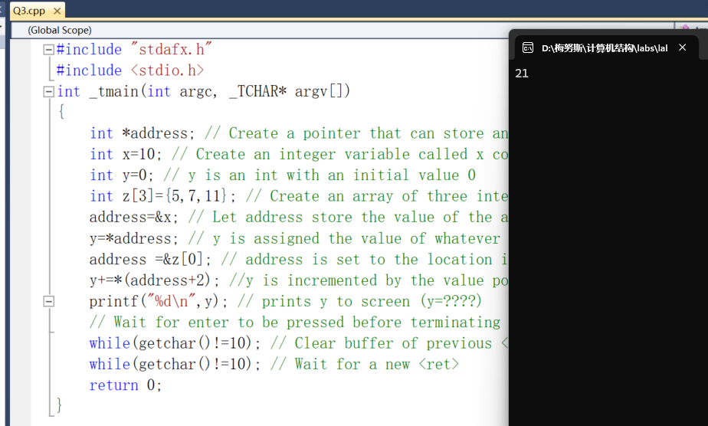

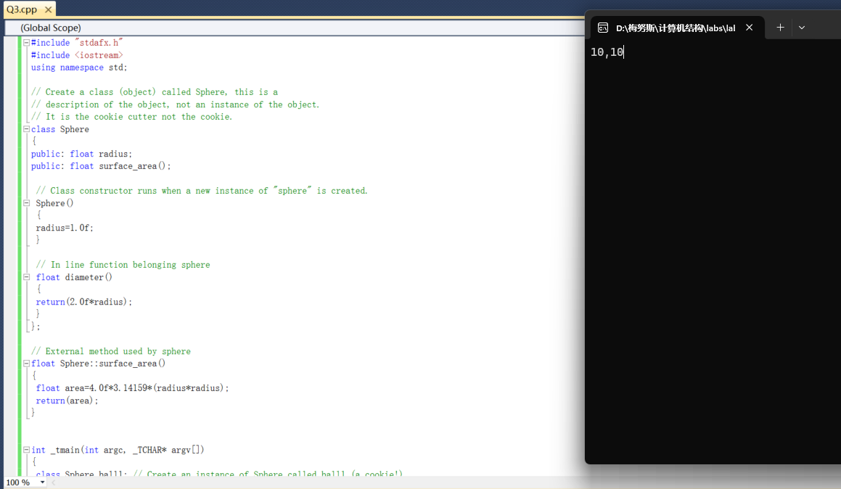

Ques4

Hello

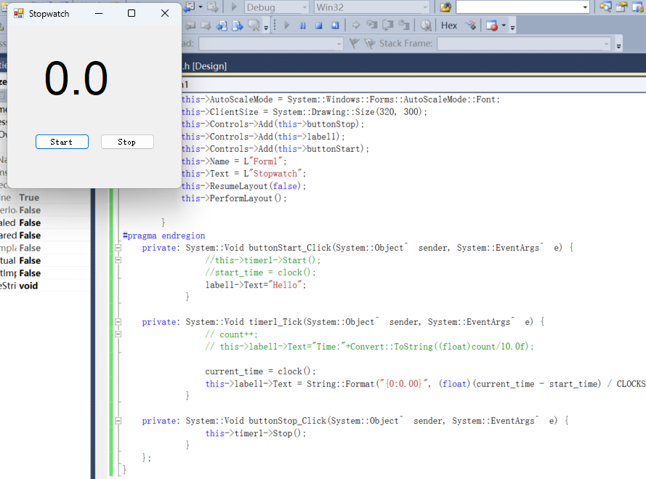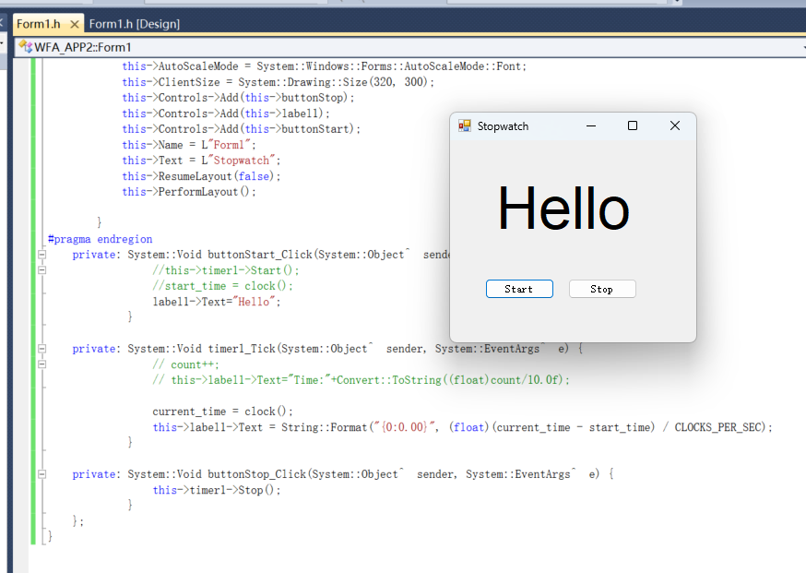

Timer
