Task1
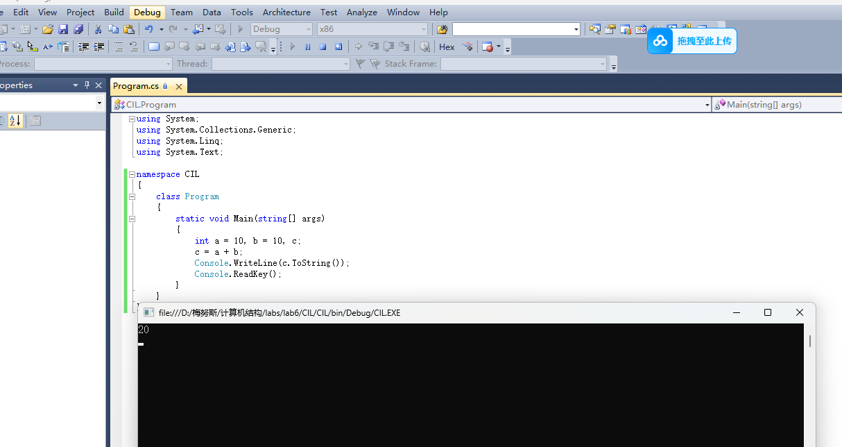

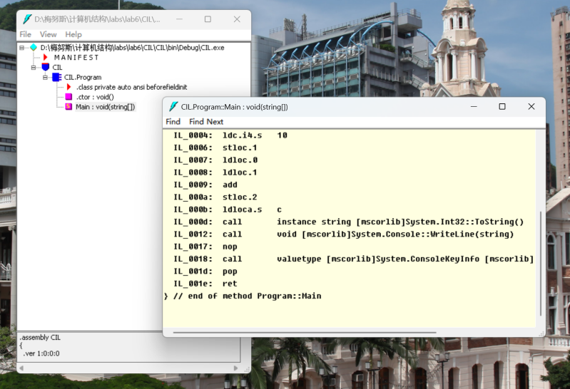

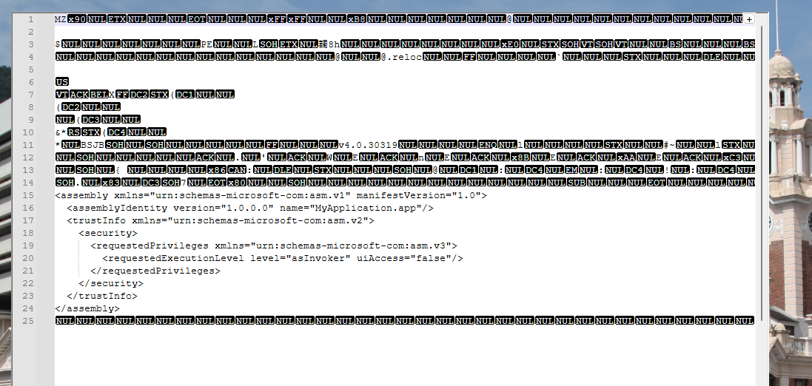

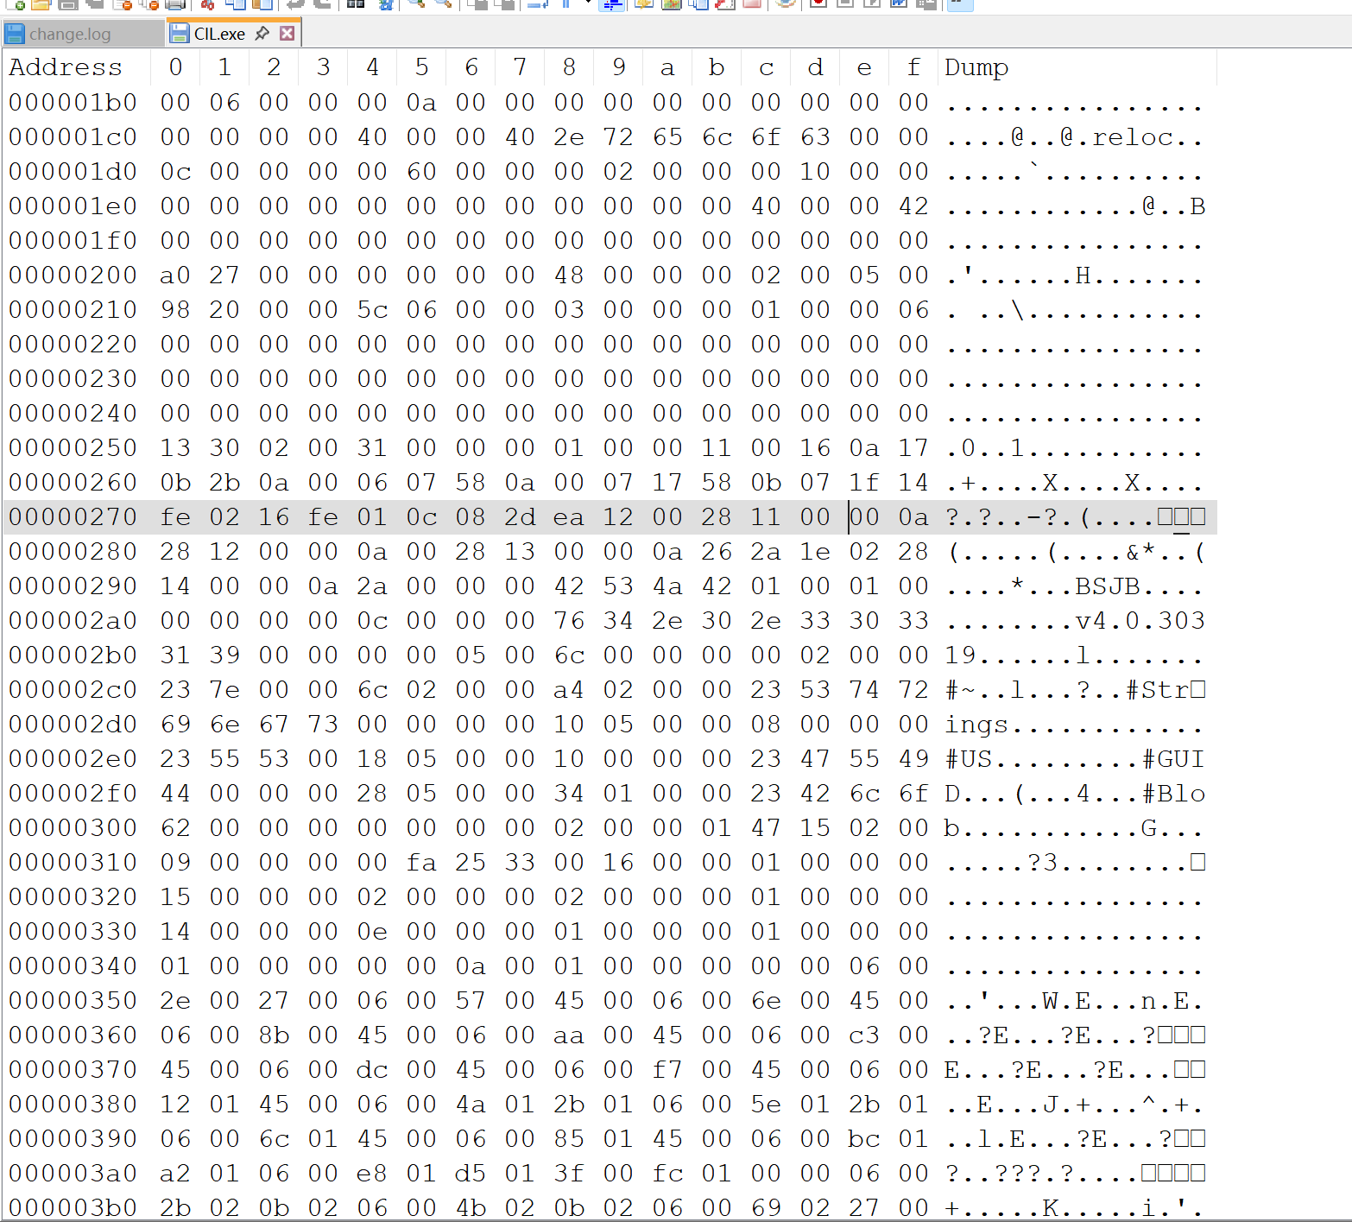

Task2

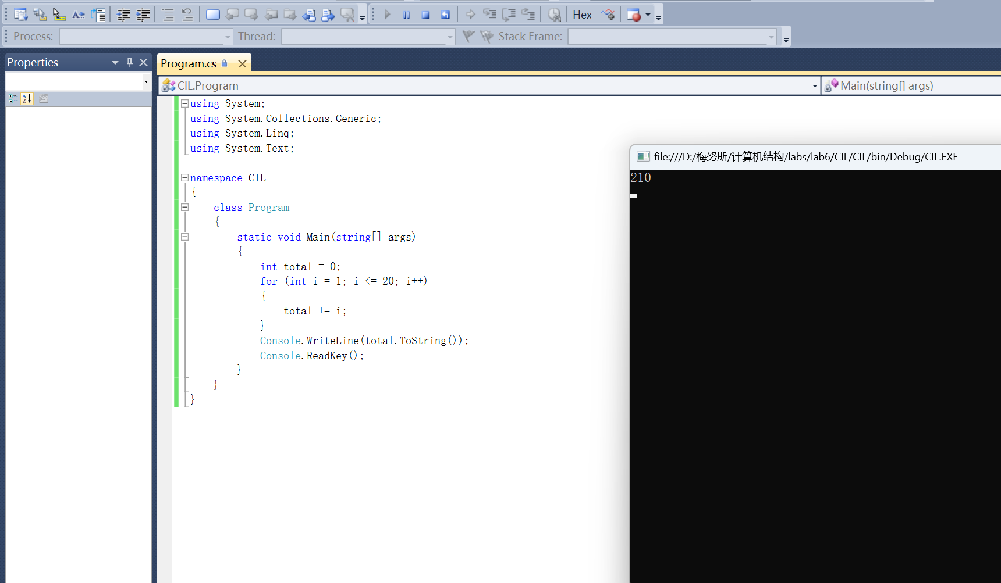

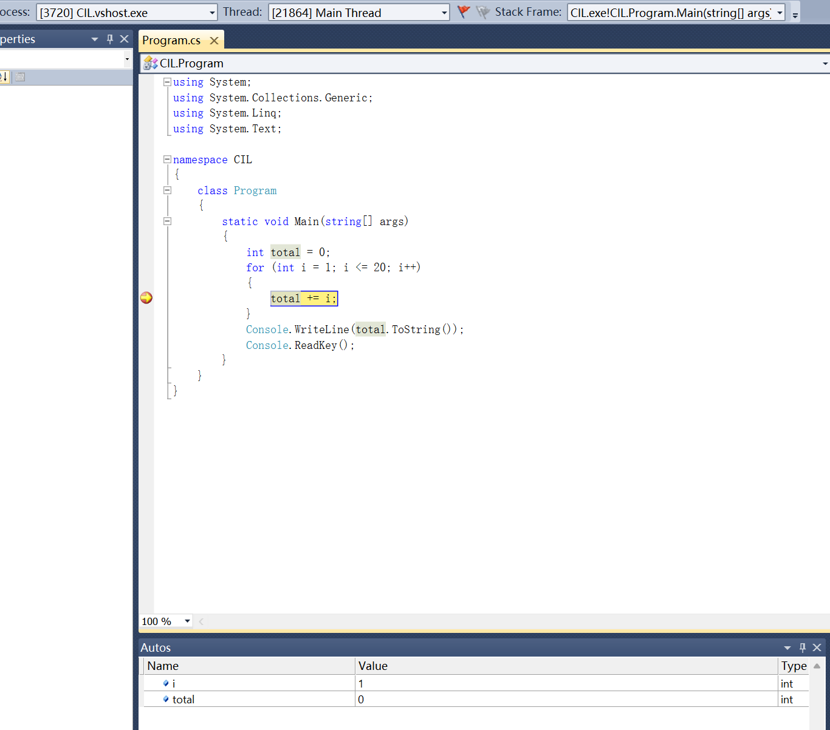

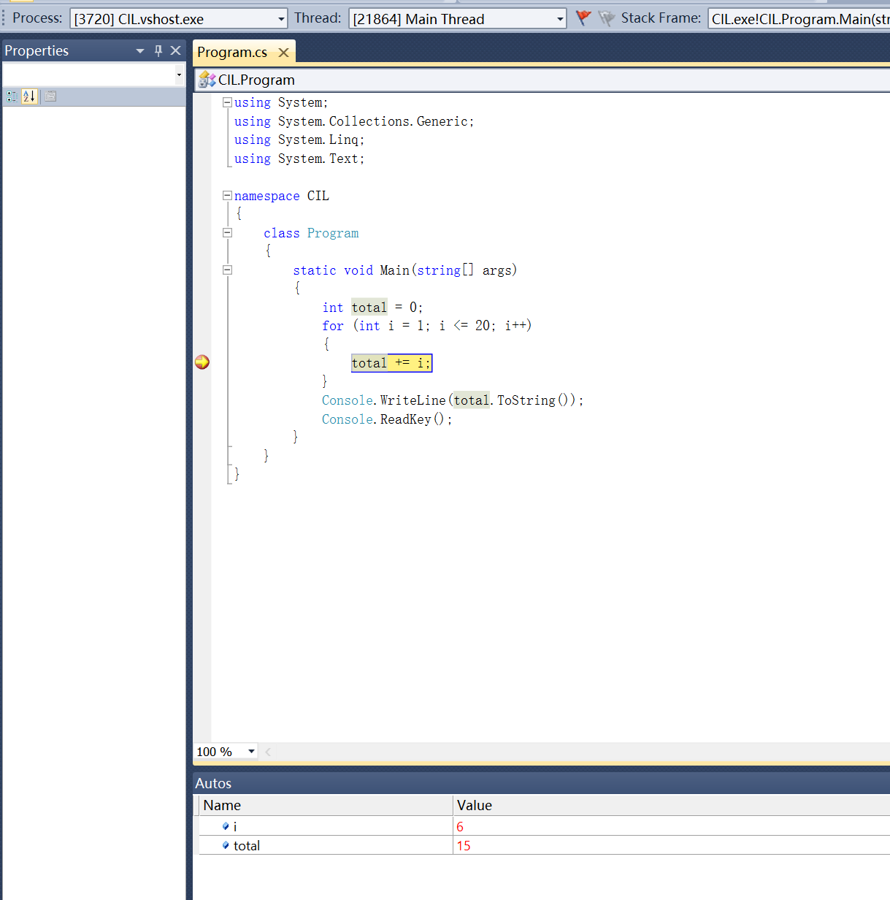

Task3

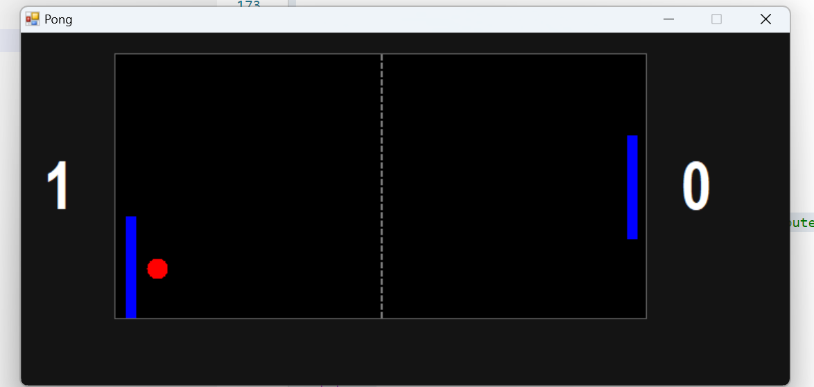

using System;
using System.Drawing;
using System.Windows.Forms;
using System.Media;
using System.Runtime.InteropServices;

namespace Pong
{
public partial class Form1 : Form
{

Point Ball;
Point Ball_Direction;
int Paddle_Left_Y = 128;
int Paddle_Right_Y = 128;
bool Game_paused = true;
int Left_score = 0;
int Right_score = 0;

SoundPlayer plickSound;
SoundPlayer plunkSound;

private Label label1;
private Label label2;
private Timer timer1;

[DllImport("user32.dll")]
static extern ushort GetAsyncKeyState(int vKey);

public static bool IsKeyPushedDown(Keys keyData)
{
return 0 != (GetAsyncKeyState((int)keyData) & 0x8000);
}

public Form1()
{

this.ClientSize = new System.Drawing.Size(740, 340);
this.Text = "Pong";
this.BackColor = Color.FromArgb(20, 20, 20); / this.FormBorderStyle = FormBorderStyle.FixedSingle; /
this.MaximizeBox = false; //

this.pictureBox1 = new System.Windows.Forms.PictureBox();
this.pictureBox1.Name = "pictureBox1";
this.pictureBox1.Location = new System.Drawing.Point(90, 20);
this.pictureBox1.Size = new System.Drawing.Size(512, 256);
this.pictureBox1.BorderStyle = System.Windows.Forms.BorderStyle.FixedSingle;
this.pictureBox1.BackColor = Color.Black;
this.pictureBox1.TabStop = false;
this.Controls.Add(this.pictureBox1);

this.label1 = new System.Windows.Forms.Label();
this.label1.Name = "label1";
this.label1.Font = new System.Drawing.Font("Arial Narrow", 48F, System.Drawing.FontStyle.Bold);
this.label1.Text = "0";
this.label1.AutoSize = true;
this.label1.ForeColor = Color.White;
this.Controls.Add(this.label1);
this.label1.Location = new System.Drawing.Point(this.pictureBox1.Left - this.label1.Width - 20 > 5 ? this.pictureBox1.Left - this.label1.Width - 20 : 5,
this.pictureBox1.Top + (this.pictureBox1.Height - this.label1.Height) / 2);

this.label2 = new System.Windows.Forms.Label();
this.label2.Name = "label2";
this.label2.Font = new System.Drawing.Font("Arial Narrow", 48F, System.Drawing.FontStyle.Bold);
this.label2.Text = "0";
this.label2.AutoSize = true;
this.label2.ForeColor = Color.White;
this.Controls.Add(this.label2);
this.label2.Location = new System.Drawing.Point(this.pictureBox1.Right + 20,
this.pictureBox1.Top + (this.pictureBox1.Height - this.label2.Height) / 2);

this.timer1 = new System.Windows.Forms.Timer();
this.timer1.Enabled = true;
this.timer1.Interval = 10; //
this.timer1.Tick += new System.EventHandler(this.timer1_Tick);

this.ResumeLayout(false); //
this.PerformLayout();

/
try
{
// bin\Release)
plickSound = new SoundPlayer(@"plick.wav");
plunkSound = new SoundPlayer(@"plunk.wav");
plickSound.LoadAsync();
plunkSound.LoadAsync();
}
catch (Exception ex)
{
MessageBox.Show("加ó载?声Θ?音?文?件t失骸?败悒? " + ex.Message + "\n请?确ā?保馈?plick.wav 和í plunk.wav 在ú程ì序ò运?行D目?录?下?。￡", "声Θ?音?错洙?误ó", MessageBoxButtons.OK, MessageBoxIcon.Warning);
plickSound = null;
plunkSound = null;
}

// 初?始?化ˉ游?戏·状痢?态?变?量?
ResetGameInitial(); // 调獭?用?一?个?方?法ぁ?来ぁ?设Θ?置?初?始?游?戏·状痢?态?
}

private void ResetGameInitial()
{
Ball = new Point(pictureBox1.Width / 2, pictureBox1.Height / 2); // 球ò从洙?中D间?开a始?
Ball_Direction = new Point(3, 3); // 初?始?速ù度è
Paddle_Left_Y = pictureBox1.Height / 2;
Paddle_Right_Y = pictureBox1.Height / 2;
Game_paused = true;
Left_score = 0;
Right_score = 0;
if (label1 != null) label1.Text = Left_score.ToString("0");
if (label2 != null) label2.Text = Right_score.ToString("0");

// 强?制?重?绘?初?始?状痢?态?
if (pictureBox1.Width > 0 && pictureBox1.Height > 0)
{
DrawGameState();
}
}

private void ResetForNewPoint(bool leftPlayerScored)
{
Game_paused = true;
if (leftPlayerScored)
{
Ball = new Point(pictureBox1.Width - 30 - 10, Paddle_Right_Y); // 右?边?发ぁ?球ò (PDF: Ball.X = 480)
Ball_Direction = new Point(-3, 3); // 向ò左哩?发ぁ?球ò
}
else
{
Ball = new Point(30 + 10, Paddle_Left_Y); // 左哩?边?发ぁ?球ò (PDF: Ball.X = 30)
Ball_Direction = new Point(3, 3); // 向ò右?发ぁ?球ò
}
DrawGameState();
}

private void timer1_Tick(object sender, EventArgs e)
{
// Paddle Movement Logic
if (IsKeyPushedDown(Keys.W)) Paddle_Left_Y -= 10;
if (IsKeyPushedDown(Keys.X)) Paddle_Left_Y += 10;
if (IsKeyPushedDown(Keys.P)) Paddle_Right_Y -= 10;
if (IsKeyPushedDown(Keys.M)) Paddle_Right_Y += 10;

int paddleHalfHeight = 50;
if (Paddle_Left_Y < paddleHalfHeight) Paddle_Left_Y = paddleHalfHeight;
if (Paddle_Left_Y > pictureBox1.Height - paddleHalfHeight) Paddle_Left_Y = pictureBox1.Height - paddleHalfHeight;
if (Paddle_Right_Y < paddleHalfHeight) Paddle_Right_Y = paddleHalfHeight;
if (Paddle_Right_Y > pictureBox1.Height - paddleHalfHeight) Paddle_Right_Y = pictureBox1.Height - paddleHalfHeight;

if (IsKeyPushedDown(Keys.Space)) Game_paused = false;
if (IsKeyPushedDown(Keys.Escape)) Application.Exit();

// Ball/Paddle collision
// Left paddle: X is 10, width is 10. Collision at X=20. Ball center X is Ball.X. Ball radius is 10.
// Ball's left edge Ball.X-10. Paddle's right edge 10+10=20.
// Collision if Ball.X-10 <= 20 AND Ball.X-10 > 10 (to avoid sticking)
if (Ball_Direction.X < 0 && Ball.X - 10 <= 20 && Ball.X + 10 > 10 && Math.Abs(Ball.Y - Paddle_Left_Y) < paddleHalfHeight + 10)
{
Ball.X = 20 + 10; // Place ball just outside paddle
Ball_Direction.X = -Ball_Direction.X;
if (plickSound != null) plickSound.Play();
}

// Right paddle: X is pictureBox1.Width-20, width is 10. Collision at X=pictureBox1.Width-20.
// Ball's right edge Ball.X+10. Paddle's left edge pictureBox1.Width-20.
if (Ball_Direction.X > 0 && Ball.X + 10 >= pictureBox1.Width - 20 && Ball.X - 10 < pictureBox1.Width - 10 && Math.Abs(Ball.Y - Paddle_Right_Y) < paddleHalfHeight + 10)
{
Ball.X = pictureBox1.Width - 20 - 10; // Place ball just outside paddle
Ball_Direction.X = -Ball_Direction.X;
if (plickSound != null) plickSound.Play();
}

if (!Game_paused)
{
Ball.X += Ball_Direction.X;
Ball.Y += Ball_Direction.Y;

// Wall collisions
if (Ball.X + 10 >= pictureBox1.Width) // Right wall
{
Left_score++;
if (plunkSound != null) plunkSound.Play();
ResetForNewPoint(false); // Left player scored, so right player (false) serves next (actually means left player serves)
// Let's re-evaluate: if Ball hits right wall, Left_score++. Ball should be reset for Left player to serve.
// PDF: Ball.X = 30; Ball.Y = Paddle_Left_Y;
}
else if (Ball.X - 10 <= 0) // Left wall
{
Right_score++;
if (plunkSound != null) plunkSound.Play();
ResetForNewPoint(true); // Right player scored, so left player (true) serves next
// PDF: Ball.X = 480; Ball.Y = Paddle_Right_Y;
}

if (Ball.Y + 10 >= pictureBox1.Height) // Bottom wall
{
Ball.Y = pictureBox1.Height - 10; // Prevent sticking
Ball_Direction.Y = -Ball_Direction.Y;
if (plunkSound != null) plunkSound.Play();
}
else if (Ball.Y - 10 <= 0) // Top wall
{
Ball.Y = 10; // Prevent sticking
Ball_Direction.Y = -Ball_Direction.Y;
if (plunkSound != null) plunkSound.Play();
}
}

DrawGameState(); // Call common drawing method

label1.Text = Left_score.ToString("0");
label2.Text = Right_score.ToString("0");

if ((Left_score > 2) || (Right_score > 2))
{
timer1.Stop();
String winnerText = (Left_score > Right_score) ? "Left" : "Right";
DialogResult reply = MessageBox.Show(winnerText + " player wins!\r\nDo you wish to play again?",
"Game Over!", MessageBoxButtons.YesNo);
if (reply == DialogResult.Yes)
{
ResetGameInitial();
timer1.Start();
}
else
{
Application.Exit();
}
}
}

private void DrawGameState()
{
if (pictureBox1.Width <= 0 || pictureBox1.Height <= 0) return; // Avoid drawing on invalid surface

Bitmap image = new Bitmap(pictureBox1.Width, pictureBox1.Height);
using (Graphics g = Graphics.FromImage(image))
{
g.Clear(pictureBox1.BackColor); // Clear with PictureBox background color

// Draw Ball
g.FillEllipse(Brushes.Red, Ball.X - 10, Ball.Y - 10, 20, 20);

// Draw Paddles
int paddleHalfHeight = 50;
g.FillRectangle(Brushes.Blue, 10, Paddle_Left_Y - paddleHalfHeight, 10, 100);
g.FillRectangle(Brushes.Blue, pictureBox1.Width - 20, Paddle_Right_Y - paddleHalfHeight, 10, 100);

// Draw center line (optional)
using (Pen dashedPen = new Pen(Color.Gray, 2))
{
dashedPen.DashStyle = System.Drawing.Drawing2D.DashStyle.Dash;
g.DrawLine(dashedPen, pictureBox1.Width / 2, 0, pictureBox1.Width / 2, pictureBox1.Height);
}
}
if (pictureBox1.Image != null)
{
pictureBox1.Image.Dispose();
}
pictureBox1.Image = image;
}

private void pictureBox1_Click(object sender, EventArgs e)
{
+
}
}
}
using System;
using System.Windows.Forms;

namespace Pong
{
static class Program
{
/// <summary>
/// The main entry point for the application.
/// </summary>
[STAThread]
static void Main()
{
Application.EnableVisualStyles();
Application.SetCompatibleTextRenderingDefault(false);
Application.Run(new Form1());
}
}
}

