Task1
Running test
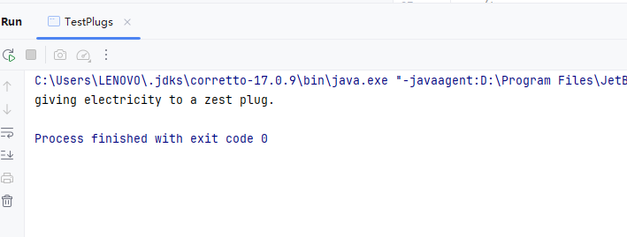

Task2

Implement code

public class Furutech implements UKPlugConnector {

@Override
public void provideElectricity() {
System.out.println("providing electricity to a Furutech plug.");
}
}

Task 3

public class UKToGermanPlugConnectorAdapter implements GermanPlugConnector {

private UKPlugConnector plug;
public UKToGermanPlugConnectorAdapter(UKPlugConnector plug) {
this.plug = plug;
}

@Override
public void giveElectricity() {
// 将调用委托给被适配的英国插头的 provideElectricity() 方法
plug.provideElectricity();
}
}

Runnning test

