- Give the definitions of the following classes: Class P and Class NP.
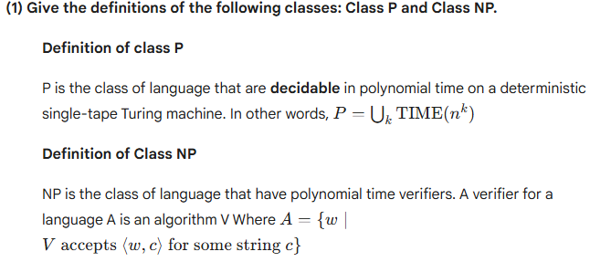
(2) Give the definitions of the following sets: PATH, RELPRIME, SAT, HAMPATH,
COMPOSITES, CLIQUE. Your definition should be self-contained (e.g. for CLIQUE, explain
what a k-clique is).
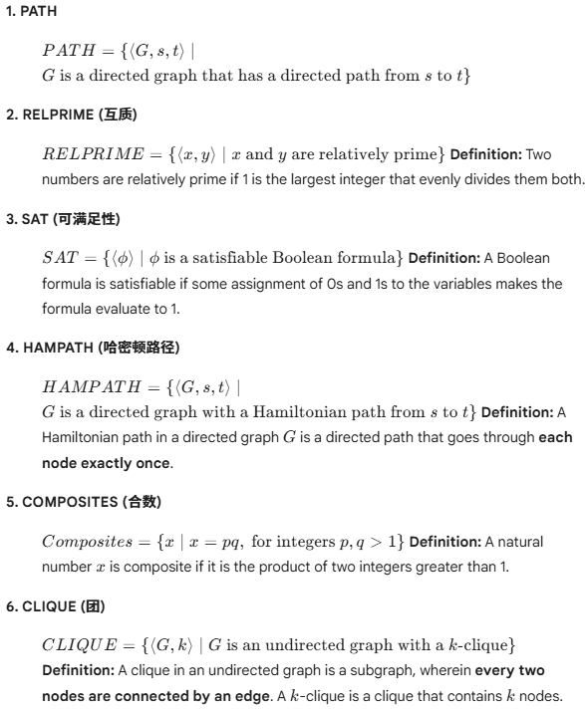
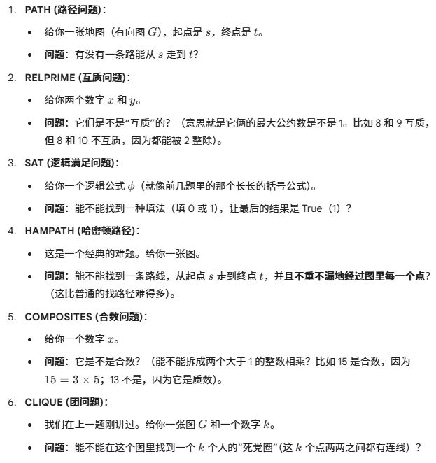

(3) Give the definitions of the following classes:
Big-O notation,

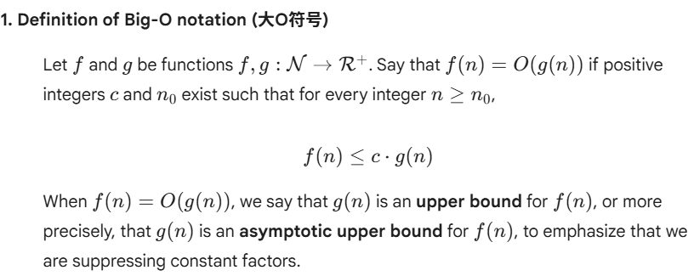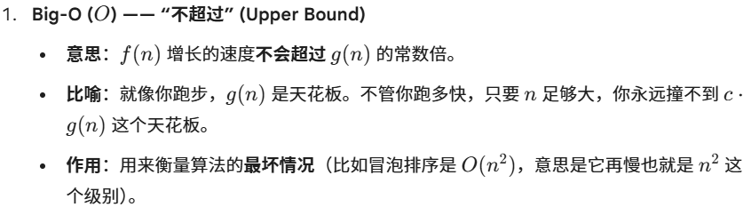
Small-O notation,
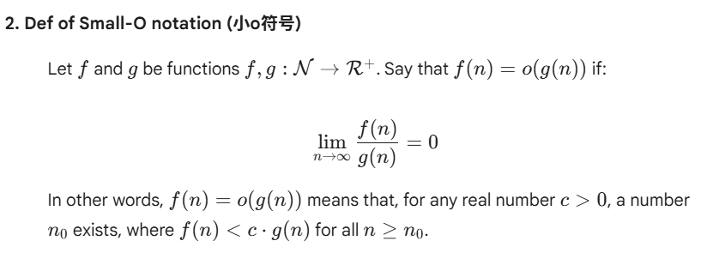

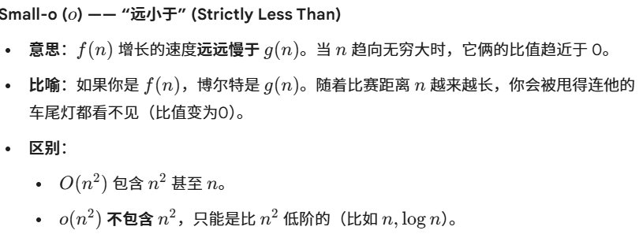
A verifier,
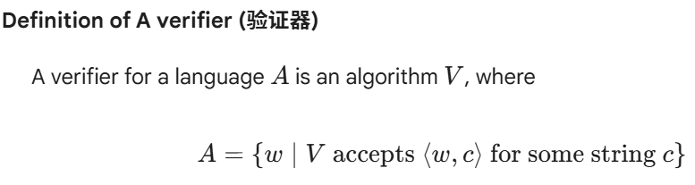
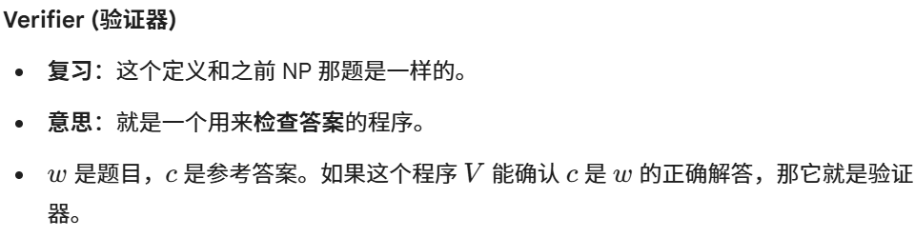

- Prove that PATH ∊ P.
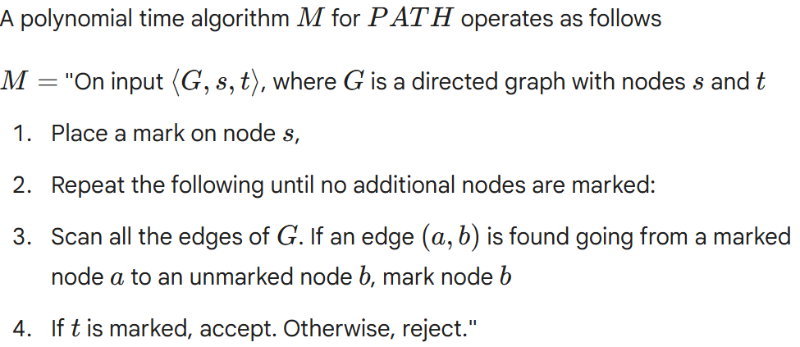
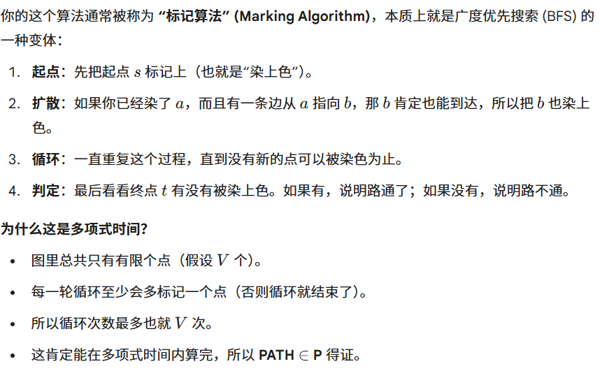
(5) Prove that CLIQUE is in NP. (give a verifier or a nondeterministic polynomial time Turing
machine that decides CLIQUE)
