1. Give self-contained definitions of the following languages/sets: ATM (the
acceptance problem), HaltTM (the halting problem), TM M decides Language L, TM
M semidecides Language L.
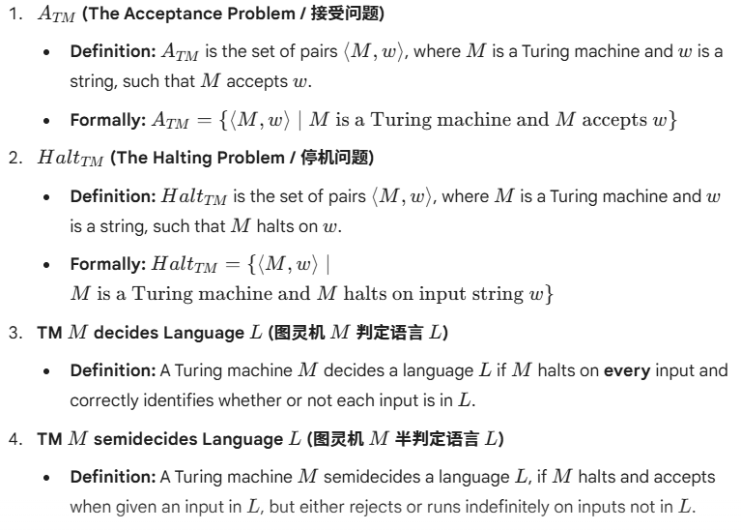

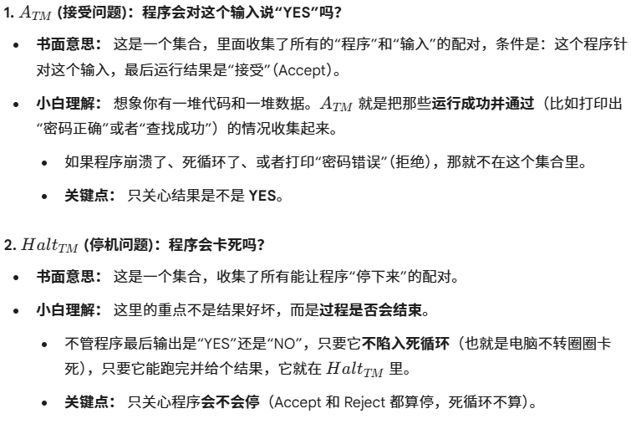

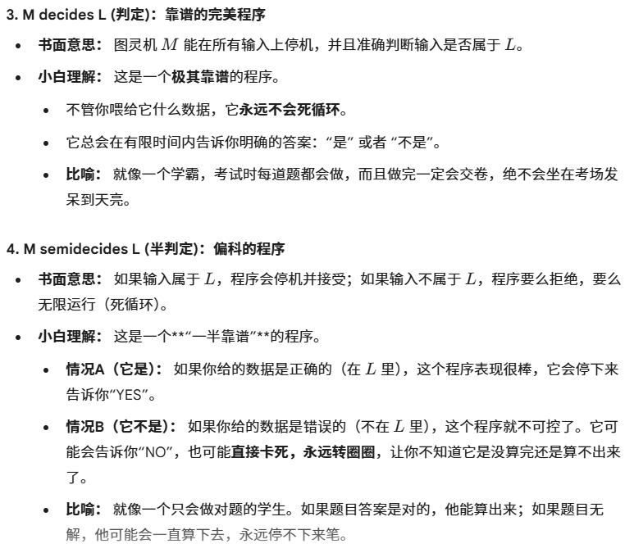

2. Show that ATM is recognizable (construct a recognizer for it) .

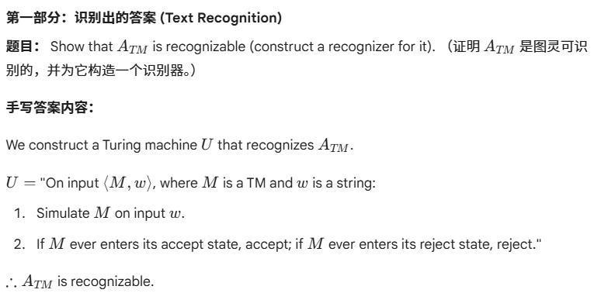

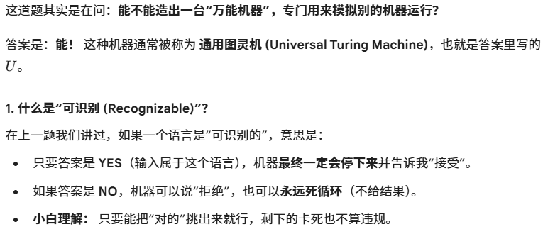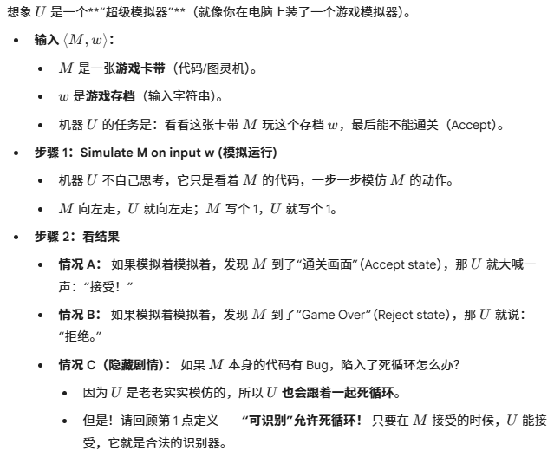

3. Show that ATM is undecidable. (You are required to use the diagonalization technique)
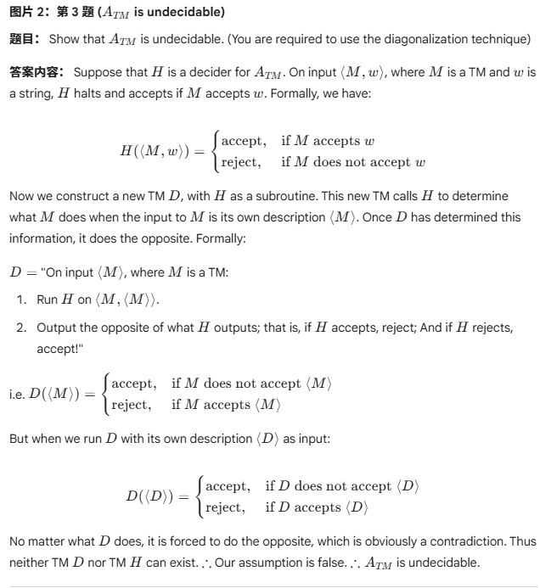
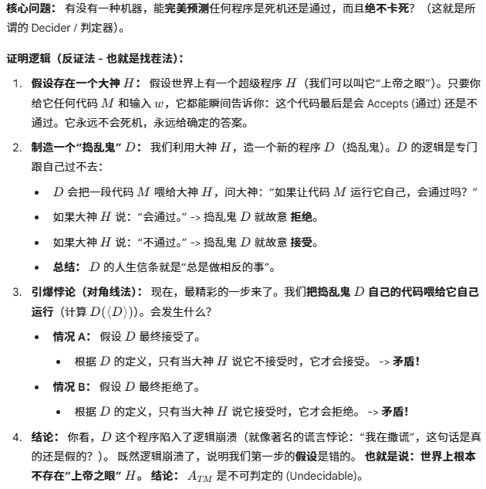

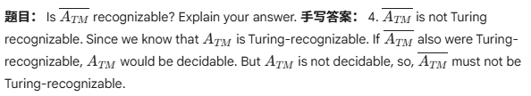
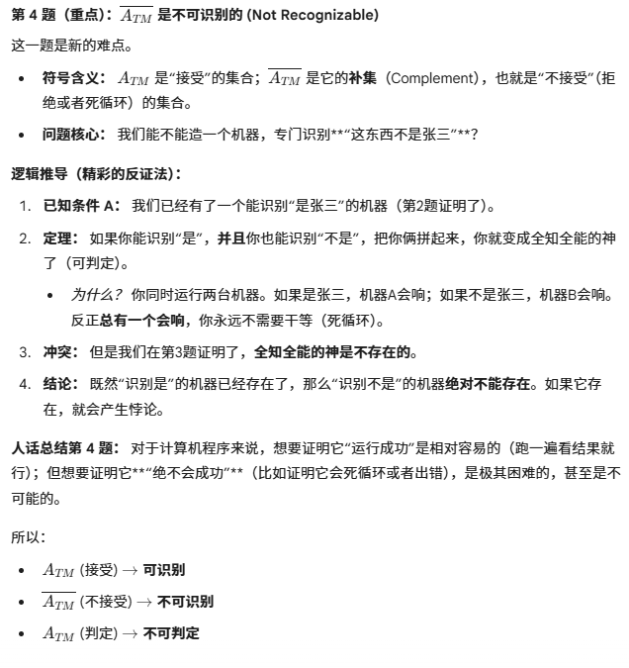

5. Give the definitions of the following classes:
1) Nondeterministic TM M decides a Language L
2) Nondeterministic TM M semidecides a Language L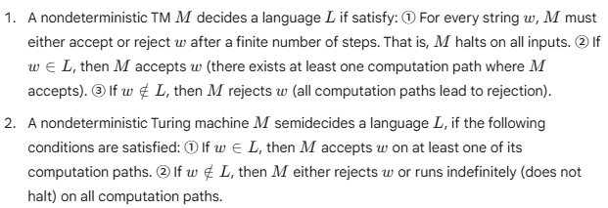
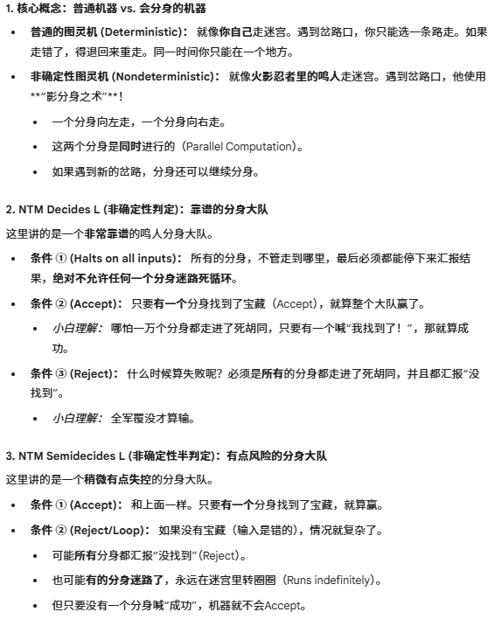

6. State the Church-Turing Thesis
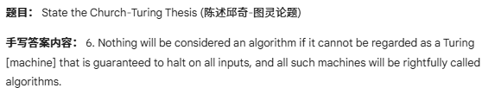
7. Prove the following language is not recursively enumerable.
