CSE 491 HW 4

Jonthan Dowdall

<https://github.com/jtdowdall/CSE847-Machine-Learning>

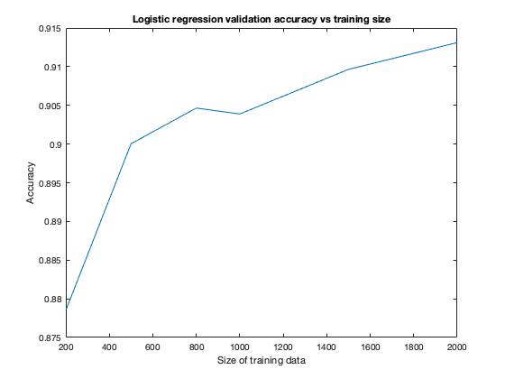1.

As the number of training points increases, the validation accuracy increases. This is expected behavior. With a small number of data points, you are less likely to fit the true population that the data points belong to. As the training size increases, you have a more representative population to train on. This allows the model to generalize better.

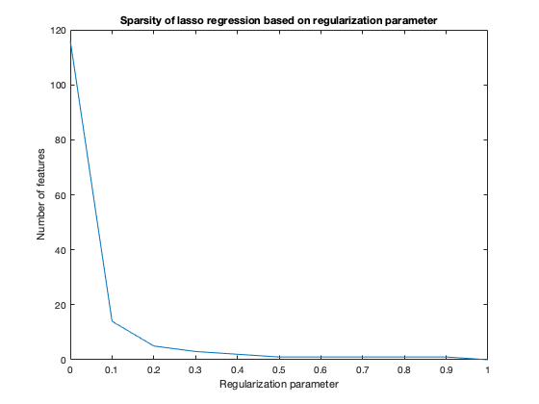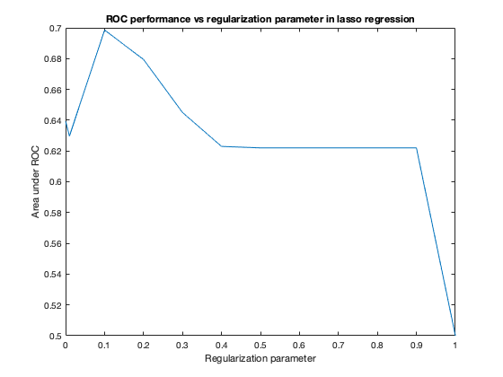2.

The regularization parameter increases the effect of L1, or lasso, regularization. Lasso regularization minimizes the L1 norm of the weights of the model, which incentivizes sparsity among the weights and therefore the features. It is demonstrated that, as the regularization parameter increases, the number of features in the model decreases.

Sparsity can help the model generalize better. If a model has too many features, it can suffer from the curse of dimensionality. A model with too many features may capture noisy variance in the training data and overfit, which reduces its ability to generalize. As is demonstrated, adding a regularization penalty helps the model’s validation performance. However, if the regularization penalty becomes too strong, the model becomes too sparse and the bias begins to take over the model and reduce the generalization performance.