Joel Rodriguez
Fall 2026
CIS 245
Midterm Portfolio

A selected showcase of hands-on Linux server setup, administration, text processing, and network troubleshooting.

Portfolio focus
My goal in this course is to become more comfortable administering Linux servers from the command line. The labs have helped me practice building servers, managing packages, finding information in files, and troubleshooting configuration problems. I am especially interested in how these skills connect to networking and cybersecurity.

Selected work

• Linux server setup: CentOS Stream 10 and Ubuntu virtual machines
• Software repositories, package installation, updates, and services
• Text processing with grep and AWK
• Ubuntu networking documentation and two Bash scripts
• Troubleshooting, instructor feedback, and next steps

GitHub
https://github.com/jtechprojects/linux_administration_class

- Building my Linux lab environment

I set up both a CentOS Stream 10 virtual machine and an Ubuntu virtual machine using Oracle VirtualBox. In my setup lab, I documented downloading installation media, configuring virtual hardware, installing CentOS Stream 10, creating user accounts, and checking network connectivity. I also worked with the command-line environment and documented how to configure a server to start in text mode. Having both Ubuntu and CentOS VMs gives me a practical way to compare Linux administration tools and test commands across distributions. 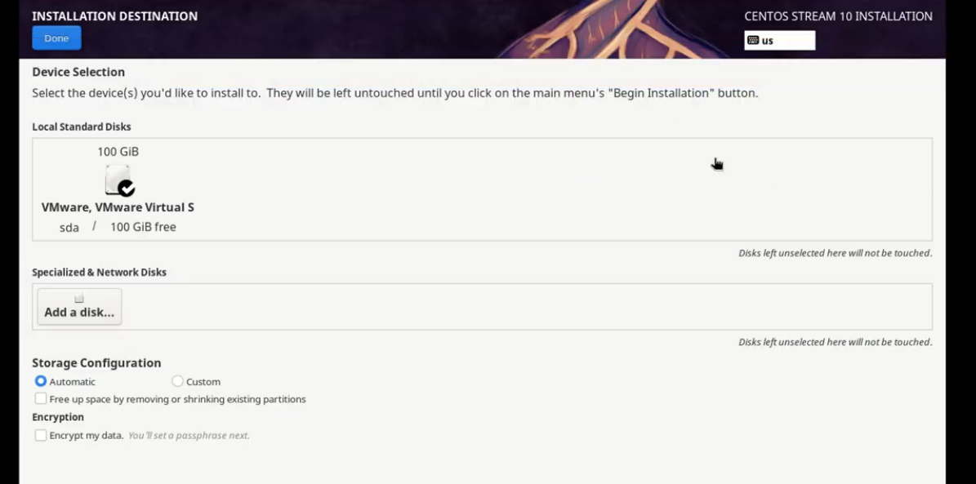
CentOS Stream 10 installer / server environment (Setup Server Lab).

What this demonstrates

• Working with virtual machines and Linux installation media
• Choosing server installation options and configuring accounts
• Understanding the difference between graphical and command-line environments
• Verifying that a newly installed system can connect to the network

Why it matters: A repeatable virtual lab gives me a safe environment to practice system administration and investigate problems without affecting a production server.

- Packages, repositories, and services

In the Installs and Updates lab, I worked with software repositories and package managers on both CentOS and Ubuntu. On CentOS Stream 10, I used DNF to inspect repositories, enabled the CRB repository, and investigated why Fail2Ban could not initially be found. I learned how the availability of a package can depend on enabling the correct repository, including EPEL. I then installed and verified tools such as tmux and Emacs and checked the status of services when needed. On Ubuntu, I practiced the corresponding package-management workflow with APT. This helped me understand both the shared goals and the differences between administering these two distributions.

Enabling and checking the CRB repository in CentOS (Installs and Updates).

Checking the installed Fail2Ban version.

What I learned

I learned to check repository configuration before troubleshooting a missing package, use the distribution’s package manager to install software, verify the installed version, and examine service status with systemctl when applicable. The Fail2Ban example showed me that installation and service configuration are separate tasks. These steps matter in real administration because they make software changes easier to verify, document, and troubleshoot.

- Searching and processing text

The Grep, AWK, and Sed labs helped me develop my skills in searching, filtering, and modifying text using the Linux command line. I started by using Grep to identify specific patterns in files, such as ^H to find lines beginning with H and 000$ to find lines ending with 000. Building on those skills, I used AWK to work with structured data by selecting specific fields, including names and phone numbers. The Sed lab introduced me to modifying text through substitutions and removing unwanted lines. For example, I used sed -n 's/^Jo /Josephine /p' SedLab to replace Jo with Josephine at the beginning of a line. In this command, ^ identifies the beginning of the line, s performs the substitution, p prints the modified line, and -n prevents other lines from being displayed. I also practiced removing blank lines using sed '/^$/d' SedLab, where ^ and $ identify an empty line and d removes it from the output. Although I still need to revise parts of my Sed lab based on the professor's feedback, these assignments have strengthened my understanding of text processing and how these commands can make working with information in Linux more efficient.
Grep: matching a pattern at the beginning of a line
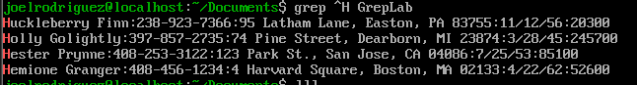
grep ^H GrepLab — searching for lines that begin with H.
AWK: selecting fields
AWK example: displaying selected names and phone numbers.

These commands are useful for working with logs, configuration files, and command output. I also learned that a good explanation should identify what each pattern or field selector means, not just describe the result.

Sed: substitution and filtering
SED: Replace Jo with Josephine at the beginning of a line using a substitution command.

What I learned: Through the Grep, AWK, and Sed labs, I learned how to search for specific patterns, extract information from structured data, and modify text using the Linux command line. These labs helped me better understand regular expressions and how these tools can make working with large files easier and more efficient. Although my Sed lab still needs some corrections, I gained valuable experience using commands that can help with system administration, troubleshooting, and managing information in Linux.

04 Networking and Bash scripting

My Ubuntu networking documentation records the hostname, interfaces, IP addresses, routes, DNS settings, Netplan configuration, systemd-networkd status, connectivity tests, and traceroute results. This gives me a baseline for understanding how the server is configured before troubleshooting.
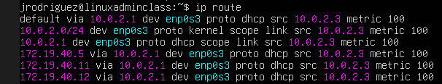
Ubuntu routing table showing the default gateway and interface.
Script samples
network_info_dump.sh — collects server, interface, route, DNS, service, ping, and ICMP traceroute information. It displays results in the terminal and saves them to a dated text file.

network_troubleshooter.sh — an interactive Bash menu that asks whether the user is working with Ubuntu or CentOS and displays appropriate troubleshooting suggestions for Internet, static IP, DNS, traceroute, and interfaces.
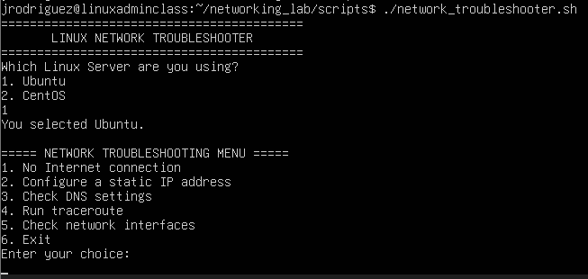
Interactive troubleshooting script menu shown in the networking lab documentation.

Status: Both scripts have been run successfully on Ubuntu. CentOS-specific documentation and testing are still to be completed.

What I learned: Through the networking lab, I learned how to identify network interfaces, check IP addresses, examine routing tables, and troubleshoot DNS and connectivity issues on my Ubuntu server. I also gained experience creating Bash scripts that automatically collect network information and provide troubleshooting instructions for common networking problems. This lab helped me better understand how Linux networking works and how scripting can make troubleshooting more efficient for system administrators.
- Troubleshooting and lessons learned

A challenge I worked through: Bash syntax
While building the interactive network troubleshooter, I encountered an unmatched quotation mark, an incorrect fi closing statement, and missing spaces in a Bash test expression. I corrected the script one issue at a time and used bash -n to check syntax before rerunning it. This taught me how small syntax details affect a script and why testing is important.

Another challenge: network diagnostic tools
The default UDP traceroute probes did not provide a useful path in my Ubuntu VM. I tested ICMP traceroute instead, which returned a response from the destination. I also used an IPv4-only APT option when repository connectivity prevented a normal traceroute installation.

Sed lab — revisions still needed
My Sed lab is NOT complete. The professor asked me to explain each portion of the regular expressions more carefully and pointed out that the final question required an actual script, rather than only a list of commands. I plan to revise the explanations, create the requested script, and test it before considering this lab finished.

The main lesson from this feedback is that showing the output is only part of the assignment: I also need to explain why the expression works and submit the requested deliverable in the correct format.

- Reflection and next steps

Biggest accomplishment so far
My biggest accomplishment is building a working Linux practice environment and using it to complete real administration tasks. The server setup, package management, and networking labs connect together: I can configure a system, inspect how it works, install tools, and collect information to troubleshoot problems.

Biggest challenge
My biggest challenge has been turning commands that work individually into reliable, clearly documented scripts. Debugging the interactive Bash script and receiving feedback on the Sed lab showed me where I need to be more precise.

What I want to improve in the second half
•Finish the CentOS networking documentation and test both networking scripts there.
•Revise the Sed lab with detailed regular-expression explanations and the required script.
•Improve script comments, error handling, and testing evidence.
•Keep organizing coursework and project documentation on GitHub.

